Project High Level Design (HLD)
Cricket Analytics Platform (Match + Ball-by-Ball)
Snowflake + Snowpipe + Informatica CDI + Star Schema + SCD2 + Streamlit + Cortex (Search, RAG, Analyst NL→SQL)
Document Date: 26 Jan 2026

1. Executive Summary
This document describes an end-to-end Cricket Analytics platform on Snowflake. CSV extracts for teams, players, matches and ball-by-ball deliveries are ingested using Snowpipe into a RAW layer, then transformed via Informatica CDI into a Star Schema optimized for performance analytics. A Snowflake Streamlit dashboard provides KPIs such as runs per over, wickets, boundary %, dot-ball %, powerplay vs death overs analysis, top batters/bowlers, and venue/format performance. Cortex Search + RAG enables semantic Q&A over tournament rules, KPI definitions and a data dictionary. Cortex Analyst enables governed Natural Language Querying (NL→SQL) over curated semantic views with safe execution controls.

2. Business Objectives & Success Metrics

2.1 Objectives
- Near real-time ingestion of match and delivery data from CSV into Snowflake using Snowpipe.
- Curated Star Schema enabling fast analysis by match, date, venue, team and player.
- Track Player history with SCD Type 2 (role/team changes) for accurate season comparisons.
- Interactive Streamlit dashboard with filters (format, competition, season/month, team, player, venue, innings, over range).
- Cortex Search + RAG for rules/KPI definition questions with citations.
- Cortex Analyst NLQ (NL→SQL) for business users over governed semantic views.

2.2 Success Metrics
- Ingestion latency < 5 minutes per file arrival to RAW availability.
- DW refresh SLA < 30 minutes after ingestion completion (hourly/daily schedule).
- Reject rate < 2% with quarantine and audit traceability.
- NLQ restricted to semantic views with SELECT-only + LIMIT + timeout enforcement.

3. Scope (In-scope / Out-of-scope)

3.1 In-scope
- CSV landing structure and sample datasets (Teams, Players, Matches, Deliveries).
- Snowflake ingestion using stages + Snowpipe (pipes per entity) with monitoring and error handling.
- Star schema: FACT_DELIVERY + DIM_PLAYER (SCD2), DIM_TEAM, DIM_MATCH, DIM_VENUE, DIM_DATE.
- CDI mappings and orchestration (dims first, then fact).
- Streamlit dashboard + Cortex Search (RAG) + Cortex Analyst (NL→SQL).

3.2 Out-of-scope
- Live scoring ingestion (streaming) and real-time fan engagement systems.
- Computer vision / video analytics, advanced win probability models (future).
- External BI tools beyond Streamlit.

4. Assumptions & Constraints

4.1 Assumptions
- Match feeds are provided as periodic CSV exports from scoring systems or partners.
- Snowflake account supports Snowpipe, Streamlit and Cortex features.
- Informatica CDI Secure Agent is configured with Snowflake connectivity.
- Rules/KPI definitions and data dictionary documents are available for indexing.

4.2 Constraints
- Schema drift possible; ingestion must validate and quarantine bad records.
- Player PII is minimal; still enforce least privilege for admin fields (contracts).
- NLQ must be governed to prevent expensive full-scan queries.

5. High Level Architecture (diagram description in text)
- Source Layer: CSV feeds (teams, players, matches, deliveries).
- Ingestion Layer: External stage + Snowpipe → RAW tables.
- Transformation Layer: Informatica CDI → DW Star Schema + SCD2 player dimension.
- Consumption Layer: Streamlit dashboard on SEMANTIC views.
- GenAI Layer: Cortex Search indexes documents; RAG answers with citations; Cortex Analyst enables NL→SQL with safeguards.

6. End-to-End Data Flow
- CSV files land by entity under landing folders.
- Snowpipe auto-ingests into RAW tables and captures rejects/load history.
- CDI taskflow: DIM_DATE → DIM_TEAM → DIM_VENUE → DIM_PLAYER (SCD2) → DIM_MATCH → FACT_DELIVERY.
- Streamlit queries SEMANTIC views for KPIs and drilldowns.
- RAG: question → retrieve relevant chunks via Cortex Search → answer with citations.
- NLQ: question → Cortex Analyst generates SQL → validate SELECT-only + LIMIT → execute on semantic views → display results.

7. Source Data (CSV specs + samples)

7.1 Landing Folder Structure
/landing/cricket_analytics/
teams/teams_YYYYMMDD.csv
players/players_YYYYMMDD.csv
matches/matches_YYYYMMDD.csv
deliveries/deliveries_YYYYMMDD.csv
/quarantine/cricket_analytics/
/archive/cricket_analytics/

7.2 Source Files Included
- cricket_teams.csv (15 rows)
- cricket_players.csv (20 rows)
- cricket_matches.csv (15 rows)
- cricket_deliveries.csv (25 rows)

8. Snowflake Ingestion Design (Snowpipe)
- Create CSV file format (skip header, null handling, trimming).
- Create external stage for landing storage; optionally internal stage for controlled replays.
- Create one pipe per entity to COPY INTO RAW tables (RAW_TEAMS, RAW_PLAYERS, RAW_MATCHES, RAW_DELIVERIES).
- Capture metadata columns (LOAD_TS, SOURCE_FILE_NAME) for traceability.
- Error handling: ON_ERROR=CONTINUE with reject capture; alerts for failed loads and high reject counts.
- Monitoring: pipe status, load history, and ingestion latency SLAs.

9. Data Model Design (Star Schema)

9.1 Star Schema Diagram
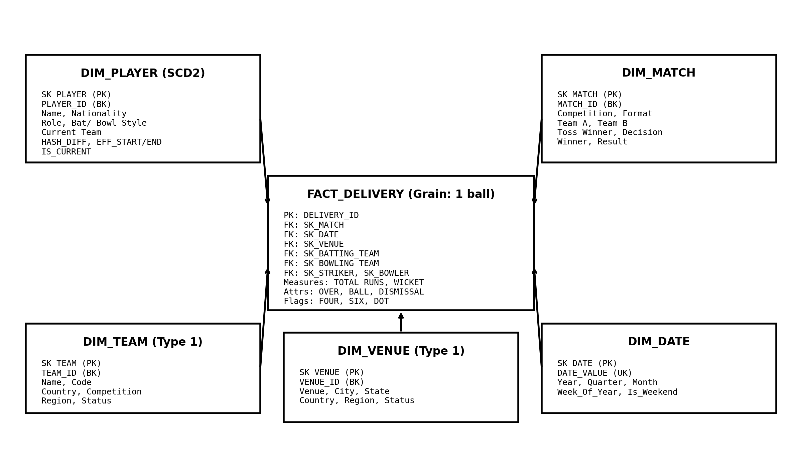
Figure: Cricket Analytics Star Schema (FACT_DELIVERY at ball-level grain with Player SCD2).

9.2 Grain and Keys
- Fact grain: 1 row per ball (DELIVERY_ID).
- Dimensions use surrogate keys (SK_*). Business keys retained for traceability.
- Player dimension is SCD2 to capture role/team changes; other dims are Type 1.

9.3 Example DDL (DW layer)
Appendix A summarizes DW DDL patterns for DIM_DATE, DIM_TEAM, DIM_VENUE, DIM_PLAYER (SCD2), DIM_MATCH and FACT_DELIVERY.

10. CDI Design (Mappings, Tasks, Parameters, Scheduling)

10.1 Mappings
- m_dim_date_load
- m_dim_team_load (Type 1 upsert)
- m_dim_venue_load (Type 1 upsert)
- m_dim_player_scd2 (SCD2 by PLAYER_ID)
- m_dim_match_load (lookup teams/venue/date)
- m_fact_delivery_load (lookup match/team/player/date/venue keys and load fact)

10.2 Transformations
- Expression: derive over_phase (Powerplay/Middle/Death), compute flags and measures; compute hash diff for SCD2.
- Lookup: fetch current SKs from dimensions (IS_CURRENT=TRUE for player).
- Joiner: attach surrogate keys (match/team/player/date/venue).
- Router/Filter: SCD2 new vs changed vs unchanged; invalid rows to quarantine path.
- Aggregator (optional): derive match-level scorecards, economy, strike rate snapshots for dashboard speed.

10.3 Parameterization
- Parameters: $P_DB$, $P_RAW_SCHEMA$, $P_DW_SCHEMA$, $P_LOAD_TS$, $P_BATCH_ID$, $P_COMPETITION$.
- DEV/TEST/PROD parameter files for portability.

10.4 Scheduling
- Taskflow tf_cricket_dw_hourly or daily (dims then fact).
- Idempotency: delivery primary key DELIVERY_ID; prevent duplicates on rerun.

11. SCD Type 2 Design (Player)
- Tracked attributes: nationality, role, batting style, bowling style, current team.
- Change detection: HASH_DIFF = MD5(concat of tracked attributes).
- New player: insert current row (EFF_START_TS=load_ts, EFF_END_TS='9999-12-31', IS_CURRENT=TRUE).
- Changed attributes: expire prior current row and insert a new current row.
- Unchanged: no action.

12. Data Quality & Reconciliation
- File row counts vs RAW loads; rejects by reason and file.
- DW checks: dim inserts/updates, fact counts per match/date/innings/over.
- Derived checks: total runs by match = sum(total_runs) across deliveries; wicket count by match = sum(is_wicket).
- Referential checks: fact must resolve match/team/player/date/venue SKs (Unknown members as needed).

13. Security & Access Control
- Roles: ROLE_INGEST, ROLE_ETL, ROLE_ANALYST, ROLE_APP_STREAMLIT, ROLE_ADMIN.
- Limit RAW schema access to ingestion/ETL roles; analysts consume SEMANTIC views only.
- Optional row-level security by competition (IPL vs International) for data segregation.

14. Monitoring & Operations
- Snowpipe monitoring: pipe status, load history, failed file alerts, ingestion latency.
- CDI monitoring: taskflow run logs and alerts on failures.
- OPS tables: LOAD_AUDIT (batch counts) and REJECTS (bad records + reason).
- Performance: warehouse sizing and query monitoring for dashboard/NLQ workloads.

15. Streamlit Dashboard Design

15.1 Pages
- Match Overview: score progression, run rate, wickets, boundary %; filters by match/team/innings.
- Player Insights: top batters (SR, boundaries), top bowlers (economy, wickets), phase-wise analysis.
- Team/Venue: performance by venue and format; home vs away; winning trends.
- Explorer: ball-by-ball drilldown with export.

15.2 KPI Tiles / Charts
- KPIs: Total Runs, Wickets, Run Rate, Boundary %, Dot Ball %, Extras.
- Charts: run-rate trend by over, wickets timeline, top-N players, venue leaderboard, heatmap by over phase.

16. Cortex Search + RAG Design
- Index documents: playing conditions, tournament rules, KPI definitions, data dictionary and glossary.
- Chunking: 500–1000 tokens with overlap; metadata: doc_type, season, rule_section.
- RAG: retrieve top-k chunks using Cortex Search; answer constrained to context; show citations.

16.1 RAG Prompt Template
System: Use only provided context; if insufficient, say so. Provide citations from retrieved chunks.
User Template: Question={user_question}; Context={retrieved_chunks_with_metadata}.

17. Cortex Analyst NL2SQL Design
- Expose only curated SEMANTIC views (e.g., V_MATCH_SUMMARY, V_PLAYER_BATTING, V_PLAYER_BOWLING, V_TEAM_TRENDS).
- SQL safeguards: SELECT-only validation, LIMIT 1000 default, require date/match filters for large views, timeout enforcement.
- Governance: allowlist views/columns; deny RAW/OPS schemas; audit NLQ queries.

17.1 NLQ Prompt Template
Instruction: Generate a single Snowflake SELECT query using only SEMANTIC views. Add filters and LIMIT 1000. Output SQL only.

18. Testing Strategy (unit/integration/UAT)
- Unit: validate each Snowpipe pipe and CDI mapping using sample files.
- Integration: end-to-end from file arrival → DW refresh → dashboard update.
- UAT: validate KPI results and drilldowns; verify RAG citations and NLQ correctness.

19. Deployment Plan (DEV → TEST → PROD)
- DEV: create objects and validate with sample data.
- TEST: regression, performance tuning and security validation.
- PROD: deploy DDL + CDI assets, enable Snowpipe notifications, schedule taskflows, enable monitoring.

20. Risks & Mitigations
- Data quality (missing balls/overs) → validation rules and quarantine.
- SCD2 growth for players → track only necessary attributes; clustering and retention strategy.
- NLQ expensive queries → semantic views only + LIMIT + timeouts.
- Schema drift → versioned contracts and ingestion validation.

21. Appendix

Appendix A: Example DDL Summary
DW tables: DIM_DATE, DIM_TEAM, DIM_VENUE, DIM_PLAYER (SCD2), DIM_MATCH, FACT_DELIVERY.

Appendix B: SCD2 High-level Pattern
1) Detect changes using HASH_DIFF.
2) Expire current row when hash changes.
3) Insert new current row.
Implement using CDI Router + Update + Insert branches or SQL override patterns where allowed.

