DBSE&DBS
Roll No: 2520030388
Name: B.PEMESH
Query-1:
Query-2:
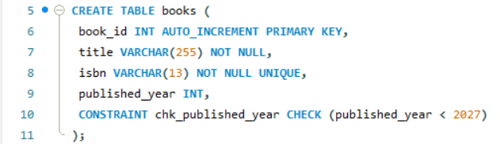
Query-3:
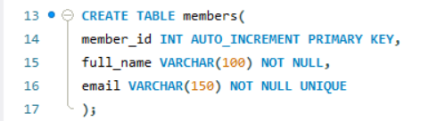
Query-4:
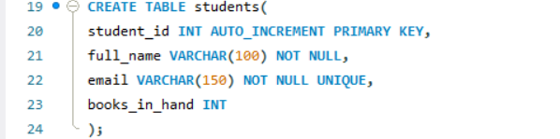
Query-5:
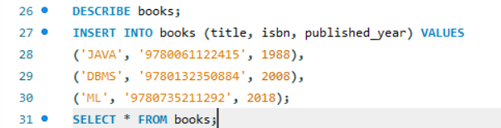
Books2:
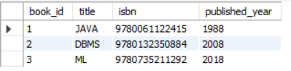
Query-6:
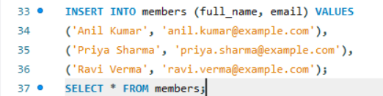
Members3:
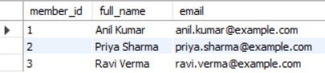
Query-7:
