DBSE&DBD
ROLL NO: 2520030388
NAME: B.PEMESH

QUERY-1:
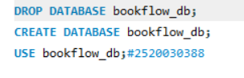
QUERY-2:
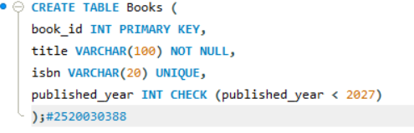
QUERY-3:
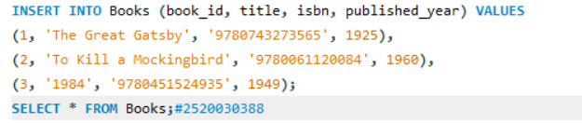

QUERY-4:
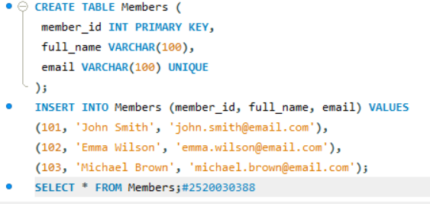
QUERY-5:
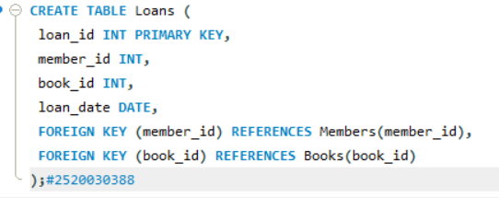
QUERY-6:
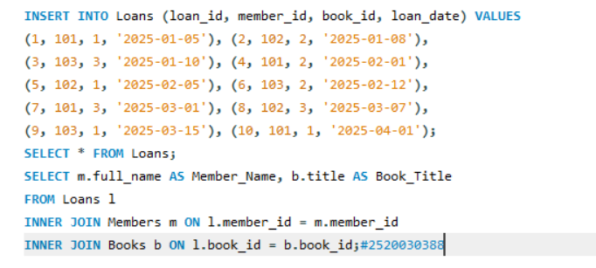

QUERY-7:
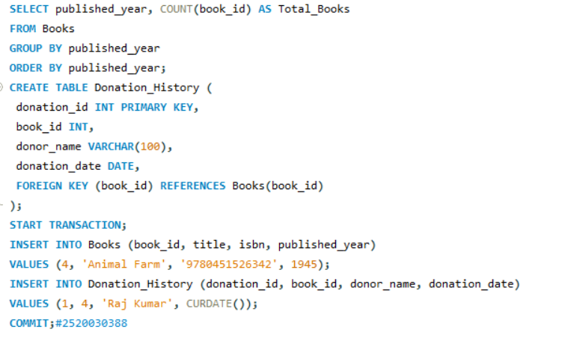
QUERY-8:

Books-9:

Members-10:

Loans-11:
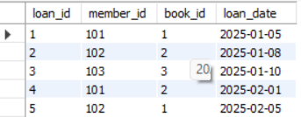
Result-12:

Result-13:
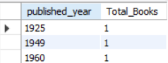
Books-14:
