**WEB-APP WORKING**

There are 3 phases in bringing a constructive website.

1. Design ( UI & Prototype designing)
2. Development ( Front end & Back end development)
3. Deployment ( Server upload & configuration )

Website : It is a collection of web pages, basically in HTML(Hyper Text Markup Language), which also includes additional documentation of CSS for styling the website.

Web Browser : Websites are accessible through web browsers. Popular web browsers are Google Chrome, Mozilla Firefox, and Safari.

Web Server : Websites and their associated HTML documents and files are stored on computers called web servers. Also, we can rent the web server from the third party for ease and productive. Popular web servers are Apache, Nginx.

So, we can justify into **Front End** & **Back End**. The static front end can be designed and developed using HTML+CSS. However, for a dynamic website with user interaction, we need to include JavaScript & it’s frameworks.

For example, server side scripting can be done by Phyton, and using it’s framework Django the Back end can be developed. There are various others like PHP, Ruby, Java, GO, etc.

Besides, we will be using database to store the complete information of the user, on request. For example, MySQL, PostgreSQL, etc. We will install the database on the server, and configure with the website.

The communication between the website[client] => web browser => web server => web browser => website[client] is as follows :

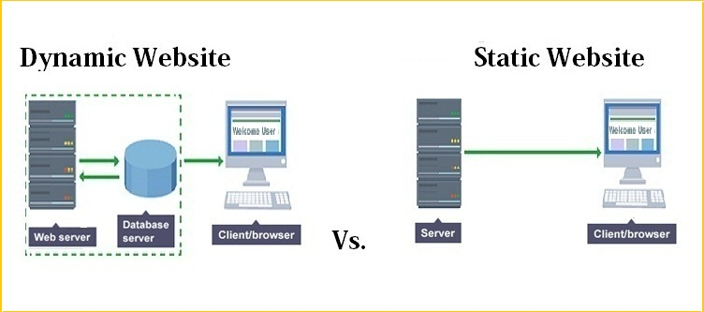

The deployment of a website can be done on web server by configuring and connecting the database, domain, frameworks required and all the files and folders of website well arranged into the server. As in,

