PYTHON FILE HANDLING & AUTOMATION
Project Report

Submitted as a practical demonstration of Python file handling,
CSV processing, file automation, and exception handling.

Student Name: Bammidi Rakesh
Roll Number: 23981A04Q9
Department: ECE
Institution: Raghu Engineering College
Date: 7 September 2026

1. Introduction
Python provides built-in modules and functions for working with files and folders. This project implements a menu-driven Automated File Manager that demonstrates text-file handling, CSV processing, file renaming, moving, deletion, and exception handling.

2. Objectives
• Create and read TXT files.
• Create and read CSV files using Python's csv module.
• Automate common file operations such as rename, move, and delete.
• Use try-except blocks to handle runtime errors safely.
• Build a simple menu-driven command-line application.

3. Tools and Technologies
• Programming Language: Python 3
• IDE: Visual Studio Code
• Modules: os, csv, shutil
• Operating environment: Windows

4. Project Structure
Python_File_Automation/
├── file_manager.py
├── input_files/
├── output_files/
└── screenshots/

5. Functional Description
Option 1 creates a TXT file in input_files. Option 2 reads and displays TXT content. Option 3 creates a CSV file with Name, Age, and Department fields. Option 4 reads the CSV row by row. Option 5 renames a file, Option 6 moves a file from input_files to output_files, and Option 7 deletes a file after confirmation. Option 8 terminates the program.

6. Exception Handling
The project uses try-except blocks to prevent the program from terminating unexpectedly. FileNotFoundError is handled specifically while reading files, and other exceptions are reported with a useful error message. Rename operations also handle FileExistsError.

7. Complete Python Source Code
import os
import csv
import shutil

input_folder = "input_files"
output_folder = "output_files"

os.makedirs(input_folder, exist_ok=True)
os.makedirs(output_folder, exist_ok=True)

# ---------------------------------------------
# MAIN MENU
# ---------------------------------------------

while True:

print("\n=========================================")
print(" AUTOMATED FILE MANAGER")
print("=========================================")

print("1. Create TXT File")
print("2. Read TXT File")
print("3. Create CSV File")
print("4. Read CSV File")
print("5. Rename File")
print("6. Move File")
print("7. Delete File")
print("8. Exit")

choice = input("\nEnter your choice: ")

# -----------------------------------------
# OPTION 1 - CREATE TXT FILE
# -----------------------------------------

if choice == "1":

try:
file_name = input("Enter TXT file name: ")

file_path = os.path.join(
input_folder,
file_name + ".txt"
)

content = input("Enter the content to write: ")

with open(file_path, "w") as file:
file.write(content)

print("\nTXT file created successfully.")
print("File location:", file_path)

except Exception as error:
print("Error while creating TXT file:", error)

# -----------------------------------------
# OPTION 2 - READ TXT FILE
# -----------------------------------------

elif choice == "2":

try:
file_name = input("Enter TXT file name: ")

file_path = os.path.join(
input_folder,
file_name + ".txt"
)

with open(file_path, "r") as file:
content = file.read()

print("\n----- FILE CONTENT -----")
print(content)
print("------------------------")

except FileNotFoundError:
print("Error: TXT file not found.")

except Exception as error:
print("Error while reading TXT file:", error)

# -----------------------------------------
# OPTION 3 - CREATE CSV FILE
# -----------------------------------------

elif choice == "3":

try:
csv_name = input("Enter CSV file name: ")

csv_path = os.path.join(
input_folder,
csv_name + ".csv"
)

with open(csv_path, "w", newline="") as file:

writer = csv.writer(file)

# Write column headings
writer.writerow(
["Name", "Age", "Department"]
)

print("\nEnter student details.")

name = input("Enter name: ")
age = input("Enter age: ")
department = input("Enter department: ")

# Write student information
writer.writerow(
[name, age, department]
)

print("\nCSV file created successfully.")
print("File location:", csv_path)

except Exception as error:
print("Error while creating CSV file:", error)

# -----------------------------------------
# OPTION 4 - READ CSV FILE
# -----------------------------------------

elif choice == "4":

try:
csv_name = input("Enter CSV file name: ")

csv_path = os.path.join(
input_folder,
csv_name + ".csv"
)

with open(csv_path, "r") as file:

reader = csv.reader(file)

print("\n----- CSV CONTENT -----")

for row in reader:
print(" | ".join(row))

print("-----------------------")

except FileNotFoundError:
print("Error: CSV file not found.")

except Exception as error:
print("Error while reading CSV file:", error)

# -----------------------------------------
# OPTION 5 - RENAME FILE
# -----------------------------------------

elif choice == "5":

try:
old_file = input("Enter current file name: ")
new_file = input("Enter new file name: ")

old_path = os.path.join(
input_folder,
old_file
)

new_path = os.path.join(
input_folder,
new_file
)

if os.path.exists(old_path):

# Rename the file
os.rename(old_path, new_path)

print("\nFile renamed successfully.")
print("New file name:", new_file)

else:
print("Error: File not found.")

except FileExistsError:
print("Error: A file with the new name already exists.")

except Exception as error:
print("Error while renaming file:", error)

# -----------------------------------------
# OPTION 6 - MOVE FILE
# -----------------------------------------

elif choice == "6":

try:
file_name = input("Enter file name to move: ")

source_path = os.path.join(
input_folder,
file_name
)

destination_path = os.path.join(
output_folder,
file_name
)

if os.path.exists(source_path):

# Move the file
shutil.move(
source_path,
destination_path
)

print("\nFile moved successfully.")
print("Moved to:", destination_path)

else:
print("Error: File not found.")

except Exception as error:
print("Error while moving file:", error)

# -----------------------------------------
# OPTION 7 - DELETE FILE
# -----------------------------------------

elif choice == "7":

try:
file_name = input("Enter file name to delete: ")

# Check input folder first
file_path = os.path.join(
input_folder,
file_name
)

# If the file is not in input_files,
# check the output_files folder
if not os.path.exists(file_path):

file_path = os.path.join(
output_folder,
file_name
)

if os.path.exists(file_path):

confirmation = input(
"Are you sure you want to delete this file? (y/n): "
)

if confirmation.lower() == "y":

# Delete the file
os.remove(file_path)

print("File deleted successfully.")

else:
print("Delete operation cancelled.")

else:
print("Error: File not found.")

except Exception as error:
print("Error while deleting file:", error)

# -----------------------------------------
# OPTION 8 - EXIT
# -----------------------------------------

elif choice == "8":

print("\nThank you for using Automated File Manager.")
print("Exiting program...")

break

# -----------------------------------------
# INVALID CHOICE
# -----------------------------------------

else:

print(
"\nInvalid choice. "
"Please enter a number from 1 to 8."
)

8. Output and Execution Evidence
The following screenshots document the successful execution of each major feature.
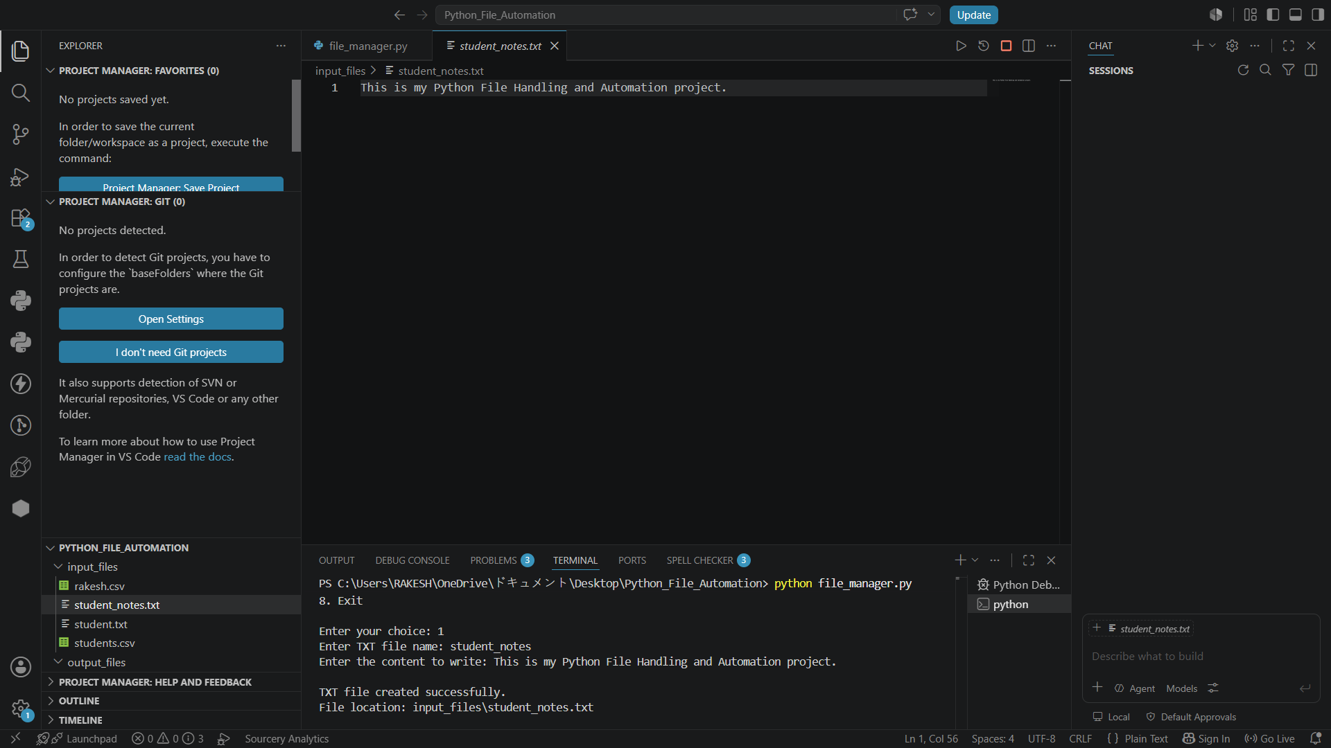
Figure 1 – Create TXT File

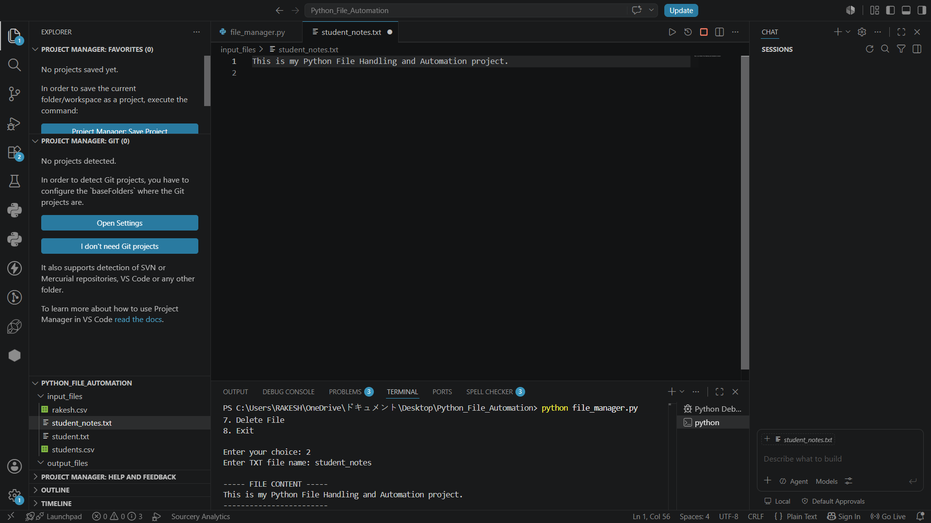
Figure 2 – Read TXT File

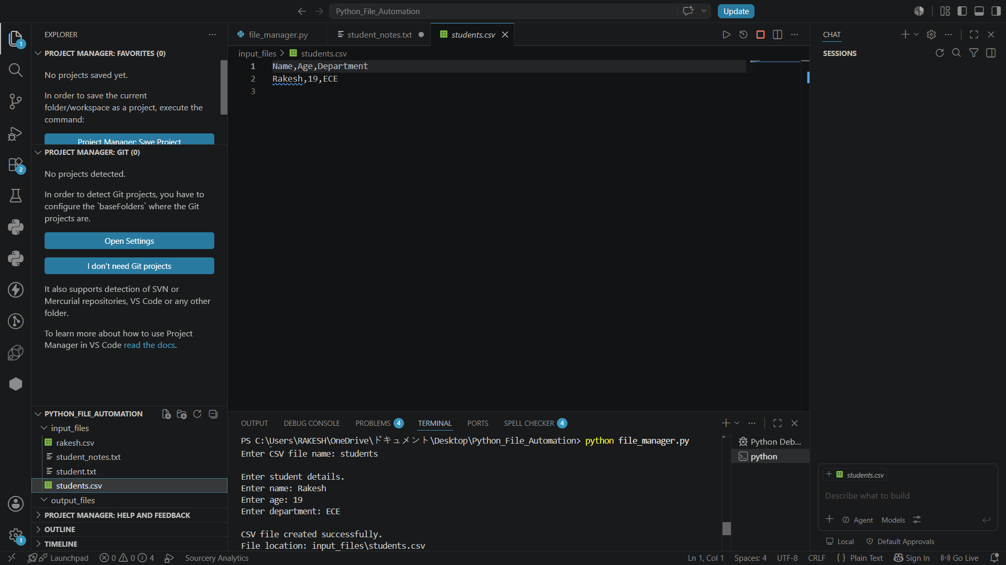
Figure 3 – Create CSV File

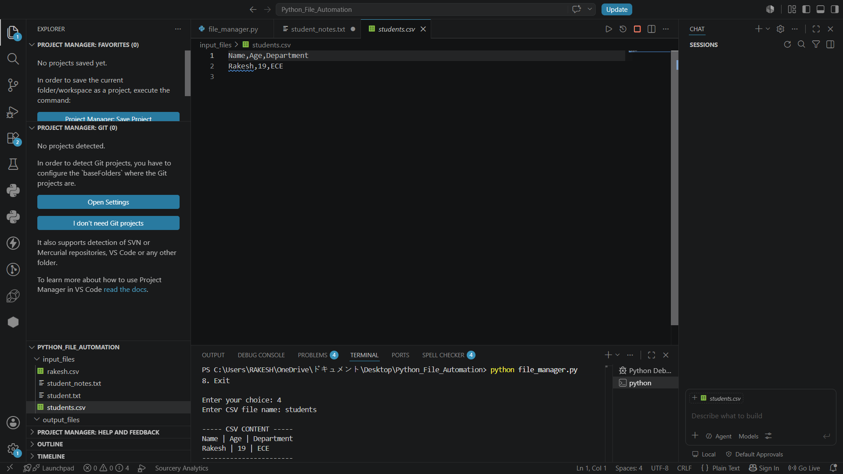
Figure 4 – Read CSV File

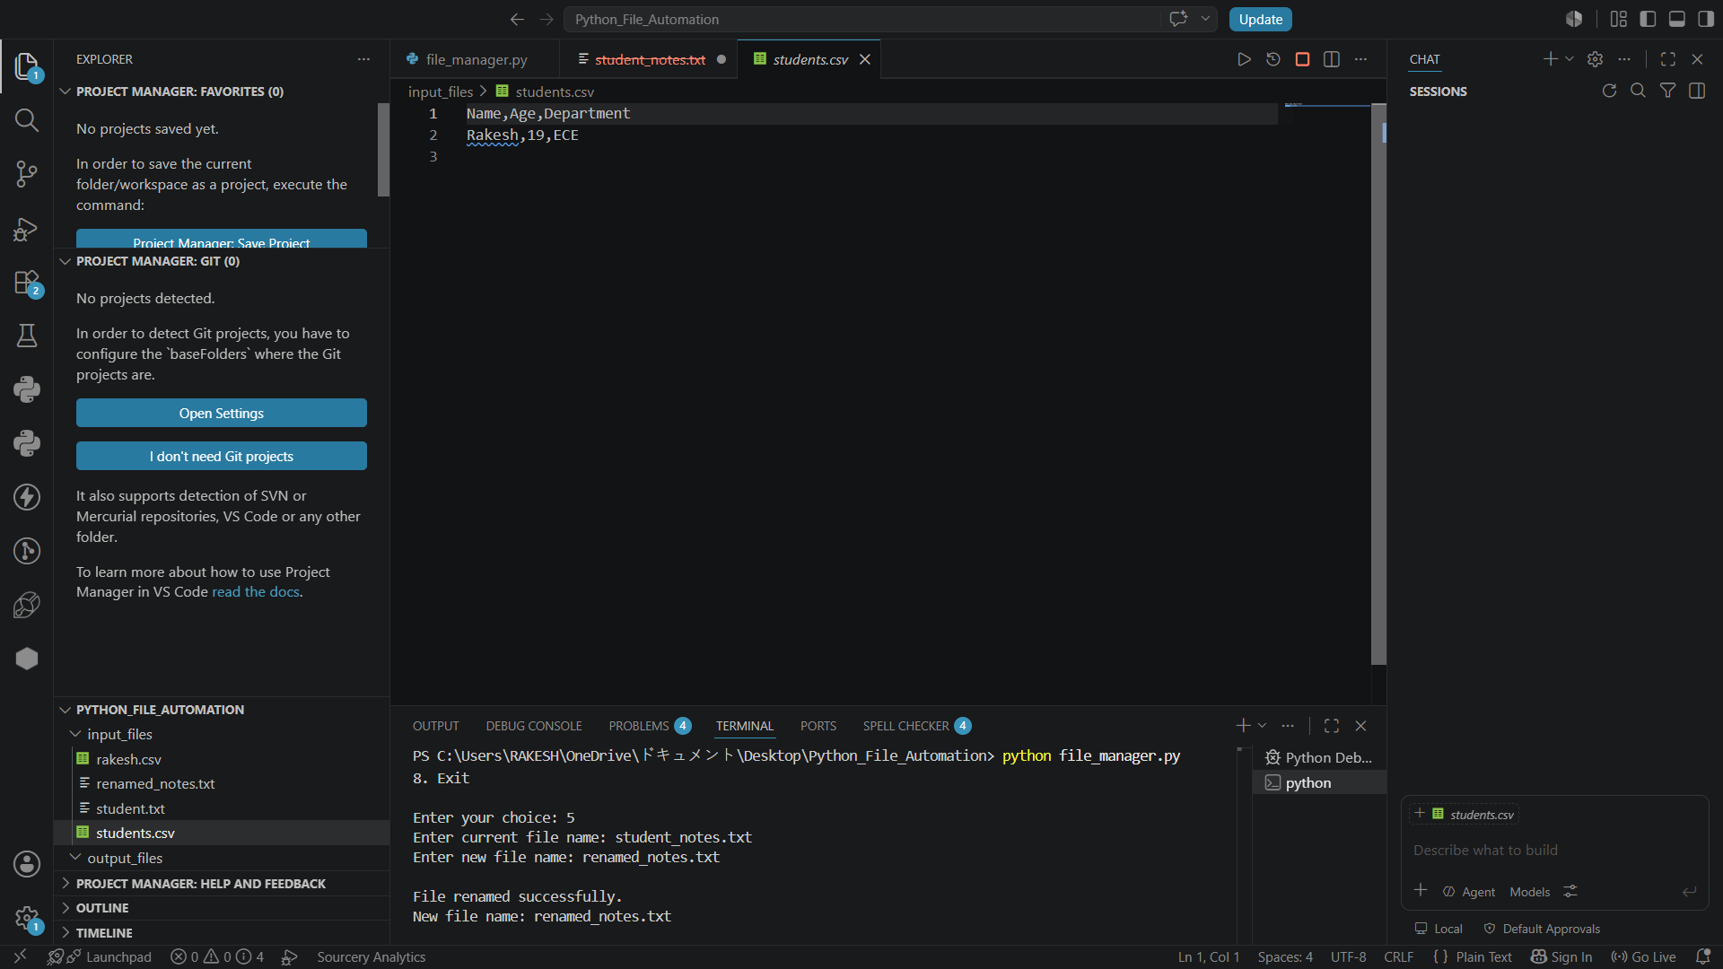
Figure 5 – Rename File

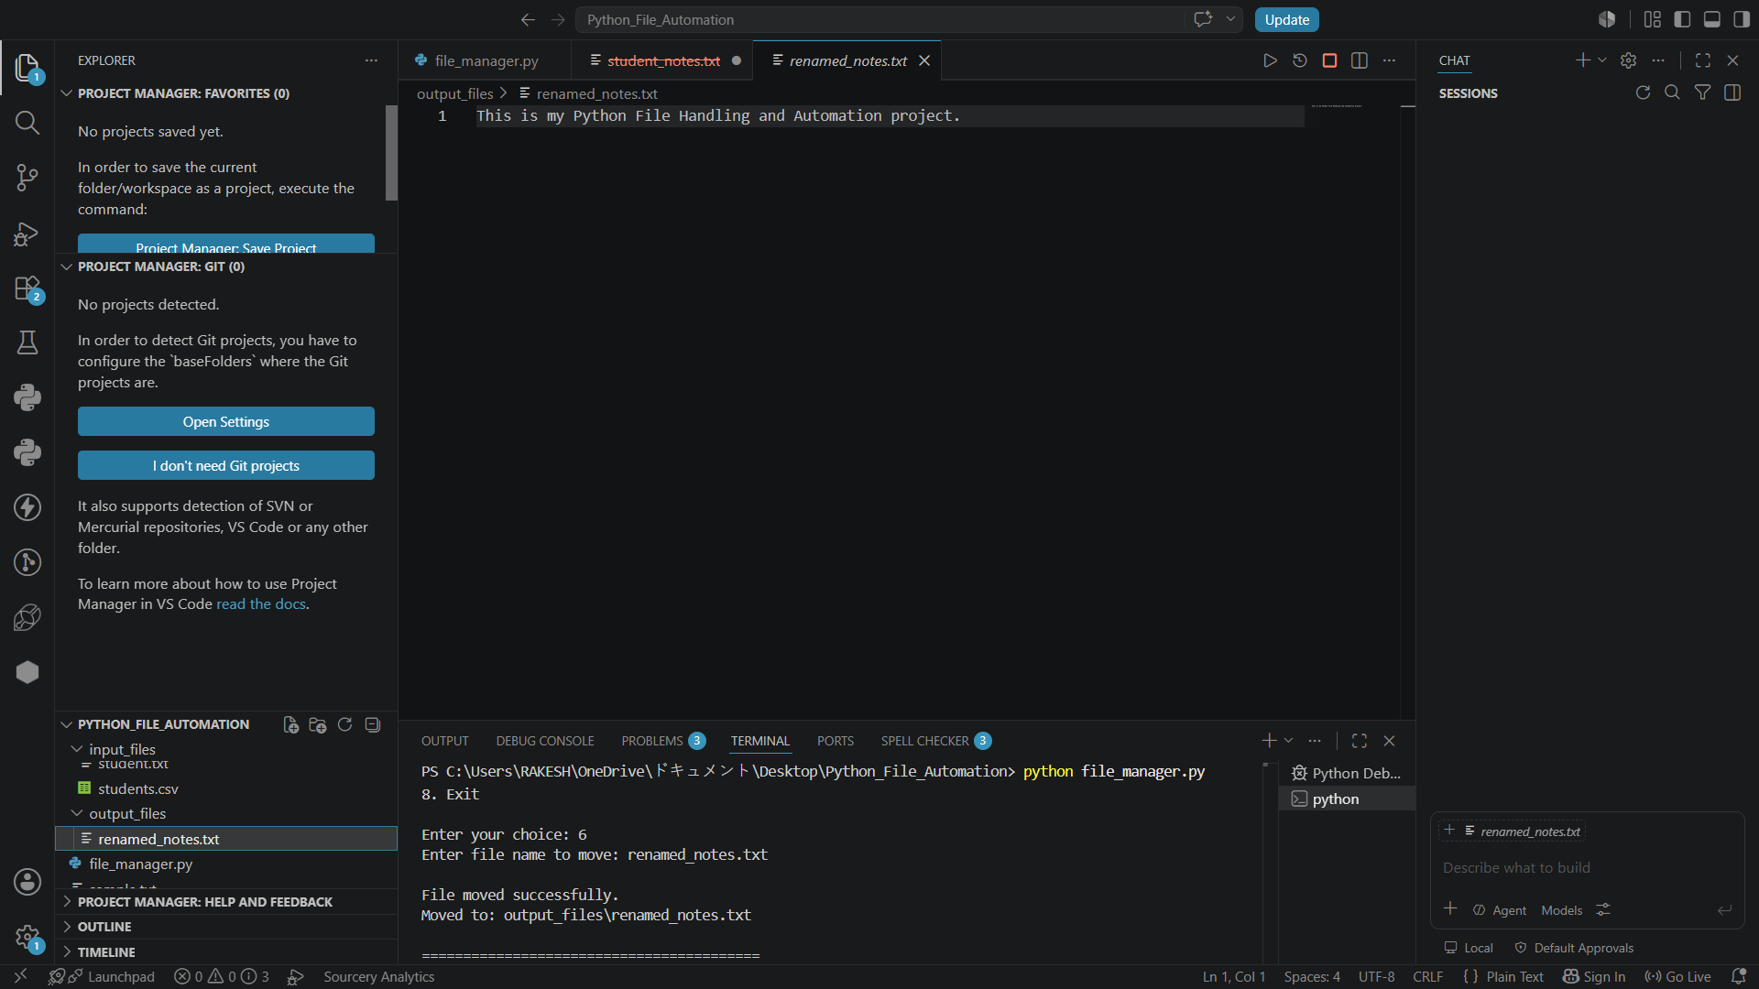
Figure 6 – Move File

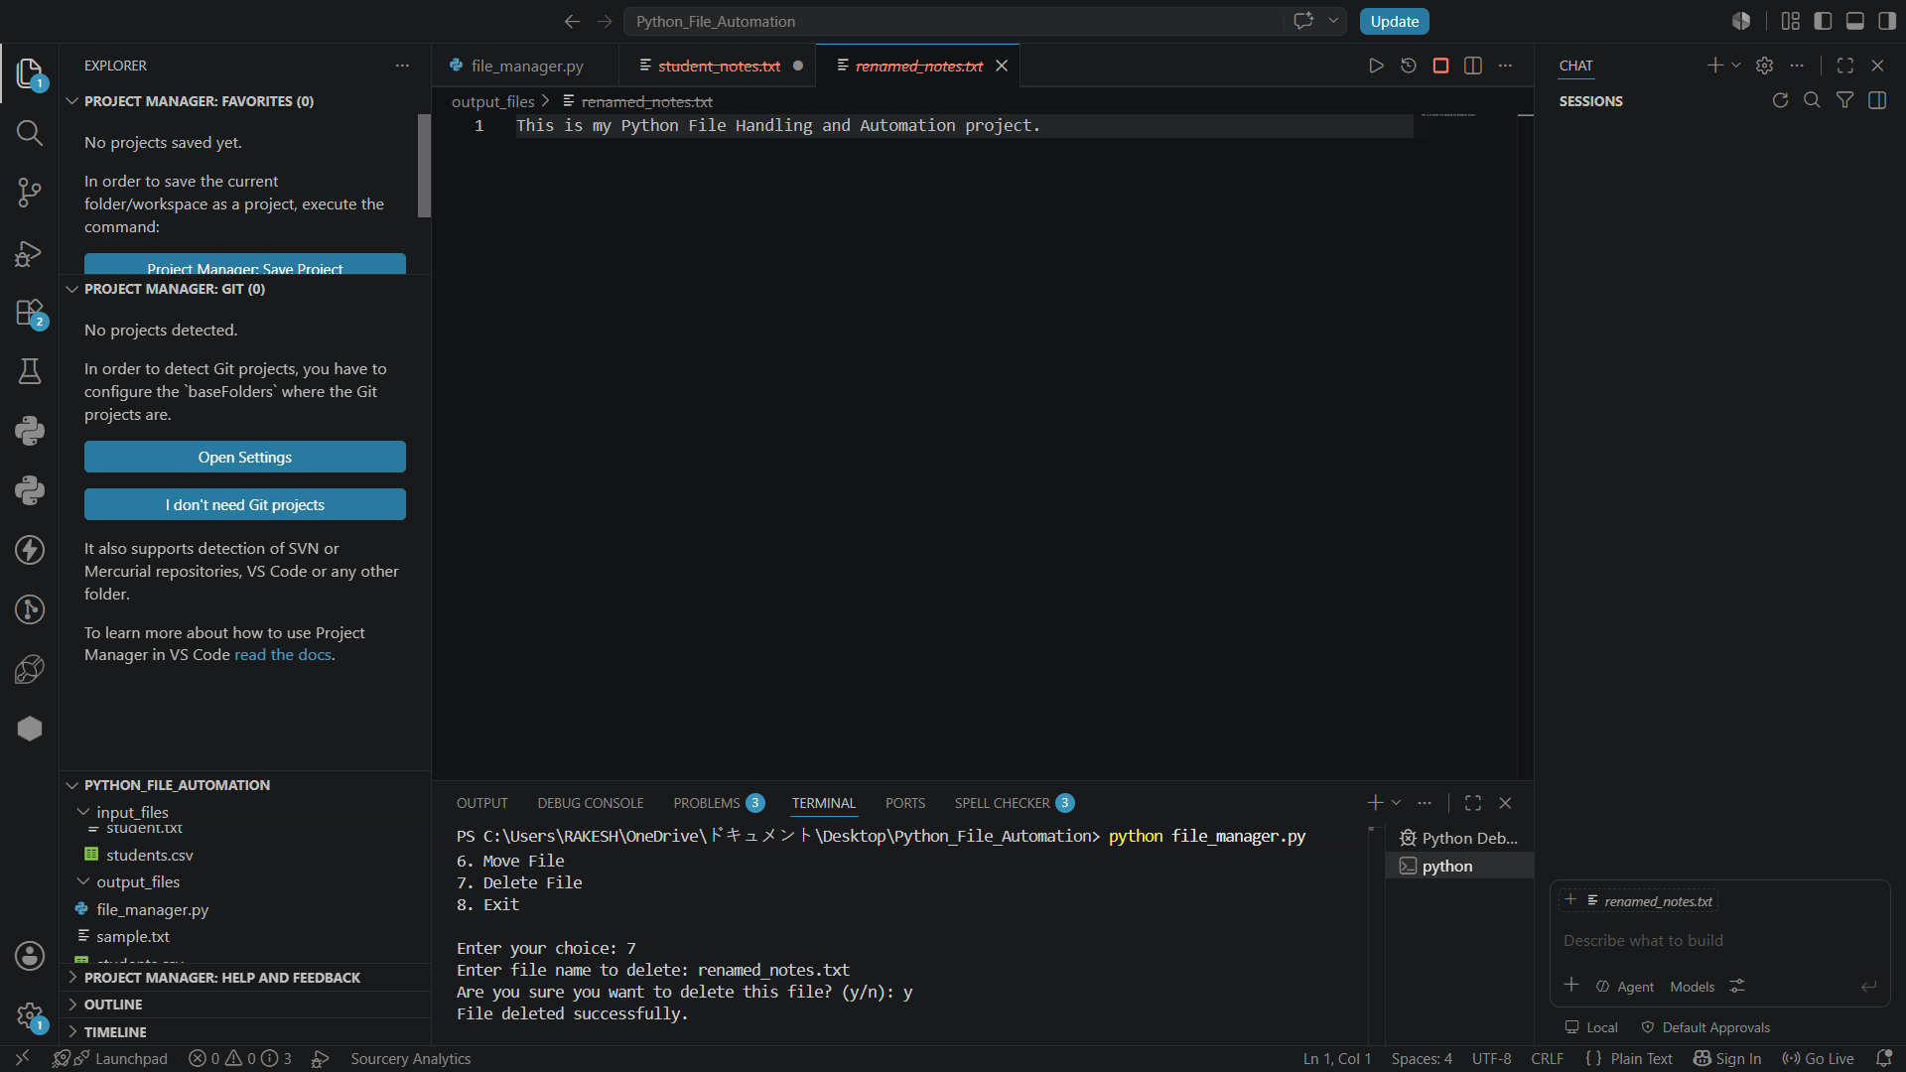
Figure 7 – Delete File

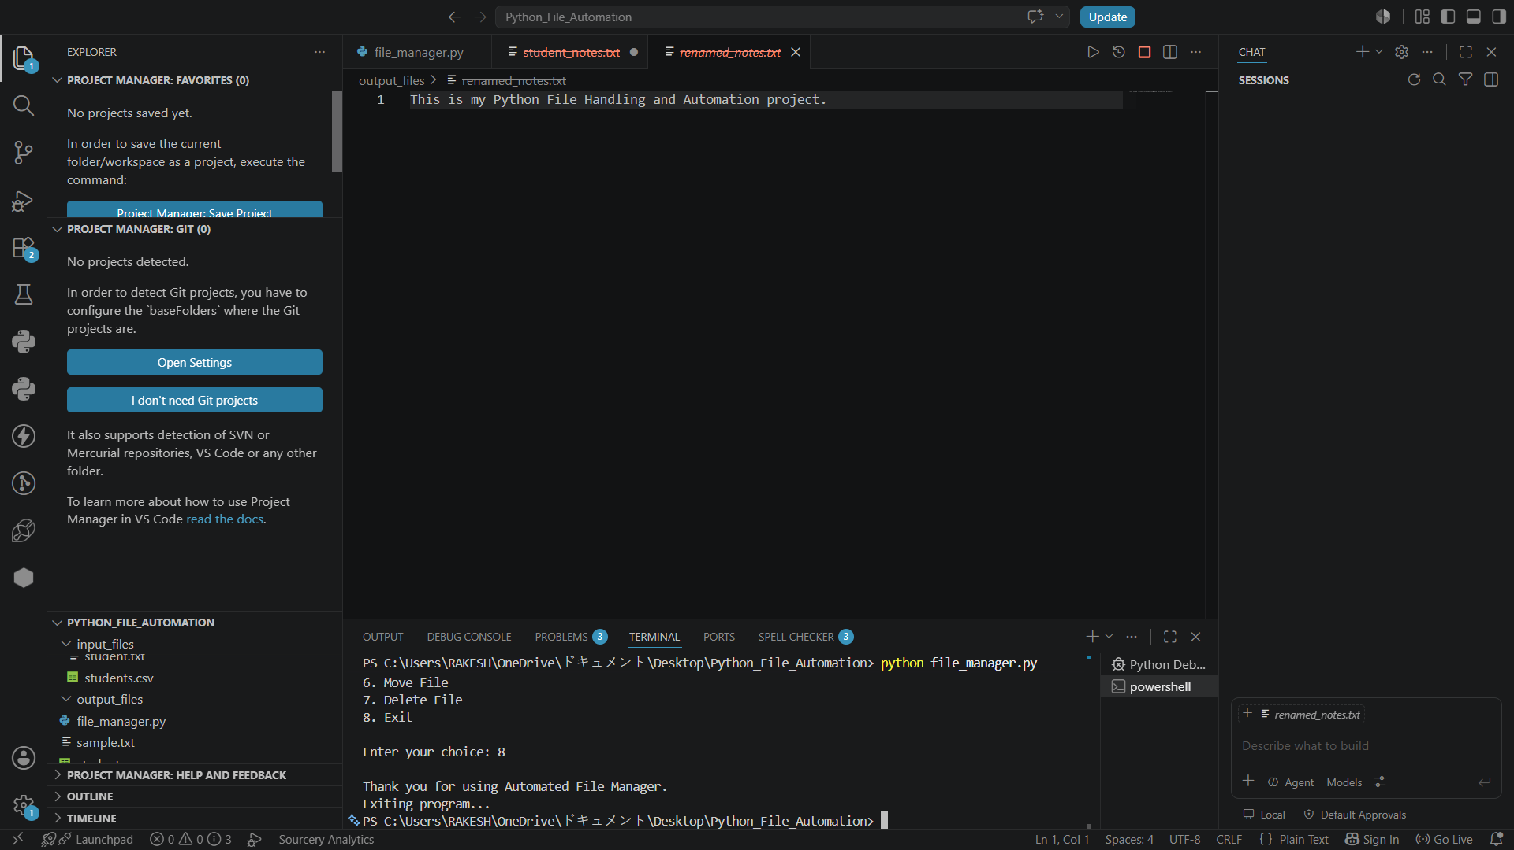
Figure 8 – Exit Program

9. Advantages
- Simple menu-driven interface.
- Supports both TXT and CSV file formats.
- Automates routine file-management tasks.
- Includes confirmation before deletion.
- Uses exception handling for safer execution.

10. Applications
- Basic document and data-file management.
- Educational demonstrations of Python file handling.
- Small-scale automation utilities.
- Organizing generated or processed files.

11. Conclusion
The Automated File Manager successfully demonstrates core Python file-handling and automation concepts. The project combines TXT and CSV operations with practical file-system automation using os and shutil, while try-except blocks improve reliability. The resulting menu-driven application provides a clear foundation for extending the project with features such as multiple CSV records, folder selection, file search, logging, and a graphical interface.

12. Submission Link
Google Drive / GitHub Public Link: https://github.com/bammidirakesh/Python-File-Automation
Task Submission Page: ___________________________________________________________

