OLABODE ALAMU

1498663

GUIDE TO ENGINEERING DATA SCIENCE

HOMEWORK 3

QUESTION 1

Write a function for the collatz sequence.

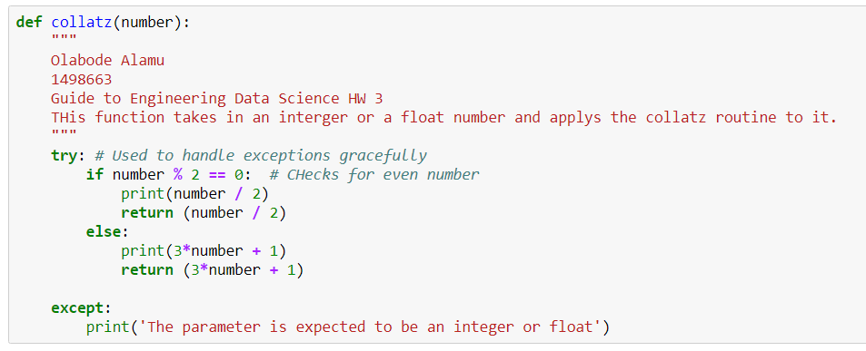

QUESTION 2

Write a function that repeatedly calls the collatz function till the inputted number becomes 1.

