# Apply filters to SQL queries

## Project description

SQL enables the search of databases to retrieve datasets based on specified conditions. The data can also be sorted by different conditions specified. The use of SQL enables the manipulation of large databases to suit one’s own needs.

## Retrieve after hours failed login attempts

The select * expression selects all information from the table while the subsequent ‘where’ and ‘and’ filters all the information to return just the failed login attempts after the specified time.

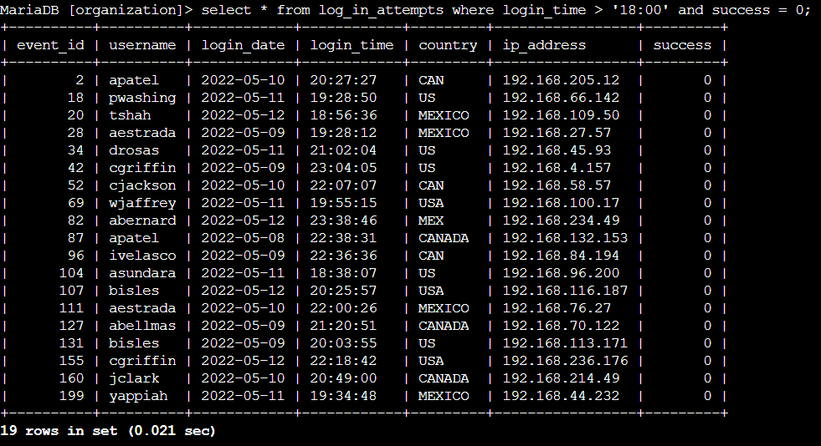

## Retrieve login attempts on specific dates

The ‘or’ expression used with the ‘where’ statement enables the filter by the dates specified.

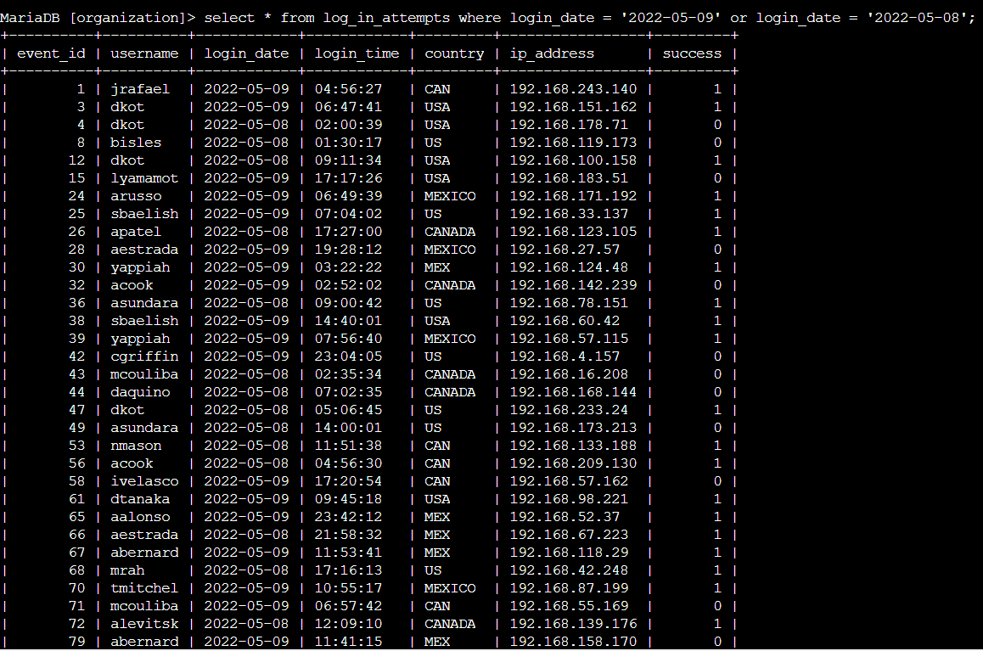

## Retrieve login attempts outside of Mexico

The ‘not’ filter used with ‘like’ enables the query to populate both MEX and MEXICO in the country column.

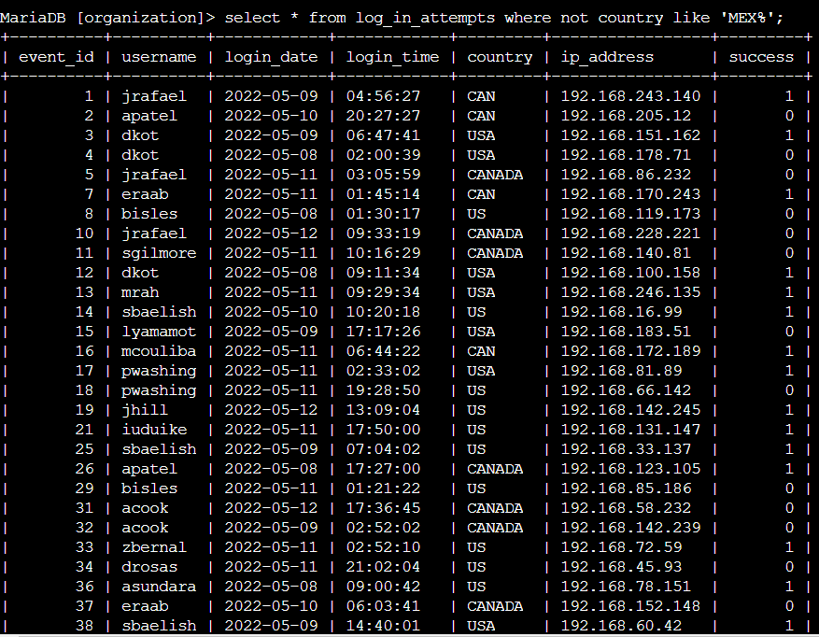

## Retrieve employees in Marketing

This query populates all employees in the marketing department with office containing ‘East’

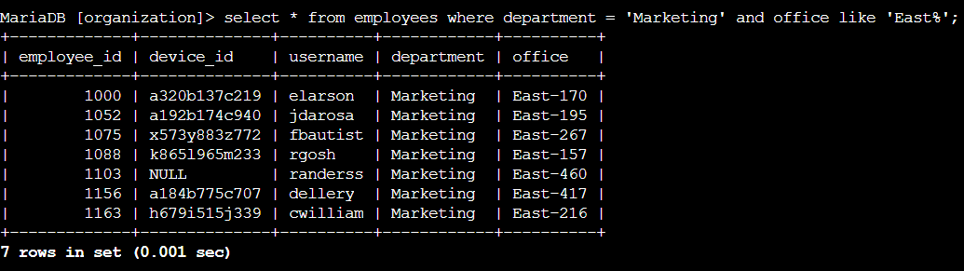

## Retrieve employees in Finance or Sales

This query filters for employees in either Sales or Finance departments.

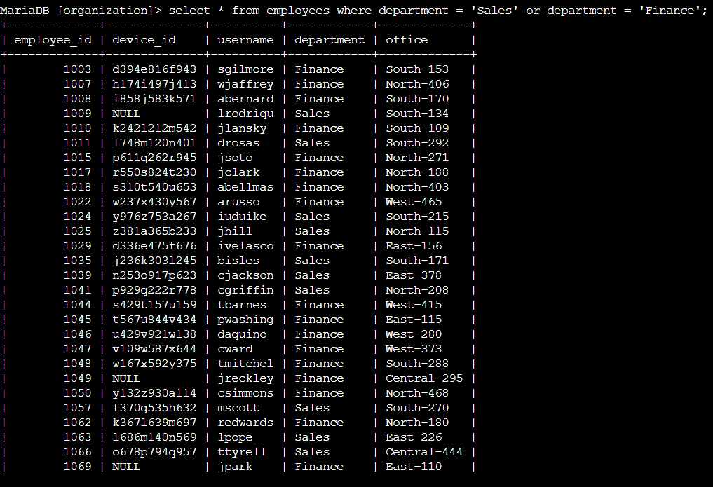

## Retrieve all employees not in IT

The query removes departments not including ‘Information Technology’

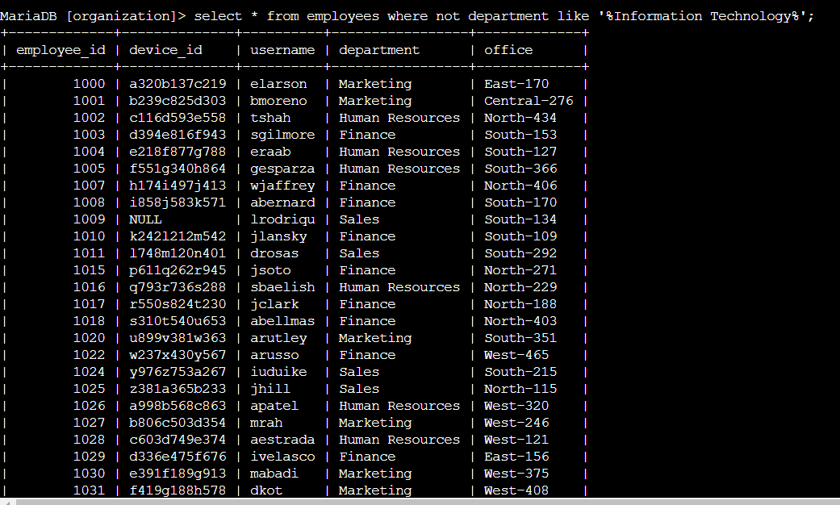

## Summary

The SQL queries enables the filtering of data using ‘Like’, ‘and’, ‘or’, ‘not’, expressions.