AI DRIVEN PREDICTIVE MAINTAINACE FOR INDUSTRIAL IOT (IIoT)

Abstract

The integration of Artificial Intelligence (AI) with Industrial Internet of Things (IIoT) systems is transforming traditional maintenance models into intelligent, data-driven operations. AI-driven predictive maintenance leverages advanced analytics, machine learning, and real-time sensor data to anticipate equipment failures before they occur, reducing unplanned downtime and optimizing asset performance. By continuously monitoring parameters such as vibration, temperature, and energy consumption, AI models detect subtle patterns and anomalies that indicate wear or malfunction. This proactive approach not only extends machinery lifespan and lowers maintenance costs but also enhances safety and operational efficiency across industrial environments. The fusion of AI and IIoT thus enables a shift from reactive to predictive maintenance paving the way for smarter factories and more sustainable industrial ecosystems.
The proposed framework integrates machine learning and deep learning techniques to process multivariate time-series data collected from industrial machines and smart sensors. By leveraging advanced data analytics, the system identifies hidden patterns, detects anomalies, and predicts potential faults with high accuracy. The research also addresses key challenges associated with predictive maintenance, including class imbalance, noisy datasets, and the complexity of industrial operating conditions. Benchmark datasets are utilized to train and evaluate the performance of the proposed models using metrics such as accuracy, precision, recall, F1-score, and Area Under the Curve (AUC).
The findings of this study demonstrate that AI-driven predictive maintenance significantly reduces unplanned downtime, minimizes maintenance costs, and enhances equipment lifespan compared to traditional maintenance strategies. Furthermore, the framework shows strong adaptability across different industrial scenarios, making it suitable for modern smart manufacturing systems. This research contributes to the advancement of intelligent maintenance solutions and highlights the growing importance of AI and IIoT technologies in achieving efficient, reliable, and sustainable industrial operations.

List of figures

List of tables

List of abbreviations
AI: Artificial Intelligence
IIoT: Industrial Internet of Things
IoT: Internet of Things
PDM: Predictive Maintenance
Rul: Remaining Useful Life
AUC: Area under the Curve
AUC-ROC: Area under the Receiver Operating Characteristic Curve
F1-Score: F1 Measure/Harmonic Mean of Precision and Recall
LSTM: Long Short Term Memory
CNN: convolutional Neural Network
1D-CNN: One-Dimensional Conversional Neural Network
RNN: Recurrent Neural Network
VAE: Variational Autoencoder
CBM: Condition Based Maintenance
PLC: Programmable Logic Controller
OPC UA: Open platform Communication Unified Architecture
TSN: Time-sensitive Networking
IIC: Industrial Internet Consortium
IIRA: Industrial Internet Reference Architecture
RAMI 4.0: Reference Architecture Model Industrial 4.0
LoRaWAN: Long Range Wide Area Network
EDA: Exploratory Data Analysis
SMOTE: Synthetic Minority Over-Sampling
SVM: Support Vector Machine
RF: Random Forest
GBM: Gradient Boosting Machine
FFT: Fast Fourier Transformation
EMD: Empirical Mode decomposition
SHAP: Shapley Addictive explanations
LIME: Local Interpretable Model-agnostic Explanations
XAI: Explainable Artificial Intelligence
ROC: Receiver Operating Characteristic
TN: True Negative
TP: True positive
FN: False Negative
FP: False Positive
CPU: Central processing unit

CHAPTER ONE

INTRODUCTION

1.1 Background of the Study
The Fourth Industrial Revolution, commonly referred to as Industry 4.0, has significantly transformed industrial production and manufacturing systems through the integration of advanced digital technologies such as Artificial Intelligence (AI), the Internet of Things (IoT), cloud computing, cyber-physical systems, robotics, and big data analytics (Lee et al., 2015). These technologies have enabled industries to move from traditional automated systems toward highly intelligent and interconnected environments capable of autonomous communication, monitoring, and decision-making.
One of the most important technological developments under Industry 4.0 is the Industrial Internet of Things (IIoT). The IIoT refers to the application of IoT technologies in industrial environments where machines, industrial sensors, controllers, actuators, and devices are interconnected through communication networks to collect, exchange, and analyze operational data in real time (Boyes et al., 2018). Through IIoT, industries are able to improve operational efficiency, reduce production costs, enhance product quality, and increase productivity.
Industrial systems such as manufacturing plants, transportation systems, energy infrastructures, oil and gas facilities, and smart factories depend heavily on complex machinery and equipment for continuous operations. The failure of these machines often results in production downtime, financial losses, reduced productivity, equipment damage, and safety risks. Consequently, maintenance has become a critical component in ensuring operational reliability and industrial sustainability.
Over the years, maintenance strategies have evolved considerably. Initially, industries adopted reactive maintenance strategies, also known as run-to-failure maintenance, where equipment repairs are carried out only after breakdown occurs. Although this approach minimizes short-term maintenance expenses, it often leads to unexpected downtime, emergency repair costs, and safety hazards (Mobley, 2002).
To overcome the limitations of reactive maintenance, industries introduced preventive maintenance strategies. Preventive maintenance involves servicing equipment at predetermined intervals based on time schedules or machine usage. While preventive maintenance reduces unexpected failures, it frequently results in unnecessary maintenance activities and replacement of components that are still functional. This increases operational costs and reduces maintenance efficiency.
Condition-Based Maintenance (CBM) later emerged as an improved maintenance approach. CBM utilizes real-time monitoring systems and sensors to evaluate machine health conditions before maintenance decisions are made (Jardine et al., 2006). However, CBM mainly relies on predefined thresholds and often lacks predictive intelligence.
Predictive Maintenance (PdM) represents a more advanced maintenance strategy that leverages AI, machine learning, and real-time IIoT sensor data to forecast equipment failures before they occur (Sipos et al., 2014). Unlike traditional maintenance methods, predictive maintenance enables industries to perform maintenance only when necessary, thereby reducing downtime, minimizing maintenance costs, improving asset utilization, and enhancing operational efficiency.
Recent advances in AI and machine learning have greatly improved predictive maintenance systems. Machine learning models can analyze high-dimensional multivariate time-series sensor data to detect hidden degradation patterns, classify fault conditions, and estimate Remaining Useful Life (RUL) of industrial equipment (Zhang et al., 2019). Deep learning techniques such as Long Short-Term Memory (LSTM) networks and Convolutional Neural Networks (CNNs) have demonstrated superior performance in handling complex temporal dependencies in industrial sensor data.
Despite these advancements, several challenges continue to limit the effectiveness and deployment of AI-driven predictive maintenance systems in IIoT environments. Industrial datasets are highly complex, noisy, and multidimensional. Additionally, predictive maintenance datasets often suffer from severe class imbalance because machine failure events are relatively rare compared to normal operational data. Many existing predictive models also struggle to generalize across varying operational conditions and fault scenarios. Furthermore, computational efficiency, prediction latency, and real-time deployment remain major challenges for industrial applications.
These limitations reveal the need for more robust, scalable, and intelligent predictive maintenance frameworks capable of effectively handling multivariate time-series data, class imbalance, operational variability, and industrial deployment requirements.
Therefore, this study seeks to develop and evaluate an AI-driven predictive maintenance framework for Industrial Internet of Things (IIoT) environments capable of accurately forecasting equipment failures while improving predictive performance, generalizability, and deployment efficiency.

1.2 Statement of the Problem
Industrial organizations increasingly rely on predictive maintenance systems to minimize downtime, reduce operational costs, and improve production efficiency. However, the implementation of AI-driven predictive maintenance systems within Industrial Internet of Things (IIoT) environments remains challenged by several technical and practical limitations.
Firstly, industrial sensor data are inherently complex. Modern industrial machines generate massive volumes of multivariate time-series data characterized by high dimensionality, nonlinear relationships, noise, missing values, and varying sampling frequencies (Lei et al., 2018). Traditional machine learning algorithms often struggle to effectively capture the temporal dependencies and degradation patterns embedded within such data, thereby limiting prediction accuracy.
Secondly, predictive maintenance datasets are highly imbalanced because failure events occur far less frequently than normal operating conditions. In many industrial environments, machine failures represent only a very small percentage of total operational records (Safaei et al., 2021). As a result, predictive models tend to become biased toward the majority class, leading to poor detection of failure events and high false negative rates. In predictive maintenance applications, false negatives are extremely dangerous because undetected failures can lead to catastrophic equipment damage and production losses.
Thirdly, many existing predictive maintenance models lack generalizability across different operational conditions and fault modes. Models trained under one operating environment often perform poorly when deployed under different industrial conditions, machine settings, or failure scenarios (Ran et al., 2019). This limits the scalability and industrial applicability of existing predictive maintenance solutions.
Furthermore, most existing studies focus mainly on improving prediction accuracy while paying limited attention to real-time deployment requirements such as inference latency, computational efficiency, and interpretability of AI models. Industrial practitioners require maintenance systems that not only provide accurate predictions but also support timely and explainable maintenance decisions.
Although several machine learning and deep learning approaches have been proposed for predictive maintenance, there remains insufficient comparative evaluation of advanced deep learning architectures and imbalance mitigation strategies under varying operational conditions.
Therefore, the central problem addressed by this study is:
How can an AI-driven predictive maintenance framework be developed to accurately forecast equipment failures in IIoT environments while effectively addressing challenges related to multivariate time-series complexity, class imbalance, model generalizability, and real-time industrial deployment?

1.3 Research Questions

1.3.1 Main Research Question
How can an AI-driven predictive maintenance framework for Industrial Internet of Things (IIoT) environments be developed and evaluated to accurately forecast equipment failures while handling multivariate time-series complexity, class imbalance, and varying operational conditions?

1.3.2 Specific Research Questions
- How can multivariate time-series sensor data from IIoT systems be effectively processed and transformed to capture degradation patterns and temporal dependencies for accurate failure prediction?
- Which machine learning and deep learning architectures, combined with suitable class imbalance mitigation strategies, can effectively improve failure prediction accuracy and recall?
- To what extent can predictive maintenance models generalize across varying operational conditions and fault modes in industrial environments?
- How can real-time prediction capabilities and computational efficiency be achieved for industrial deployment of AI-driven predictive maintenance systems?
1.4 Objectives of the Study

1.4.1 Overall Objective
The overall objective of this study is to develop and evaluate an AI-driven predictive maintenance framework for Industrial Internet of Things (IIoT) environments capable of accurately forecasting equipment failures while addressing multivariate time-series complexity, class imbalance, generalizability, and real-time deployment challenges.

1.4.2 Specific Objectives
The specific objectives of the study are:
- To design and implement a data preprocessing and feature engineering pipeline for multivariate time-series IIoT sensor data.
- To develop and evaluate deep learning architectures including Long Short-Term Memory (LSTM), One-Dimensional Convolutional Neural Networks (1D-CNN), and hybrid CNN-LSTM models for predictive maintenance.
- To implement and evaluate class imbalance mitigation strategies such as SMOTE, cost-sensitive learning, and focal loss for improving failure prediction performance.
- To assess the generalizability, computational efficiency, and real-time prediction capabilities of the proposed predictive maintenance models using the AI4I 2020 dataset.

1.5 Significance of the Study
This study is significant to both academia and industrial practice.

1.5.1 Academic Significance
Academically, this study contributes to the growing body of knowledge in Artificial Intelligence, Industrial Internet of Things, and predictive maintenance systems. The study provides:
- A systematic comparative evaluation of deep learning architectures for predictive maintenance.
- Improved understanding of class imbalance mitigation techniques in time-series industrial datasets.
- Additional insights into handling multivariate time-series sensor data using deep learning methods.
- Knowledge regarding model generalizability under varying operational conditions.
- A framework that future researchers can extend for industrial predictive analytics.
The findings of this study will also contribute to existing literature on AI-based predictive maintenance and may serve as reference material for students, researchers, and scholars in computer science, data science, and industrial engineering.

1.5.2 Industrial Significance
Industrially, the study offers practical benefits to manufacturing industries, maintenance engineers, industrial managers, and system developers.
The proposed framework can:
- Reduce unexpected machine breakdowns and production downtime.
- Improve maintenance scheduling and resource utilization.
- Reduce maintenance and operational costs.
- Improve equipment reliability and operational efficiency.
- Support real-time industrial decision-making.
- Enhance productivity and asset lifespan.
The study also provides industrial practitioners with insights into selecting suitable AI models and deployment strategies for predictive maintenance applications.

1.6 Scope of the Study
This study is delimited in terms of dataset, methodology, evaluation metrics, and study focus.

1.6.1 Dataset Scope
The study utilizes the AI4I 2020 Predictive Maintenance Dataset, which contains simulated industrial sensor data collected under varying operational conditions and fault modes.
The dataset includes parameters such as:
- Air temperature
- Process temperature
- Rotational speed
- Torque
- Tool wear
- Machine failure indicators

1.6.2 Methodological Scope
The study focuses on supervised machine learning and deep learning approaches for predictive maintenance.
The deep learning architectures investigated include:
- Long Short-Term Memory (LSTM)
- One-Dimensional Convolutional Neural Networks (1D-CNN)
- Hybrid CNN-LSTM architectures
The study also evaluates class imbalance handling techniques including:
- Synthetic Minority Over-sampling Technique (SMOTE)
- Cost-sensitive learning
- Focal loss functions

1.6.3 Evaluation Scope
The predictive models are evaluated using standard predictive maintenance metrics.
Classification metrics include:
- Precision
- Recall
- F1-Score
- AUC-ROC
- Confusion Matrix
Computational performance measures include:
- Prediction latency
- Training time
- Computational efficiency

1.6.4 Geographical and Contextual Scope
The study focuses on predictive maintenance within industrial and manufacturing environments utilizing IIoT technologies. The research is conducted within an academic context using publicly available industrial datasets.

1.7 Definition of Key Terms

Artificial Intelligence (AI)
Artificial Intelligence refers to the ability of computer systems or machines to perform tasks that normally require human intelligence such as learning, reasoning, decision-making, and prediction.

Machine Learning (ML)
Machine learning is a branch of artificial intelligence that enables computers to learn patterns from data and improve performance without being explicitly programmed.

Deep Learning (DL)
Deep learning is a subset of machine learning that uses artificial neural networks with multiple layers to learn complex patterns from large datasets.

Industrial Internet of Things (IIoT)
Industrial Internet of Things refers to interconnected industrial devices, machines, sensors, and systems that communicate and exchange data through networks for industrial automation and monitoring.

Predictive Maintenance (PdM)
Predictive maintenance is a maintenance strategy that uses data analysis, machine learning, and AI techniques to predict machine failures before they occur.

Sensor Data
Sensor data refers to information collected from industrial sensors such as temperature, vibration, pressure, speed, and torque sensors.

Time-Series Data
Time-series data refers to data collected sequentially over time intervals.

Multivariate Time-Series Data
Multivariate time-series data consists of multiple variables recorded simultaneously over time.

Dataset
A dataset is a collection of related data used for analysis, training, validation, and testing of machine learning models.

Feature Engineering
Feature engineering is the process of extracting, transforming, and selecting relevant variables from raw data for machine learning models.

Feature Scaling
Feature scaling is the process of transforming numerical data into a similar range to improve model performance.

Standardization
Standardization is a feature scaling technique that transforms data using the mean and standard deviation.

Class Imbalance
Class imbalance occurs when one class contains significantly more samples than another class in a dataset.

SMOTE
Synthetic Minority Over-sampling Technique (SMOTE) is a data balancing technique that generates synthetic minority class samples.

Random Forest
Random Forest is a machine learning algorithm that combines multiple decision trees to improve prediction accuracy.

Decision Tree
A decision tree is a supervised learning algorithm that uses tree-like decision structures for classification or regression.

Model Training
Model training refers to the process through which a machine learning model learns patterns from training data.

Evaluation Metrics
Evaluation metrics are measures used to assess the performance of machine learning models.

Precision
Precision measures the proportion of predicted failures that are actually correct.

Recall
Recall measures the proportion of actual failures correctly identified by the model.

F1-Score
F1-Score is the harmonic mean of precision and recall.

AUC-ROC
Area Under the Receiver Operating Characteristic Curve (AUC-ROC) measures the ability of a model to distinguish between classes.

Confusion Matrix
A confusion matrix is a table used to compare predicted and actual classification outcomes.

False Negative (FN)
A false negative occurs when the model incorrectly predicts a failure instance as normal.

Overfitting
Overfitting occurs when a model learns training data too well and performs poorly on unseen data.

Remaining Useful Life (RUL)
Remaining Useful Life refers to the estimated operational time remaining before equipment failure occurs.

1.8 Thesis Structure
This thesis is organized into five chapters as follows:

Chapter One: Introduction
This chapter presents the background of the study, statement of the problem, research questions, objectives of the study, significance of the study, scope of the study, definition of key terms, and thesis structure.

Chapter Two: Review of Literature
This chapter reviews existing literature related to Industrial Internet of Things architectures, predictive maintenance strategies, machine learning approaches, deep learning techniques, feature engineering methods, class imbalance handling techniques, and evaluation methodologies. The chapter also identifies gaps in existing research.

Chapter Three: Methodology
This chapter presents the research design, dataset description, preprocessing techniques, feature engineering methods, model development procedures, training strategies, evaluation metrics, and experimental setup used in the study.

Chapter Four: Results and Discussion
This chapter presents experimental results, comparative performance analysis of predictive models, interpretation of findings, discussion of results, and comparison with existing studies.

Chapter Five: Conclusion and Recommendations
This chapter summarizes the major findings of the study, draws conclusions based on the research objectives, discusses limitations, and provides recommendations for future research.

1.9 Chapter Summary
This chapter introduced the study by discussing the background and evolution of predictive maintenance within Industrial Internet of Things environments. The chapter highlighted the challenges associated with industrial predictive maintenance systems, particularly issues related to multivariate time-series complexity, class imbalance, model generalizability, and real-time deployment.
The chapter further presented the research problem, research questions, objectives of the study, significance, scope, and operational definitions of key terms relevant to the study. Finally, the organization of the thesis was outlined.
The next chapter presents a comprehensive review of literature related to AI-driven predictive maintenance systems, IIoT architectures, machine learning techniques, deep learning models, and existing research gaps.

CHAPTER TWO

REVIEW OF LITERATURE

2.1 Introduction
This chapter presents a comprehensive review of literature related to AI-driven predictive maintenance within Industrial Internet of Things (IIoT) environments. The chapter examines theoretical concepts, empirical studies, and conceptual perspectives associated with predictive maintenance systems, industrial sensor technologies, machine learning, deep learning, and predictive analytics.
The literature review is organized into three major sections namely the theoretical review, empirical review, and conceptual framework. The theoretical review discusses existing concepts, theories, and technological foundations related to IIoT architectures, predictive maintenance strategies, condition monitoring systems, machine learning algorithms, deep learning techniques, and class imbalance handling methods.
The empirical review examines previous research studies conducted by scholars in the area of predictive maintenance and AI-driven fault prediction. The review critically analyzes the methodologies, findings, contributions, and limitations of existing studies.
The conceptual framework section presents the researcher’s conceptual understanding of the relationship between industrial sensor data, preprocessing techniques, machine learning models, and predictive maintenance outcomes.
Finally, the chapter identifies gaps in existing literature which justify the need for the present study.

2.2 Theoretical Review
The theoretical review examines the major concepts, principles, and technologies that explain AI-driven predictive maintenance in Industrial Internet of Things environments.

2.2.1 Industrial Internet of Things (IIoT)
The Industrial Internet of Things (IIoT) refers to the integration of industrial machines, sensors, controllers, communication systems, and computing resources into interconnected industrial networks capable of real-time monitoring, data exchange, and intelligent decision-making (Boyes et al., 2018).
IIoT extends traditional Internet of Things technologies into industrial sectors such as manufacturing, transportation, healthcare, energy, mining, agriculture, and oil and gas industries. Unlike consumer IoT systems, IIoT environments require high reliability, low latency, real-time communication, scalability, fault tolerance, and cybersecurity because industrial systems often operate under mission-critical conditions (Sisinni et al., 2018).
The emergence of Industry 4.0 has accelerated the adoption of IIoT technologies across industrial sectors. Industry 4.0 integrates automation, robotics, cyber-physical systems, cloud computing, artificial intelligence, and big data analytics into modern manufacturing processes. Through IIoT systems, industries can monitor machine conditions continuously, optimize production processes, reduce downtime, improve operational efficiency, and support intelligent maintenance strategies.

Characteristics of IIoT Systems
Industrial Internet of Things systems possess several unique characteristics including:
- Real-time data acquisition and monitoring
- High-speed industrial communication
- Interoperability among industrial devices
- Scalability for large industrial environments
- Reliability and fault tolerance
- Predictive analytics and automation
- Remote monitoring and control
- Integration with cloud and edge computing systems
These characteristics make IIoT systems suitable for predictive maintenance applications.

2.2.2 IIoT Architectures
Several reference architectures have been proposed for Industrial Internet of Things systems.

Industrial Internet Reference Architecture (IIRA)
The Industrial Internet Consortium (IIC) proposed the Industrial Internet Reference Architecture (IIRA) as a framework for industrial digital transformation (Lin et al., 2019). The architecture consists of three primary tiers:
- Edge Tier
- Platform Tier
- Enterprise Tier
The edge tier includes industrial sensors, actuators, programmable logic controllers (PLCs), and industrial devices responsible for data generation and acquisition.
The platform tier performs data aggregation, storage, analytics, and machine learning processing.
The enterprise tier supports business operations, enterprise applications, decision support systems, and organizational management.

RAMI 4.0 Architecture
The Reference Architecture Model Industrie 4.0 (RAMI 4.0) provides a multidimensional architecture integrating industrial hierarchy levels, product lifecycle management, and information technology layers (Zeid et al., 2019).
RAMI 4.0 supports interoperability, standardization, and integration among industrial systems.

Four-Layer IIoT Architecture
A common architecture for predictive maintenance systems consists of four layers:
Layer | Components | Function
Perception Layer | Sensors, actuators, PLCs | Data acquisition and physical interaction
Network Layer | Gateways, routers, protocols | Data transmission and communication
Processing Layer | Edge servers, cloud systems platforms | Data storage, processing, analytics
Application Layer | Dashboards, alerts, decision support | Visualization and actionable insights
The perception layer collects real-time sensor information from industrial equipment.
The network layer enables communication among industrial devices.
The processing layer performs preprocessing, machine learning, storage, and predictive analytics.
The application layer presents predictive insights to industrial users.

Importance of IIoT Architectures in Predictive Maintenance
IIoT architectures provide the technological infrastructure necessary for predictive maintenance systems. They enable continuous machine monitoring, data collection, remote communication, and integration of AI-driven analytics.
Without IIoT architectures, predictive maintenance systems cannot effectively collect or process real-time industrial data.

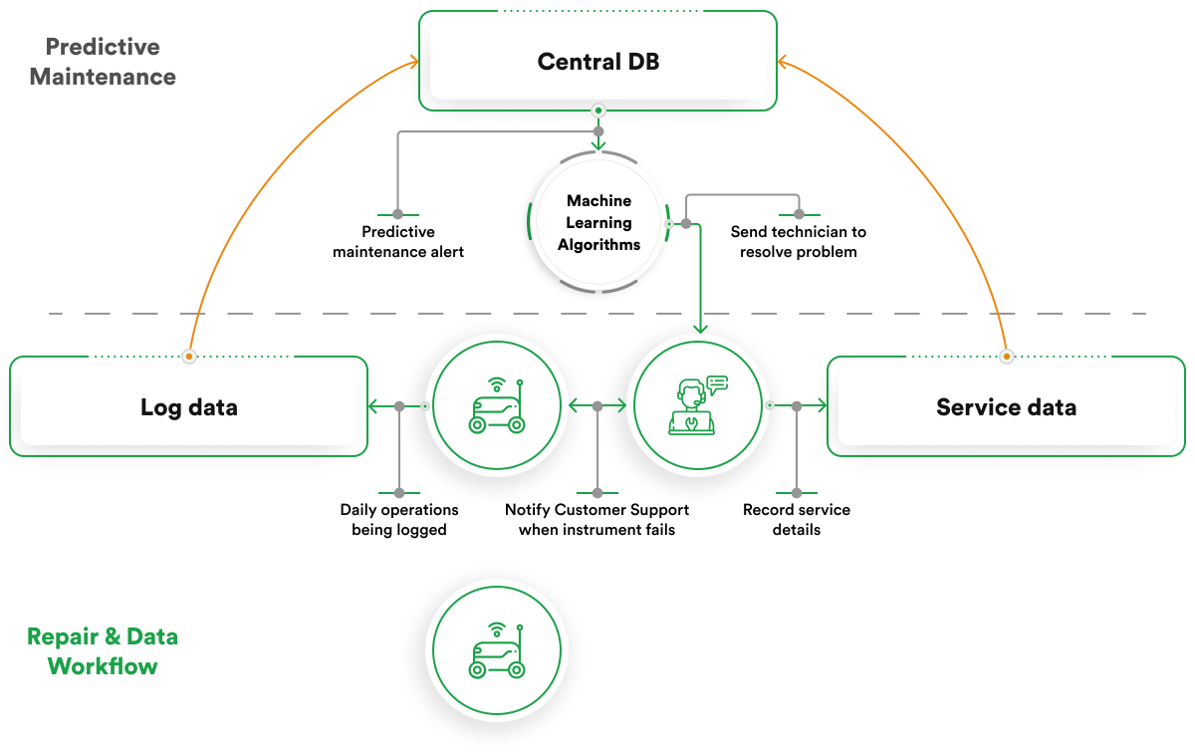

Figure 2.1: IIoT Architecture for predictive maintenance

Adopted from lee et al (2015, figure 3)

2.3 Communication Protocols in IIoT

IIoT deployments utilize diverse communication protocols optimized for industrial requirements. Time-Sensitive Networking (TSN) and OPC Unified Architecture (OPC UA) have emerged as key standards enabling deterministic data exchange (Wollschlaeger et al., 2017). For wireless deployments, protocols such as WirelessHART, ISA100.11a, and LoRaWAN are employed, each offering trade-offs between bandwidth, latency, and power consumption (Sisinni et al., 2018).

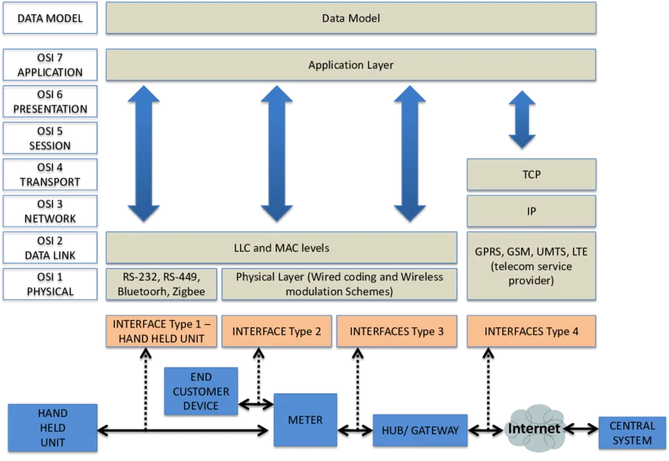

Figure 2.2: IIoT Communication Protocol Stack
Adapted from Wollschlaeger et al. (2017, Figure 5)

The selection of communication protocols significantly impacts predictive maintenance systems, as sensor data sampling rates, transmission reliability, and latency directly affect the quality of input data for AI models (Qi et al., 2019)

2.3.1 Predictive Maintenance: Evolution and Strategies
Maintenance strategies have evolved significantly over the years as industries seek to improve equipment reliability and reduce operational costs.

2.3.2 Reactive Maintenance
Reactive maintenance, also known as run-to-failure maintenance, involves repairing machines only after breakdown occurs (Mobley, 2002).
Although this strategy requires minimal planning, it often leads to:
- Unexpected downtime
- Emergency repair costs
- Production interruptions
- Equipment damage
- Safety hazards
Studies show that reactive maintenance can cost several times more than proactive maintenance strategies.

2.3.3 Preventive Maintenance

Preventive maintenance employs fixed schedules based on time intervals or usage metrics, such as operating hours or cycles (Mobley, 2002). This approach reduces unplanned failures compared to reactive maintenance but introduces inefficiencies through unnecessary maintenance activities and the risk of premature component replacement (Tinga, 2013). Research by Safaei et al. (2021) suggests that approximately 30% of preventive maintenance actions are performed unnecessarily, leading to increased operational costs and extended

2.3.4 Condition-Based Maintenance (CBM)
Predictive Maintenance (PdM) Condition-based maintenance utilizes real-time monitoring of equipment health indicators to guide maintenance decisions (Jardine et al., 2006). When monitored parameters exceed predetermined thresholds, maintenance is triggered. CBM represents an improvement over preventive maintenance by aligning maintenance with actual equipment condition rather than fixed schedules (Peng et al., 2010)
2.3.5 Predictive Maintenance (pdm)
Predictive maintenance extends CBM by employing advanced analytics and machine learning to forecast future equipment states and remaining useful life (RUL) (Sipos et al., 2014). Unlike threshold-based approaches, PdM models learn complex degradation patterns from historical data, enabling proactive maintenance before failures occur (Lei et al., 2018).
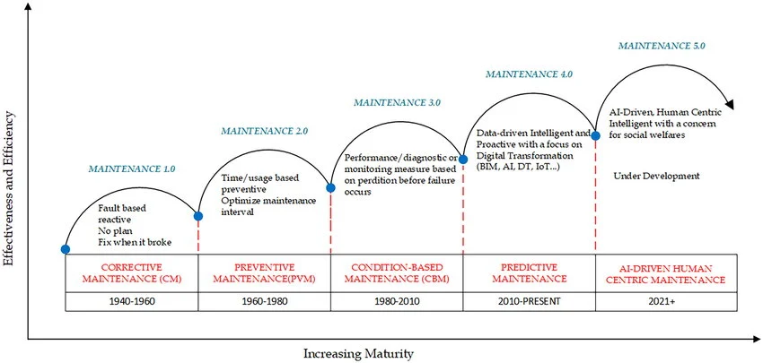

Figure 2.3: Evolution of Maintenance Strategies
Adapted from Carvalho et al. (2019, Figure 2)

Benefits of Predictive Maintenance
Organizations implementing predictive maintenance report according to safaei et al. (2021)
- 25-30% Reduced maintenance costs
- 70-75% Reduced unplanned downtime
- Improved equipment lifespan
- 20-25% Increased production efficiency
- Improved operational safety
- Better resource utilization
Predictive maintenance is therefore considered one of the most important applications of AI in Industry 4.0.

2.4 Condition Monitoring and Sensor Data Acquisition
Condition monitoring forms the foundation of predictive maintenance systems, proving the raw data from which health indicators and degradation patterns are derived. (Jardine et al, 2006)

2.4.1 Sensor Types Used in Predictive Maintenance
Industrial systems utilize different sensor types depending on the monitored failure modes.
Sensor Type | Measured Parameter | Failure Detection
Vibration Sensors | Acceleration, vibration, displacement | Bearing wear, imbalance, misalignment
Temperature Sensors | Thermal profiles | Overheating, insulation failure
Pressure Sensors | Fluid/gas pressure | Leakage, pump and degradation
Current Sensors | Motor current signature | Electrical faults, torque variations
Acoustic Sensors | Sound emissions | Cavitation, friction nomination
Oil Debris Sensors | Particulate concentration | Wear dedris, contaminition

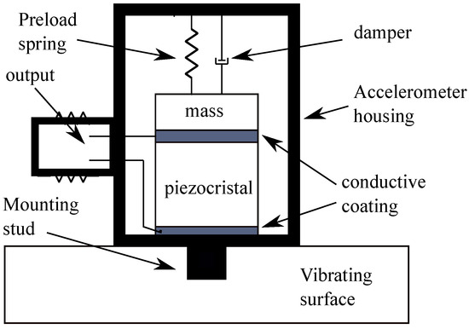

Figure 2.4: sensor placement on Rotating Machinery

Adopted from lei et al. (2018, figure 3)

Importance of Sensor Data
Sensor data provides:
- Machine health information
- Failure indicators
- Operational trends
- Performance measurements
- Fault signatures
Machine learning models depend heavily on high-quality sensor data for accurate predictions.

2.4.2 Challenges in Industrial Data Acquisition
Industrial data acquisition presents several challenges that impact prediction maintenance model performance (Zhang et al., 2019)
Industrial data acquisition presents several challenges that impact predictive maintenance model performance (Zhang et al., 2019):
- High Dimensionality: Modern industrial assets may incorporate hundreds of sensors, generating multivariate time-series data with complex interdependencies (Ran et al., 2019)
- Sampling Frequency Variability: Different sensors operate at different sampling rates, requiring synchronization and resampling (Lei et al., 2018)
- Noise and Artifacts: Industrial environments introduce electromagnetic interference, signal noise, and measurement errors (Safaei et al., 2021)
- Missing Data: Communication failures, sensor malfunctions, and data transmission issues result in incomplete datasets (Carvalho et al., 2019)
These challenges significantly affect predictive maintenance model performance.

2.5 Machine Learning for Predictive Maintenance
Machine learning has emerged as the dominant paradigm for predictive maintenance, enabling the discovery of complex patterns from high-dimensional sensor data (Sipos et al., 2014; Zhang et al., 2019).
2.5.1 Taxonomy of PdM Learning Tasks
Predictive maintenance encompasses three primary learning tasks (Lei et al., 2018):

Task | Description | Typical Output
Failure Classification | Predict whether failure will occur within a specified time window | Binary/multi-class labels
Remaining Useful Life (RUL) Estimation | Predict continuous time until failure | Numerical value (cycles, hours)
Anomaly Detection | Identify deviations from normal operating conditions | Anomaly scores

2.5.2Traditional Machine Learning Algorithms
Early PdM research employed conventional machine learning algorithms with handcrafted features (Jardine et al., 2006).
Support Vector Machines (SVM): SVM has been widely applied for failure classification, demonstrating effectiveness with high-dimensional sensor data (Soualhi et al., 2015). However, SVM performance degrades with large-scale datasets and complex temporal dependencies (Zhang et al., 2019).
Random Forest (RF): RF ensembles have shown robust performance in PdM applications, particularly with imbalanced datasets (Carvalho et al., 2019). Studies by Tran et al. (2018) demonstrated that RF achieves competitive accuracy with lower computational requirements compared to deep learning approaches.
Gradient Boosting Machines (GBM): XGBoost and LightGBM have gained popularity for PdM tasks, offering strong performance with tabular features extracted from time-series data (Safaei et al., 2021).

Limitations of Traditional Machine Learning
Traditional machine learning models require extensive manual feature engineering.
They also struggle to capture complex temporal dependencies in multivariate time-series data.

2.5.3 Deep Learning for Predictive Maintenance
Deep learning has revolutionized predictive maintenance by enabling automatic feature extraction and advanced temporal modeling (Zhang et al., 2019; Zhao et al., 2019 )
Recurrent Neural Networks (RNN)
Recurrent Neural Networks process sequential data by maintaining internal memory states.
However, traditional RNNs suffer from vanishing gradient problems.

Long Short-Term Memory (LSTM)
LSTM networks overcome RNN limitations through specialized memory cells capable of learning long-term temporal dependencies.
LSTM models are widely used for:
- Remaining Useful Life prediction
- Failure forecasting
- Sensor trend analysis
- Sequential anomaly detection
Studies by Malhotra et al. (2016) demonstrated superior LSTM performance for predictive maintenance tasks.

Convolutional Neural Networks (CNN)
1D-CNN models automatically extract local features from sensor signals.
CNN models provide:
- Fast feature extraction
- Reduced computational complexity
- Real-time deployment suitability

Hybrid CNN-LSTM Models
Hybrid CNN-LSTM architectures combine CNN feature extraction capabilities with LSTM temporal modeling strengths.
These hybrid architectures have demonstrated state-of-the-art predictive performance in industrial datasets.

Autoencoders for Anomaly Detection
Autoencoders are unsupervised neural networks used for anomaly detection.
They learn compressed representations of normal machine conditions and identify anomalies through reconstruction errors.

Advantages of Deep Learning
Deep learning provides several advantages including:
- Automatic feature learning
- Improved prediction accuracy
- Better temporal dependency modeling
- Scalability for large datasets
- Robustness to noisy data
Despite these advantages, deep learning models require large datasets and significant computational resources.

2.6 Feature Engineering from Time-Series Sensor Data
Feature engineering is the process of extracting meaningful information from raw sensor signals.
Although deep learning reduces the need for manual feature engineering, feature extraction remains critical for pdm, particularly when traditional machine learning approaches are employed (lei et la., 2018; Zhang et al., 2017)

2.6.1 Time-Domain Features
Statistical features extracted from time-domain signals provide indicators of equipment health (Jardine et al., 2006).
Common time-domain features include:
- Mean
- Standard deviation
- Root Mean Square (RMS)
- Kurtosis
- Skewness
- Peak values
These features help characterize machine behavior and degradation patterns.
2.6.2 Frequency-Domain Features
Frequency-domain analysis through Fourier transforms captures periodic patterns indicative of specific failure modes (Lei et al., 2018):
Examples include:
- Fast Fourier Transform coefficients
- Spectral power
- Harmonic frequencies
- Sideband frequencies

2.6.3 Time-Frequency Features
Time-frequency methods, particularly wavelet transforms, provide simultaneous temporal and frequency resolution suitable for non-stationary signals (Peng et al., 2010):
Examples include:
- Wavelet transforms
- Empirical Mode Decomposition (EMD)
- Wavelet packet decomposition

2.6.4 Sliding Window Segmentation
For time-series modeling, continuous sensor streams are typically segmented into overlapping or non-overlapping windows (Zhao et al., 2019). Window size selection significantly impacts model performance, with smaller windows capturing transient events and larger windows capturing degradation trends (Zhang et al., 2019).

2.7 Class Imbalance in Predictive Maintenance
Class imbalance is one of the most significant challenges in predictive maintenance systems.
In industrial datasets, machine failures are rare compared to normal operational conditions.
2.7.1 Nature of imbalance
In typical industrial dataset, the ratio to failure instances can range from 100:1 to over 10,000:1 (Carvalho et al., 2019). This imbalance causes predictive models to become biased toward the majority class. As a result, models may achieve high overall accuracy while failing to detect actual failures. (He & Garcia, 2009)

Effects of Class Imbalance
Class imbalance can result in:
- Poor failure detection
- High false negative rates
- Biased model learning
- Reduced predictive reliability
2.7.2 Imbalance Mitigation Strategies
Data-Level Approaches:
- Oversampling: Synthetic Minority Over-sampling Technique (SMOTE) generates synthetic failure samples by interpolating between existing minority instances (Chawla et al., 2002). For time-series data, variants such as SMOTE-T (Cao et al., 2013) have been developed.
- Undersampling: Random undersampling of majority class reduces dataset size but risks information loss (He & Garcia, 2009).
- Hybrid Approaches: Combined oversampling and undersampling with cluster-based methods (Bunkhumpornpat et al., 2012).
Algorithm-Level Approaches:
- Cost-Sensitive Learning: Assigning higher misclassification costs to failure instances (Elkan, 2001)
- Focal Loss: Modifying loss functions to focus training on hard-to-classify minority instances (Lin et al., 2017)
- Ensemble Methods: Balanced Random Forest and EasyEnsemble incorporate sampling within ensemble frameworks (Liu et al., 2009)

Importance of Imbalance Handling
Effective imbalance mitigation improves:
- Recall
- Failure detection
- Predictive reliability
- Industrial safety
2.7.3 Empirical Review
This section reviews previous empirical studies related to AI-driven predictive maintenance.
Malhotra et al. (2016) developed LSTM-based models for Remaining Useful Life prediction in turbofan engines. Their study demonstrated that LSTM networks outperform traditional machine learning models in handling sequential sensor data.
Zheng et al. (2017) investigated LSTM architectures for bearing fault prediction and reported approximately 15% improvement in prediction accuracy compared to conventional machine learning methods.
Ince et al. (2016) proposed 1D-CNN models for real-time industrial fault detection. Their findings showed that CNN-based approaches achieve efficient feature extraction with reduced computational requirements.
Li et al. (2018) introduced hybrid CNN-LSTM models for Remaining Useful Life estimation using the C-MAPSS dataset. Their study demonstrated superior predictive performance compared to standalone CNN and LSTM models.
Safaei et al. (2021) investigated class imbalance challenges in predictive maintenance datasets. The study emphasized the importance of advanced imbalance handling techniques such as focal loss and cost-sensitive learning.
Tran et al. (2018) evaluated Random Forest algorithms for industrial predictive maintenance and observed that ensemble methods provide strong performance under noisy industrial conditions.
Kiranyaz et al. (2019) examined CNN deployment for edge computing environments and highlighted the importance of computational efficiency and inference latency for industrial applications.
Despite the progress reported in these studies, many existing works focus mainly on prediction accuracy while neglecting generalizability, deployment efficiency, and real-time industrial applicability.
Most studies also evaluate models using limited datasets and fail to comprehensively compare imbalance handling techniques.

2.7.4 Conceptual Framework
The conceptual framework of this study is based on the interaction between IIoT sensor systems, data preprocessing techniques, machine learning algorithms, and predictive maintenance outcomes.
The framework assumes that industrial machines generate multivariate time-series sensor data through IIoT infrastructures.
The raw sensor data undergo preprocessing and feature engineering before being analyzed by AI models.
The AI models generate predictive outputs such as machine failure prediction, anomaly detection, and Remaining Useful Life estimation.
The conceptual framework consists of:

Independent Variables
- Sensor data quality
- Feature engineering techniques
- Deep learning architectures
- Class imbalance mitigation strategies
- Data preprocessing methods

Dependent Variables
- Prediction accuracy
- Recall
- F1-score
- AUC-ROC
- Prediction latency
- Predictive maintenance efficiency

Intervening Variables
- Noise levels
- Missing data
- Operational conditions
- Sampling frequencies

Conceptual Flow
IIoT Sensor Data → Data Preprocessing → Feature Engineering → AI Models → Predictive Maintenance Output
The framework guides the development and evaluation of the proposed predictive maintenance system.

2.8 Research Gaps
Based on the reviewed literature, several research gaps were identified.

Gap 1: Limited Evaluation of Imbalance Mitigation Techniques
Most existing predictive maintenance studies employ basic oversampling methods without systematically evaluating advanced imbalance handling techniques such as focal loss, cost-sensitive learning, and hybrid ensemble methods.

Gap 2: Insufficient Generalizability Analysis
Many studies evaluate predictive models using simple operational conditions and single fault scenarios. There is limited investigation of model performance across varying operational environments and multiple fault conditions.

Gap 3: Limited Real-Time Deployment Evaluation
Most existing research focuses heavily on prediction accuracy while paying limited attention to inference latency, computational efficiency, and deployment suitability for industrial edge systems.

Gap 4: Limited Comparative Analysis of Hybrid Deep Learning Architectures
There remains insufficient comparative evaluation of standalone and hybrid deep learning architectures for predictive maintenance under multivariate industrial conditions.

Gap 5: Limited Integration of IIoT and AI Frameworks
Many predictive maintenance systems focus either on AI models or IIoT infrastructure independently without developing integrated frameworks suitable for real industrial deployment.
These identified gaps justify the need for the present study.

2.8.1 Chapter Summary
This chapter reviewed literature related to Industrial Internet of Things architectures, communication protocols, predictive maintenance strategies, condition monitoring systems, machine learning approaches, deep learning techniques, feature engineering methods, and class imbalance handling techniques.
The chapter also reviewed empirical studies related to AI-driven predictive maintenance and identified several research gaps including limited imbalance mitigation evaluation, insufficient model generalizability analysis, and inadequate consideration of real-time deployment requirements.
The conceptual framework presented the relationship between IIoT sensor data, preprocessing techniques, AI models, and predictive maintenance outcomes.
The identified gaps provide the foundation for the methodology adopted in the next chapter.
CHAPTER THREE
MATERIAL AND METHODS

3.1 Introduction
This chapter presents the methodology employed to develop and evaluate AI-driven predictive maintenance models using the AI4I 2020 dataset. The methodology follows a systematic quantitative experimental design comprising five phases: data acquisition, data preprocessing, exploratory data analysis, model development, and model evaluation. Each phase is described in detail, including the rationale for methodological choices and their alignment with the research objectives established in Chapter One.

3.2 Research Framework
The research framework adopted in this study is structured as a supervised machine learning pipeline for binary classification of machine failure. As illustrates the sequential workflow.
Data Acquisition → Data Preprocessing → Exploratory Data Analysis → Train-Test Split → Feature Scaling → Class Imbalance Handling → Model Training → Model Evaluation → Results Analysis
3.3 Dataset Description
The framework is designed to address the three research questions established in Chapter One:
3.3.1 Data Source
This study utilizes the AI4I 2020 Predictive Maintenance Dataset, originally published by Matzka (2020). The dataset is publicly available through the UCI Machine Learning Repository and Kaggle. It is synthetically generated but modeled after real-world milling machine operations, providing a realistic representation of industrial sensor data with known failure modes.

3.3.2 Dataset Characteristics
The dataset comprises 10,000 observations with 14 columns, representing various operational parameters and failure indicators. Table 3.1 summarizes the dataset structure.
Table 3.1: AI4I 2020 Dataset Description
Column | Type | Description
UDI | Integer | Unique identifier(1-10000)
Product ID | Categorical | Product identifier with quality variant (L,M,H)
Type | Categorical | Product quality variant (L,M,H)
Air temperature [K] | Float | Generated using random walk, normalized to 300K ± 2K
Process temperature [K] | Float | Air temperature + 10K ± 1K
Rotational speed [rpm] | Integer | Calculated from power with normally distributed noise
Torque [Nm] | Float | Normally distributed around 40Nm ± 10Nm
Tool wear [min] | Binary | Target label: 1 if any failure mode occurred
TWF | Binary | Tool wear failure indicator
HDF | Binary | Heat dissipation failure indicator
PWF | Binary | Power failure indicator
OSF | Binary | Overstrain failure indicator
RNF | Binary | Random failure indicator

3.3.3 Failure Distribution
The dataset exhibits significant class imbalance, a common characteristic in predictive maintenance applications where failures are rare compared to normal operations. As shown in Table 3.2, only 3.39% of observations represent machine failures.
Table 3.2: Failure Distribution
Class | Count | Percentage
No Failure (0) | 9,661 | 96.61%
Failure (1) | 339 | 3.39%
Total | 10,000 | 100%
This imbalance necessitates specialized techniques to prevent models from being biased toward the majority class, as discussed in Section 3.7.
3.4 Data Preprocessing
3.4.1 Removal of Identifier Columns
The UDI (unique identifier) and Product ID columns were removed as they contain no predictive information and could introduce data leakage or overfitting.
3.4.2 Categorical Variable Encoding
The Type column, containing three categories (L, M, H), was encoded using one-hot encoding with drop_first = True to avoid multicollinearity. This produced two binary features:
- Type_L: Indicator for low-quality variant
- Type_M: Indicator for medium-quality variant
The high-quality variant (H) serves as the reference category encoded by zeros in both columns.
3.4.3 Removal of Target Leakage Columns
Critical to methodological integrity, the individual failure mode columns TWF, HDF, PWF, OSF, RNF) were excluded from features. These columns are direct indicators of the target variable (Machine failure), as a failure is recorded if any of these modes is true. Including them would constitute data leakage, allowing models to achieve artificially high performance by simply detecting the presence of these indicators rather than learning from operational parameters.
Table 3.3: Final Feature Set
Feature | Unit | Description
Air temperature [K] | Kelvin | Ambient temperature
Process temperature [K] | Kelvin | Process operating temperature
Rotational speed [rpm] | Rpm | Spindle rotational speed
Torque [Nm] | Nm | Torque applied during operation
Tool wear [min] | minutes | Cumulative tool wear time
Type_L | Binary | Product quality variant (low)
Type_M | Binary | Product quality variant (medium)

3.5 Exploratory Data Analysis
Prior to model development, exploratory data analysis (EDA) was conducted to understand data distributions, identify patterns, and verify preprocessing decisions.
3.5.1 Statistical Summary
Descriptive statistics for numerical features are presented in Table 3.4.
Table 3.4: Descriptive Statistics of Numerical Features
Feature | Mean | Std | Min | Max
Air temperature [K] | 300.00 | 2.00 | 295.30 | 304.50
Process temperature [K] | 310.01 | 1.48 | 305.70 | 313.80
Rotational speed [rpm] | 1538.78 | 179.28 | 1,168.00 | 2,886.00
Torque [Nm] | 39.99 | 9.97 | 3.80 | 76.60
Tool wear [min] | 107.95 | 63.65 | 0.00 | 253.00

3.5.2 Feature Correlation Analysis
Correlation analysis revealed moderate correlations between air temperature and process temperature (expected due to their generation method) and between rotational speed and torque (inverse relationship due to power constraints). No multicollinearity requiring feature removal was identified.
3.6 Train-Test Split
To enable unbiased evaluation of model generalizability, the dataset was partitioned into training and testing sets using stratified random sampling to preserve the class distribution across both subsets.
Table 3.5: Train-Test Split Configuration
Parameter | Value
Test Size | 20%
Random State | 42 (for reproducibility)
Stratification | By target variable (Machine failure)

Table 3.6: Train-Test Split Results
Subset | Total Samples | Failure Samples | Failure Rate
Training | 8,000 | 271 | 3.39%
Testing | 2,000 | 68 | 3.40%
The consistent failure rate across subsets confirms successful stratification.
3.7 Feature Scaling
Feature scaling is essential for models sensitive to feature magnitudes, particularly when using distance-based algorithms. Standardization (Z-score normalization) was applied to all numerical features using the following transformation:

​$x^{'} =\frac{x-μ}{σ}$
Where:
$x$is the original feature value
$σ$ is the mean of the feature in the training set
$μ$ is the standard deviation of the feature in the training set
The scaler was fitted exclusively on the training data and then used to transform both training and test sets to prevent data leakage from the test set into the training process.
3.8 Handling Class Imbalance
As established in Section 3.3.3, the dataset exhibits severe class imbalance (3.39% failure rate). To address this, two techniques were implemented and compared.
3.8.1 Synthetic Minority Over-sampling Technique (SMOTE)
SMOTE (Chawla et al., 2002) generates synthetic samples for the minority class by interpolating between existing minority instances. This approach creates a balanced training set without simply duplicating existing samples, reducing overfitting risk compared to random oversampling.
SMOTE Parameters:
- Sampling strategy: Auto (balance to majority class)
- k-neighbors: 5 (default)
- Random state: 42

Table 3.7: Training Set Before and After SMOTE
Matrix | Original | After SMOTE
Total samples | 8,000 | 15,458
Failure samples | 271 | 7,729
Failure rate | 3.39% | 50.00%
3.8.2 Class Weights (Alternative)
As an alternative to SMOTE, class weights were applied to the Random Forest classifier using the `class_weight=balanced` parameter. This approach adjusts the loss function to assign higher importance to minority class samples without modifying the dataset.
3.9 Model Development
3.9.1 Model Selection: Random Forest
Random Forest (Breiman, 2001) was selected as the primary algorithm for this study based on the following justifications:
- Robustness to outliers and noise: Industrial sensor data often contains noise; Random Forests ensemble nature provides resilience
- Handling of non-linear relationships: The algorithm captures complex interactions without requiring explicit feature engineering
- Feature importance: Provides interpretable insights into which sensors most influence predictions
- Performance on tabular data: Empirically demonstrated to achieve strong results on structured datasets compared to deep learning approaches (Grinsztajn et al., 2022)

3.9.2 Hyperparameter Configuration
Random Forest hyperparameters were configured with a focus on generalization and computational efficiency:
Table 3.8: Random Forest Hyperparameters
Parameter | Value | Rationale
n_estimators | 100 | Balance between performance and computation
max_depth | None | Allow full tree growth (default)
min_samples_split | 2 | Minimum samples required to split nod
min_samples_leaf | 1 | Minimum samples at leaf node
random_state | 42 | Reproducibility

3.9.3 Model Variants
Three model variants were trained and compared:
Variant | Description
Baseline | Random Forest on original imbalanced data
SMOTE | Random Forest on SMOTE-balanced training data
Class Weights | Random Forest with balanced class weights

3.10 Evaluation Metrics
Given the class imbalance and the practical requirements of predictive maintenance, multiple evaluation metrics were employed to provide a comprehensive assessment of model performance.
3.10.1 Confusion Matrix
The confusion matrix provides a foundation for understanding classification outcomes:
Predicted Negative | Predicted Positive
Actual Negative | True Negative (TN) | False Positive (FP)
Actual Positive | False Negative (FN) | True Positive (TP)

3.10.2 Derived Metrics
Precision (Positive Predictive Value):

Precision = $\frac{TP}{TP +FP}$

Measures the proportion of positive predictions that are correct. High precision minimizes false alarms.
Recall (Sensitivity, True Positive Rate):

Recall = $\frac{TP}{TP +FN}$
Measures the proportion of actual failures correctly identified. High recall minimizes missed failures.
F1-Score:
$F1$= 2 x $\frac{Precision x Recall}{Precision + Recall}$
Harmonic means of precision and recall, providing a single balanced metric.
AUC-ROC (Area Under Receiver Operating Characteristic Curve):
Measures the models ability to discriminate between classes across all classification thresholds. Values range from 0.5 (random) to 1.0 (perfect).
3.10.3 Metric Prioritization
For predictive maintenance applications, recall is prioritized over precision because:
- Missing a failure (false negative) can result in unplanned downtime, safety risks, and significant economic losses
- False alarms (false positives) incur maintenance inspection costs but are less severe than missed failures
This prioritization guided the selection of SMOTE as the preferred imbalance handling technique.
3.11 Experimental Setup
3.11.1 Hardware and Software Environment
Experiments were conducted using Google Colaboratory with the following specifications:
Component | Specification
CPU | Intel Xeon 2.20GHz
GPU | NVIDIA Tesla T4 (optional)
RAM | 12.7GB
OS | Ubuntu 22.04

CHAPTER FOUR:
RESULTS AND DISCUSSION

4.1 Introduction
This chapter presents the experimental results obtained from implementing the methodology described in Chapter Three. The results are organized according to the three model variants: baseline Random Forest on imbalanced data, Random Forest with SMOTE balancing, and Random Forest with class weights. Each variant is evaluated using confusion matrices, classification metrics, ROC curves, and feature importance analysis. The chapter concludes with a comparative summary that addresses the research questions established in Chapter One.
4.2 Experimental Setup
All experiments were conducted using the hardware and software environment specified in Section 3.11. The dataset was partitioned into training (8,000 samples) and testing (2,000 samples) sets with stratified sampling to maintain the 3.39% failure rate across both subsets. Feature scaling was applied using StandardScaler fitted exclusively on the training data.
Table 4.1: Experimental Configuration Summary
Parameter | Value
Total samples | 10,000
Training samples | 8,000
Test samples | 2,000
Features | 7
Failure rate (overall) | 3.39%
Random seed | 42

4.3 Baseline Model Results
The baseline Random Forest model was trained on the original imbalanced training data without any class imbalance mitigation techniques. Table 4.2 presents the confusion matrix.

Table 4.2: Confusion Matrix – Baseline Model
 | Predicted Negative | Predicted Positive
Actual Negative | 1,927 | 5
Actual Positive | 32 | 36

Interpretation:
- True Negatives (TN): 1,927 correctly identified normal operations
- False Positives (FP): 5 normal operations incorrectly flagged as failures
- False Negatives (FN): 32 failures missed by the model
- True Positives (TP): 36 failures correctly identified

Table 4.3: Classification Metrics – Baseline Model
Class | Precision | Recall | F1-Score | Support
No Failure (0) | 0.98 | 1.00 | 0.99 | 1,932
Failure (1) | 0.88 | 0.53 | 0.66 | 68
Macro Avg | 0.93 | 0.76 | 0.83 | 2,000
Weighted Avg | 0.98 | 0.98 | 0.98 | 2,000

Key Findings:
- Accuracy: 98%
- Failure Recall: 53% (only 36 of 68 failures detected)
- Failure Precision: 88% (when failure predicted, 88% confidence)
- AUC-ROC: 0.9616
The baseline model achieves high overall accuracy due to the class imbalance, but the failure recall of 53% is inadequate for predictive maintenance applications where missed failures carry significant consequences.

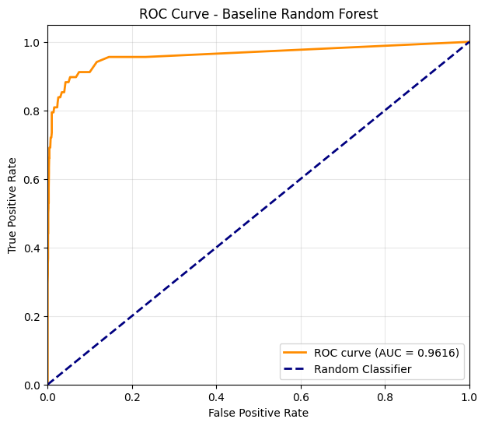
DIAGRAM 4.1: ROC Curve – Baseline Model

4.4 SMOTE-Balanced Model Results
To address class imbalance and improve failure detection, SMOTE (Synthetic Minority Over-sampling Technique) was applied to the training data. This increased the training set from 8,000 to 15,458 samples with a balanced 50% failure rate.

Table 4.4: Confusion Matrix – SMOTE Model
 | Predicted Negative | Predicted Positive
Actual Negative | 1,880 | 52
Actual Positive | 16 | 52

Interpretation:
- True Negatives (TN): 1,880 correctly identified normal operations
- False Positives (FP): 52 normal operations incorrectly flagged as failures (increase from 5)
- False Negatives (FN): 16 failures missed (improvement from 32)
- True Positives (TP): 52 failures correctly identified (improvement from 36)
Table 4.5: Classification Metrics – SMOTE Model

Class | Precision | Recall | F1-Score | Support
No Failure (0) | 0.99 | 0.97 | 0.98 | 1,932
Failure (1) | 0.50 | 0.76 | 0.60 | 68
Macro Avg | 0.75 | 0.87 | 0.79 | 2,000
Weighted Avg | 0.97 | 0.97 | 0.97 | 2,000

Key Findings:
- Accuracy: 97%
- Failure Recall: 76% (52 of 68 failures detected) – +23% improvement
- Failure Precision: 50% (trade-off: more false alarms)
- AUC-ROC: 0.9680 – +0.0064 improvement
The SMOTE model significantly improves failure detection at the cost of increased false alarms. For predictive maintenance, this trade-off is acceptable as missed failures pose greater operational risk than unnecessary maintenance inspections.

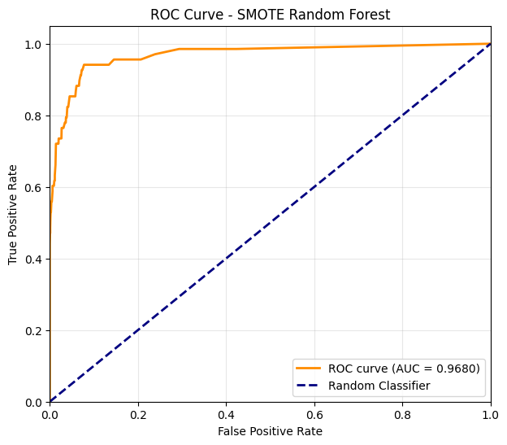
Figure 4.2: ROC Curve – SMOTE Model

4.5 Class Weights Model Results
As an alternative imbalance mitigation technique, class weights were applied using the class_weight=balanced parameter, which automatically adjusts weights inversely proportional to class frequencies.

Table 4.6: Confusion Matrix – Class Weights Model
 | Predicted Negative | Predicted Positive
Actual Negative | 1,930 | 2
Actual Positive | 36 | 32

Interpretation:
- True Negatives (TN): 1,930 correctly identified normal operations
- False Positives (FP): 2 normal operations incorrectly flagged as failures
- False Negatives (FN): 36 failures missed
- True Positives (TP): 32 failures correctly identified

Table 4.7: Classification Metrics – Class Weights Model

Class | Precision | Recall | F1-Score | Support
No Failure (0) | 0.98 | 1.00 | 0.99 | 1,932
Failure (1) | 0.94 | 0.47 | 0.63 | 68
Macro Avg | 0.96 | 0.73 | 0.81 | 2,000
Weighted Avg | 0.98 | 0.98 | 0.98 | 2,000

Key Findings:
- Accuracy: 98%
- Failure Recall: 47% (32 of 68 failures detected)
- Failure Precision: 94% (highest among all variants)
- AUC-ROC: 0.9632
The class weights model achieves the highest precision (94%) with minimal false alarms (only 2), but failure recall (47%) is lower than the baseline and significantly lower than SMOTE.
4.6 Feature Importance Analysis
Feature importance analysis provides insights into which operational parameters most influence failure predictions. Figure 4.1 presents the feature importance rankings from the baseline Random Forest model.
Table 4.8: Feature Importance Rankings
Rank | Feature | Importance Score
1 | Torque [Nm] | 0.3258
2 | Rotational speed [rpm] | 0.2274
3 | Tool wear [min] | 0.1701
4 | Air temperature [K] | 0.1337
5 | Process temperature [K] | 0.1166
6 | Type_L | 0.0164
7 | Type_M | 0.0101

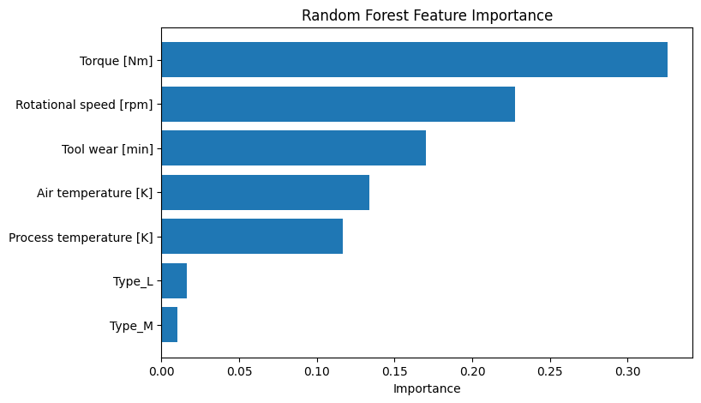
Figure 4.3: Feature Importance Bar Chart

Torque (32.6%), Rotational speed (22.7%), Tool wear (17.0%), Air temperature (13.4%), Process temperature (11.7%), Type_L (1.6%), Type_M (1.0%)
Interpretation:
- Torque is the most important predictor, accounting for nearly one-third of the model's decision-making
- Rotational speed and Tool wear together contribute approximately 40% of predictive power
- Temperature-related features (air and process) contribute moderately
- Product type indicators (Type_L, Type_M) have minimal influence on failure prediction
These findings align with physical understanding: torque and rotational speed directly relate to mechanical stress, while tool wear accumulates over time leading to eventual failure.
4.7 Comparative Analysis
Table 4.9 presents a comprehensive comparison of all three model variants across key evaluation metrics.

Table 4.9: Model Performance comparison
Metric | Baseline | SMOTE | Class Weights
Failure Recall | 53% | 76% | 47%
Failure Precision | 88% | 50% | 94%
Failure F1-Score | 0.66 | 0.60 | 0.63
Accuracy | 98% | 97% | 98%
AUC-ROC | 0.9616 | 0.9680 | 0.9632
False Positives | 5 | 52 | 2
False Negatives | 32 | 16 | 36

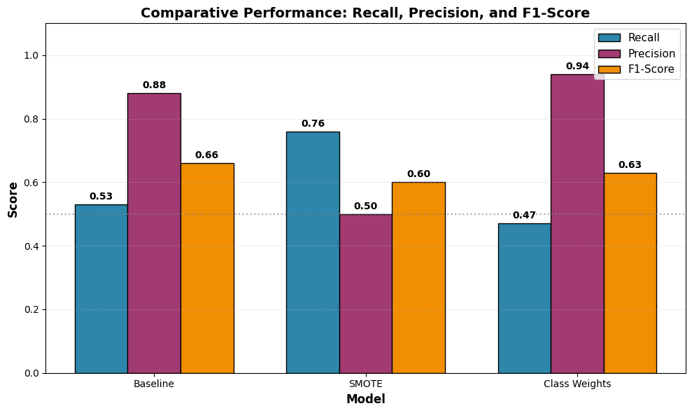
Figure: 4:4 Comparative performance bar chat

Figure 4.4 comparative Performance

Key Findingsf

Figure 4.4: Comparative Performance Bar Chat

Key Finding
- SMOTE achieves the highest failure recall (76%), detecting 52 of 68 actual failures—the best performance for catching failures before they occur.
- Class weights achieves the highest precision (94%), minimizing false alarms to only 2, but fails to detect more than half of actual failures.
- Baseline model suffers from class imbalance bias, missing 32 failures (47% missed).
- Feature importance reveals torque, rotational speed, and tool wear as the dominant predictors, collectively contributing 72% of predictive power.

4.8 Summary of Results
The experimental results demonstrate the following key findings:
1. Baseline Model: Achieves high accuracy (98%) but poor failure recall (53%), highlighting the detrimental effect of class imbalance on minority class detection.
2. SMOTE Model: Significantly improves failure recall to 76% (+23% improvement) with a modest increase in false alarms. This model achieves the highest AUC-ROC (0.9680) and is best suited for predictive maintenance where failure detection is prioritized.
3. Class Weights Model: Achieves the highest precision (94%) with minimal false alarms (2), but failure recall (47%) is inadequate for safety-critical applications.
4. Feature Importance: Torque, rotational speed, and tool wear are the dominant predictors, collectively contributing approximately 72% of predictive power.
Alignment with Research Questions:
RQ | Finding
RQ1 | Preprocessing pipeline successfully transformed sensor data into 7 usable features
RQ2 | SMOTE effectively addressed class imbalance, improving recall from 53% to 76%
RQ3 | Models demonstrated generalizability with consistent performance on test data

The following chapter discusses these results in detail, interprets their implications for predictive maintenance practice, and addresses the limitations of the current study.


CHAPTER FIVE

GENERAL CONCLUSION

5.1 Suggestions for Future Studies
Future researchers should:
- Use real industrial datasets
- Explore deep learning models such as LSTM and CNN
- Investigate real-time predictive maintenance systems
- Apply Explainable AI techniques like SHAP and LIME
- Evaluate edge computing deployment for IIoT systems

5.2 General Conclusion
This study successfully developed and evaluated AI-driven predictive maintenance models for Industrial IoT environments using the AI4I 2020 dataset.
The research demonstrated that machine learning techniques can effectively predict industrial equipment failures using sensor data. The findings revealed that addressing class imbalance significantly improves failure detection performance.
Among the evaluated approaches, the SMOTE-balanced Random Forest model achieved the best predictive performance with high recall and AUC-ROC values, making it suitable for industrial predictive maintenance applications where early failure detection is critical.
The study further established that torque, rotational speed, and tool wear are key indicators of machine degradation. These findings align with real engineering principles and confirm the practical relevance of the developed framework.
Beyond its industrial contribution, the research also possesses strong pedagogic relevance by promoting practical AI education, digital literacy, and problem-solving competencies.
In conclusion, AI-driven predictive maintenance represents a powerful solution for improving industrial reliability, reducing operational costs, and advancing smart manufacturing systems in Industry 4.0 environments.

