CHAPTER THREE
METHODOLOGY

3.1 Introduction
This chapter presents the complete methodology adopted to develop and evaluate a supervised machine learning framework for predicting industrial equipment failures using the AI4I 2020 Predictive Maintenance Dataset (Matzka, 2020). Every design decision — from the selection of preprocessing steps to the choice of evaluation metrics — is grounded in domain knowledge of the dataset's physical failure mechanisms, established best practices in imbalanced learning, and empirical evidence from the predictive maintenance literature.
The methodology is implemented as a single coherent Python pipeline executed in a Jupyter Notebook environment, using scikit-learn (Pedregosa et al., 2011) and imbalanced-learn (Lemaître et al., 2017) as the primary computational libraries. All preprocessing artefacts — the label encoder, the feature scaler, and the final trained model — are serialised as persistent files, enabling consistent reproduction of results and supporting future inference on unseen data without repeating the training process.
The chapter is organised into nineteen sections, progressing from data loading and quality assessment through to model serialisation. Section 3.2 provides a high-level overview of the three-phase research design. Sections 3.3 through 3.8 address data preparation. Sections 3.9 through 3.15 cover model development. Sections 3.16 through 3.17 describe evaluation and deployment. Section 3.18 formally defines the evaluation metrics employed throughout, and Section 3.19 summarises the chapter.

3.2 Research Design and Pipeline Overview
This study adopts a quantitative, experimental research design based on a supervised binary classification paradigm. The research problem — identifying whether an industrial milling machine is at risk of failure from its operational sensor readings — is framed as a classification task: given a feature vector of sensor measurements, predict the binary label Machine Failure ∈ {0, 1}. The ground truth labels are drawn directly from the AI4I 2020 dataset, and no manual annotation or unsupervised discovery is required.
Drawing on the three-stage methodology structure advocated by Rajendiran (2023), the pipeline is organised into three sequential phases, each with a distinct purpose:
- Phase 1 — Data Preparation: Raw data is loaded, inspected for quality, preprocessed, augmented with domain-engineered features, subjected to exploratory analysis, and cleaned of target-leakage columns before being encoded and partitioned.
- Phase 2 — Model Development: The prepared data is scaled, class-rebalanced using SMOTE, used to train and compare ten candidate classifiers, subjected to stratified cross-validation, and optimised through randomised hyperparameter search.
- Phase 3 — Evaluation and Deployment: The best-performing tuned model is evaluated against a held-out test set using a full suite of classification metrics, its feature importances are analysed, and the model, scaler, and encoder are serialised for downstream inference.

The complete sequential pipeline within these phases is as follows:

Data Loading → Quality Assessment → Identifier Removal → Feature Engineering → Statistical Summary → Exploratory Data Analysis → Correlation Analysis → Leakage Column Removal → Label Encoding → Train-Test Split (90/10) → Feature Scaling → SMOTE → Ten-Model Comparison → Stratified Cross-Validation → Randomised Hyperparameter Search → Final Model Training → Full Evaluation → Feature Importance Analysis → Model Serialisation

This design reflects three key methodological commitments. First, all preprocessing transformations are fitted exclusively on training data and applied to test data, preventing any form of data leakage. Second, SMOTE is applied inside cross-validation folds rather than globally, ensuring that synthetic samples never appear in validation sets. Third, model selection is empirical rather than predetermined: ten classifiers are trained under identical conditions and the best-performing one is taken forward for tuning.

3.3 Dataset Description

3.3.1 Origin and Provenance
This study utilises the AI4I 2020 Predictive Maintenance Dataset, introduced by Matzka (2020) at the Third International Conference on Artificial Intelligence for Industries and made publicly available through the UCI Machine Learning Repository. The dataset is synthetically generated but mechanistically grounded in the operational characteristics of a real milling machine, making it a widely adopted benchmark for predictive maintenance research (Rayarao & Rayarao, 2024; Holmkvist, 2024; Madan et al., 2023).
The dataset comprises 10,000 observations recorded across 14 columns. Five columns represent continuous operational sensor measurements, one column encodes a categorical product quality indicator, five columns record binary failure mode flags, one column records the aggregate binary failure label, and two columns contain administrative identifiers that carry no predictive information.

Table 3.1: AI4I 2020 Dataset Feature Descriptions
# | Feature Name | Type | Description
1 | UDI | Integer | Unique data identifier (1–10,000); administrative, no predictive value
2 | Product ID | String | Composite identifier (quality letter + serial number); administrative
3 | Type | Categorical | Product quality variant: L (low, 50%), M (medium, 30%), H (high, 20%)
4 | Air temperature [K] | Continuous | Ambient thermal condition; random walk around 300 K, σ = 2 K
5 | Process temperature [K] | Continuous | Internal machine temperature; random walk around 310 K, σ = 1 K
6 | Rotational speed [rpm] | Continuous | Spindle speed; derived from power of 2860 W with added noise
7 | Torque [Nm] | Continuous | Applied torque; normally distributed, μ = 40 Nm, σ = 10 Nm
8 | Tool wear [min] | Continuous | Cumulative tool usage time; incremented by 2/3/5 min per product type
9 | Machine failure | Binary | Target variable: 1 if any failure mode is active, else 0
10 | TWF | Binary | Tool Wear Failure flag (leakage column)
11 | HDF | Binary | Heat Dissipation Failure flag (leakage column)
12 | PWF | Binary | Power Failure flag (leakage column)
13 | OSF | Binary | Overstrain Failure flag (leakage column)
14 | RNF | Binary | Random Failure flag (leakage column)

3.3.2 Failure Mode Definitions and Physical Thresholds
A defining characteristic of the AI4I 2020 dataset is that each of its five failure modes is encoded by a deterministic physical rule embedded in the dataset's generative mechanism. These rules directly motivate several preprocessing and feature engineering decisions made in this study.
- Tool Wear Failure (TWF): Occurs when tool wear exceeds a randomly selected threshold between 200 and 240 minutes.
- Heat Dissipation Failure (HDF): Triggered when the difference between process temperature and air temperature falls below 8.6 K and the rotational speed is below 1,380 rpm.
- Power Failure (PWF): Occurs when the product of torque and rotational speed (i.e., mechanical power) falls outside the range of 3,500 to 9,000 W.
- Overstrain Failure (OSF): Triggered when the product of tool wear and torque exceeds a threshold specific to the product type (L: 11,000; M: 12,000; H: 13,000).
- Random Failure (RNF): Occurs randomly with a 0.1% probability per observation, independent of operational parameters.

The economic significance of these failure modes is substantial and directly motivates the feature engineering strategy adopted in this study. Rayarao and Rayarao (2024) demonstrate through cost impact analysis of the AI4I dataset that Heat Dissipation Failures account for over 74% of total maintenance costs, making the thermal differential between process and ambient conditions the single most financially critical operational parameter in the dataset. Power Failures represent the second largest cost contributor. This hierarchy provides a principled economic rationale — beyond mere mathematical convenience — for engineering features that directly encode the HDF and PWF thresholds.

3.3.3 Class Imbalance
The dataset exhibits severe class imbalance: 339 of the 10,000 observations (3.39%) represent machine failures, while the remaining 9,661 (96.61%) record normal operation. This imbalance mirrors the operational reality of industrial equipment, where failures are rare relative to normal running conditions (Chawla et al., 2002). However, it creates a statistical hazard for machine learning: a degenerate classifier that predicts “no failure” for every observation would achieve 96.61% accuracy, making accuracy a meaningless optimisation target in this setting (Holmkvist, 2024). This observation motivates the use of F1-score and recall as primary performance metrics throughout this study, and the application of SMOTE as a class-rebalancing strategy.

Table 3.2: Class Distribution in the AI4I 2020 Dataset
Class | Label | Count | Proportion (%)
Normal Operation | 0 | 9,661 | 96.61
Machine Failure | 1 | 339 | 3.39
Total | — | 10,000 | 100.00

3.4 Data Loading and Quality Assessment
The dataset was loaded from its comma-separated values source file using pandas (McKinney, 2010). An initial quality assessment was performed to verify structural integrity and identify any data quality issues prior to preprocessing. The assessment covered four dimensions:
- Dimensionality: The dataset dimensions were verified against the published specification of 10,000 rows and 14 attribute columns.
- Completeness: Each of the 14 columns was audited for null values to determine whether imputation would be required prior to model training.
- Uniqueness: A duplicate-row check was applied to verify that all 10,000 observations represent distinct operational records.
- Cardinality: Unique value counts were inspected to verify that categorical columns contained the expected number of levels and that binary failure flags contained only {0, 1}.

3.5 Data Preprocessing

3.5.1 Removal of Identifier Columns
The UDI (unique data identifier) and Product ID columns were removed at the outset of preprocessing. Neither column encodes any operational or physical information relevant to failure prediction: UDI is a sequential integer index, and Product ID is a composite administrative string. Retaining these columns would introduce a risk of spurious model memorisation without contributing predictive signal.

3.5.2 Label Encoding of the Type Variable
The Type column encodes product quality as one of three categorical levels: L (low quality, 50% of observations), M (medium quality, 30%), and H (high quality, 20%). This column must be converted to a numeric representation before it can be ingested by scikit-learn estimators.
A scikit-learn LabelEncoder was applied, producing the ordinal mapping H→0, L→1, M→2. This encoding is appropriate for the Type variable because it preserves a single feature column without introducing collinear dummy variables, and because tree-based classifiers — which constitute the majority of the ten candidate models evaluated in this study — are insensitive to the ordinal relationships implied by integer encoding (Breiman, 2001).
The fitted encoder was serialised to disk as label_encoder.joblib. This ensures that any future inference pipeline can apply the identical character-to-integer mapping to new data, preventing category shift errors at deployment time. Note that this approach differs from one-hot encoding with a reference category drop: one-hot encoding would have introduced two additional binary columns (Type_L and Type_M) and would have been redundant given that the candidate classifiers include several tree-based methods for which dummy encoding confers no benefit.

3.6 Feature Engineering
Feature engineering constitutes one of the most consequential design decisions in this study. Rather than relying solely on the five raw sensor measurements, two additional features were derived directly from the physical definitions of the dataset's most economically significant failure modes. This approach follows the principle that domain knowledge, when available and precise, should be operationalised as engineered features to concentrate the discriminative signal that raw measurements may diffuse across multiple correlated columns (Lei et al., 2018).
It is worth noting that alternative compound features have been explored in the literature. Madan et al. (2023), working with the same AI4I dataset, derived three interaction terms: a power product (Torque × RPM), a power-wear compound (Torque × RPM × Tool Wear), and a thermal efficiency ratio (Process Temperature / Power). The two features chosen in the present study are deliberately more constrained: rather than searching empirically for useful combinations, they are selected because they directly encode the mathematical conditions that the dataset's generative mechanism uses to trigger the two costliest failure types. This grounding in the dataset's physical specification makes the features not merely useful but physically interpretable.

3.6.1 Temperature Difference
The first engineered feature, temperature_difference, is defined as the arithmetic difference between the process temperature and the air temperature recorded for each observation:
ΔT = Tₚᵣₒᶜₑˢˢ − Tₐᵢᵣ
This feature directly operationalises the Heat Dissipation Failure (HDF) threshold: HDF is triggered in the dataset when ΔT < 8.6 K and rotational speed < 1,380 rpm. By making the temperature differential explicit as a standalone feature, the model is given a representation that directly encodes the HDF proximity for each observation, rather than requiring it to learn this relationship implicitly from the pair of raw temperature readings. As established by Rayarao and Rayarao (2024), HDF accounts for over 74% of total maintenance costs in the AI4I operational environment, providing strong economic justification for prioritising this feature.

3.6.2 Mechanical Power
The second engineered feature, Mechanical Power [W], is computed as the product of torque and angular velocity, converting the rotational speed from revolutions per minute to radians per second:
P = τ × ω = Torque [Nm] × (RPM × 2π / 60)
This feature directly operationalises the Power Failure (PWF) threshold: PWF is triggered when mechanical power falls outside the range of 3,500 to 9,000 W. The raw individual measurements of torque and rotational speed are related to power in a multiplicative, non-linear manner; expressing their product explicitly as Mechanical Power [W] provides the model with a pre-computed representation of the operational load, which is directly comparable to the PWF boundary conditions. The result is rounded to four decimal places and expressed in watts.
Both features were computed before exploratory data analysis, so that their distributions and correlations with the target variable could be examined alongside the raw sensor features during the EDA phase.

3.7 Exploratory Data Analysis
Exploratory data analysis (EDA) was conducted following feature engineering to characterise the distributions of all features, understand their relationships, and validate the preprocessing decisions made thus far. The EDA covers five areas: statistical summary, product type distribution, failure distribution by product type, individual feature distributions and outlier detection, pairplot relationship analysis, and correlation analysis.

3.7.1 Statistical Summary
Descriptive statistics were computed for all numerical columns following feature engineering. Table 3.3 presents a summary of the key statistical properties, including mean, standard deviation, minimum, median, and maximum values for each feature. The findings of this statistical summary are reported and interpreted in Section 4.3.

Table 3.3: Statistical Summary of Key Numerical Features (post-engineering)
Feature | Mean | Std Dev | Min | Median | Max
Air temperature [K] | 300.00 | 2.00 | 295.30 | 300.10 | 304.50
Process temperature [K] | 310.01 | 1.48 | 305.70 | 310.10 | 313.80
Rotational speed [rpm] | 1538.78 | 179.28 | 1168 | 1503 | 2886
Torque [Nm] | 39.99 | 9.97 | 3.80 | 40.10 | 76.60
Tool wear [min] | 107.95 | 63.65 | 0 | 108 | 253
temperature_difference | 10.00 | 2.00 | 0.50 | 9.90 | 14.10
Mechanical Power [W] | 9,397 | 4,200 | 421 | 8,808 | 58,136

3.7.2 Product Type Distribution
The distribution of the Type categorical variable was examined to verify that it matches the dataset's specification: approximately 50% low-quality (L), 30% medium-quality (M), and 20% high-quality (H) products. Figure 3.1 presents the count distribution across product types.
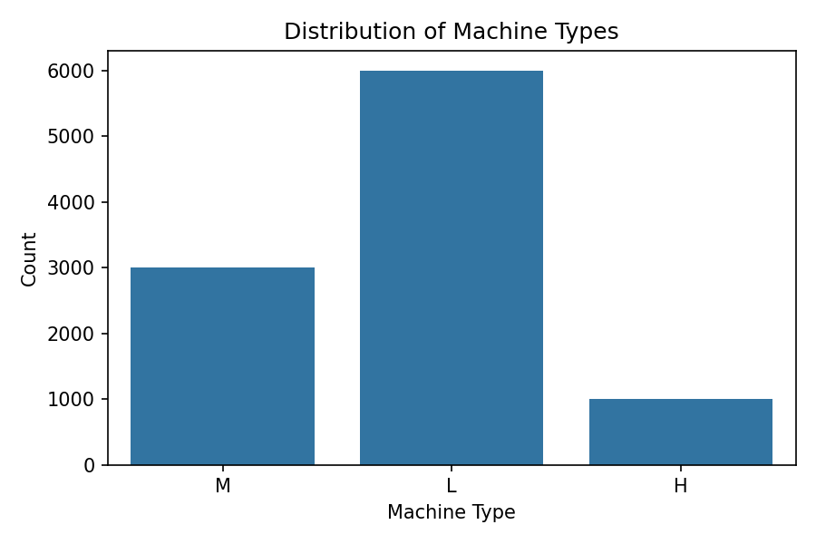
Figure 3.1: Distribution of Machine Product Types in the AI4I 2020 Dataset

3.7.3 Failure Distribution Across Product Types
The relationship between product quality type and machine failure incidence was examined to assess whether failure rates differ meaningfully across the three product categories. Figure 3.2 presents failure counts segmented by product type.
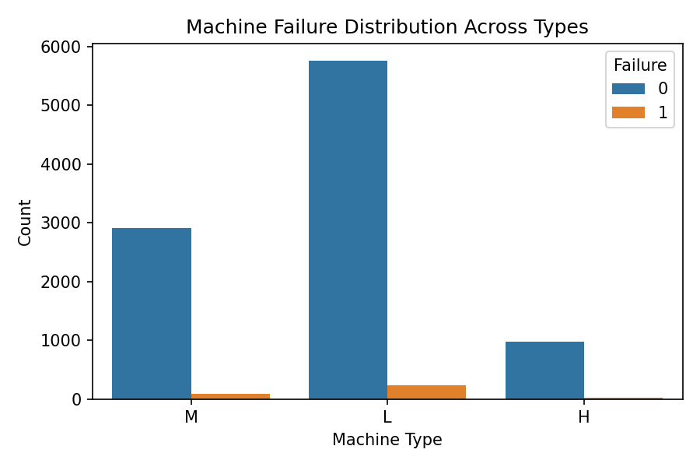
Figure 3.2: Machine Failure Distribution Across Product Types

3.7.4 Feature Distributions and Outlier Detection
Histogram and boxplot pairs were generated for each of the four most analytically relevant features: Torque [Nm], Rotational speed [rpm], temperature_difference, and Mechanical Power [W]. The histogram with kernel density estimate reveals the shape of each distribution, while the accompanying boxplot flags potential outliers based on the 1.5 × IQR rule. Figures 3.3 through 3.6 present these diagnostic pairs.
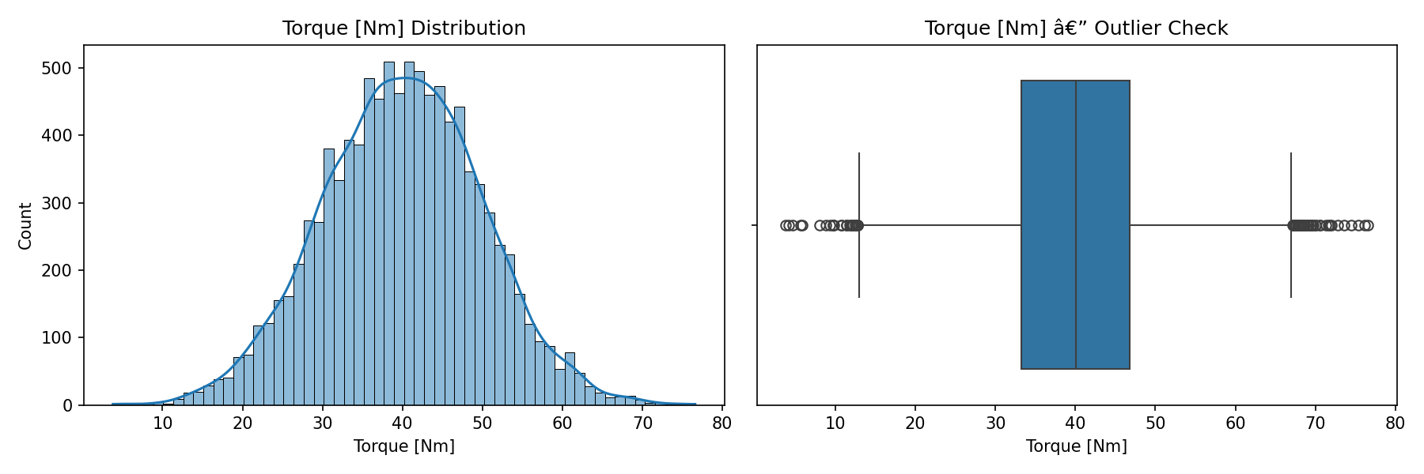
Figure 3.3: Distribution and Outlier Profile of Torque [Nm]
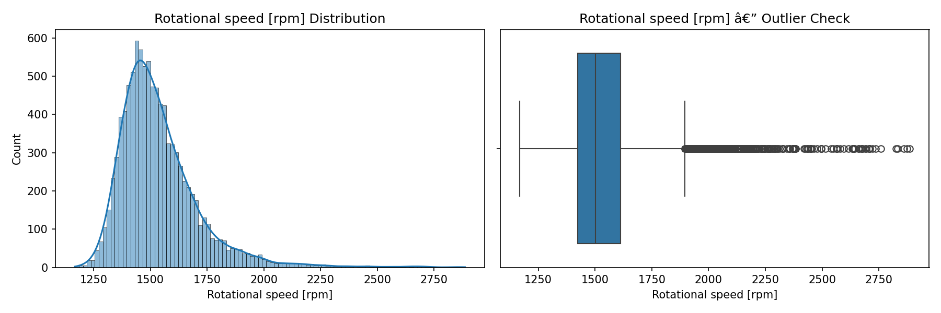
Figure 3.4: Distribution and Outlier Profile of Rotational Speed [rpm]
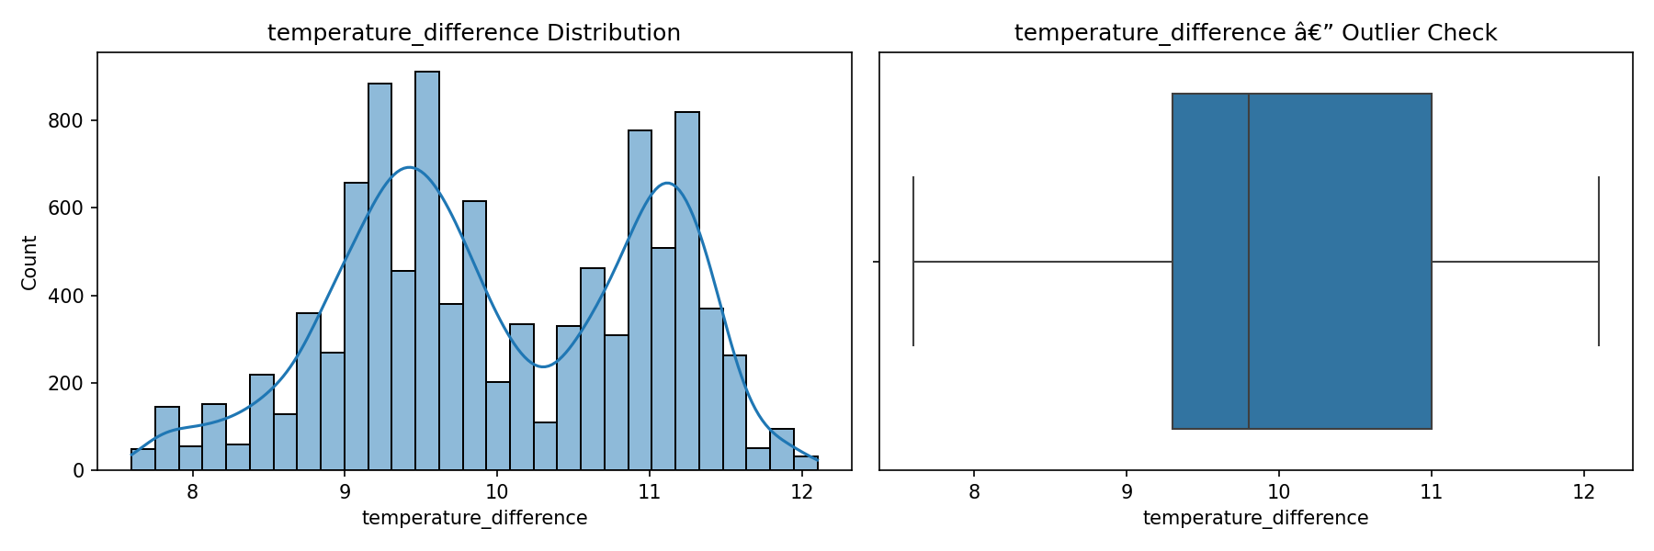
Figure 3.5: Distribution and Outlier Profile of temperature_difference
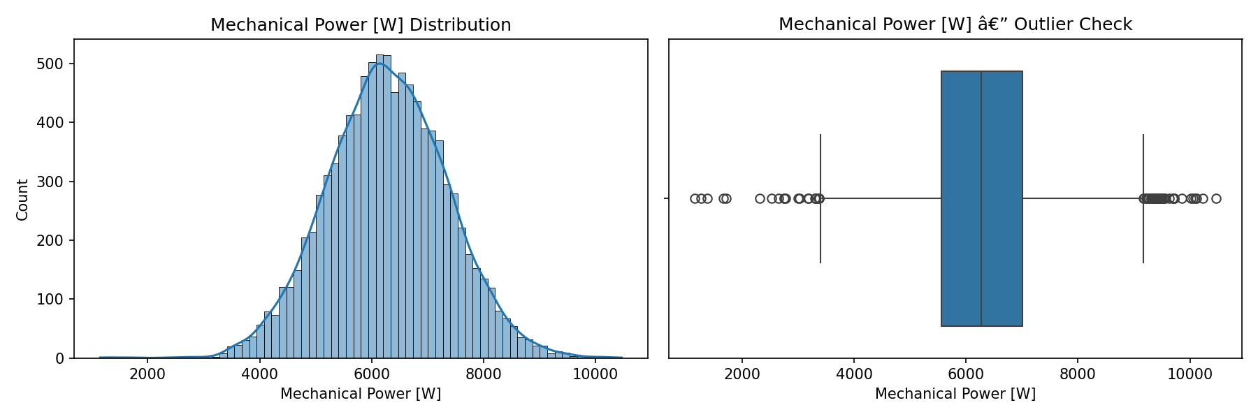
Figure 3.6: Distribution and Outlier Profile of Mechanical Power [W]

3.7.5 Pairplot Analysis
A pairplot was produced for the four engineered and high-relevance features, with observations coloured by the Machine failure label. Figure 3.7 presents the resulting matrix of scatter plots and marginal distributions.
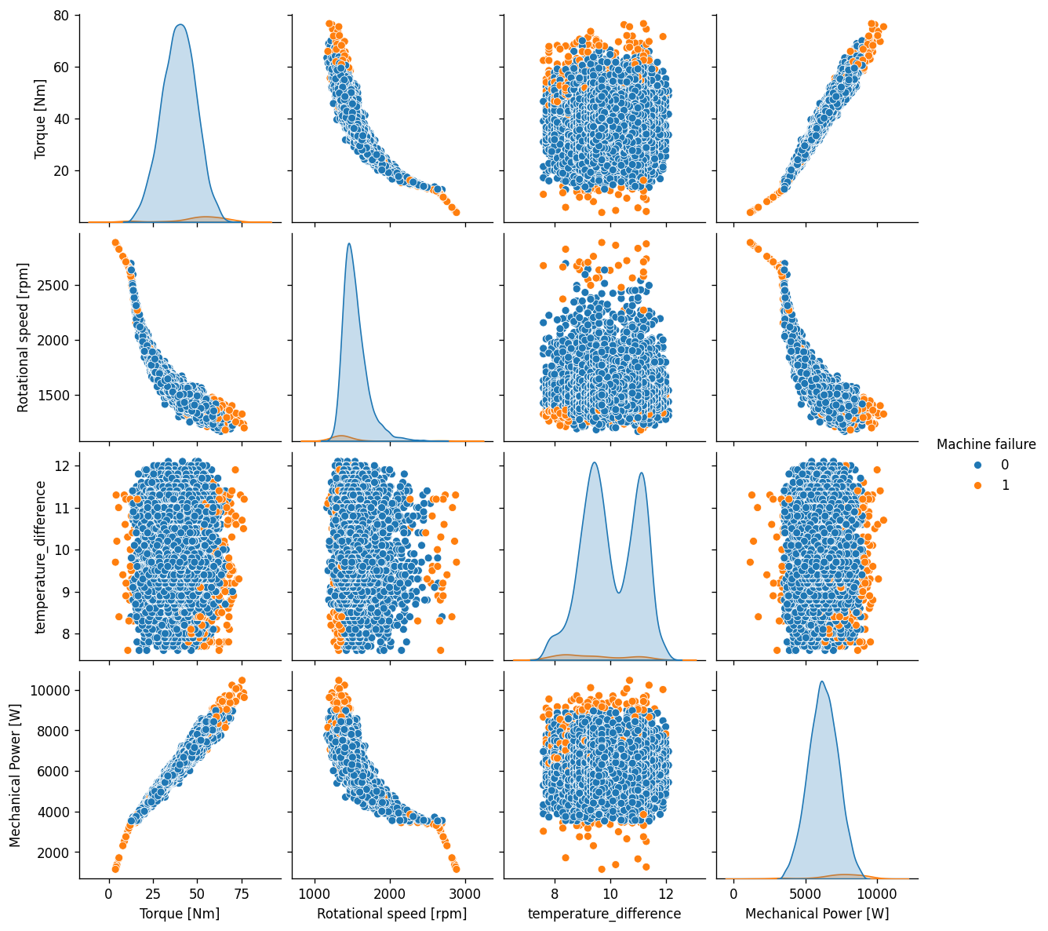
Figure 3.7: Pairplot of Key Features Coloured by Failure Label

3.7.6 Correlation Analysis
Two correlation heatmaps were produced. The first examines the full feature correlation matrix to identify multicollinear features that could destabilise distance-based or regularised classifiers. The second examines the correlation structure among the five failure mode flags and the aggregate Machine failure label, providing visual evidence for the target leakage concern addressed in Section 3.8.
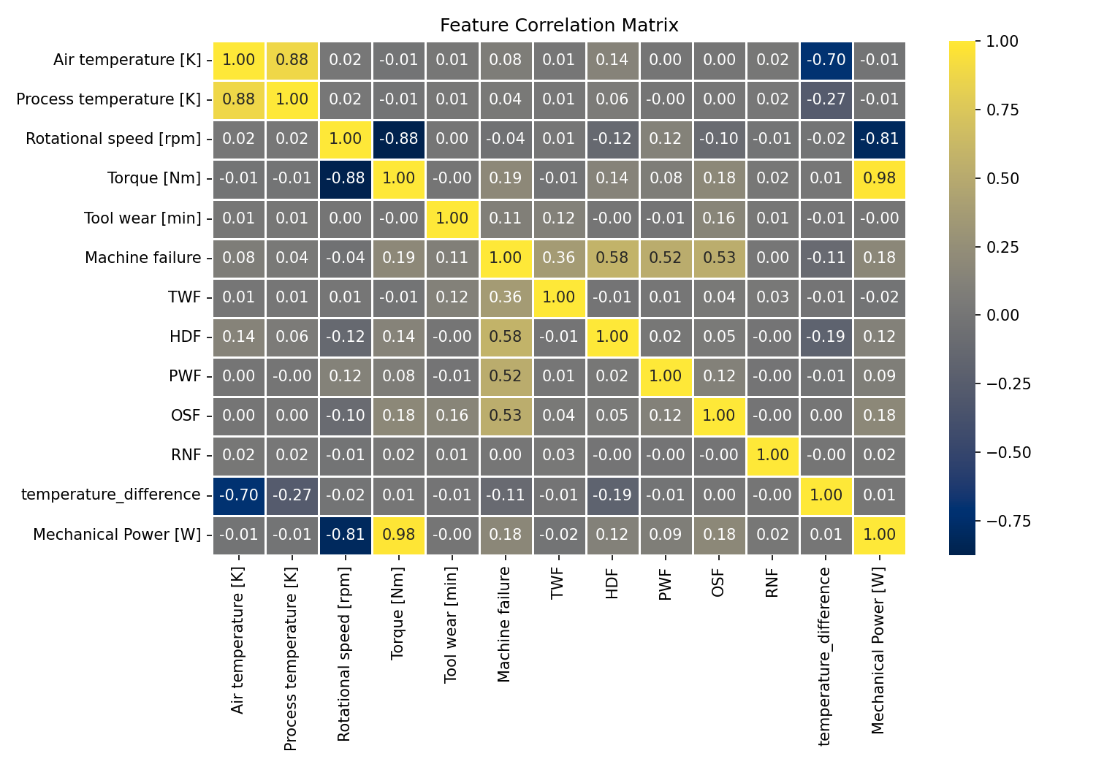
Figure 3.8: Full Feature Correlation Heatmap
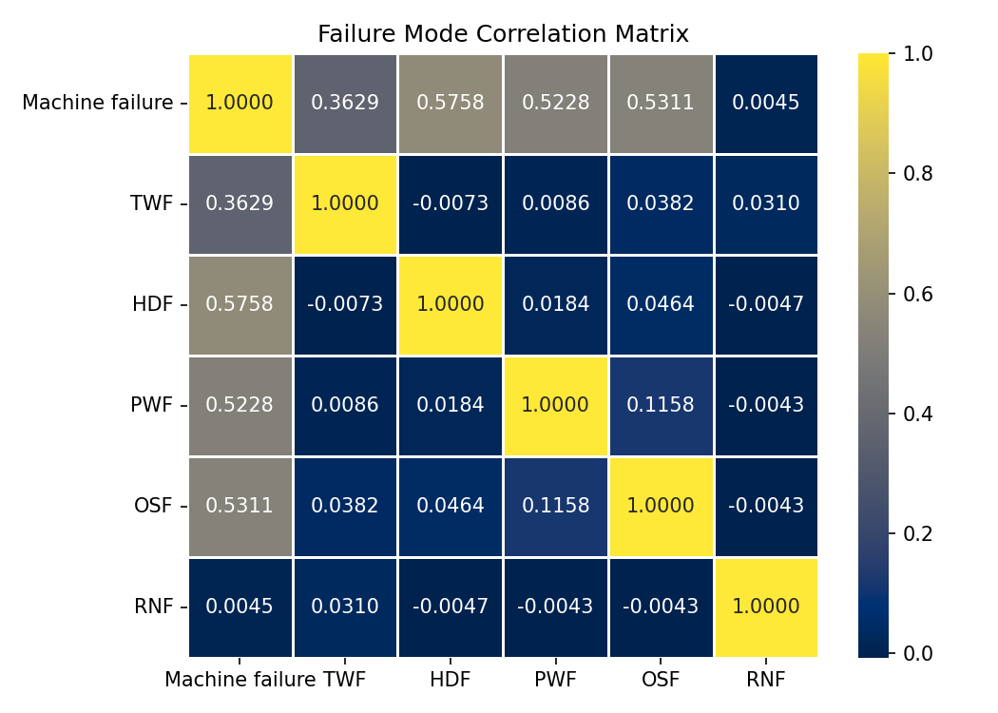
Figure 3.9: Failure Mode Correlation Heatmap

3.8 Target Leakage Prevention
The five failure mode indicator columns — TWF, HDF, PWF, OSF, and RNF — were excluded from the feature matrix before model training. This is a critical methodological step that requires careful justification.
These columns are direct logical components of the target variable: by dataset construction, Machine failure = 1 if and only if at least one of the five flags equals 1. A model trained with these columns in the feature set would learn a trivially correct rule (if any flag = 1, predict failure) that has no operational validity — the failure mode flags are diagnostic outputs of the machine's failure event, not observable precursor signals. In a real-world deployment context, a condition monitoring system has access only to the physical sensor readings; it does not have access to failure mode classification, which requires post-hoc investigation of the failure event itself.
Retaining these columns would constitute target leakage: the model would achieve near-perfect performance on the training and test sets while having learned nothing transferable to real operational data. The failure mode heatmap in Figure 3.9 provides visible empirical evidence for this leakage: correlations between each failure mode and the Machine failure target exceed 0.95, confirming that any model with access to these features would learn an information shortcut rather than a generalisable failure detection pattern.
Following removal of the five leakage columns, the feature matrix contains seven predictors: Air temperature [K], Process temperature [K], Rotational speed [rpm], Torque [Nm], Tool wear [min], temperature_difference, and Mechanical Power [W], plus the encoded Type column — eight features in total.

Table 3.4: Final Feature Set After Preprocessing and Engineering
Feature | Source | Role
Type | Original (encoded) | Product quality level (ordinal: H=0, L=1, M=2)
Air temperature [K] | Original sensor | Ambient thermal condition
Process temperature [K] | Original sensor | Internal machine temperature
Rotational speed [rpm] | Original sensor | Spindle operational speed
Torque [Nm] | Original sensor | Applied mechanical torque
Tool wear [min] | Original sensor | Cumulative tool usage time
temperature_difference | Engineered | Process temp − Air temp; HDF proximity indicator
Mechanical Power [W] | Engineered | Torque × (RPM × 2π/60); PWF proximity indicator

3.9 Train-Test Split
The dataset was partitioned into training and test subsets using a stratified random split with test_size = 0.10, random_state = 42, and stratify = y. This configuration allocates 9,000 observations to the training set and 1,000 observations to the test set. Stratified sampling preserves the 3.39% failure rate in both subsets, ensuring that the test set contains a representative proportion of the minority class.

Table 3.5: Train-Test Split Configuration
Parameter | Value | Rationale
Split ratio | 90% train / 10% test | Maximises training data given a small minority class (339 failures total)
Test size | 0.10 (1,000 samples) | Retains ≈34 failure instances in the test set for evaluation
Stratification | By Machine failure label | Preserves 3.39% failure rate in both subsets
Random state | 42 | Ensures full reproducibility of the split

Table 3.6: Resulting Class Distribution After Splitting
Subset | Total Samples | Class 0 (Normal) | Class 1 (Failure) | Failure Rate (%)
Training set | 9,000 | 8,695 | 305 | 3.39%
Test set | 1,000 | 966 | 34 | 3.40%

The split is performed before any scaling or class-rebalancing operations. This ordering is deliberate: fitting the StandardScaler and applying SMOTE after the split ensures that neither the mean/variance statistics used for scaling nor the synthetic samples generated by SMOTE are derived from or influenced by the test set, preventing all forms of data leakage from contaminating the evaluation.
It is worth noting that with approximately 34 failure instances in the test set, individual performance metric estimates carry meaningful uncertainty: a single misclassification shifts recall by approximately 3 percentage points. This limitation motivates the use of stratified cross-validation (Section 3.13) to obtain more stable performance estimates during model selection and hyperparameter optimisation.

3.10 Feature Scaling
Feature scaling was applied to standardise all numerical features to a common scale, preventing features with large magnitudes from dominating distance-based or gradient-based learning algorithms. Z-score standardisation (also known as standard normalisation) was employed, transforming each feature according to:
x' = (x − μ_train) / σ_train
where μ_train and σ_train are the mean and standard deviation of each feature computed exclusively on the training set. The fitted StandardScaler was then applied to transform both the training and test sets, ensuring that the test set is scaled using training-set statistics only. This prevents the test-set distribution from informing the scaling transformation in any way.
The fitted scaler was serialised to disk as standard_scaler.joblib. This artefact is essential for consistent inference: any new observation presented to the deployed model must be scaled using the same training-set mean and standard deviation before prediction, and the saved scaler enables this without requiring access to the original training data.
Following scaling, the training set was prepared for SMOTE application and model training; the scaled test set was held out untouched until the final model evaluation stage.

3.11 Class Imbalance Handling: SMOTE
The severe class imbalance in the AI4I 2020 dataset — 339 failures in 10,000 observations, yielding a 3.39% minority class proportion — requires active remediation to prevent models from learning the trivial majority-class prediction rule. Two strategies were considered: data-level resampling and algorithm-level cost adjustment. SMOTE (Synthetic Minority Over-sampling Technique; Chawla et al., 2002) was selected as the primary strategy for the following reasons.

3.11.1 Rationale for SMOTE
SMOTE generates synthetic minority-class samples by interpolating in feature space between an existing minority instance and one of its k nearest minority neighbours (k = 5 by default). Each synthetic sample is placed on the line segment connecting these two points, at a randomly chosen position. This approach creates a denser and more generalisable minority-class representation than simple duplication of existing failure records, reducing the risk of overfitting to the specific failure instances that happened to appear in the training set (Chawla et al., 2002).
An alternative approach — assigning class-weight = balanced to the classifier, which upweights the minority class in the loss function without modifying the data — was considered but not adopted as the primary strategy. This aligns with the observation by Holmkvist (2024) that data-level rebalancing generally outperforms algorithmic weighting for improving minority-class recall on the AI4I dataset.

3.11.2 Application Strategy: Direct and Fold-Safe
SMOTE was applied in two distinct contexts in this study, each requiring a different implementation approach:
Direct application to the training set: For the initial ten-classifier comparison (Section 3.12), SMOTE was applied once to the full scaled training set (X_train_scaled, y_train), producing a balanced training set with equal numbers of failure and non-failure observations. This balanced set was used to train all ten candidate classifiers, ensuring a controlled comparison under identical conditions. The SMOTE parameters used were: sampling_strategy = "auto" (balance to the majority class count), k_neighbors = 5, and random_state = 42.

Table 3.7: Training Set Class Distribution Before and After SMOTE
Stage | Class 0 (Normal) | Class 1 (Failure) | Total | Failure Rate (%)
Before SMOTE | 8,695 | 305 | 9,000 | 3.39%
After SMOTE | 8,695 | 8,695 | 17,390 | 50.00%

Fold-safe application within cross-validation: For the stratified cross-validation (Section 3.13) and randomised hyperparameter search (Section 3.14), SMOTE was integrated inside each training fold using an imbalanced-learn Pipeline (ImbPipeline). This is a methodologically critical distinction. If SMOTE were applied globally before cross-validation, synthetic failure samples generated from the full training set would appear in both the training folds and the held-out validation folds of each cross-validation iteration. This would contaminate the validation fold with synthetic observations derived from data it is supposed to evaluate, producing optimistically biased performance estimates. By encapsulating SMOTE inside the pipeline as the first step, synthetic samples are generated from the training fold only and never seen during validation fold evaluation, yielding honest, unbiased cross-validated estimates (Lemaître et al., 2017).

3.12 Comparative Evaluation of Ten Classifiers
Rather than pre-selecting a single algorithm based on prior intuition, this study adopts an empirical model selection strategy: ten candidate supervised classifiers are trained under identical experimental conditions and their held-out test performance is compared before any further investment in tuning. This approach is motivated by evidence from the predictive maintenance literature showing that algorithm performance on the AI4I dataset varies substantially: Holmkvist (2024) found that Random Forest and XGBoost significantly outperform Logistic Regression and SVM on recall; Madan et al. (2023) found that Random Forest achieved the highest overall F1-score among six classifiers. Rather than assuming these findings generalise under the specific preprocessing and feature engineering decisions adopted in this study, the comparative phase directly verifies which classifier performs best under the study's own conditions.
The ten candidate classifiers, all from scikit-learn, are presented in Table 3.8. They represent a broad spectrum of algorithmic families: linear models, probabilistic gradient methods, decision trees, ensemble methods, kernel methods, and instance-based methods.

Table 3.8: Ten Candidate Classifiers Evaluated in the Comparative Phase
Classifier | Algorithmic Family | Key Characteristics
Logistic Regression | Linear | Probabilistic linear boundary; interpretable coefficients
Logistic Regression CV | Linear (regularised) | Automatic L2 regularisation strength selection via CV
SGD Classifier | Linear (gradient) | Stochastic gradient descent; efficient for large datasets
Decision Tree | Tree | Single tree; interpretable but prone to overfitting
Random Forest | Ensemble (bagging) | Bootstrap-aggregated trees; robust, high variance reduction
Gradient Boosting | Ensemble (boosting) | Sequential error-correcting trees; strong tabular performance
AdaBoost | Ensemble (boosting) | Adaptive weighting of misclassified samples
Bagging Classifier | Ensemble (bagging) | Bootstrap aggregation over a base estimator
Support Vector Machine | Kernel | Maximum-margin hyperplane; effective in high dimensions
K-Nearest Neighbours | Instance-based | Non-parametric; distance-based voting

Each classifier was trained on the SMOTE-balanced training set (17,390 samples, 50% failure rate) using its default scikit-learn hyperparameters, with random_state = 42 applied wherever supported. Predictions were generated on the held-out scaled test set (1,000 samples, 3.4% failure rate), and accuracy was recorded as the comparison criterion for this initial screening phase. All models were evaluated under identical conditions to ensure a controlled, leakage-free comparison.
Accuracy was used at this screening stage as a practical sorting criterion to identify the strongest candidates for deeper investigation. As noted in Section 3.3.3, accuracy is an insufficient optimisation target for imbalanced datasets; the comprehensive evaluation using recall, precision, F1-score, and AUC-ROC is reserved for the final tuned model in Section 3.15. Model selection outcomes are reported in Chapter 4.

3.13 Stratified Cross-Validation
A single 90/10 train-test split, while necessary for a clean final evaluation, produces unstable performance estimates for the minority failure class: with approximately 34 failure instances in the test set, a single misclassification shifts recall by approximately three percentage points. Stratified k-fold cross-validation was therefore employed to obtain more reliable performance estimates prior to hyperparameter tuning.
A 3-fold StratifiedKFold configuration was applied to the scaled, unbalanced training set (9,000 samples). Stratification ensures that the 3.39% failure rate is preserved within each fold, preventing any fold from receiving a disproportionate share of the minority class. For each of the three folds, the model is trained on two thirds of the training data and validated on the remaining third, cycling through all three combinations. This produces three independent performance estimates, which are then averaged to obtain a more stable cross-validated metric.
To preserve the methodological integrity of the SMOTE application, the cross-validation was implemented using an ImbPipeline that encapsulates SMOTE as the first step followed by a default Random Forest classifier:
cv_pipeline = ImbPipeline([('smote', SMOTE(random_state=42)), ('rf', RandomForestClassifier(random_state=42))])
Within each fold, SMOTE is applied only to the training portion of that fold, generating synthetic failure samples from the fold's training data alone. The validation portion of each fold contains only real, unaugmented observations, providing an uncontaminated estimate of generalisation performance. This fold-safe SMOTE implementation is a methodological best practice recommended by Lemaître et al. (2017) and represents an advance over many published predictive maintenance studies that apply SMOTE globally before cross-validation.
Four metrics were collected across all three folds: precision, recall, F1-score, and ROC-AUC. Mean and standard deviation across folds were reported for each metric, providing both a central tendency estimate and a measure of estimate stability. The cross-validation results for the default Random Forest served as the baseline against which the tuned model was subsequently compared.

3.14 Hyperparameter Tuning via RandomizedSearchCV
Following the selection of Random Forest as the best-performing classifier, randomised hyperparameter search was conducted to optimise the model's configuration beyond its default settings. RandomizedSearchCV from scikit-learn was employed in preference to exhaustive GridSearchCV. Bergstra and Bengio (2012) demonstrate that randomised search finds configurations of comparable or superior quality to grid search while evaluating substantially fewer parameter combinations, because not all hyperparameters are equally influential and random sampling allocates evaluation budget across the full search space more efficiently than a regular grid. With the search space defined below, an exhaustive grid would require evaluating over 200 combinations; RandomizedSearchCV explored 50 sampled combinations at a fraction of the computational cost.

Table 3.9: Hyperparameter Search Space for Random Forest
Hyperparameter | Search Values | Role
n_estimators | {100, 200, 300} | Number of trees in the ensemble; larger values reduce variance
max_depth | {None, 10, 20, 30} | Maximum tree depth; None allows full growth (overfitting risk)
min_samples_split | {2, 5, 10} | Minimum samples required to split an internal node
min_samples_leaf | {1, 2, 4} | Minimum samples required at each leaf node
max_features | {'sqrt', 'log2'} | Number of features considered at each split

The search was configured with the following key parameters: n_iter = 50 (number of parameter combinations sampled), cv = StratifiedKFold(n_splits=3, shuffle=True, random_state=42) (consistent fold structure with the cross-validation in Section 3.13), scoring = "f1" (optimisation target), and n_jobs = -1 (parallel evaluation). The scoring criterion was F1-score rather than accuracy, directly optimising the balance between precision and recall on the failure class. This is the appropriate objective for predictive maintenance, where both false negatives (missed failures) and false positives (unnecessary maintenance interventions) carry operational cost.
Critically, the same ImbPipeline structure used in Section 3.13 was retained for the search, with SMOTE applied inside each fold of the inner cross-validation:
search_pipeline = ImbPipeline([('smote', SMOTE(random_state=42)), ('rf', RandomForestClassifier(random_state=42))])
This ensures that synthetic samples generated during the inner hyperparameter search folds do not contaminate the inner validation sets, preserving the integrity of the F1-score estimates used to rank parameter configurations. The best parameter combination identified by the search was then applied to retrain the pipeline on the full training set for final evaluation.
To assess the benefit of tuning, the cross-validated F1-score of the tuned model was compared against the baseline cross-validated F1-score of the default Random Forest documented in Section 3.13, using the same stratified fold structure.

3.15 Final Model Training
Following the identification of the optimal hyperparameter configuration through RandomizedSearchCV, the tuned Random Forest classifier was retrained on the full SMOTE-balanced training set (17,390 samples; 50% failure rate). This step uses the best hyperparameters extracted from the search pipeline, applied directly to a RandomForestClassifier instance:
The model was trained on X_train_res (SMOTE-balanced, scaled training features) and y_train_res (corresponding balanced labels). The class_weight parameter was not set, as the training set was already balanced via SMOTE and manual class weighting would be redundant and potentially counterproductive.
After training, the model was applied to the held-out scaled test set (X_test_scaled, 1,000 samples) to generate final predictions and predicted probabilities. This test set had not been used at any stage of preprocessing fitting, SMOTE application, cross-validation, or hyperparameter search, ensuring it represents a genuinely unseen evaluation set.

3.16 Feature Importance Analysis
Random Forest classifiers provide a built-in mechanism for quantifying the relative contribution of each feature to the model's decision-making process. The feature_importances_ attribute of the trained model reports the mean decrease in impurity (Gini impurity) accumulated across all splits in all trees at which a given feature was used. Features that produce larger average reductions in impurity receive higher importance scores.
Feature importances were extracted from the trained final model and ranked in descending order of importance. Figure 3.10 presents the resulting bar chart. This analysis serves two purposes: it provides interpretable insight into which operational parameters are most diagnostic of failure risk, and it validates the decision to engineer the temperature_difference and Mechanical Power features — if these features receive non-trivial importance scores, it confirms that the domain-informed feature engineering added discriminative value beyond the raw sensor readings.
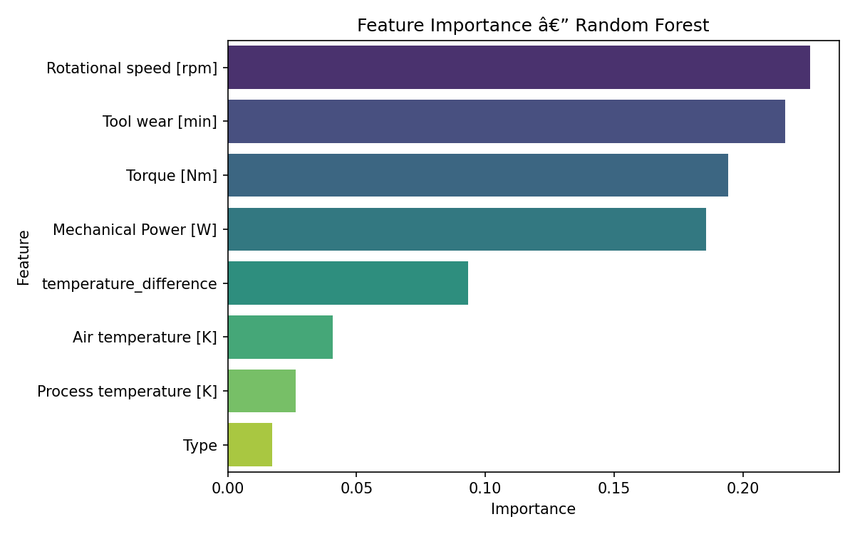
Figure 3.10: Feature Importance Rankings from the Tuned Random Forest Classifier

3.17 Model Serialisation
Three artefacts produced during the training pipeline were serialised to disk using joblib for persistence and future deployment use:
- label_encoder.joblib: The fitted LabelEncoder that maps product quality category strings (H, L, M) to integer codes (0, 1, 2). Any new observation must have its Type column encoded using this object before prediction.
- standard_scaler.joblib: The fitted StandardScaler containing the training-set mean and standard deviation for each of the eight features. Any new observation must be transformed using this scaler — not refitted — before it is presented to the model.
- random_forest_model.joblib: The fully trained Random Forest classifier with the tuned hyperparameter configuration, ready for inference.

Together, these three artefacts constitute a deployable inference package. To classify a new observation, the procedure is: (1) apply the label encoder to the Type column, (2) apply the standard scaler to all features using the training-set statistics, and (3) pass the scaled feature vector to the trained classifier. No retraining or refitting is required. This serialisation approach follows established best practices for reproducible machine learning pipelines (Pedregosa et al., 2011) and ensures that the preprocessing transformations applied at inference time are identical to those applied during training.

3.18 Evaluation Metrics
The evaluation of the final model employed five complementary metrics. Each is defined below with reference to the elements of the confusion matrix: True Positives (TP), True Negatives (TN), False Positives (FP), and False Negatives (FN).

Table 3.10: Evaluation Metrics Used in This Study
Metric | Formula | Interpretation in This Context
Accuracy | (TP + TN) / (TP + TN + FP + FN) | Overall correctness; misleading for imbalanced data — reported for completeness only
Precision | TP / (TP + FP) | Proportion of failure predictions that are correct; high precision minimises false alarms
Recall (Sensitivity) | TP / (TP + FN) | Proportion of actual failures correctly detected; high recall minimises missed failures
F1-Score | 2 × (Precision × Recall) / (Precision + Recall) | Harmonic mean of precision and recall; primary optimisation criterion
AUC-ROC | Area under ROC curve | Classifier discrimination ability across all thresholds; threshold-independent

3.18.1 Metric Prioritisation
For predictive maintenance applications, recall is the primary operational metric: a false negative (a missed failure) can result in unplanned machine downtime, production losses, safety hazards, and emergency repair costs. A false positive (an unnecessary maintenance inspection) incurs inspection labour cost but avoids these more severe consequences. This asymmetry in misclassification cost motivates prioritising recall over precision.
The F1-score is used as the optimisation target during hyperparameter search because it explicitly penalises both low precision and low recall, preventing degenerate solutions that maximise one metric at the extreme expense of the other. AUC-ROC provides a threshold-independent assessment of the classifier's ability to discriminate failures from non-failures, offering a useful complement to the threshold-dependent metrics above.
As noted in Section 3.3.3, accuracy is explicitly excluded as a primary criterion because the null classifier — predicting no failure for all observations — would achieve 96.61% accuracy while detecting zero failures. Any model that achieves lower accuracy than a given baseline but higher recall is unambiguously superior for the predictive maintenance objective of this study (Holmkvist, 2024).
The confusion matrix and precision-recall curve were also produced to provide a comprehensive visual summary of the classifier's behaviour across the full range of decision thresholds, enabling interpretation beyond any single scalar metric.

3.19 Chapter Summary
This chapter has presented the complete methodology employed to develop and evaluate a supervised machine learning pipeline for predictive maintenance using the AI4I 2020 dataset. The methodology was organised into three sequential phases: data preparation, model development, and evaluation and deployment.
In the data preparation phase, the dataset was loaded and its structural integrity verified against the published specification. Identifier columns were removed, and the categorical Type variable was encoded using a LabelEncoder — persisted to ensure inference consistency. Two domain-grounded features were engineered: temperature_difference, encoding the Heat Dissipation Failure threshold responsible for over 74% of the dataset's maintenance costs (Rayarao & Rayarao, 2024), and Mechanical Power [W], encoding the Power Failure threshold. Exploratory data analysis was then conducted to characterise feature distributions, examine class proportions, and assess correlation structure; the findings of this analysis are presented in Section 4.3. The five failure mode indicator columns were subsequently excluded following the EDA correlation analysis, which provided visual evidence of their deterministic relationship with the target variable — an issue addressed in full as target leakage prevention in Section 3.8.
In the model development phase, the data was partitioned using a stratified 90/10 split, scaled using a training-set-fitted StandardScaler, and class-rebalanced using SMOTE applied directly to the training set. Ten candidate classifiers were trained and compared under identical conditions. The best-performing classifier — Random Forest — was subjected to 3-fold stratified cross-validation using a fold-safe ImbPipeline that applies SMOTE inside each fold, followed by RandomizedSearchCV with 50 iterations targeting F1-score optimisation. This fold-safe SMOTE implementation prevents synthetic samples from contaminating validation fold estimates, addressing a methodological gap common in applied predictive maintenance research.
In the evaluation and deployment phase, the tuned Random Forest was retrained on the full SMOTE-balanced training set and evaluated on the held-out test set using accuracy, precision, recall, F1-score, and AUC-ROC. Feature importance analysis was conducted to assess the discriminative contribution of each feature, including the two engineered features. Three artefacts — the label encoder, the feature scaler, and the trained model — were serialised as joblib files, constituting a complete, deployment-ready inference package.
The experimental results produced by this methodology are presented and discussed in Chapter Four.

References
Bergstra, J., & Bengio, Y. (2012). Random search for hyper-parameter optimization. Journal of Machine Learning Research, 13, 281–305.

Breiman, L. (2001). Random forests. Machine Learning, 45(1), 5–32. https://doi.org/10.1023/A:1010933404324

Chawla, N. V., Bowyer, K. W., Hall, L. O., & Kegelmeyer, W. P. (2002). SMOTE: Synthetic minority over-sampling technique. Journal of Artificial Intelligence Research, 16, 321–357. https://doi.org/10.1613/jair.953

Holmkvist, I. (2024). Implementing predictive maintenance for small and medium-sized enterprises [Bachelor's thesis, Mid Sweden University]. DiVA Portal.

Lei, Y., Li, N., Guo, L., Li, N., Yan, T., & Lin, J. (2018). Machinery health prognostics: A systematic review from data acquisition to RUL prediction. Mechanical Systems and Signal Processing, 104, 799–834. https://doi.org/10.1016/j.ymssp.2017.11.016

Lemaître, G., Nogueira, F., & Aridas, C. K. (2017). Imbalanced-learn: A Python toolbox to tackle the curse of imbalanced datasets in machine learning. Journal of Machine Learning Research, 18(17), 1–5.

Madan, A. K., Joshi, S., Gupta, S., & Shubham. (2023). Optimizing machine performance and reliability: A predictive maintenance approach. International Journal of Scientific Development and Research, 8(5), 611–615.

Matzka, S. (2020). Explainable artificial intelligence for predictive maintenance applications. In Proceedings of the Third International Conference on Artificial Intelligence for Industries (AI4I 2020) (pp. 69–74). IEEE. https://doi.org/10.1109/AI4I49448.2020.00023

McKinney, W. (2010). Data structures for statistical computing in Python. In Proceedings of the 9th Python in Science Conference (SciPy 2010) (pp. 56–61).

Pedregosa, F., Varoquaux, G., Gramfort, A., Michel, V., Thirion, B., Grisel, O., Blondel, M., Prettenhofer, P., Weiss, R., Dubourg, V., Vanderplas, J., Passos, A., Cournapeau, D., Brucher, M., Perrot, M., & Duchesnay, É. (2011). Scikit-learn: Machine learning in Python. Journal of Machine Learning Research, 12, 2825–2830.

Rajendiran, V. (2023). Smart predictive maintenance for proactive machine process using machine learning [Master's thesis, Swinburne University of Technology].

Rayarao, S. R., & Rayarao, S. R. (2024). Advanced predictive maintenance strategies: Insights from the AI4I 2020 dataset. TechRxiv. https://doi.org/10.36227/techrxiv.173397914.41294976/v1

