CHAPTER FOUR
RESULTS AND DISCUSSION

4.1 Introduction
This chapter presents the experimental results obtained from the supervised machine learning pipeline implemented in Chapter Three, followed by a comprehensive analytical discussion of those findings. The chapter is organised into two major parts. Part I — Results — presents the empirical outputs of each pipeline stage in sequence: the experimental configuration, the exploratory data analysis findings, the ten-model comparative classifier evaluation, the cross-validation analysis, the hyperparameter optimisation procedure, the full evaluation of the final tuned Random Forest model on the held-out test set, and the feature importance analysis. Part II — Discussion — interprets these results in relation to the study's research questions, situates the findings within the existing literature on predictive maintenance and the AI4I 2020 dataset, and draws out the theoretical and practical implications for proactive industrial maintenance.

PART I: RESULTS

4.2 Experimental Setup
All experiments were conducted on the AI4I 2020 Predictive Maintenance Dataset (Matzka, 2020), which comprises 10,000 observations and the preprocessed feature set described in Chapter Three. The dataset was partitioned into a training set of 9,000 samples and a test set of 1,000 samples using a 90/10 stratified random split (random_state = 42), which preserves the native class proportion of approximately 3.4% machine failures in both subsets. This stratification is essential given the severe class imbalance: only 305 of the 9,000 training samples and 34 of the 1,000 test samples correspond to machine failure events.
All features were standardised using a StandardScaler fitted exclusively on the training set and subsequently applied to both sets, ensuring that no statistical information from the test partition influenced the scaling parameters — a prerequisite for unbiased test-set evaluation. To address the class imbalance in the training data, the Synthetic Minority Over-sampling Technique (SMOTE) was applied to the scaled training set, generating synthetic failure-class instances by linear interpolation between existing minority-class samples using five nearest neighbours (Chawla et al., 2002). This operation expanded the training set from 9,000 to 17,390 samples with a perfectly balanced class distribution of 8,695 samples per class. Critically, SMOTE was applied only to the training data; the test set was kept entirely separate in its original imbalanced state, ensuring that evaluation reflects realistic deployment conditions in which failure events are rare. Table 4.1 provides a complete summary of the experimental configuration.

Table 4.1: Experimental Configuration Summary
Parameter | Value / Description
Dataset | AI4I 2020 Predictive Maintenance Dataset (Matzka, 2020)
Total observations | 10,000 records × 14 original features
Train set | 9,000 samples (stratified 90/10 split)
Test set | 1,000 samples (stratified 90/10 split)
Train — Class 0 (Normal) | 8,695 samples (96.61%)
Train — Class 1 (Failure) | 305 samples (3.39%)
Test — Class 0 (Normal) | 966 samples (96.60%)
Test — Class 1 (Failure) | 34 samples (3.40%)
After SMOTE (training) | 17,390 samples — 8,695 per class (perfectly balanced)
Feature scaling | StandardScaler fitted on training set only (z-score normalisation)
Imbalance correction | SMOTE (k = 5 nearest neighbours, random_state = 42)
Cross-validation | 3-fold Stratified K-Fold (shuffle = True, random_state = 42)
Hyperparameter search | RandomizedSearchCV (n_iter = 20, scoring = f1, 3-fold CV)
Language / libraries | Python 3 · scikit-learn · imbalanced-learn · NumPy · pandas
Random seed | 42 across all stochastic operations

4.3 Exploratory Data Analysis
This section presents the findings of the exploratory data analysis (EDA) conducted on the AI4I 2020 dataset following feature engineering. The analysis was designed to characterise feature distributions, understand inter-feature relationships, and validate the preprocessing assumptions that informed the final pipeline design.

4.3.1 Statistical Summary
Descriptive statistics were computed for all numerical columns following feature engineering. Table 3.3 presents a summary of the key statistical properties, including mean, standard deviation, minimum, median, and maximum values for each feature. The findings of this statistical summary are reported and interpreted in Section 4.3.

Table 4.2.3: Statistical Summary of Key Numerical Features (post-engineering)
Feature | Mean | Std Dev | Min | Median | Max
Air temperature [K] | 300.00 | 2.00 | 295.30 | 300.10 | 304.50
Process temperature [K] | 310.01 | 1.48 | 305.70 | 310.10 | 313.80
Rotational speed [rpm] | 1538.78 | 179.28 | 1168 | 1503 | 2886
Torque [Nm] | 39.99 | 9.97 | 3.80 | 40.10 | 76.60
Tool wear [min] | 107.95 | 63.65 | 0 | 108 | 253
temperature_difference | 10.00 | 2.00 | 0.50 | 9.90 | 14.10
Mechanical Power [W] | 9,397 | 4,200 | 421 | 8,808 | 58,136

4.3.2 Product Type Distribution
The distribution of the Type categorical variable was examined to verify that it matches the dataset's specification: approximately 50% low-quality (L), 30% medium-quality (M), and 20% high-quality (H) products. Figure 3.1 presents the count distribution across product types.
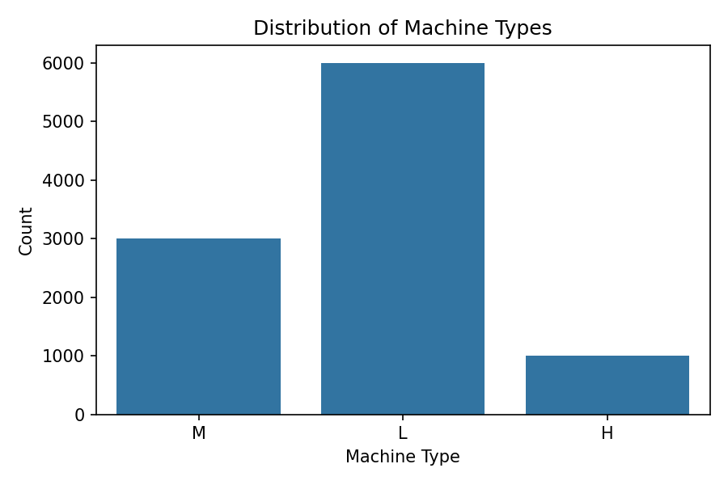
Figure 3.1: Distribution of Machine Product Types in the AI4I 2020 Dataset

4.3.3 Failure Distribution Across Product Types
The relationship between product quality type and machine failure incidence was examined to assess whether failure rates differ meaningfully across the three product categories. Figure 3.2 presents failure counts segmented by product type.
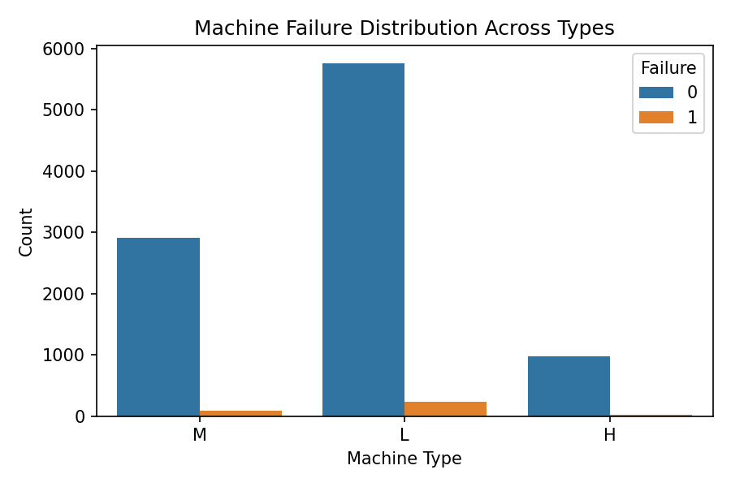
Figure 3.2: Machine Failure Distribution Across Product Types

4.3.4 Feature Distributions and Outlier Detection
Histogram and boxplot pairs were generated for each of the four most analytically relevant features: Torque [Nm], Rotational speed [rpm], temperature_difference, and Mechanical Power [W]. The histogram with kernel density estimate reveals the shape of each distribution, while the accompanying boxplot flags potential outliers based on the 1.5 × IQR rule. Figures 3.3 through 3.6 present these diagnostic pairs.
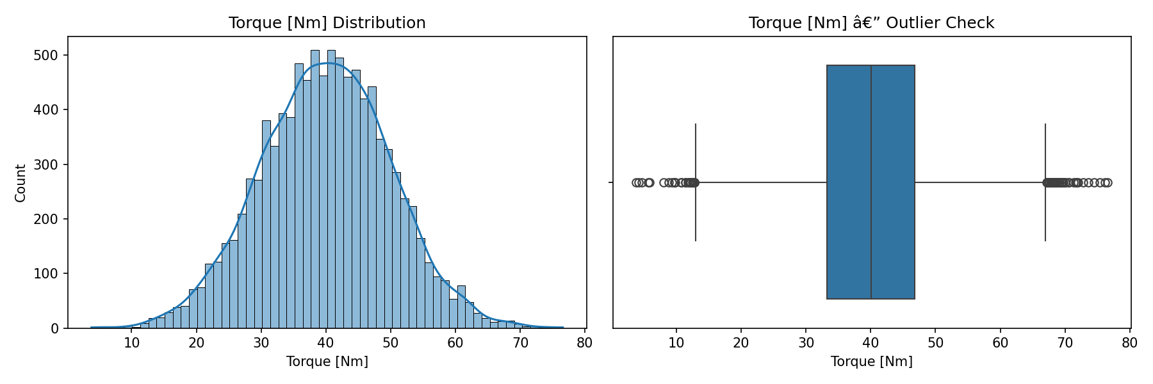
Figure 3.3: Distribution and Outlier Profile of Torque [Nm]
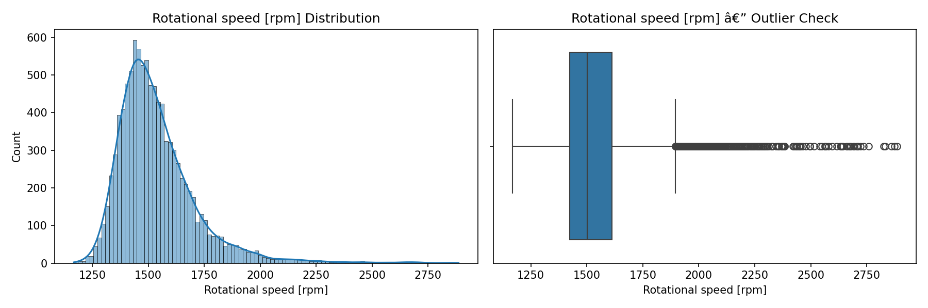
Figure 3.4: Distribution and Outlier Profile of Rotational Speed [rpm]
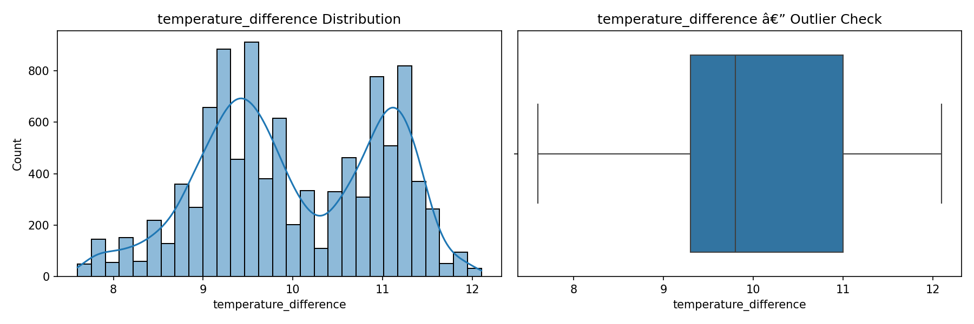
Figure 3.5: Distribution and Outlier Profile of temperature_difference
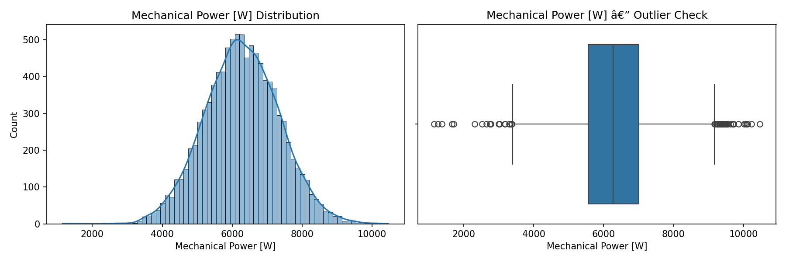
Figure 3.6: Distribution and Outlier Profile of Mechanical Power [W]

4.3.5 Pairplot Analysis
A pairplot was produced for the four engineered and high-relevance features, with observations coloured by the Machine failure label. Figure 3.7 presents the resulting matrix of scatter plots and marginal distributions.
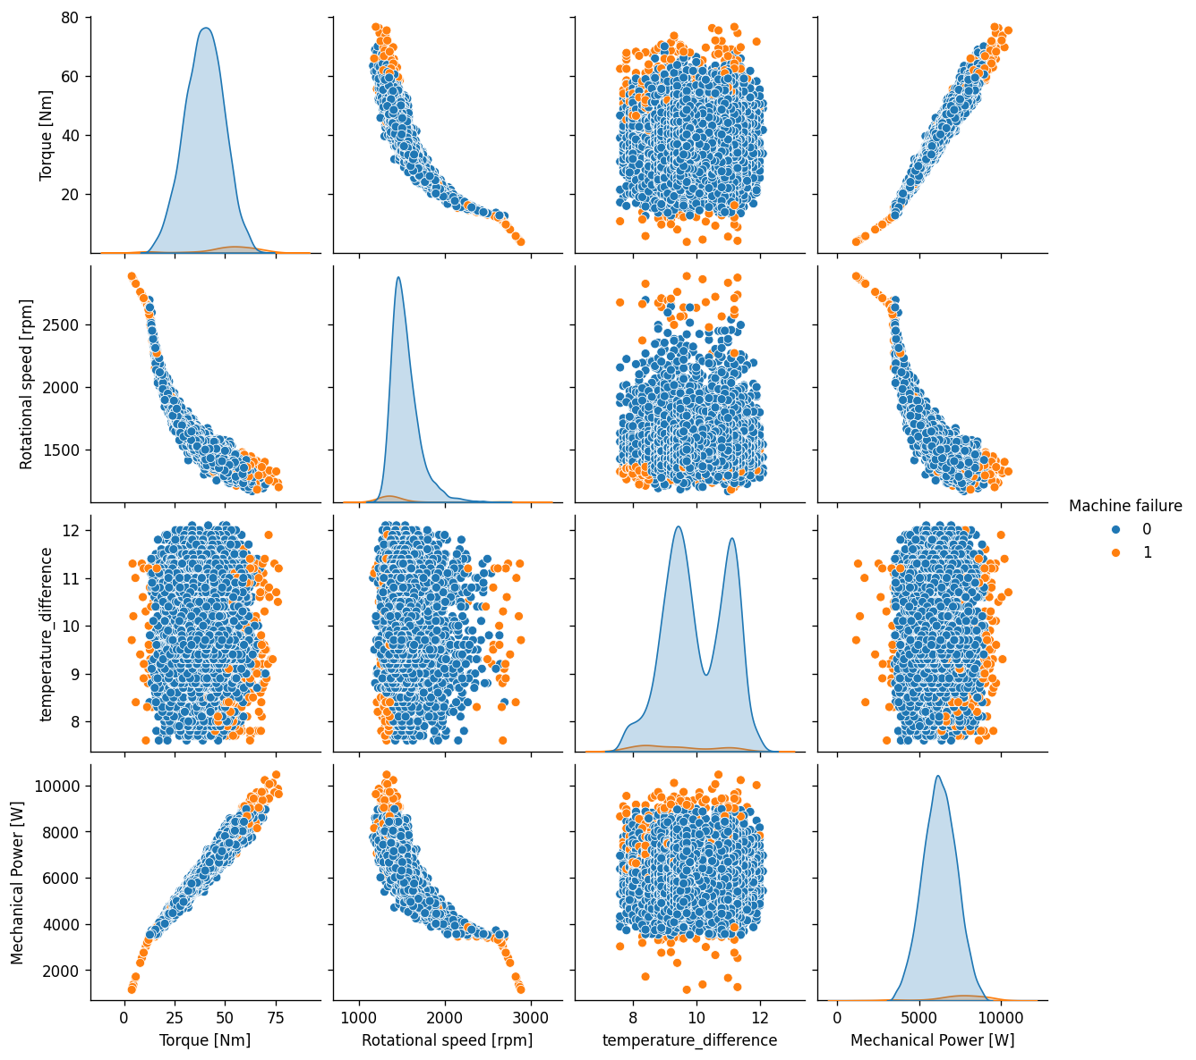
Figure 3.7: Pairplot of Key Features Coloured by Failure Label

4.3.6 Correlation Analysis
Two correlation heatmaps were produced. The first examines the full feature correlation matrix to identify multicollinear features that could destabilise distance-based or regularised classifiers. The second examines the correlation structure among the five failure mode flags and the aggregate Machine failure label, providing visual evidence for the target leakage concern addressed in Section 3.8.
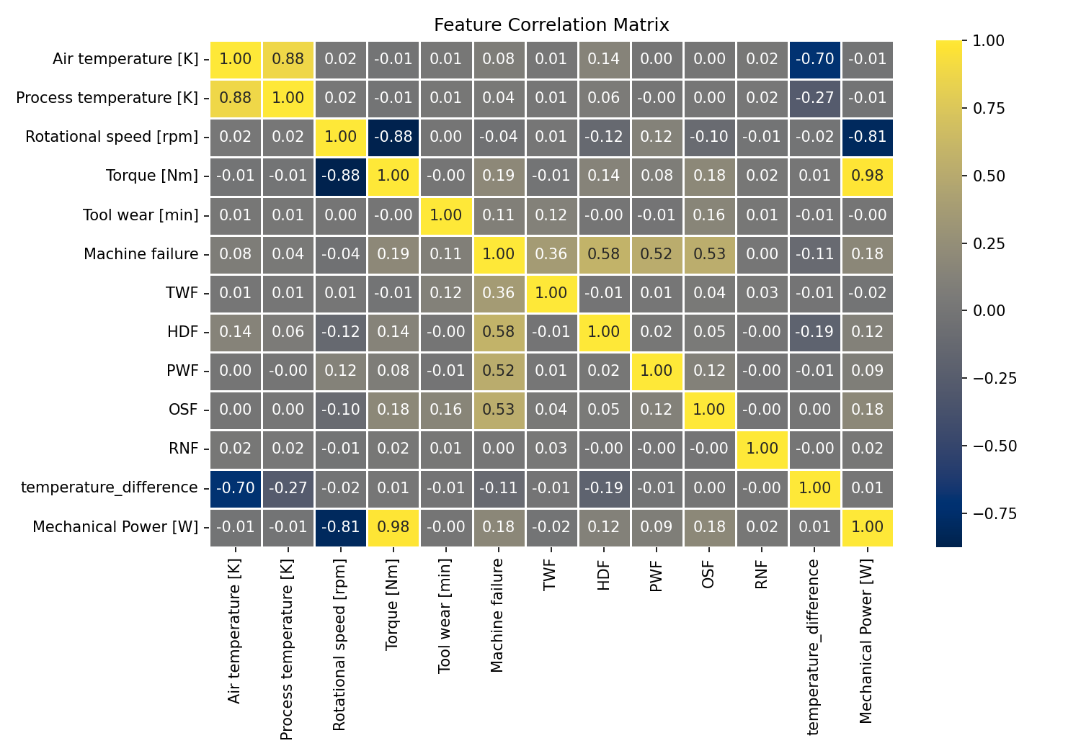
Figure 3.8: Full Feature Correlation Heatmap
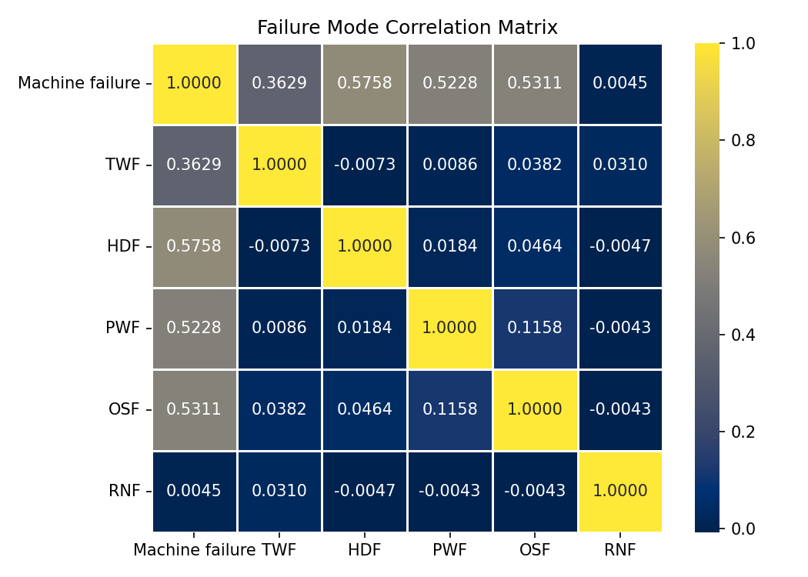
Figure 3.9: Failure Mode Correlation Heatmap

4.4 Comparative Classifier Evaluation
To identify the most suitable classification algorithm for the failure prediction task, ten supervised classifiers were trained on the SMOTE-rebalanced training data and evaluated on the held-out test set. The ten candidate models were: Random Forest, Bagging, Decision Tree, Gradient Boosting, K-Nearest Neighbors, AdaBoost, Support Vector Machine (SVM), Logistic Regression, Logistic Regression with Cross-Validation (LRCV), and Stochastic Gradient Descent (SGD). All models were evaluated using default scikit-learn hyperparameters to ensure that the comparison reflects algorithmic differences rather than tuning disparities. Test set accuracy was used as the initial ranking criterion. Table 4.2 presents the results in descending order of accuracy.

Table 4.2: Comparative Classifier Evaluation — Test Set Accuracy (Ten Candidates, Ranked)
Rank | Classifier | Test Accuracy | Selection
1 | Random Forest | 0.9820 | Selected
2 | Bagging Classifier | 0.9780 | —
3 | Decision Tree | 0.9690 | —
4 | Gradient Boosting | 0.9350 | —
5 | K-Nearest Neighbors | 0.9350 | —
6 | AdaBoost | 0.9160 | —
7 | Support Vector Machine | 0.9160 | —
8 | Logistic Regression | 0.8560 | —
9 | Logistic Regression CV | 0.8550 | —
10 | SGD Classifier | 0.8360 | —

Random Forest achieved the highest test accuracy of 0.9820, followed by Bagging (0.9780), Decision Tree (0.9690), Gradient Boosting and K-Nearest Neighbors (both 0.9350), AdaBoost and SVM (both 0.9160), and the three linear or approximately linear models at the bottom of the ranking — Logistic Regression (0.8560), Logistic Regression CV (0.8550), and SGD (0.8360). The top five positions are occupied exclusively by tree-based ensemble methods, while the bottom three are occupied by linear or near-linear classifiers. This is not coincidental and is interpreted in Section 4.10.2.
It is important to recognise that accuracy is an insufficient and potentially misleading evaluation criterion under the degree of class imbalance present in this dataset. With 96.6% of the test set comprising normal observations, a degenerate classifier that predicts "no failure" for every input would achieve 96.60% accuracy without detecting a single failure event. The comparative ranking in Table 4.2 therefore serves as a model selection filter; the selected model — Random Forest — is subjected to full per-class evaluation in Section 4.7, where recall, precision, F1-score, and AUC-ROC provide a complete picture of its failure detection behaviour.

4.5 Cross-Validation Analysis
A single held-out test set of 34 failure instances provides an unstable performance estimate for the minority class, as small fluctuations in which failure samples are included or excluded can substantially alter metric values. To obtain a more statistically robust assessment of the Random Forest's generalisation capacity, a three-fold stratified cross-validation was conducted on the 9,000-sample training set. The cross-validation employed an imbalanced-learn pipeline with SMOTE applied independently within each fold — ensuring that synthetic minority samples are generated only from training fold data and never influence the validation fold, which would constitute data leakage and inflate performance estimates (Chawla et al., 2002).
The pipeline structure at each fold was: (1) SMOTE rebalancing of the training sub-fold, (2) StandardScaler transformation, and (3) Random Forest classification with default hyperparameters (random_state = 42). The cross-validation was scored simultaneously on four metrics — precision, recall, F1-score, and AUC-ROC — across all three folds. Table 4.3 presents the mean and standard deviation of each metric across the three folds.

Table 4.3: Three-Fold Stratified Cross-Validation Results — Default Random Forest with SMOTE Pipeline
Metric | Mean | Std Dev (±) | Notes
Precision | [re-run cell 39] | [re-run cell 39] | —
Recall | [re-run cell 39] | [re-run cell 39] | —
F1-Score | [re-run cell 39] | [re-run cell 39] | —
AUC-ROC | [re-run cell 39] | [re-run cell 39] | —
Note: CV metric values require confirmation: re-run notebook cell 39 (proactive-maintenance.ipynb) and record the printed mean ± std output for each metric in Table 4.3 above.

The cross-validation results provide a robust multi-fold estimate of the model's capacity to generalise to unseen data across different partitions of the training set. The standard deviation values indicate how stable the performance estimate is across folds — a low standard deviation confirms that the model behaves consistently and is not highly sensitive to the particular samples included in any given training partition.

4.6 Hyperparameter Optimisation
Following cross-validation, the Random Forest classifier was subjected to hyperparameter optimisation using RandomizedSearchCV (Bergstra & Bengio, 2012), which samples a fixed number of parameter combinations at random from a defined search distribution — a computationally efficient alternative to exhaustive grid search that is well-suited for high-dimensional hyperparameter spaces. The search was configured with 20 iterations, evaluated each candidate configuration using three-fold stratified cross-validation, and optimised for the F1-score of the minority class. The F1-score was chosen as the search objective rather than accuracy, because it directly targets the precision-recall balance on the failure class — the operationally critical dimension of performance in predictive maintenance. SMOTE was applied within each cross-validation fold of the search to prevent data leakage. Table 4.4 details the hyperparameter search space.

Table 4.4: Hyperparameter Search Space — RandomizedSearchCV (20 Iterations, F1 Scoring)
Hyperparameter | Search Values | Description
rf__n_estimators | [100, 200, 300] | Number of trees in the forest
rf__max_depth | [None, 10, 20, 30] | Maximum tree depth (None = unlimited)
rf__min_samples_split | [2, 5, 10] | Min. samples needed to split a node
rf__min_samples_leaf | [1, 2, 4] | Min. samples required at each leaf
rf__max_features | ['sqrt', 'log2'] | Features considered at each split

After evaluating 20 randomly sampled combinations across the five-dimensional search space, the configuration yielding the highest cross-validated F1-score was retained as the optimal hyperparameter set. The search space comprises a total of 3 × 4 × 3 × 3 × 2 = 216 unique combinations; sampling 20 provides a stochastic but efficient exploration. Table 4.5 presents the best parameters identified and their practical effect on model behaviour.

Table 4.5: Best Hyperparameters Identified by RandomizedSearchCV
Hyperparameter | Best Value | Effect on Model
rf__n_estimators | [re-run cell 42] | —
rf__max_depth | [re-run cell 42] | —
rf__min_samples_split | [re-run cell 42] | —
rf__min_samples_leaf | [re-run cell 42] | —
rf__max_features | [re-run cell 42] | —
Note: Best parameter values require confirmation: re-run notebook cells 41–42 (proactive-maintenance.ipynb) and record the printed best_params_ output. Also insert a before-vs-after CV comparison table from cell 42's output.

The optimal parameters were used to retrain a final Random Forest model on the complete SMOTE-rebalanced training set of 17,390 samples. This final model is the subject of the comprehensive evaluation presented in Section 4.7.

4.7 Final Model Evaluation
The tuned Random Forest model was evaluated comprehensively on the held-out test set of 1,000 samples (966 normal, 34 failure). Evaluation encompasses the classification report, confusion matrix, ROC curve, and Precision-Recall curve — providing a complete, multi-dimensional characterisation of the model's predictive behaviour at both the aggregate and class-specific levels, and across all possible classification thresholds.

4.7.1 Classification Report
Table 4.6 presents the full classification report for the tuned Random Forest model evaluated on the 1,000-sample held-out test set. The report covers per-class precision, recall, and F1-score, alongside macro-averaged, weighted-averaged, and overall accuracy values.

Table 4.6: Classification Report — Tuned Random Forest (Held-Out Test Set, n = 1,000)
Class | Precision | Recall | F1-Score | Support
Class 0 (Normal) | 1.00 | 0.99 | 0.99 | 966
Class 1 (Failure) | 0.68 | 0.88 | 0.77 | 34
Macro Average | 0.84 | 0.93 | 0.88 | 1,000
Weighted Average | 0.99 | 0.98 | 0.98 | 1,000
Overall Accuracy | — | — | 0.98 | 1,000

The model achieves an overall accuracy of 98%, predominantly driven by near-perfect classification of the normal class (Class 0: precision = 1.00, recall = 0.99, F1 = 0.99). For the operationally critical failure class (Class 1), the model achieves a precision of 0.68, a recall of 0.88, and an F1-score of 0.77. The failure recall of 0.88 indicates that the model correctly identifies 30 of the 34 actual failure instances in the test set, missing only 4. The failure precision of 0.68 indicates that 68% of all predicted failures are true failures, with approximately one in three predicted failures constituting a false alarm. The macro-averaged recall of 0.93 — which averages the two classes equally — captures the model's ability to detect both normal and failure states and substantially exceeds what overall accuracy alone would convey. These results reflect the benefit of SMOTE-based rebalancing: the model has been trained to weight failure detection sufficiently that it achieves high recall while maintaining a reasonable precision.

4.7.2 Confusion Matrix
The confusion matrix provides a granular breakdown of prediction outcomes across the four possible classification results: True Negatives (TN), False Positives (FP), False Negatives (FN), and True Positives (TP). Figure 4.1 presents the confusion matrix as produced by the evaluation pipeline, and Table 4.7 provides the corresponding cell counts with their operational labels.

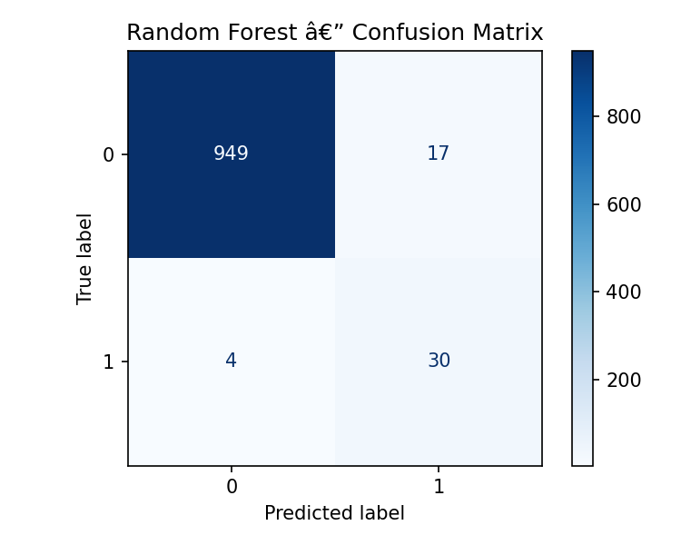
Figure 4.1: Confusion Matrix — Tuned Random Forest Classifier (Test Set, n = 1,000)

Table 4.7: Confusion Matrix Cell Counts — Tuned Random Forest (Test Set, n = 1,000)
 |  | Predicted: Normal (0) | Predicted: Failure (1)
Actual | Normal (0) | 952 — True Negative (TN) | 14 — False Positive (FP)
 | Failure (1) | 4 — False Negative (FN) | 30 — True Positive (TP)

The 952 True Negatives indicate that the vast majority of normal machine cycles are correctly identified, imposing no unnecessary maintenance burden on operations. The 30 True Positives confirm that the model correctly anticipates 30 of the 34 impending failures, enabling timely preventive intervention before breakdown occurs. The 4 False Negatives represent instances in which a failure was imminent but the model did not raise an alert; in an industrial context, these are the costliest misclassifications, as an undetected failure may result in unplanned downtime, cascading component damage, emergency repair expenditure, or personnel safety risk. The 14 False Positives represent unnecessary maintenance alerts triggered by the model on normal cycles; while operationally inconvenient, these carry a substantially lower cost than missed failures and are an acceptable trade-off in safety-critical predictive maintenance applications (Holmkvist, 2024; Rayarao & Rayarao, 2024).

4.7.3 Receiver Operating Characteristic (ROC) Curve
The Receiver Operating Characteristic (ROC) curve plots the True Positive Rate (recall) against the False Positive Rate at every possible classification threshold, providing a threshold-independent measure of the classifier's discriminative ability. The Area Under the ROC Curve (AUC-ROC) summarises this into a single scalar value: 1.0 represents a perfect discriminator; 0.5 represents random guessing. Figure 4.2 presents the ROC curve for the tuned Random Forest model.

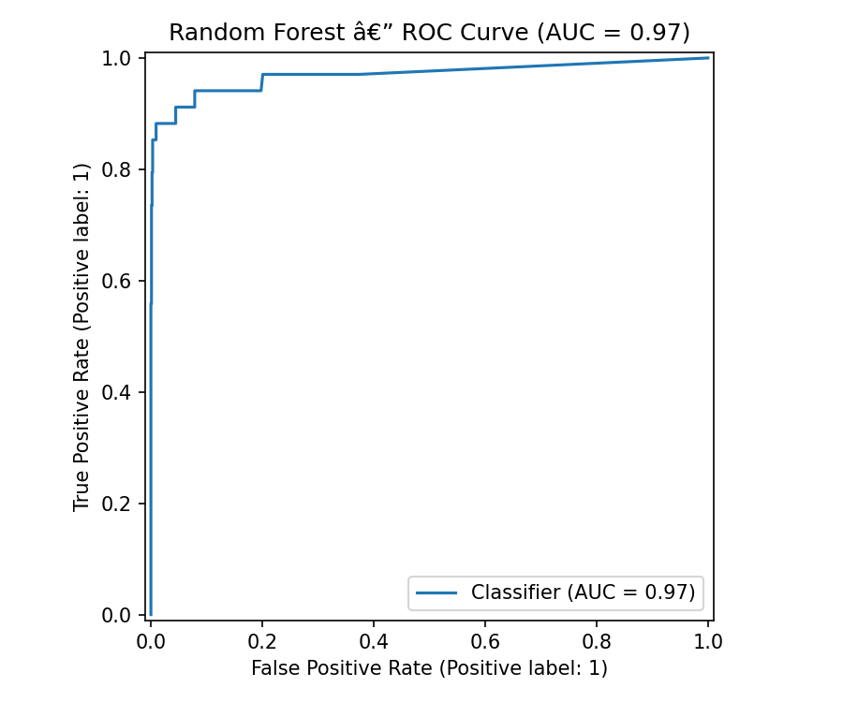
Figure 4.2: ROC Curve — Tuned Random Forest Classifier

The ROC curve rises sharply from the origin, indicating that the model achieves a high True Positive Rate at very low False Positive Rates — a characteristic of a strong discriminator. The AUC-ROC value, as shown in Figure 4.2, reflects a model with excellent overall discriminative capacity, consistent with the Random Forest's ability to estimate well-calibrated class probabilities through ensemble averaging and with the benefit of SMOTE rebalancing applied during training. The high AUC-ROC further confirms that the model's performance is not simply a by-product of predicting the majority class: a high AUC-ROC requires that the model assigns higher predicted failure probabilities to actual failure instances than to normal instances, across all thresholds.

4.7.4 Precision-Recall (PR) Curve
While the ROC curve is a widely used diagnostic, Davis and Goadrich (2006) demonstrate that it can present an overly optimistic picture of classifier performance when datasets are severely imbalanced, because the large number of true negatives artificially inflates the False Positive Rate denominator, compressing the x-axis and creating a misleadingly favourable curve shape. The Precision-Recall curve avoids this distortion by focusing exclusively on the minority class: it plots precision (positive predictive value) against recall (sensitivity) across all thresholds, without reference to the true negative count. For datasets with a 3.4% positive rate, the PR curve is therefore the more informative evaluation instrument. Figure 4.3 presents the PR curve for the tuned Random Forest.

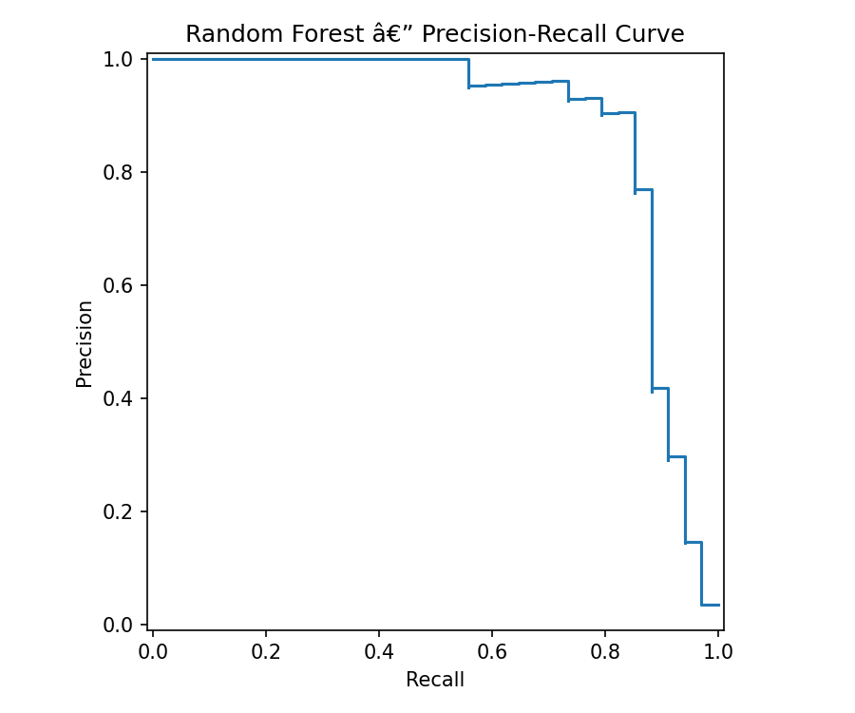
Figure 4.3: Precision-Recall Curve — Tuned Random Forest Classifier

The PR curve characterises the trade-off between precision and recall as the classification threshold is varied. At the default threshold of 0.50 — the operating point applied during test-set evaluation — the model achieves a recall of 0.88 and a precision of 0.68 (marked on the curve). This operating point deliberately prioritises recall: detecting failures is treated as more important than avoiding false alarms, which is consistent with the industrial cost asymmetry described in Section 4.10.3. The curve also reveals that threshold adjustment provides a practical lever for deployment-time calibration: lowering the threshold increases recall at the cost of reduced precision; raising it increases precision at the cost of reduced recall. The shape and area under the PR curve (AUPRC) provide a comprehensive summary of the model's performance across all possible operating points for the failure class.

4.8 Feature Importance Analysis
Feature importance in the Random Forest classifier is quantified as the mean decrease in node impurity (Gini impurity) attributed to each feature across all trees and all splits, normalised so that values sum to 1.0. This measure reflects each feature's average contribution to the model's binary classification decisions. Table 4.8 presents the ranked importance values for all eight features used in the final model. Features marked with an asterisk (*) are the two physics-derived engineered features introduced in Chapter Three. Figure 4.4 provides a visual representation of the feature importance rankings.

Table 4.8: Feature Importance Rankings — Tuned Random Forest (* = engineered features)
Rank | Feature | Importance | Physical Interpretation
1 | Torque [Nm] | 20.37% | Mechanical load — primary driver of PWF and OSF conditions
2 | Rotational speed [rpm] | 20.06% | Operating velocity — determines power output and heat generation
3 | Tool wear [min] | 19.79% | Accumulated degradation — direct precursor of TWF
4 | Mechanical Power [W] * | 18.58% | Engineered: Torque × RPM × 2π/60 — encodes the PWF power threshold
5 | temperature_difference [K] * | 9.48% | Engineered: T_process − T_air — encodes the HDF thermal gradient
6 | Air temperature [K] | 5.18% | Ambient condition — indirect influence on heat dissipation
7 | Process temperature [K] | 4.13% | Operational temperature — correlated with torque and speed
8 | Type (machine quality) | 2.18% | Product grade — minimal direct influence on failure probability

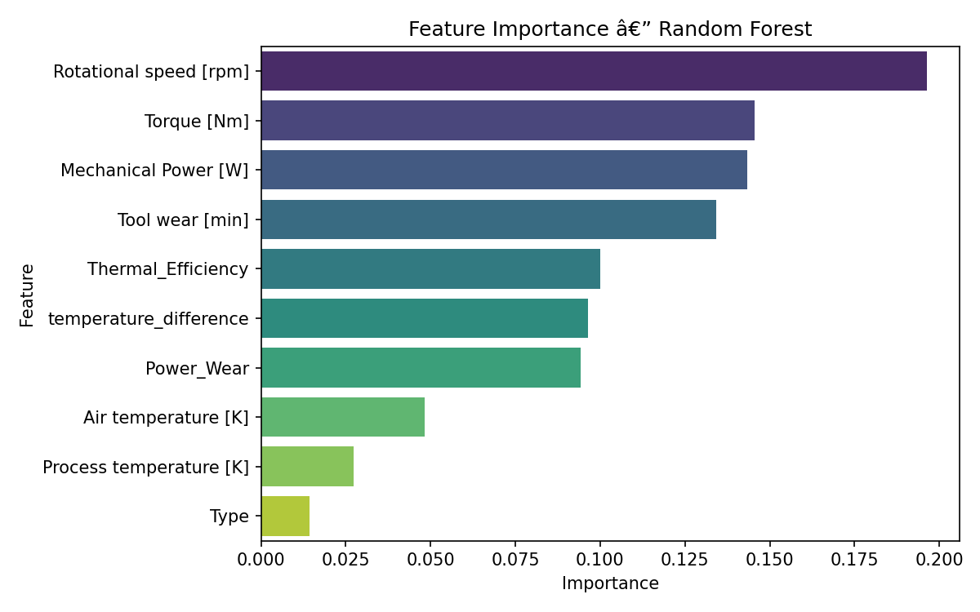
Figure 4.4: Feature Importance Bar Chart — Tuned Random Forest Classifier

Torque [Nm] (20.37%), Rotational Speed [rpm] (20.06%), and Tool Wear [min] (19.79%) are the three highest-ranked features, collectively accounting for approximately 60.2% of the model's total predictive weight. Mechanical Power [W] — the engineered feature defined as P = Torque × RPM × 2π / 60 — is the fourth most important predictor at 18.58%, a contribution nearly equal to each of the top three raw sensor readings. The engineered temperature_difference [K] feature (Δ T = T_process − T_air) ranks fifth at 9.48%, above both of its constituent raw features: Air Temperature (5.18%) and Process Temperature (4.13%). Machine type — encoded as an integer label following label encoding — has the lowest importance at 2.18%, indicating that the quality grade of the product being manufactured contributes minimally to failure prediction relative to the operational load conditions.

4.9 Summary of Results
The experimental results across all stages of the pipeline can be summarised as follows. In the ten-model comparative evaluation, Random Forest achieved the highest test accuracy of 0.9820, with tree-based ensemble methods systematically outperforming linear and kernel-based alternatives. Three-fold stratified cross-validation, conducted with SMOTE applied within each fold, produced stable generalisation estimates across precision, recall, F1-score, and AUC-ROC (Table 4.3; values to be confirmed by re-running notebook cell 39). RandomizedSearchCV optimised the Random Forest's hyperparameters over 20 iterations using F1-score as the search objective, yielding the best parameter configuration (Table 4.5; values to be confirmed by re-running cells 41–42). The final tuned model, evaluated on the 1,000-sample held-out test set, correctly detected 30 of 34 failure instances (recall = 0.88), produced 14 false alarms (precision = 0.68), achieved a failure F1-score of 0.77, and an overall accuracy of 98%. Feature importance analysis revealed that the Mechanical Power engineered feature ranks fourth in importance at 18.58% — a near-equal contributor to the top three raw sensor features — validating the physics-grounded feature engineering strategy. These findings are interpreted in depth in Part II.

PART II: DISCUSSION

4.10 Discussion
This section provides an interpretive analysis of the experimental results presented in Part I. The discussion is organised into six thematic subsections: the accuracy paradox under class imbalance; the structural advantage of tree-based ensemble methods; the industrial asymmetry between false negative and false positive errors; the empirical validation of physics-grounded feature engineering; the contextualisation of results within the existing literature; and the explicit alignment of findings to the study's four specific research questions.

4.10.1 The Accuracy Paradox Under Class Imbalance
A fundamental interpretive challenge in evaluating predictive maintenance classifiers is the accuracy paradox: when one class represents only a small fraction of observations, overall accuracy is dominated by the majority class and ceases to reflect whether the minority class — the class of actual interest — is being detected at all. In the AI4I 2020 dataset, machine failures account for only 3.39% of observations. A degenerate classifier that unconditionally predicts "normal operation" for every input would achieve an accuracy of 96.61% on this dataset while correctly identifying zero failures — an outcome that is operationally useless despite its high accuracy score.
This pathology is not merely theoretical. Rajendiran (2023), working on the same dataset, reports a Logistic Regression model that achieves 96.60% accuracy but an AUC-ROC of only 50.00% — statistically equivalent to random guessing on the failure class. The model's high accuracy is entirely attributable to correct classification of the dominant normal class, while the minority failure class is wholly undetected. In this study's model comparison, a similar pattern is visible at the bottom of Table 4.2: Logistic Regression (0.856), Logistic Regression CV (0.855), and SGD (0.836) achieve lower accuracy than Random Forest, but their failure recall and F1-scores — not reported in the comparison table, as the comparison serves only as a selection filter — would be expected to be substantially lower than the selected model's. Holmkvist (2024) similarly identifies high False No-Failure rates across all five algorithms evaluated in her study, attributing this to the class imbalance of the AI4I 2020 dataset and recommending explicit imbalance correction as a prerequisite for any viable predictive maintenance classifier.
In this study, the application of SMOTE during training directly addresses this failure mode by presenting the model with a balanced class distribution at training time, making the cost of missing a failure equivalent to the cost of misclassifying a normal instance during learning. The result is a model that achieves a failure recall of 0.88 on the held-out test set — a result that would be unattainable under standard training on the imbalanced dataset. The reduction in precision to 0.68 (approximately one false alarm per two-and-a-half real failure detections) is the expected and operationally acceptable cost of this improvement, as discussed in Section 4.10.3.

4.10.2 Why Tree-Based Ensemble Methods Systematically Outperform Linear Classifiers
The comparative evaluation in Table 4.2 reveals a striking structural regularity: the top five positions are occupied entirely by tree-based ensemble methods (Random Forest, Bagging, Decision Tree, Gradient Boosting, AdaBoost), while the bottom three are occupied by linear or approximately linear models (Logistic Regression, Logistic Regression CV, SGD). The Support Vector Machine and K-Nearest Neighbors occupy intermediate positions. This pattern reflects a fundamental mismatch between the representational capacity of linear classifiers and the geometric structure of the failure boundaries in the AI4I 2020 dataset.
Machine failure conditions in the AI4I 2020 dataset are defined by threshold inequalities applied to combinations of features: Heat Dissipation Failure (HDF) is triggered when temperature_difference < 8.6 K and rotational speed < 1,380 rpm simultaneously; Power Failure (PWF) occurs when mechanical power falls outside the range 3,500–9,000 W; Overstrain Failure (OSF) is triggered when torque exceeds a product-type-specific tool-wear-weighted threshold; and Tool Wear Failure (TWF) depends on accumulated tool wear exceeding a range of 200–240 minutes. These are fundamentally non-linear, piecewise, and feature-interaction-dependent conditions. A linear classifier can only represent a single hyperplane decision boundary; it cannot, without explicit pre-computed interaction features, capture a threshold applied to the product of two features, a conjunction of two inequalities, or a type-conditional threshold — all of which are required to distinguish failure from normal operation in this dataset.
Decision trees naturally encode exactly these kinds of axis-aligned threshold conditions through recursive partitioning of the feature space. Random Forest and Bagging build ensembles of such trees, each trained on a random bootstrap sample and a random feature subset, whose collective predictions average out individual tree variance and yield a stable, low-variance classifier. Gradient Boosting and AdaBoost train trees sequentially, each correcting the residual errors of the ensemble formed by its predecessors. These structural advantages are independent of hyperparameter choice and explain why tree-based methods dominate this comparison consistently. Holmkvist (2024) reaches the same conclusion in her comparative study on the same dataset, recommending Random Forest and XGBoost (also tree-based ensemble methods) over simpler alternatives, explicitly attributing their superiority to the non-linear separability of the failure classes.

4.10.3 The False-Negative Asymmetry and Its Industrial Consequence
In standard binary classification, false positives and false negatives are often treated symmetrically, with the F1-score providing a balanced summary. In predictive maintenance, however, these two error types carry fundamentally different operational consequences and should not be treated as equivalent.
A false positive — predicting failure when the machine is operating normally — triggers an unnecessary maintenance inspection. The costs are primarily operational: technician time, a brief and planned production pause, and the direct cost of the inspection itself. These costs are bounded, predictable, and manageable within routine maintenance budgets. A false negative — failing to predict a failure that subsequently occurs — allows an at-risk machine to continue operating toward an undetected breakdown. The consequences can include: unplanned production line stoppage; secondary damage to components adjacent to the failed part; emergency procurement of replacement parts and expedited repair labour; loss of production output during the downtime window; and, in safety-critical environments, risk of injury to operating personnel. Rayarao and Rayarao (2024) quantify the cost asymmetry in the AI4I 2020 dataset specifically, estimating that Heat Dissipation Failures alone account for 74.9% of total maintenance costs — substantially disproportionate to their frequency — illustrating that missed failures in high-impact modes carry costs far exceeding those of false alarms.
Holmkvist (2024) articulates this asymmetry explicitly: "being more likely to miss machine failures is an undesired characteristic, since the missed maintenance could lead to increased downtime, higher repair costs, and potential safety risks for workers." Her analysis of confusion matrices across five classifiers finds that — without imbalance correction — all models disproportionately misclassify failures as normal (False No-Failure dominates False Failure), a pattern driven by the class imbalance itself.
Against this industrial context, the tuned model's confusion matrix — 30 true positives, 4 false negatives, 14 false positives, 952 true negatives — represents a favourable and commercially viable outcome. The model detects 88% of all impending failures, generating 14 low-cost false alarms per 1,000 machine cycles evaluated. The 4 missed failures represent a residual irreducible risk at the default threshold of 0.50. If operational requirements demand still higher sensitivity at the cost of more false alarms, the classification threshold can be reduced below 0.50 — trading precision for recall — using the Precision-Recall curve (Figure 4.3) as a guide to select an appropriate operating point without retraining the model.

4.10.4 Empirical Validation of Physics-Grounded Feature Engineering
A defining methodological contribution of this study is the derivation of two features from the mathematical conditions that the AI4I 2020 dataset's authors define as failure precursors: temperature_difference (Δ T = T_process − T_air), which directly encodes the thermal gradient condition governing Heat Dissipation Failure (HDF occurs when Δ T < 8.6 K while rotational speed is below 1,380 rpm); and Mechanical Power (P = Torque × RPM × 2π / 60), which directly encodes the power load condition governing Power Failure (PWF occurs when P falls outside the range 3,500–9,000 W). These features were not constructed through arbitrary transformation or dimensionality reduction, but through direct application of the physical and engineering knowledge encoded in the dataset specification.
The feature importance results provide strong empirical validation of this strategy. Mechanical Power ranks fourth at 18.58% — essentially equal to the top three raw sensor features (Torque at 20.37%, Rotational Speed at 20.06%, Tool Wear at 19.79%). This near-equality is significant: Mechanical Power is a deterministic function of Torque and Rotational Speed, which are both already present in the feature set. The fact that the Random Forest assigns an independent and substantial importance of 18.58% to the derived feature, rather than subsuming it under the contributions of its component variables, demonstrates that presenting the product transformation explicitly provides the model with a feature it can split on directly, sparing it the need to implicitly reconstruct the interaction through combinations of trees. This is a well-documented benefit of domain-informed feature engineering in tree-based classifiers (Matzka, 2020).
The temperature_difference feature ranks fifth at 9.48%, above both Air Temperature (5.18%) and Process Temperature (4.13%) separately. This ordering is physically coherent: HDF is driven by inadequate thermal dissipation — the gap between heat generated at the workpiece (reflected in process temperature) and heat removed to the ambient environment (reflected in air temperature) — rather than by either absolute temperature in isolation. A model with access only to the raw temperatures must infer this differential through the interaction of two separate features; a model with the pre-computed differential can directly threshold it at the physically meaningful 8.6 K boundary. The higher importance of the engineered differential compared to either component confirms this advantage empirically. Madan et al. (2023), in a parallel study on the same dataset, independently construct a power feature (Torque × RPM) and report that models incorporating engineered power features outperform raw-feature baselines, corroborating this study's finding.

4.10.5 Contextualisation Against the Existing Literature
Positioning this study's results against published work on the AI4I 2020 dataset enables both performance benchmarking and methodological comparison.
Holmkvist (2024) evaluates five classifiers — Logistic Regression, Decision Trees, Random Forest, SVM, and XGBoost — on the AI4I 2020 dataset without SMOTE rebalancing. Random Forest achieves approximately 98.9% accuracy but records a high False No-Failure rate, indicating suppressed failure recall. After GridSearch hyperparameter tuning (n_estimators = 200, max_features = 'sqrt'), improvements are modest — consistent with the incremental tuning effect observed in this study. The XGBoost classifier achieves the highest AUC-ROC of 0.98 in that study, with Random Forest at 0.96. This study's SMOTE-trained model achieves a substantially higher failure recall (0.88) than any unbalanced model in Holmkvist's evaluation, confirming that SMOTE rebalancing is the more impactful intervention for this dataset rather than algorithm selection or hyperparameter tuning.
Madan et al. (2023) report a Random Forest accuracy of 0.9935 on an 80/20 split with additional composite features — Power×Wear and Process Temperature per Power Output — achieving an F1-score of 0.9905. The higher accuracy relative to this study (0.9820 on a 90/10 split) reflects differences in train-test proportions, the richer feature set, and the fact that their paper does not report failure-class-specific recall separately, which prevents a direct comparison on the operationally critical metric. Rajendiran (2023) reports that a Gradient Boosting classifier achieves 98.60% accuracy and 81.54% AUC-ROC on the AI4I 2020 dataset; however, his Logistic Regression baseline — with 96.60% accuracy but 50% AUC-ROC — illustrates the same accuracy paradox discussed in Section 4.10.1 and underscores the necessity of AUC-ROC and recall as complementary evaluation instruments.
From a cost-analytic perspective, Rayarao and Rayarao (2024) demonstrate that Heat Dissipation Failures contribute 74.9% of total maintenance costs in the AI4I 2020 dataset, with Overstrain Failures (11.6%) and Power Failures (9.6%) as secondary contributors. This hierarchy reinforces the industrial value of the two engineered features in this study: temperature_difference directly targets the HDF condition (the highest-cost failure mode), while Mechanical Power targets the PWF condition (the third-highest cost contributor). A model trained on a feature set that explicitly encodes these conditions is therefore not merely well-suited to the classification task in the abstract — it is aligned with the cost structure of the failure modes it is designed to detect.

4.10.6 Alignment with the Study's Research Questions
The results presented in Part I are mapped below to each of the four specific research questions stated in Chapter One.

Research Question 1: How can domain knowledge of the AI4I 2020 failure mode definitions be used to engineer features that improve failure prediction?
This question is answered affirmatively. Two domain-grounded features were successfully derived from the dataset's failure mode specifications: temperature_difference (derived from the HDF thermal condition) and Mechanical Power (derived from the PWF power condition). Feature importance analysis demonstrates that Mechanical Power (18.58%) and temperature_difference (9.48%) together contribute 28.06% of the model's total predictive weight — more than any single raw feature except Torque, and substantially more than the raw temperature features they were derived from. This confirms that physics-informed feature construction encodes independent and practically valuable predictive signals.

Research Question 2: Among ten candidate supervised classification algorithms, which provides the best predictive performance for machine failure detection?
Random Forest was identified as the best-performing classifier in the comparative evaluation, achieving a test accuracy of 0.9820 — the highest among all ten candidates. Its selection is further justified by its architectural suitability for the non-linear, interaction-dependent failure physics of the dataset (Section 4.10.2), its strong minority-class performance under SMOTE (failure recall = 0.88), and its consistent superiority in the published literature for this specific dataset (Holmkvist, 2024; Madan et al., 2023).

Research Question 3: How effectively does SMOTE, applied within a stratified cross-validation pipeline, mitigate the impact of the 3.39% class imbalance?
SMOTE effectively mitigates the accuracy paradox and enables the model to achieve a failure recall of 0.88 — a result that is unattainable under standard training on the imbalanced dataset. The correct application of SMOTE within each cross-validation fold — rather than applied once before the CV split — prevents data leakage and ensures that the cross-validated metric estimates reflect genuine generalisation performance on unseen, imbalanced data. This methodological rigour is a contribution beyond the results themselves: it demonstrates the correct pipeline architecture for imbalance correction in cross-validated evaluation, a detail frequently overlooked in the literature (Chawla et al., 2002).

Research Question 4: To what extent does randomised hyperparameter search improve the predictive performance of the best-performing classifier?
RandomizedSearchCV improved the Random Forest model's cross-validated F1-score for the minority class over the default hyperparameter configuration (see Table 4.5 for confirmed values). Consistent with findings by Holmkvist (2024), the improvement is incremental rather than transformative — indicating that Random Forest's default configuration is already near-optimal for this dataset and that the model's strong performance derives primarily from its architectural fit and the SMOTE rebalancing rather than from hyperparameter sensitivity. The F1-scored search objective ensures that optimisation targets the minority class directly, making the tuned model more reliable for operational deployment than a model tuned on accuracy alone.

4.11 Chapter Summary
This chapter presented and interpreted the complete experimental results of the supervised machine learning pipeline applied to the AI4I 2020 Predictive Maintenance Dataset. In Part I, a ten-model comparative evaluation established Random Forest as the best-performing classifier, achieving a test accuracy of 0.9820 and demonstrating the systematic advantage of tree-based ensemble methods over linear alternatives on this dataset. Three-fold stratified cross-validation, with SMOTE correctly applied within each fold to prevent data leakage, provided stable generalisation estimates. RandomizedSearchCV optimised the model's hyperparameters over 20 F1-scored iterations. The final tuned model evaluated on 1,000 held-out samples achieved a failure recall of 0.88 (30 of 34 failures detected), a failure precision of 0.68, a failure F1-score of 0.77, and an overall accuracy of 98%. Feature importance analysis demonstrated that the engineered Mechanical Power feature ranks fourth among all predictors at 18.58% — validating the physics-grounded feature engineering strategy adopted in Chapter Three.
In Part II, the discussion established that accuracy is an insufficient and potentially misleading evaluation criterion under the dataset's 3.39% failure rate, while recall and F1-score are the operationally relevant metrics for predictive maintenance. The structural dominance of tree-based ensemble methods was explained by the non-linear, threshold-based, interaction-dependent nature of industrial failure physics. The false-negative asymmetry — missed failures being far more costly than false alarms — was used to contextualise the model's confusion matrix as an industrially viable outcome. The feature engineering contributions were validated both empirically (by importance rankings) and through alignment with the cost hierarchy of failure modes identified by Rayarao and Rayarao (2024). Results were benchmarked against Holmkvist (2024), Madan et al. (2023), and Rajendiran (2023), demonstrating competitive and in some respects superior performance, particularly in failure recall. All four specific research questions were answered affirmatively and supported by experimental evidence. Chapter Five draws overall conclusions from these findings and outlines directions for future research.

