**Index Page**

As soon as you enter the 1st page you will see the following page.

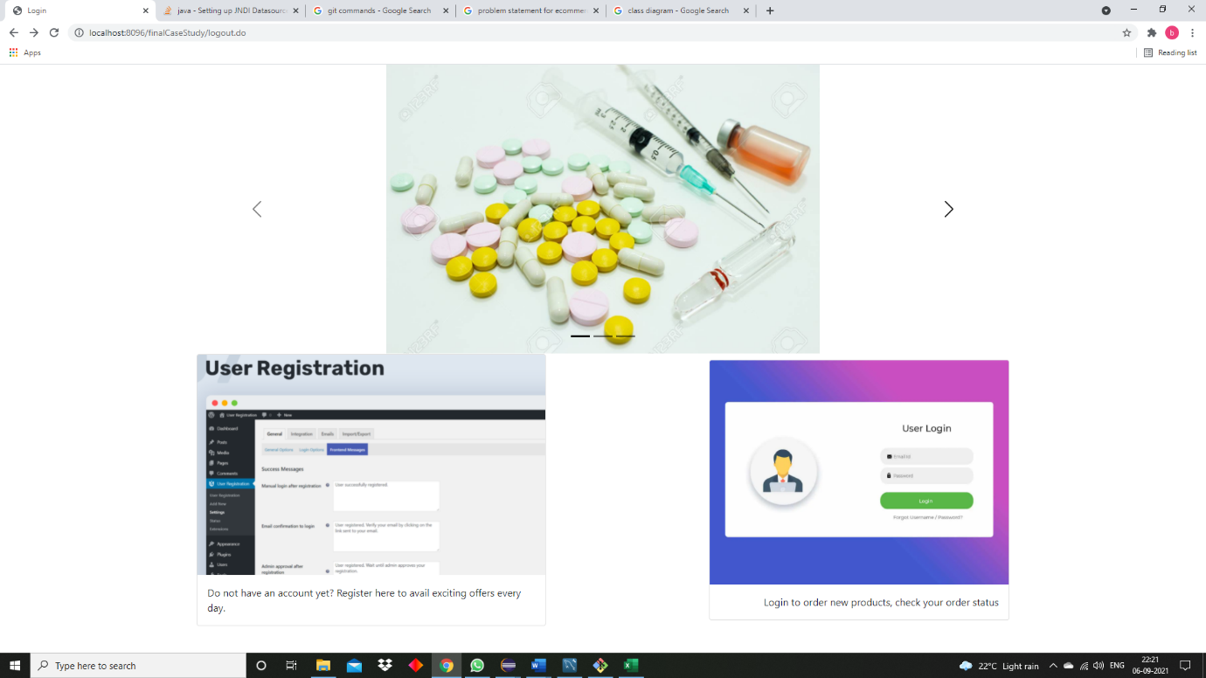

You can perform two operations in the index page.

1)Register

2)Login

**Register**

When you click on the image which says User Registration you will be redirected to a page which looks like this.

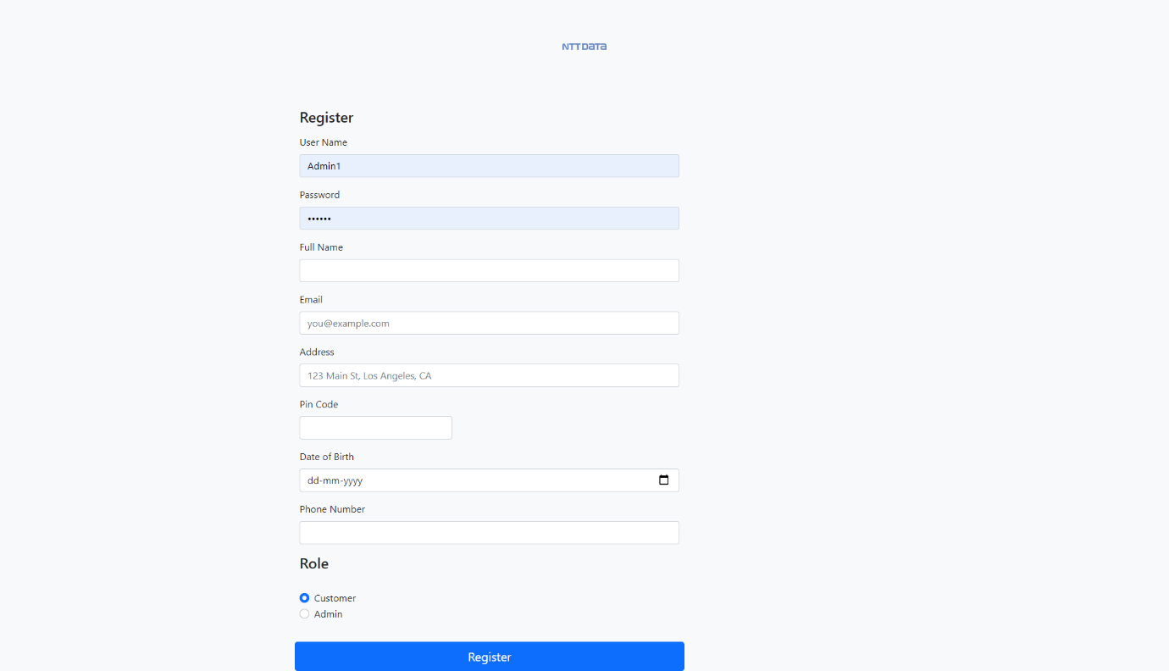

Once you enter your details and click on submit you will be redirected to the login page.

**Login**

The login page will look like this:

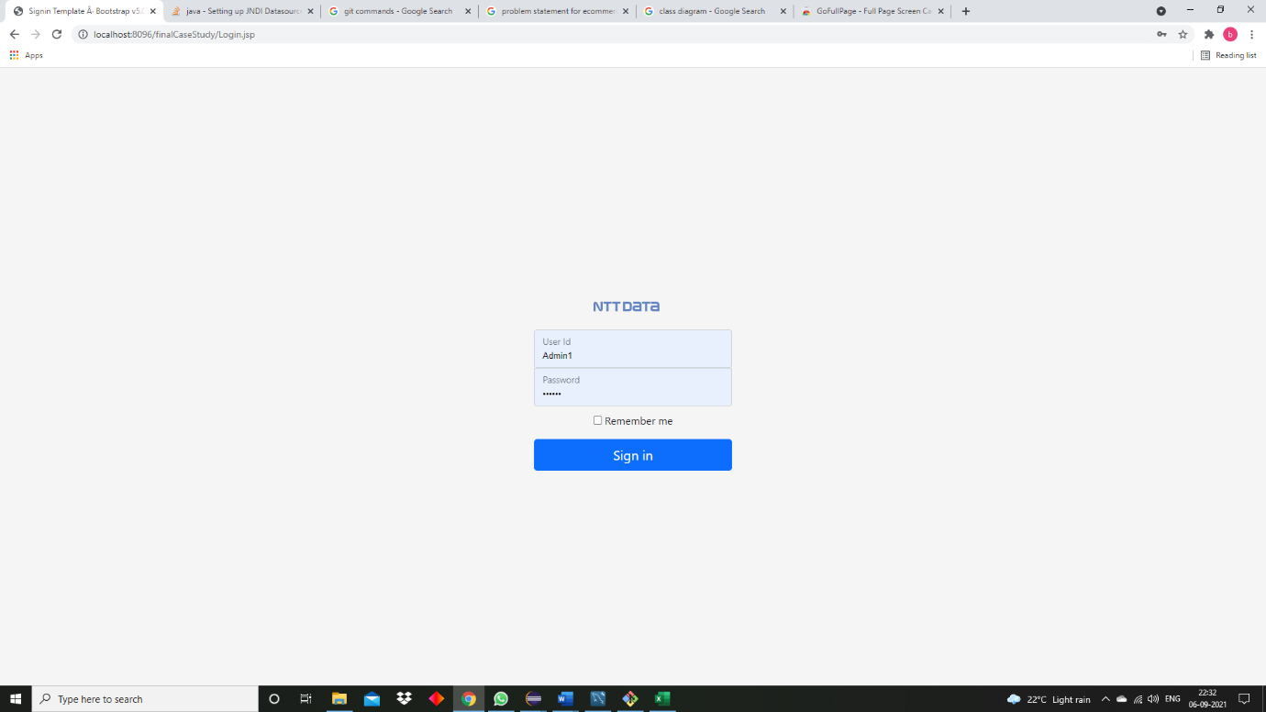

If incorrect login credentials will be entered then the user will remain in the login page and a message will display saying that they are supposed to enter the correct credentials.

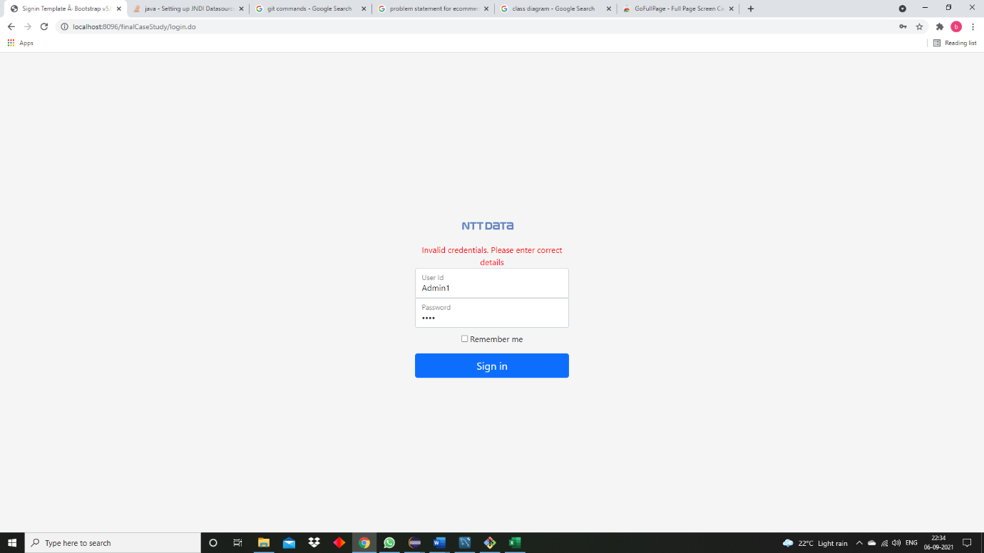

Since there are 2 types of users

1)Customer

2) Admin

They will see different pages once they login.

**Customer Login Page**

As soon as the customer is logged in, he will see this

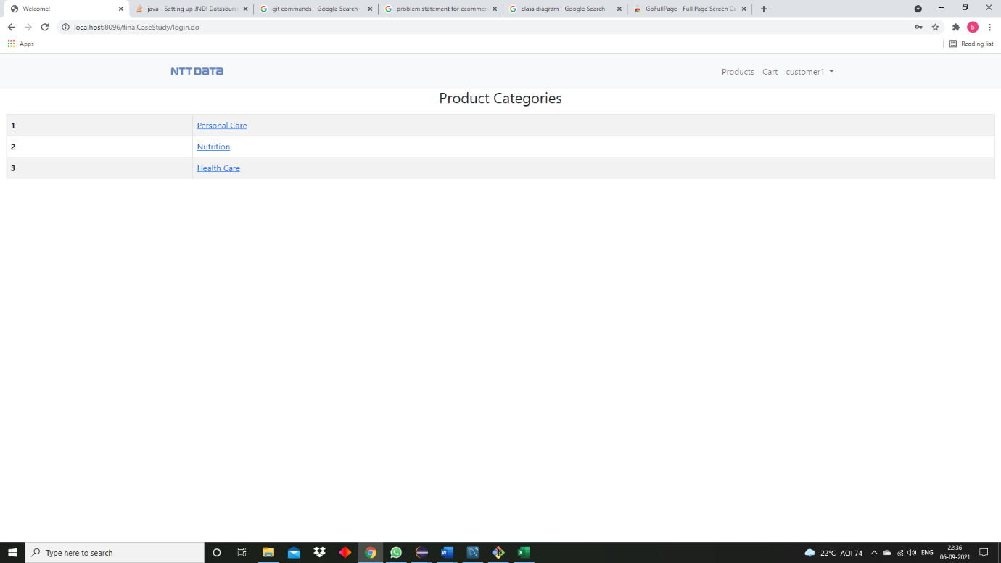

Once the user clicks on the Personal care link he will see all the products related to Personal care.

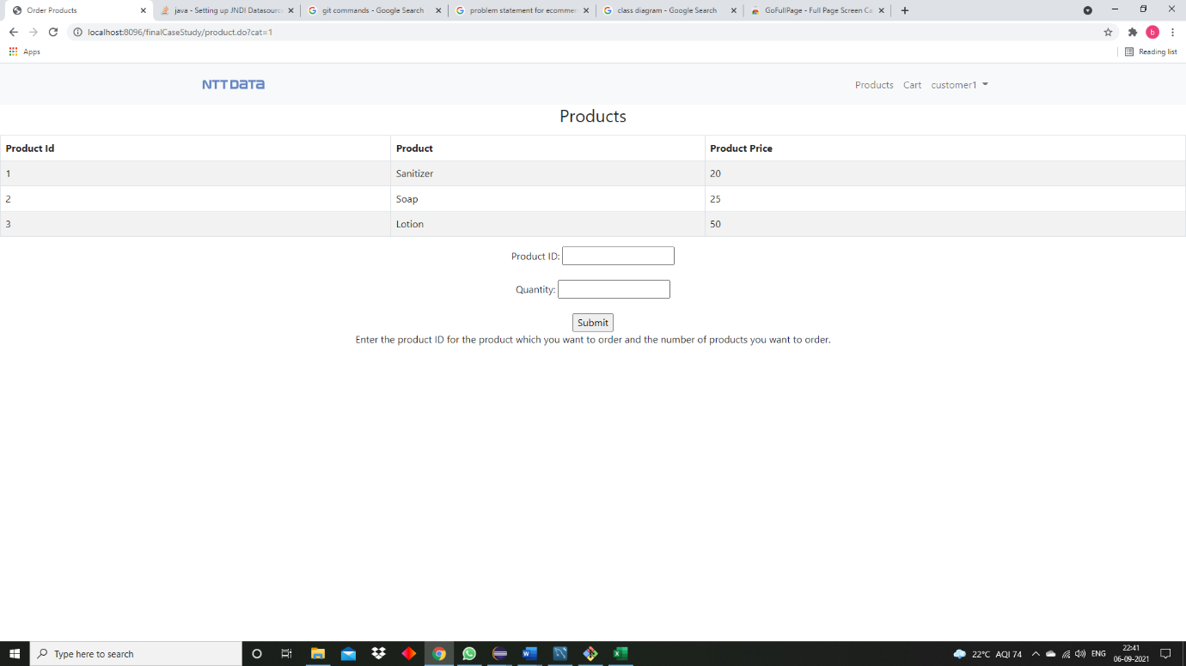

If the user clicks on Nutrition or Health Care he will see products related to Nutrition and Health Care.

Health Care

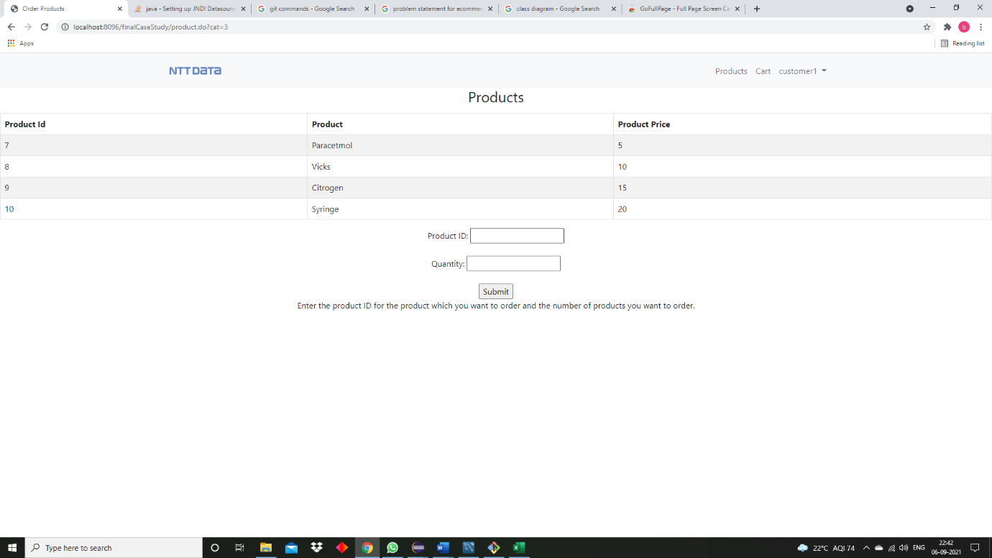

Nutrition

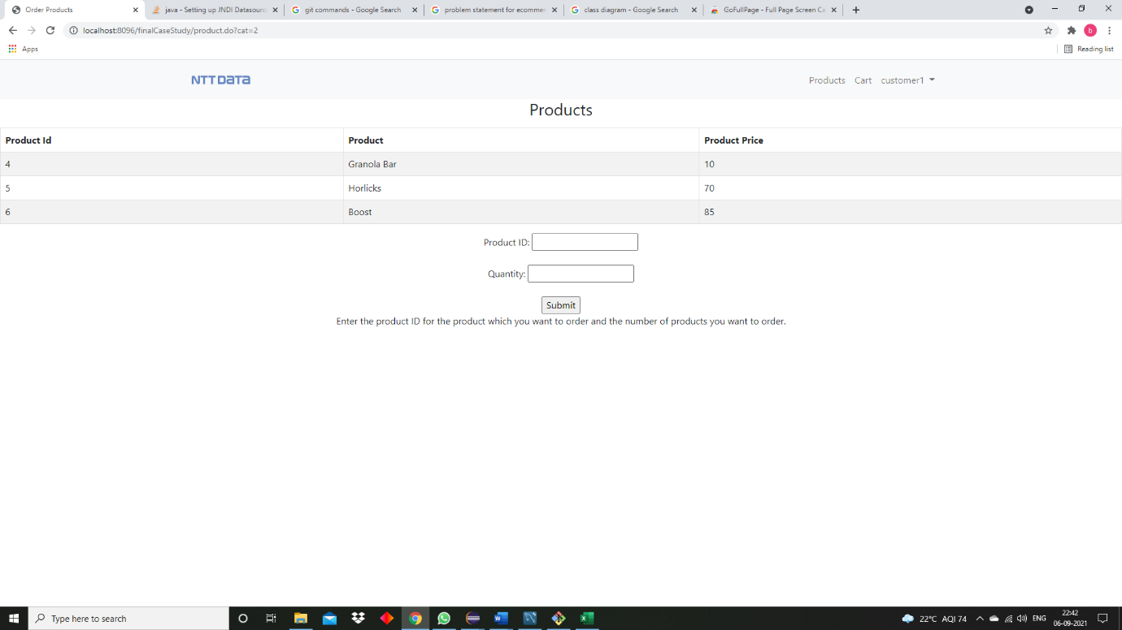

The customer can order products by entering the product id in the box below and the quantity of products he wants to order and click on the submit button.

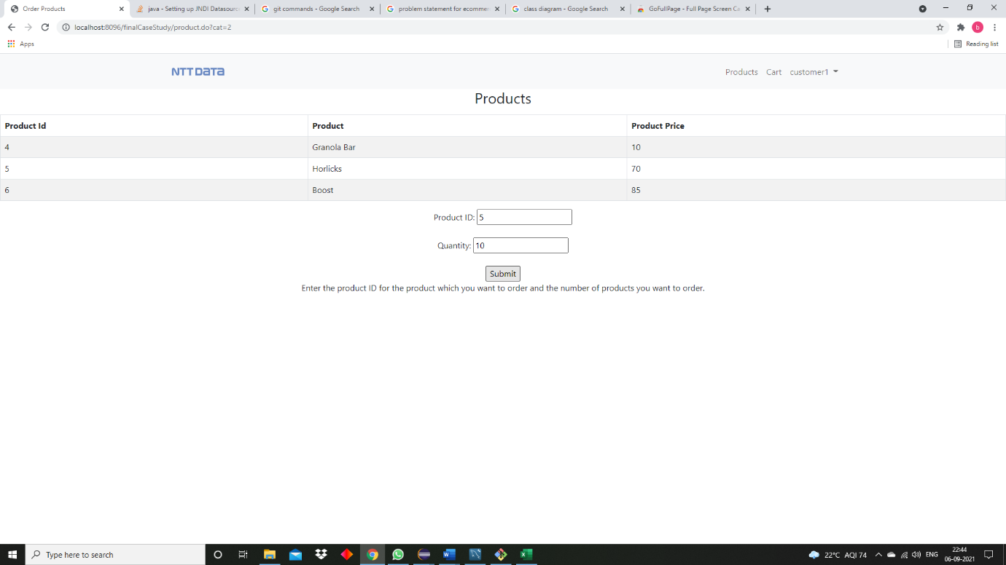

After clicking on the submit button, they will see their cart which contains all the orders they have placed.

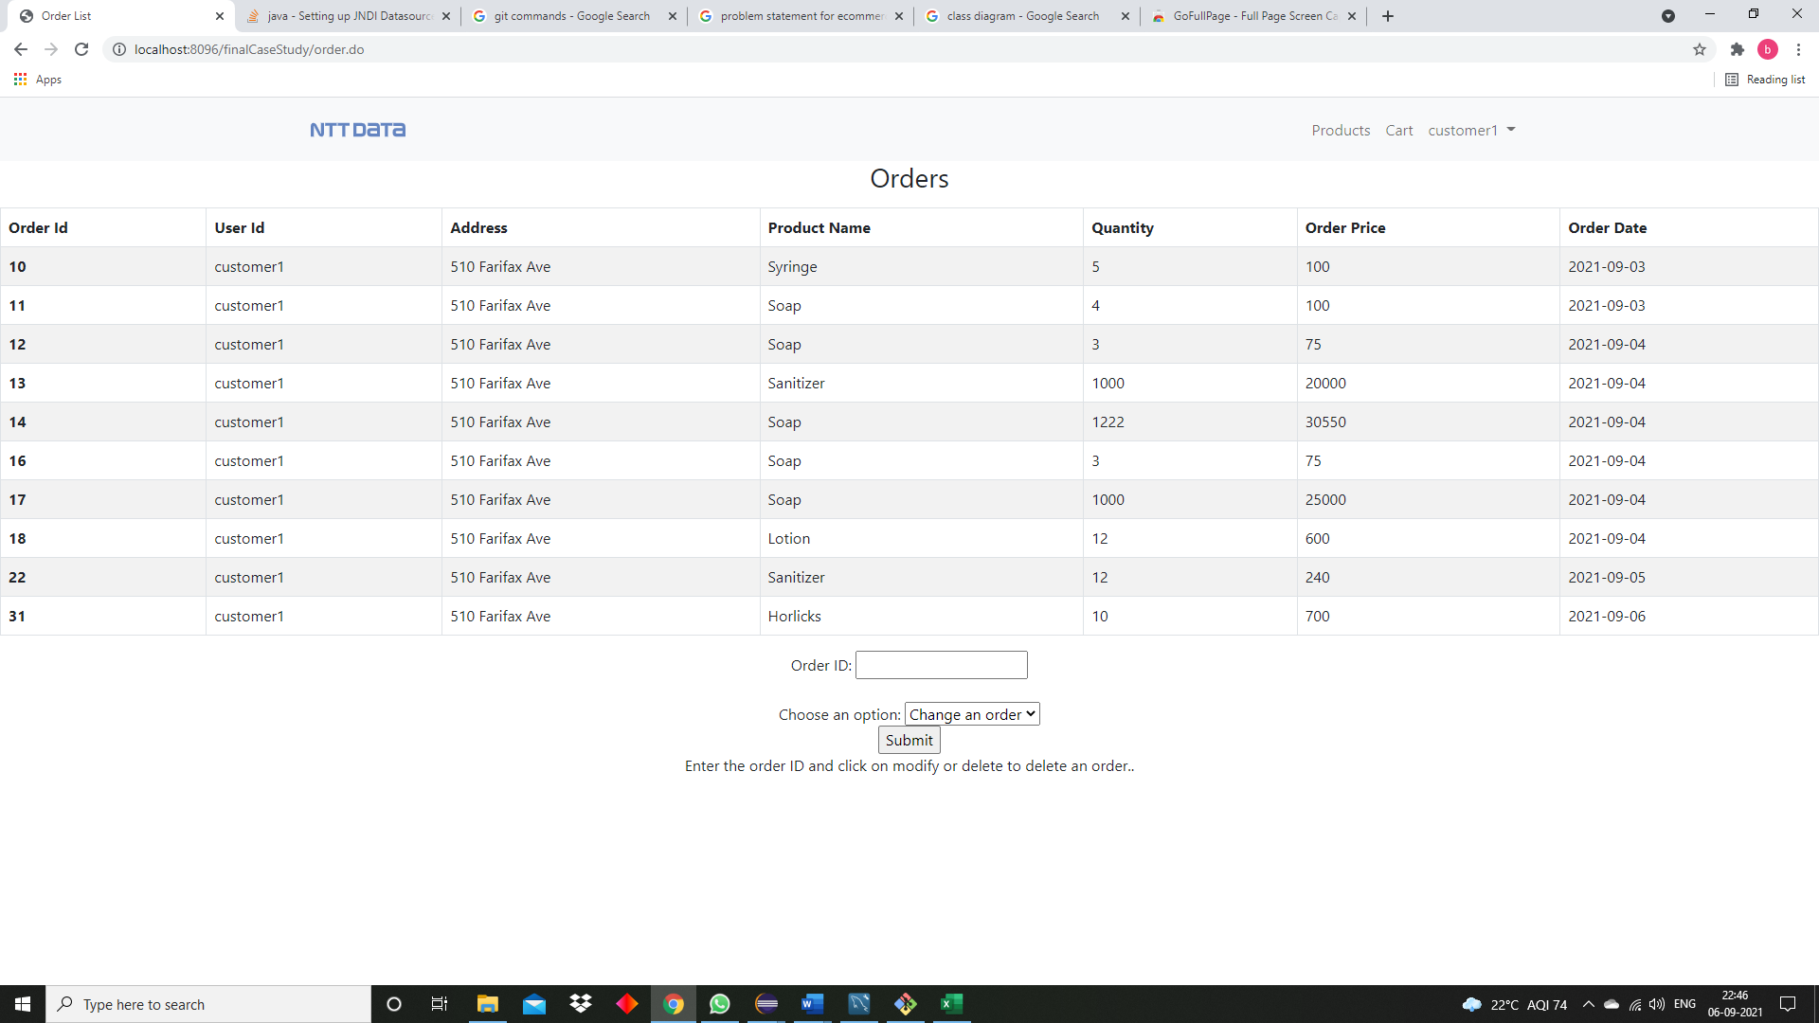

As you can see that order id 31 is the order which was currently placed.

The user can also see all their current existing orders by clicking on Cart which is present at the Navigation bar.

The user can modify or delete any order he has placed by entering the order Id and clicking on submit.

**Delete**

After entering the order Id, he can delete the order by clicking on submit button.

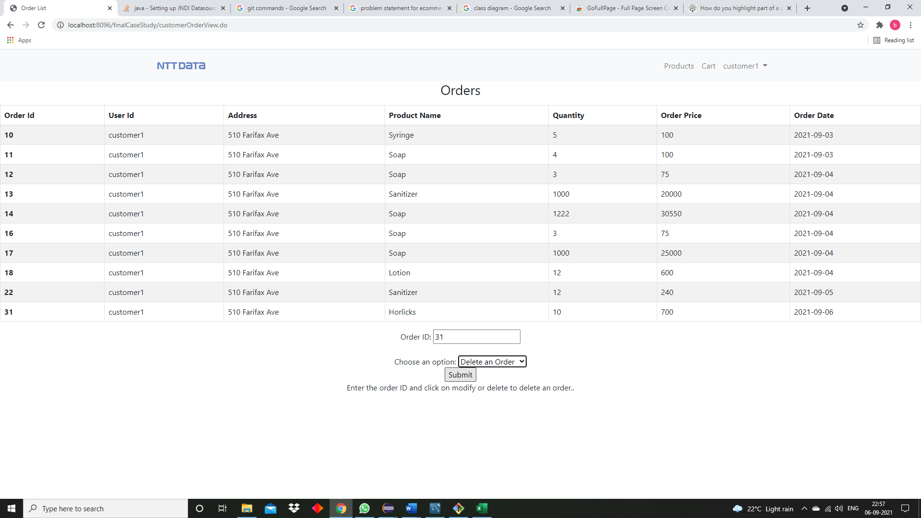

After clicking on the submit button, he will be redirected to the Product Categories page.

**Modify**

A user can also modify one of their orders by selecting Modify an order and clicking on the submit button.

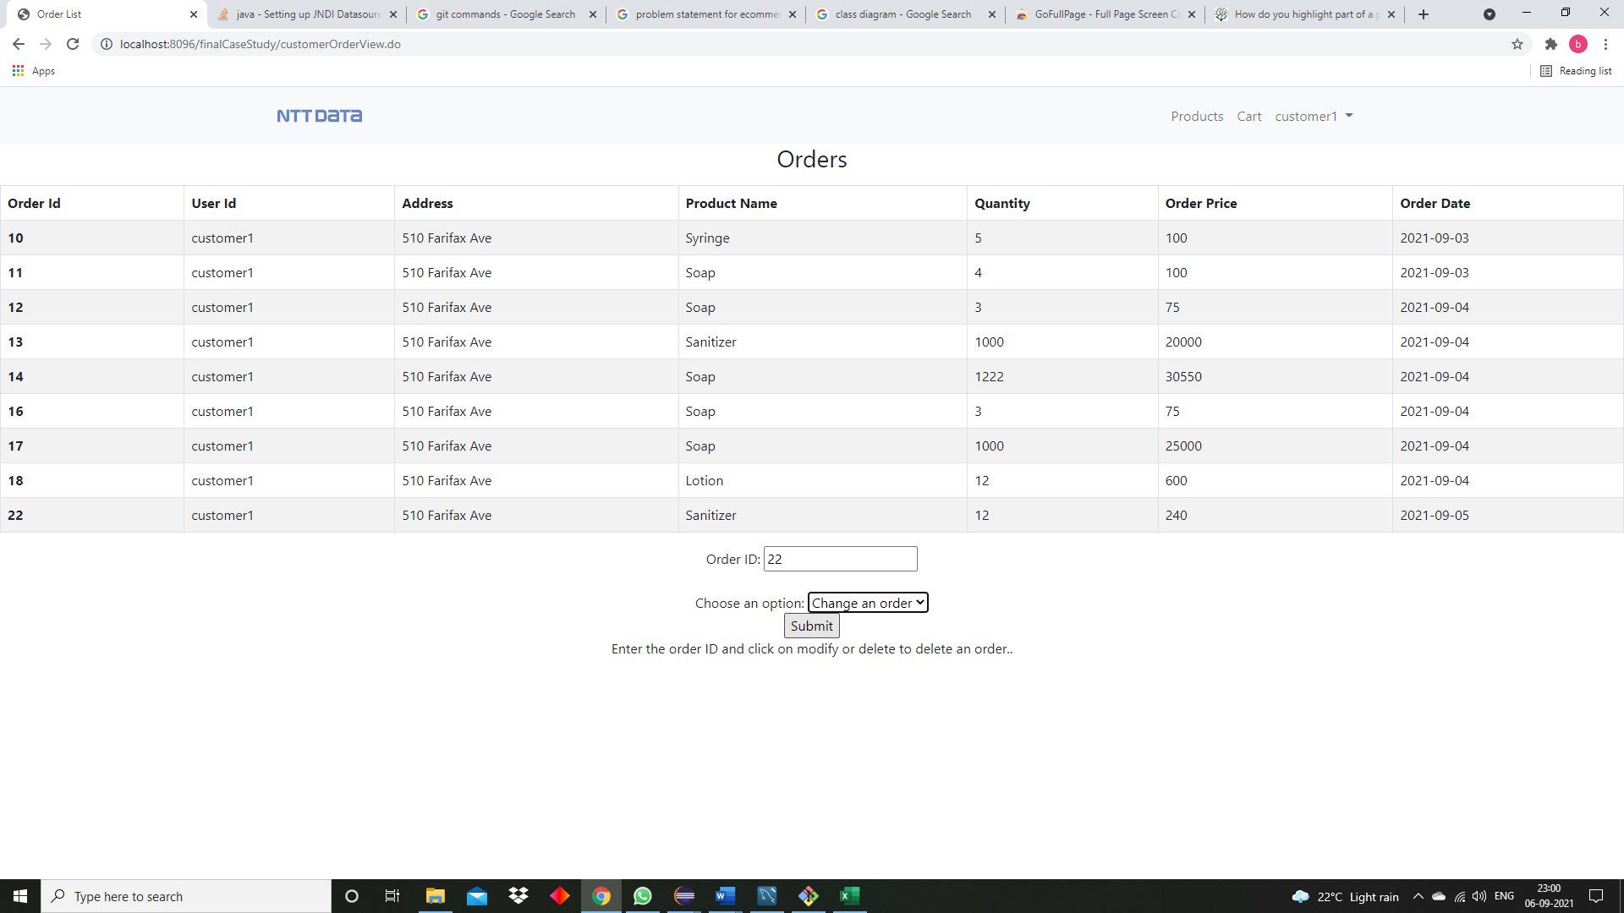 Once they click on the submit button they will be redirected to the products page where he will be asked to enter the product Id and the quantity of products he wants to order, after he clicks on the submit button their order will change according to what they have entered.

After entering the product Id and the quantity and clicking on the submit button the user can check that his order will be changed

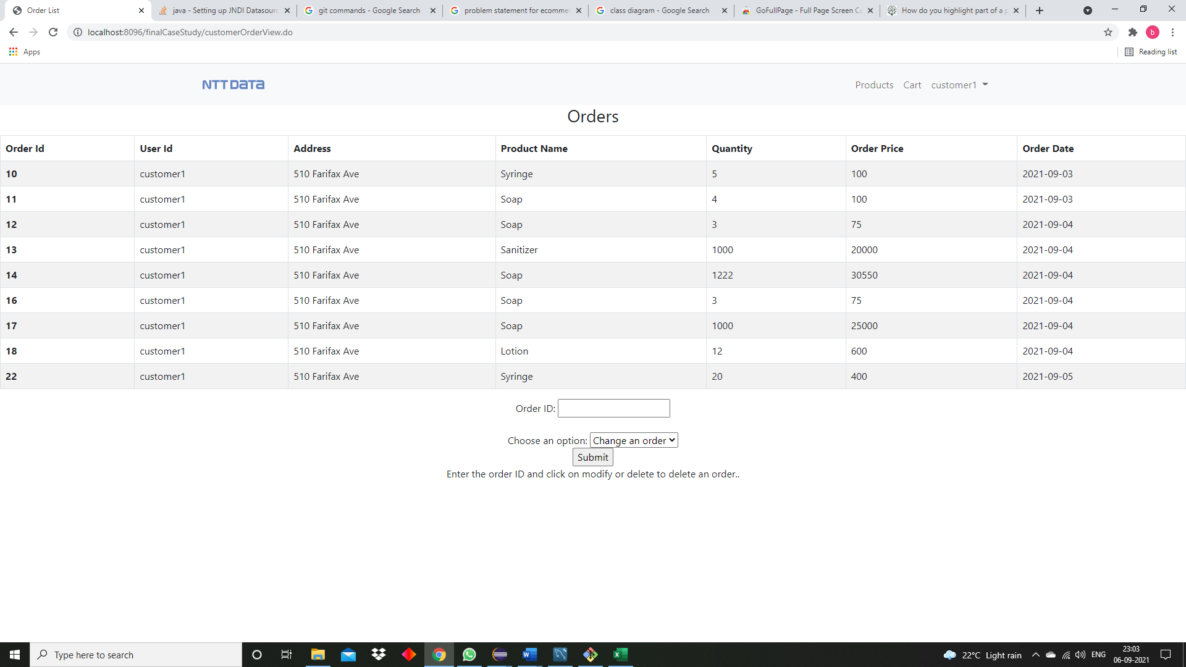

The Customer can log out by clicking on the log out button in the navigation bar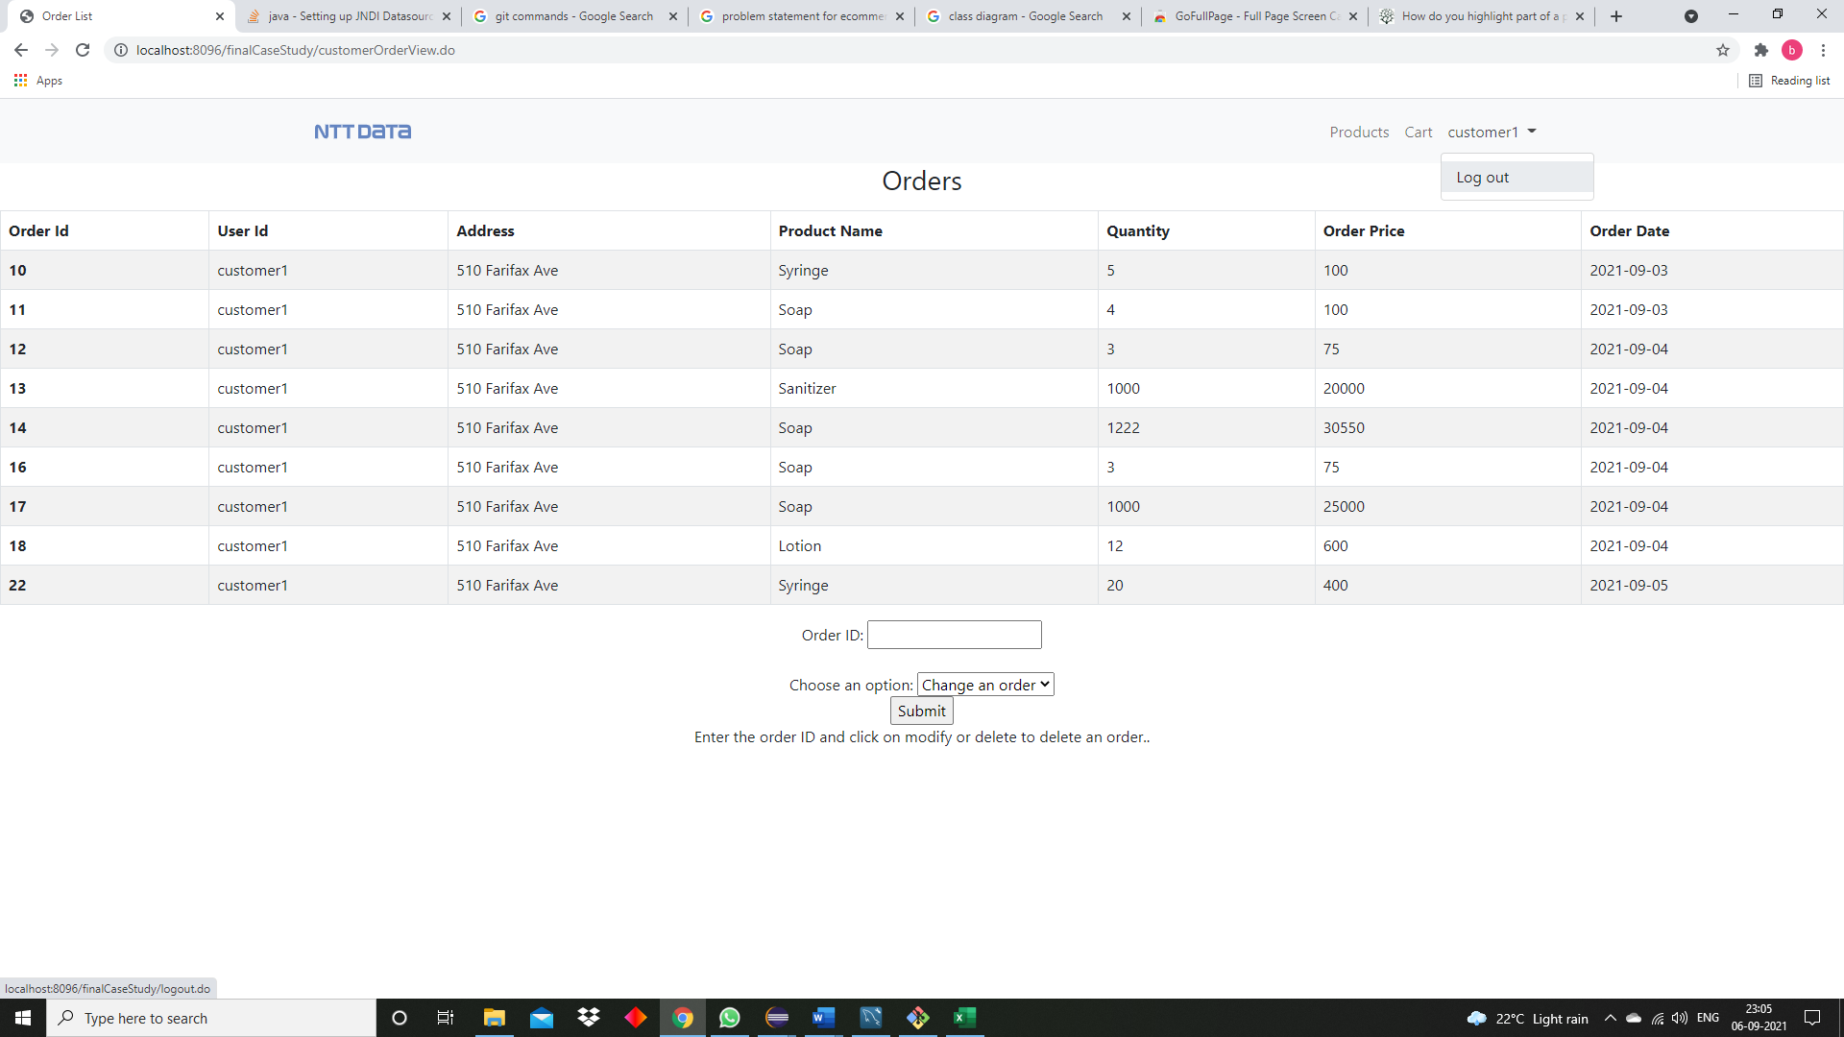

After clicking on the log out button he will be redirected to the index page.

**Admin**

Once an admin user logs in to the website he will see this page.

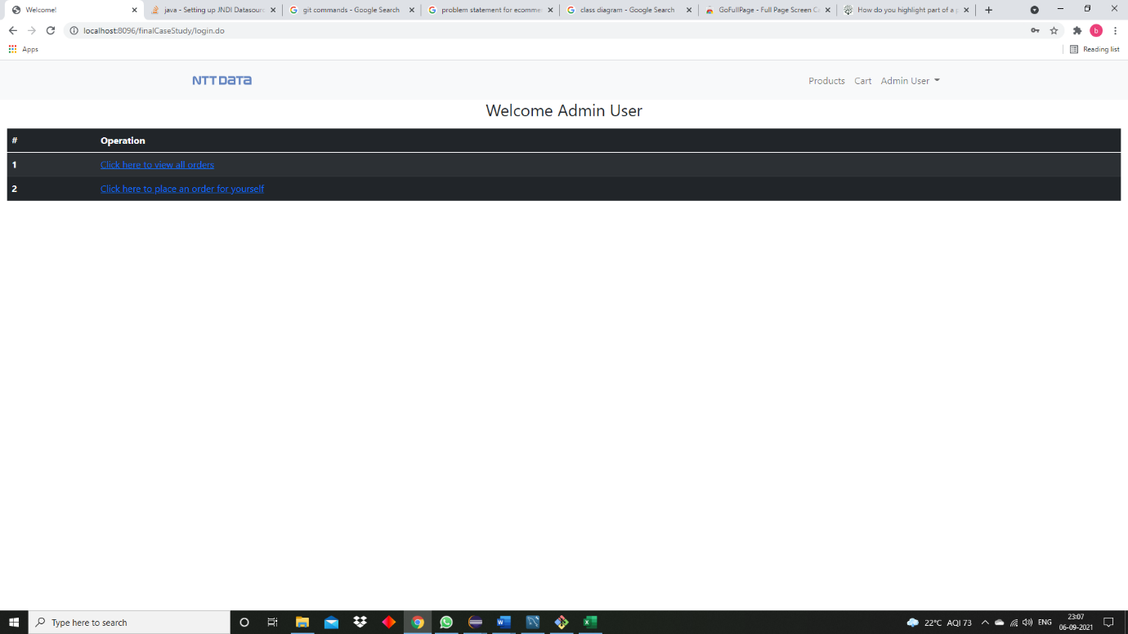

He can perform all the operations that the customer has performed. He can also look at all orders placed by the customers and delete or modify some of the orders.

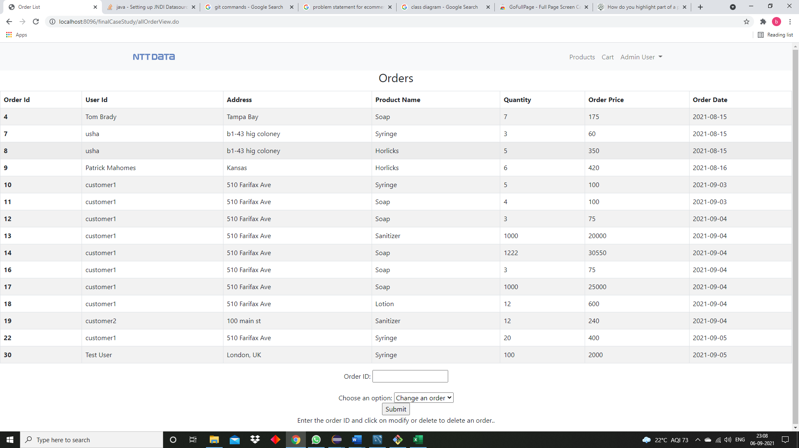

All of the rest of the operations are the same as what the customer can perform.