Development of FACTS Technology for Power System Stability Improvement

**Chetan Goel1 Dr. Shikha Gupta2**

**1**[**chetangoel0605@gmail.com**](mailto:chetangoel0605@gmail.com)**, 2shikhagupta@bpitindia.com**

*1,2Department of Electrical and Electronics Engineering, Bhagwan Parshuram Institute of Technology, Delhi India*

***Abstract— The power transmission system has evolved and got more efficient over the last few decades due to gradual improvements in the electronics sector with High power control which gave birth to a novel field i.e. Power Electronics. And, in the last years, power demand has increased substantially compared to power generation and transmission due to which some transmission lines are heavily loaded, and the system stability becomes a power transfer limiting factor. Flexible AC Transmission Systems(FACTS) are the power electronic devices that allow flexible and dynamic control of power systems. Also, it is equally important to make the transmission more efficient and lossless for reliable distribution of power as per load demand. FACTS devices fulfills all these requirements by providing the smooth control of the power flow in transmission lines with improved system stability. This improved stability of the power transmission system makes these FACTS devices an essential part of it. This paper is aimed at the evolution and the benefits of FACTS devices with the purpose of improving the operation of an electrical power system. Performance comparison of different FACTS controllers has been discussed. Applications of FACTS to power system studies have also been discussed.***

#### ***Keywords—FACTS Technology, System Stability, SVC, TCSC, TCPS, STATCOM, SSSC, UPFC, DPFC.***

1. **INTRODUCTION**

The FACTS controller provides a great opportunity to govern the flow of alternating current (AC), reducing the responding time for increasing or diminishing the power flow in specific lines. The advantage of this technology is the optimal control of the power flow and enhancement of the system performance. FACTS devices are basically the power electronic device which are static in nature and capable for the transmission of electrical energy with a smooth, fast and convenient control over the system. The FACTS devices can be divided in three groups, dependent on their switching technology: mechanically switched (such as phase shifting transformers), thyristor switched or fast switched, using IGBTs. While some types of FACTS, such as the phase shifting transformer (PST) and the static VAR compensator (SVC) are already well known and used in power systems, new developments in power electronics and control have extended the application range of FACTS [1]. In addition to this, the non- conventional energy resources and hybrid systems for the power generation offers some modern applications for Flexible Alternating Current Transmission System (FACTS). Furthermore, FACTS also helps in reducing the oscillations occurring in the system which is beneficial for the intermittent power flow of renewable energy systems. Increase in the power demand of the world is shown in Figure 1. In the early years of power system developments this demand has rapidly increased. Such fast increase is nowadays still present in the emerging countries, especially in Asia. However, the growth of transmission systems in these countries does not follow the increase in power demand & hence, there is a difference between transmission capacity and actual power demand, which leads to problems in the overloaded transmission systems [2].

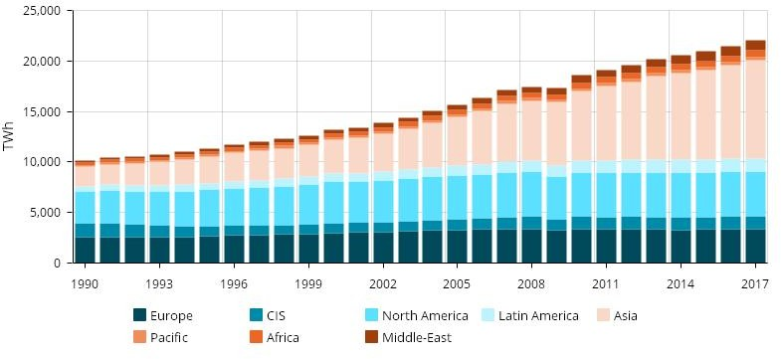

Fig.1. Analysis of power demand in the world (1990-2017)

The additional flexibility and controllability of FACTS allow to reduce the problems associated with the unreliable of supply issues of renewable. SVCs and STATCOM devices are favorable to offer contributory services (such as voltage control) to the grid and fault ride through capabilities which standard wind farms cannot provide.

1. **FLEXIBLE AC TRANSMISSION SYSTEMS**

Flexible AC Transmission Systems (FACTS), based on power electronics have been developed to improve the performance of the long-distance AC transmission and further expanded the technology of the device which can perform suitable control of the power flow. Excellent operating experiences are available world- wide and the FACTS technology became mature and reliable.

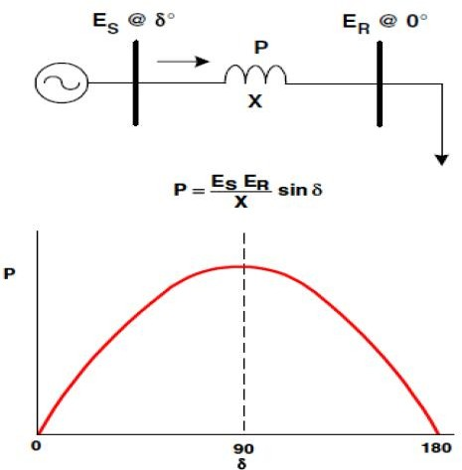

Fig.2. FACTS working for transmission

The main idea of FACTS can be explained by the basic equation for transmission in Figure 2. To illustrate that the power system only has certain variables that can be impacted by control, we have considered here the power-angle curve. Although this is a steady-state curve and the implementation of FACTS is primarily for dynamic issues, this illustration demonstrates the point that there are primarily three main variables that can be directly controlled in the power system to impact its performance.

These are:

* Voltage
* Angle
* Impedance

FACTS controllers for the enhancement of power system control are:

* + Static VAR Compensator (SVC) - Controls voltage
  + Thyristor Controlled Series Compensator (TCSC) - Controls impedance
  + Thyristor Controlled Phase Shifter (TCPS) - Controls angle
  + Static Synchronous Compensator (STATCOM) - Controls voltage
  + Static Synchronous Series Controller (SSSC)
  + Unified Power Flow Controller (UPFC)
  1. **DISTRIBUTED POWER FLOW CONTROLLER (DPFC)**

Each of the above three have an impact on voltage, impedance, and/or angle (and power)

* 1. **STATIC VAR COMPENSATOR (SVC)**

A static VAR compensator (or SVC) is an electrical device for providing fast-acting reactive power on high-voltage electricity transmission networks. SVCs are part of the Flexible AC transmission system device family, regulating voltage and stabilizing the system. The term "static" refers to the fact that the SVC has no moving parts (other than circuit breakers and disconnects, which do not move under normal SVC operation). Prior to the invention of the SVC, power factor compensation was the preserve of large rotating machines such as synchronous condensers. The SVC is an automated impedance matching device, designed to bring the system closer to unity power factor. Typically, an SVC comprises one or more banks of fixed or switched shunt capacitor or reactor, of which at least one bank is switched by thyristors as shown in Figure 3. If the power system's reactive load is capacitive (leading), the SVC will use reactors (usually in the form of thyristor-Controlled Reactors) to consume VARs from the system, lowering the system voltage. They also may be placed near high and rapidly varying loads, such as arc furnaces, where they can smooth flicker voltage. By means of phase angle modulation switched by the thyristors, the reactor may be variably switched into the circuit and so provide a continuously variable in VAR injection (or absorption) to the electrical network [3].

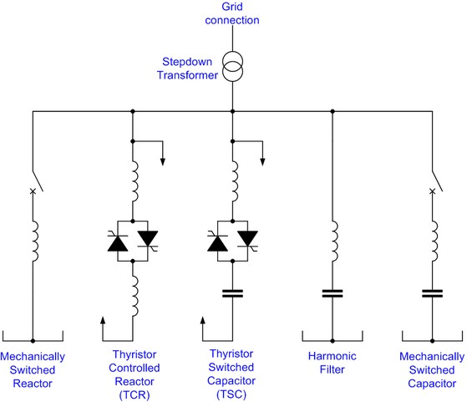

Fig. 3 Static VAR Compensator

Generally, static VAR compensation is not done at line voltage; a bank of transformers steps the transmission voltage (for example, 230 kV) down to a much lower level (for example, 9.0 kV) [4]. This reduces the size and number of components needed the SVC, although the conductors must be very large to handle the high currents associated with the lower voltage.

* 1. **THYRISTOR-CONTROLLED SERIES CAPACITOR (TCSC)**

TCSC controllers use a thyristor-controlled reactor (TCR) in parallel with capacitor segments of series capacitor bank as in Figure 4. The combination of TCR and capacitor allow the capacitive reactance to be smoothly controlled over a wide range and switched upon command to a condition where the bi-directional thyristor pairs conduct continuously and insert an inductive reactance into the line. TCSC is an effective and economical means of solving problems of transient stability, dynamic stability, steady state stability and voltage stability in long transmission lines. TCSC can control the line impedance through the introduction of a thyristor-controlled capacitor in series with the transmission line. A TCSC is a series-controlled capacitive reactance that can provide continuous control of power on the ac line over a wide range. The functioning of TCSC can be comprehended by analyzing the behavior of a variable inductor connected in series with a fixed capacitor.

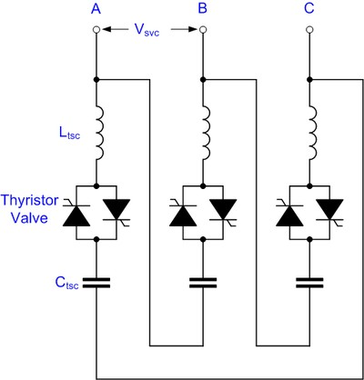

Fig. 4 Thyristor-Controlled Series Capacitor

* 1. **THYRISTOR-CONTROLLED PHASE SHIFTER (TCPS)**

In a TCPS control technique the phase shift angle is determined as a nonlinear function of rotor angle and speed. However, in real-life power system with many generators, the rotor angle of a single generator measured with respect to the system reference will not be very meaningful.

* 1. **STATIC COMPENSATOR (STATCOM)**

The emergence of FACTS devices and in particular GTO thyristor based STATCOM (Figure 5) has enabled such technology to be proposed as serious competitive alternatives to conventional SVC [9].

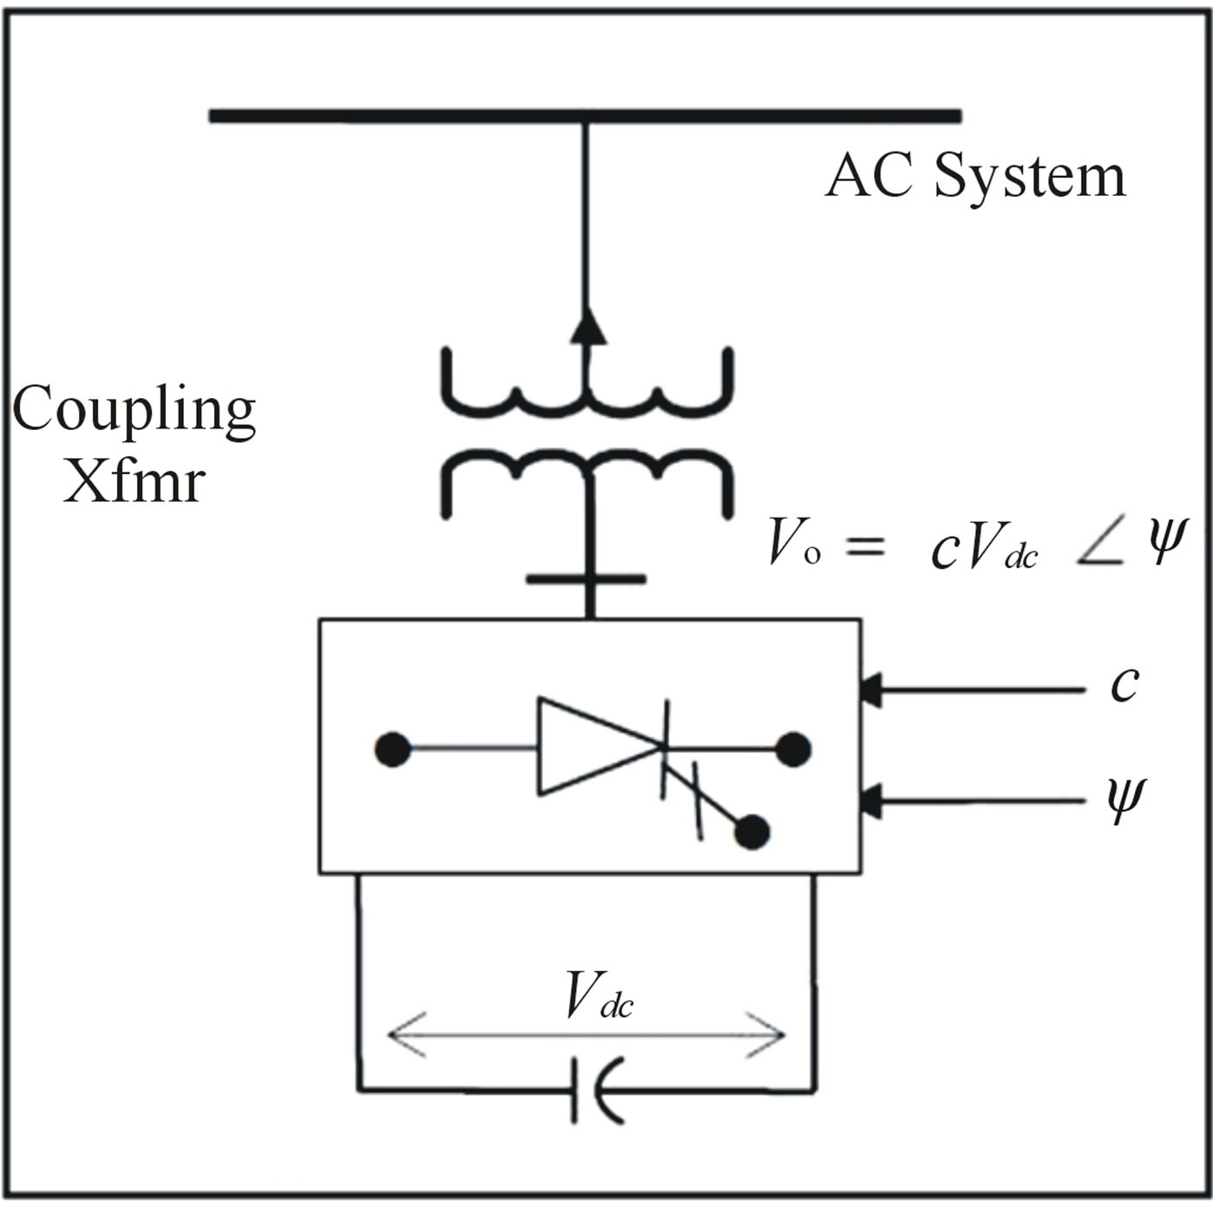

Fig. 5 Static Compensator (STATCOM)

A static synchronous compensator (STATCOM) is a regulating device used on alternating current electricity transmission networks. It is based on a power electronics voltage-source converter and can act as either a source or sink of reactive AC power to an electricity network. If connected to a source of power, it can also provide active AC power. It is a member of the FACTS family of devices. Usually, a STATCOM is installed to support electricity networks that have a poor power factor and often poor voltage regulation. There are, however, other uses, the most common use is for voltage stability.

* 1. **STATIC SYNCHRONOUS SERIES COMPENSATOR (SSSC)**

This device works the same way as the STATCOM. It has a voltage source converter serially connected to a transmission line through a transformer. It is necessary an energy source to provide a continuous voltage through a condenser and to compensate the losses of the VSC as shown in Figure 6. A SSSC can exchange active and reactive power with the transmission system. But if our only aim is to balance the reactive power, the energy source could be quite small. The injected voltage can be controlled in phase and magnitude if we have an energy source that is big enough for the purpose. With reactive power compensation only, the voltage is controllable because the voltage vector forms 90º degrees with the line intensity. In this case the serial injected voltage can

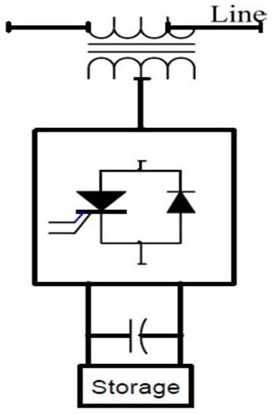delay or advanced the line current. This means that the SSSC can be uniformly controlled in any value, in the VSC working slot.

Fig.6 Static Synchronous Series Compensator (SSSC)

* 1. **UNIFIED POWER FLOW CONTROLLER (UPFC)**

A unified power flow controller (UPFC) is the most promising device in the FACTS concept. The Unified Power Flow Controller (UPFC) is comprised of a STATCOM and a SSSC [5], coupled via a common DC link shown in Figure 7 to allow bi-directional flow of active power between the series output terminals of the SSSC and the shunt output terminals of the STATCOM [6]. The two converters are operated from a DC link provided by a DC storage capacitor. It has the ability to adjust the three control parameters, *i.e.,* the bus voltage, transmission line reactance, and phase angle between two buses, either simultaneously or independently. A UPFC performs this through the control of the in-phase voltage, quadrature voltage, and shunt compensation. The UPFC is the most versatile and complex power electronic equipment that has emerged for the control and optimization of power flow in electrical power transmission systems. It offers major potential advantages for the static and dynamic operation of transmission lines. It can independently control both the real and reactive power flow in the line unlike all other controllers.

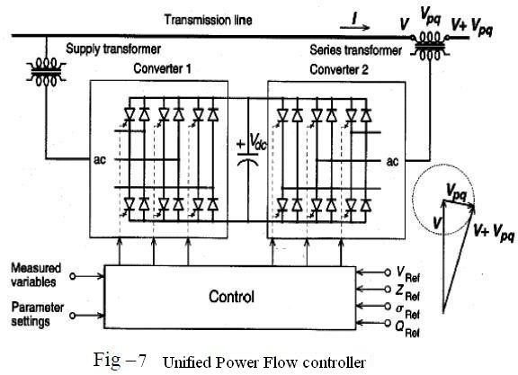The UPFC is not widely applied in practice, due to their high cost and the susceptibility to failures. Generally, the reliability can be improved by reducing the number of components; however, this is not possible due to the complex topology of the UPFC. To reduce the failure rate of the components, selecting components with higher ratings than necessary or employing redundancy at the component or system levels. Unfortunately, these solutions increase the initial investment necessary, negating any cost related advantages.

Fig.7 Unified Power Flow Controller

* 1. **DISTRIBUTED POWER FLOW CONTROLLER (DPFC)**

The DPFC can control all system parameters like line impedance, transmission angle & bus voltage. The DPFC eliminates the common dc link between the shunt and series converters. The series converter of the DPFC employs the distributed FACTS (D-FACTS) concept [8]. The DPFC have two major advantages:

1. Low cost because of the low-voltage isolation and the low component rating of the series converter.
2. High reliability because of the redundancy of the series converters and high control capability.

DPFC can also be used to improve the power quality and system stability such as power oscillation damping [7], Voltage sag restoration or balancing asymmetry.

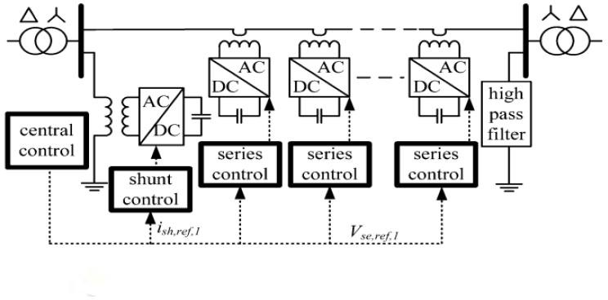Fig.8 Distributed Power Flow Controller

The DPFC consists of shunt and series connected converters. The shunt converter is similar as a STATCOM, while the series converter employs the Distributed Static series compensator (DSSC) concept, which is to use multiple single-phase converters instead of one three-phase converter. Each converter within the DPFC is independent and has its own DC capacitor to provide the required DC voltage. The configuration of the DPFC is shown in Figure 8.

The high-pass filter within the DPFC blocks the fundamental frequency components and allows the harmonic components to pass, thereby providing a return path for the harmonic components. The shunt and series converters, the high pass filter, and the ground form a closed loop for the harmonic current. In a three-phase system, the 3rd harmonic in each phase is identical, which means they are zero-sequence components. Because the voltage isolation is high and the harmonic frequency is close to the cutoff frequency, the filter will be costly. By using the zero-sequence harmonic, the costly filter can be replaced by a cable that connects the neutral point of the Y- Δ transformer on the right side. Because the Δ -winding appears open-circuit to the 3rd harmonic current, all harmonic current will flow through the Y-winding and concentrate to the grounding cable [12].

A DPFC consists of three types of controllers: central control, shunt control and series control, as shown in Figure 8.

### CENTRAL CONTROL

The central control generates the reference signals for both the shunt and series converters of the DPFC. It is focused on the DPFC tasks at the power-system level, such as power-flow control, low-frequency power oscillation damping, and balancing of asymmetrical components. According to the system requirement, the central control gives corresponding voltage reference signals for the series converters and reactive current signal for the shunt converter. All the reference signals generated by the central control are at the fundamental frequency.

### SERIES CONTROL

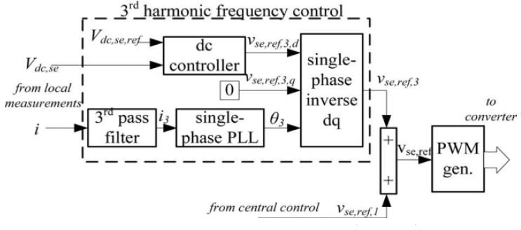Each DPFC series converter is locally controlled by its own controller, and the scheme for each series control is identical. To control the series converter, separate control loops are employed for the two frequency components. The 3rd harmonic control loop is used for DC voltage control. The block diagram of the DPFC series converter control is shown in Fig 9.

Fig.9 Block diagram of the series converter control [10]

1. ***SHUNT CONTROL***

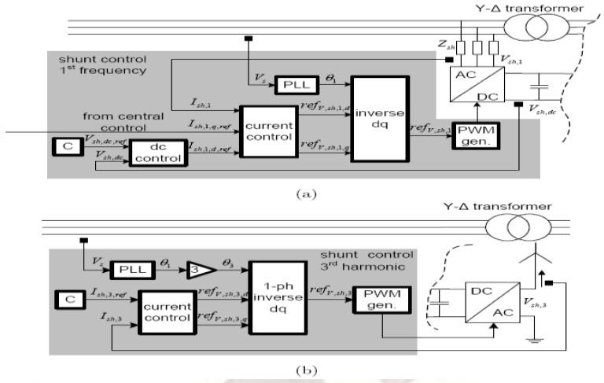The shunt converter contains two converters. The single-phase converter injects the constant 3rd harmonic current into the grid. The three-phase converter maintains the DC voltage at a constant value and generates reactive power to the grid. The control of each converter is independent. A block diagram of the shunt converter control is shown in Fig 10.

Fig.10 Control scheme of the shunt converter [11] (a) for the fundamental frequency components; (b) for the 3rd harmonic frequency components

1. ***BENEFITS OF USING FACTS DEVICES***

The benefits of using FACTS devices in electrical transmission systems are summarized as follows:

* Better utilization of existing transmission system assets.
* Increased transmission system reliability and availability.
* Increased dynamic and transient grid stability and reduction of loop flows.
* Increased quality of supply for large industries.
* Beneficial for Environment.

1. **FACTS APPLICATIONS TO STEADY STATE POWER SYSTEM PROBLEMS**

A brief overview of the FACTS devices applications to different steady state power system problems is presented in this section. Especially, applications of FACTS in optimal power flow and deregulated electricity market will be reviewed.

1. **FACTS APPLICATIONS TO OPTIMAL POWER FLOW**

Generally, in power flow studies, the thyristor-controlled FACTS devices, such as SVC and TCSC, are usually modeled as controllable impedance [13- 18]. However, VSC-based FACTS devices, including IPFC and SSSC, shunt devices like STATCOM, and combined devices like UPFC and DPFC, are more complex and usually modeled as controllable sources [13, 14, 17-22]. The Interline Power Flow Controller (IPFC) is one of the voltage source converters (VSC) based FACTS Controllers which can effectively manage the power flow via multi-line Transmission System. IPFC Consisting of two (or more) series voltage source converter-based devices (SSSCs) installed in two (or more) lines and connected at their DC terminals. Thus, in addition to serially compensate the reactive power, each SSSC can provide real power to the common DC link from its own line.

1. **FACTS APPLICATIONS TO DEREGULATED ELECTRICITY MARKET**

Presently, electricity demand is rapidly increasing without major reinforcement projects to enhance power transmission networks. Also, the electricity market is going toward open market and deregulation creating an environment for forces of competition and bargaining. FACTS devices can be an alternative to reduce the flows in heavily loaded lines, resulting in an increased load handling ability, low system loss, improved stability of the network and fulfilled contractual requirements by controlling the power flows in the network. Commercial pressures on obtaining greater returns from existing assets suggests an increasingly important role for dynamic network management using FACTS devices and energy storage as an important resource in generation, transmission, distribution, and customer service. There has been an increased use of the FACTS devices applications in an electricity market having pool and contractual dispatches. [1]

1. **FACTS APPLICATIONS TO DEREGULATED ELECTRICITY MARKET**

Presently, electricity demand is rapidly increasing without major reinforcement projects to enhance power transmission networks. Also, the electricity market is going toward open market and deregulation creating an environment for forces of competition and bargaining. FACTS devices can be an alternative to reduce the flows in heavily loaded lines, resulting in an increased load handling ability, low system loss, improved stability of the network and fulfilled contractual requirements by controlling the power flows in the network. Commercial pressures on obtaining greater returns from existing assets suggests an increasingly important role for dynamic network management using FACTS devices and energy storage as an important resource in generation, transmission, distribution, and customer service. There has been an increased use of the FACTS devices applications in an electricity market having pool and contractual dispatches.[1]

1. **BENEFITS OF FACTS DEVICES**

The technical benefits of the principal for dynamic applications of FACTS in addressing problems in transient stability, dampening, voltage control and load flow control are summarized in Table-1. FACTS devices are required when there is a need to respond to dynamic (fast-changing) network conditions. The conventional solutions are normally less expensive than FACTS devices but limited in their dynamic behavior. It is the task of the planners to identify the most economical solution. DPFC are more advantageous than these Facts devices as discussed in 2.7.

**Table1. Technical benefits of the main FACTS devices**

|  |  |  |  |  |
| --- | --- | --- | --- | --- |
| Facts Devices | Load Flow Control | Voltage Control | Transient Stability | Dynamic Stability |
| SVC | + | +++ | + | ++ |
| STATCOM | + | +++ | ++ | ++ |
| TCSC | ++ | + | +++ | ++ |
| UPFC | +++ | +++ | +++ | +++ |
| Good(+), Better(++), Best(+++) | | | | |

1. **CONCLUSION**

FACTS controllers have been developed to improve the performance of long-distance AC transmission. Later their use has been extended to load-flow control in meshed and interconnected systems. Typical applications of FACTS in power systems are presented and the benefits for power system are shown. The FACTS technology became mature and reliable over the years and still emerging in direction of improvement. Performance comparison of different FACTS controllers has been reviewed. A brief review of FACTS applications to optimal power flow and deregulated electricity market has been presented.

# REFERENCES

1. Alok Kumar Mohanty,Amar Kumar Barik,"Power System Stability Improvement Using FACTS Devices",Vol.1,pp-666-672.J. Clerk Maxwell, A Treatise on Electricity and Magnetism, 3rd ed., vol. 2. Oxford: Clarendon, 1892, pp.68–73.
2. D. Povh, D. Retzmann,"DEVELOPMENT OF FACTS FOR TRANSMISSION SYSTEMS",Siemens, Erlangen, Germany,Session Paper,November 2003.
3. Deb, Anjan K.,"Power Line Ampacity System", CRC Press. pp. 169&ndash, 171. ISBN 978-0-8493-1306-6.
4. Ryan, H.M. (2001),"High Voltage Engineering and Testing", IEE. pp. 160&ndash, 161. ISBN 978-0- 85296-775-1.
5. K. K. Sen,"Sssc-static synchronous series compensator: Theory, modeling, and application", IEEE Trans. Power Del., vol. 13, no. 1, pp. 241–246, Jan. 1998.
6. A.-A. Edris,"Proposed terms and definitions for flexible ac transmission system (facts)", IEEE Trans. Power Del., vol. 12, no. 4, pp. 1848–1853, Oct. 1997.
7. Y. Zhihui, S.W. H. de Haan, and B. Ferreira",Utilizing distributed power flow controller (dpfc) for power oscillation damping," in Proc. IEEE Power Energy Soc. Gen. Meet. (PES), 2009, pp. 1–5.
8. M. D. Deepak, E. B. William, S. S. Robert, K. Bill, W.

G. Randal, T. B. Dale, R. I. Michael, and S. G. Ian,"A distributed static series compensator system for realizing active power flow control on existing power lines", IEEE Trans. Power Del., vol. 22, no. 1, pp. 642–649, Jan.2007.

1. D. J. Hanson, M. L. Woodhouse, C. Horwill, D. R. Monkhouse, and M. M. Osborne, “STATCOM: A New Era of Reactive Compensation”, Power Engineering Journal, June 2002, pp. 151–160.
2. Y. Sozer and D. A. Torrey,"Modeling and control of utility interactive inverters", IEEE Trans. Power Electron., vol. 24, no. 11, pp. 2475–2483, Nov. 2009.
3. L. Huber, B. T. Irving, and M. M. Jovanovic,"Review and stability analysis of pll-based interleaving control of dcm/ccm boundary boost pfc converters", IEEE Trans. Power Electron., vol. 24, no. 8, pp. 1992–1999, Aug. 2009.
4. P. RAMESH, Dr.M.DAMODARA REDDY,"Modeling and Analysis of Distributed Power- Flow Controller (DPFC)",ISSN: 2248-9622 Vol. 2, Issue 2,Mar-Apr 2012, pp.609-615.
5. N. G. Hingorani and L. Gyugyi,"Understanding FACTS: Concepts and Technology of Flexible AC Transmission Systems", New York: IEEE Press, 2000.
6. Yong Hua Song and Allan T. Johns,"Flexible AC Transmission Systems (FACTS)", London, UK: IEE Press, 1999.
7. M. Noroozian and G. Andersson, “Power Flow Control by Use of Controllable Series Components”, IEEE Trans. PWRD, 8(3) (1993), pp. 1420–1429.
8. E. Acha, C. R. Fuerte-Esquivel, and H. Ambriz-Perez, “Advanced SVC model for Newton-Raphson Load Flow and Newton Optimal Power Flow Studies”, IEEE Trans. PWRS, 15(1) (2000), pp. 129–136.
9. E. Acha, C. R. Fuerte-Esquivel, and H. Ambriz-Perez et al.,"FACTS: Modeling and Simulation in Power Networks", London, U.K.: Wiley, 2004.
10. D. J. Gotham and G. T. Heydt, “Power Flow Control and Power Flow Studies for Systems with FACTS Devices”, IEEE Trans. PWRS, 13(1) (1998), pp. 60–65.
11. T. S. Chung, D. Qifeng, Z. Bomina, “Optimal Active OPF with FACTS Devices by Innovative Load- Equivalent Approach”, IEEE Power Engineering Review, 20(5) (2000), pp. 63–66.
12. Ying Xiao, Y. H. Song, and Y. Z. Sun, “Power Flow Control Approach to Power Systems with Embedded FACTS Devices”, IEEE Trans. on PWRS, 17(4) (2002), pp. 943–950
13. L. Gyugyi, K. K. Sen, and C. D. Schauder, “The Interline Power Flow Controller Concept: a New Approach to Power Flow Management in Transmission Systems”, IEEE Trans. PWRD, 14(3) (1999), pp. 1115–1123.
14. A. Nabavi-Niaki and M. R. Iravani, “Steady-State and Dynamic Models of Unified Power Flow Controller (UPFC) for Power System Studies”, IEEE Transactions on Power Systems, 11(4) (1996), pp. 1937–1943.
15. T. S. Chung, D. Qifeng, Z. Bomina, “Optimal Active OPF with FACTS Devices by Innovative Load- Equivalent Approach”, IEEE Power Engineering Review, 20(5) (2000), pp. 63–66.
16. Ying Xiao, Y. H. Song, and Y. Z. Sun, “Power Flow Control Approach to Power Systems with Embedded FACTS Devices”, IEEE Trans. on PWRS, 17(4) (2002), pp. 943–950
17. L. Gyugyi, K. K. Sen, and C. D. Schauder, “The Interline Power Flow Controller Concept: a New Approach to Power Flow Management in Transmission Systems”, IEEE Trans. PWRD, 14(3) (1999), pp. 1115–1123.
18. A. Nabavi-Niaki and M. R. Iravani, “Steady-State and Dynamic Models of Unified Power Flow Controller (UPFC) for Power System Studies”, IEEE Transactions on Power Systems, 11(4) (1996), pp. 1937–1943.