Vehicle Accident Prevention System on Hilly Areas

**Anurag Kumar1, Mishra Anusha2, Preeti Singh3**

*1 ,2 ,3 Department of Electronics and Communication Engineering, Bhagwan Parshuram Institute of Technology, Delhi*

1[anuragmishra1504@gmail.com](mailto:anuragmishra1504@gmail.com), [2anushab08.ab@gmail.com](mailto:2anushab08.ab@gmail.com), 3s23.preeti@gmail.com

***Abstract- Often modern cars have a collision avoidance system built into them known as Pre-Crash System, Forward Collision Warning System, or Collision Mitigation System in order to reduce the severity of a collision. But majority of vehicles on the road, especially heavy motor vehicles lack in such a system. In this paper, the implementation of the accident-Avoidance System is aimed to reduce the risks of accidents at the hairpin bend on a Hilly track, Ghats, or other Zero visibility turns. The proposed system contains a Liquid Crystal Display (LCD), warning lights combined with a buzzer are installed by the side of the road. It uses four IR sensors, which are placed on either side of the hairpin bend. The sensors are mutually exclusive and are connected to microcontroller through wires. Based on the output of sensors, position of vehicles on either side of the bend is detected which is provided as an input to the microcontroller. The priority algorithm intelligently controls the movement of the vehicles at the hairpin bend based on the sensor values giving appropriate warnings on detection. For different conditions appropriate warning Light Emitting Diode (LED) is triggered thereby prioritizing the vehicles’ movement. In case of a system breakdown a caution LED is triggered also sending a signal to notify the maintenance department about the same.***

***Keywords- Alerting driver, Hairpin Bending, IR Sensors, Mountain roads, Road Accident***

1. **INTRODUCTION**

In developing countries like India, the emergency services and trauma care are underdeveloped. In the hilly regions of Northern India (Uttarakhand), the traffic accidents are due to the poorly developed national highways, poor infrastructure and unattended hazard zones. The quick response teams are unable to deal with the accidents in a judicial and scientific way because of lack of knowledge. In India, the rate of traffic accidents is increasing day by day, but the development of emergency services is lagging far behind. As expected, the accident scene is chaotic since there are no quick response teams. To help victims rescue efforts are made usually by the passers-by and bystanders. The ill-fated unconscious patients, who are rescued by kind-hearted persons but invariably untrained, are being mishandled to the extent that the gravity of injury increases in many cases. The bystander's only concern is to transport the patient to the nearby hospital without any knowledge of the field triage. It is a good initiative that many developed countries have realized this deficit as the emergency services/physician’s presence is limited and have instead started training their citizens to respond to an emergency until advanced help gets to the incident site. In India, 1 out of 6 serious trauma victims die, but in the USA the figure is 1:200. In India, however, the lacuna lies with the emergency services.

The rest of the paper is organized as follows; section 2 provides the understanding and backdrop and related work, section 3 explains our proposed system methodology and in section 4 we have discussed the results followed by conclusion and future.

1. **RELATED WORK**

There are many dangerous roads in the world like mountain roads, narrow curve roads, T roads. In these some mountain roads will be very narrow and they contain so many curves. For example, Kinnaur road in Himachal Pradesh, Zoji La Pass in the Himalayas, the Road of Death Bolivia, Fairy Meadows Road (Pakistan) [1]. If the road is in remote areas sometimes there will be the chances of animals on the road and that is also dangerous if the driver couldn’t see them. For example, Pitt Enterprises Ltd. v. Farkes, 2005 BCCA 511 the defendant collided with a moose standing in his lane and that caused his vehicle to move into the oncoming lane and strike the plaintiff’s vehicle [2]. In some of the curve roads, the other end of the curve road cannot be seen by the driver because of the obstacles like trees or rocks etc. present in the middle. In these type of roads thousands of people die because careless or presence of unexpected obstacles. According to Million Death Study (MDS) about 2.3 million people die in India per year. In that 137 thousand is because of road accidents. That is about 377 people per day. In that 3.7% because of failed to look the road [3]. The problem in these curve roads is drivers can’t able to see the vehicle or obstacles coming from another end of the curve. If the vehicle is in very speed then it is difficult to control and there are chances of falling to cliff. The solution for this problem is alerting the driver about the obstacle or vehicle. Usually horn is used for this purpose. But in the rainy seasons horn will not be heard. Some people will not use horn itself. So, horn is not a good solution to solve this problem. These are the major reasons for accidents [4]. To avoid these problems in curve roads or T roads we are introducing sensor-based accident prevention system. That’s why we are keeping IR sensor in one side of the road before the curve and keeping a LED light after the curve. IR sensor sends signal as pulse from trigger. If vehicle is present signal will hit the vehicle and it is received by the sensor. At that time light will glow at the other side of the curve. In the absence of the vehicle the signal will not be received by the sensor and the light will not glow. As soon as the light glows and buzzer buzzes, the driver then can slow down his vehicle. He could even stop it if it’s necessary [6]. This sensor based light system can be applicable when the driver cannot see the vehicle coming from another end of the road. Using this idea, we can make all the mountain roads and curve roads safer from accidents and can save thousands of lives. Currently, the following methods are being incorporated to negotiate a hairpin bend on a Hilly track, Ghats or any other kind of zero visibility turns.

* 1. *Vehicle Horn*

This is one of the traditional ways to negotiate a hairpin bend. The drivers on both sides judge the distance of one another based on the intensities of sound from their respective horns. This method although being the simplest poses to be highly inefficient also causing a lot of confusion between the drivers.

* 1. *Headlights*

Flashing headlights during the night works similar to the vehicle horn making it yet another inefficient method. Also this method is completely ineffective in day light conditions.

* 1. *Convex Mirrors*

This setup is most widely used nowadays to give a glimpse of any vehicle approaching the hairpin bend from the opposite end. But, these have their shortcomings such as the mirror needs to be kept clean at all times which is difficult in hilly areas as its always cold and misty, thereby reducing its visibility. Jessen Joseph Leo et al in [1] talks about an inbuilt system in vehicles using GPS technology which takes care of location of the vehicles with respect to the hairpin bend to decide the priority in which the vehicles have to move. The main disadvantage of this method is the complexity in installing the system in all vehicles and communication between the vehicles in hairpin bends. R. S. Rahul et al in [8] have proposed a model to implement the vehicle mishap averting system using Arduino microcontroller. Through Wi-Fi a signal is transmitted to driver about the traffic and vehicle arrival on the other bend followed by a buzzer on the hairpin bends. EiEi Thwe in [9] gives an idea to reduce the accidents and safety measuring techniques in hairpin bends using obstacle detection system. A GUI is developed to monitor and control the system which detects the obstacles within 13 feet range of the vehicle using ultrasonic sensors.

1. **METHODOLOGY**
2. *Hardware Setup*

The basic idea of this project is that it deals with the solution of the accidents on the hilly areas. This paper proposes a simplistic approach for the implementation of a Collision Avoidance System in hairpin bends on a hilly track, or zero visibility turns using sensors. Fig 1 shows the block hardware setup of the project. It uses four IR sensors, which are placed on either side of the hairpin bend. Two sensors S1 and S2 are installed by the side of the uphill section of the road, similarly two more sensors S3 and S4 are installed by the side of the downhill section of the road. The sensors are mutually exclusive and are connected to ATmega32 microcontroller through wires. Based on the output of sensors, position of vehicles on either side of the bend is detected which is provided as an input to the microcontroller. The microcontroller which works on a power supply of 9V runs a Priority algorithm which triggers the warning LEDs to glow (W1 in Downhill or W2 in Uphill) and thereby intelligently controlling the movement of vehicles at the bend. Warning LEDs are used. Another LED (W3) is placed in order to notify a system breakdown.

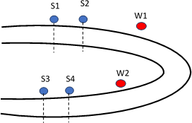Fig1: Hardware setup

1. *ATMEGA 32 Microcontroller*

The high-performance, low-power Microchip 8-bit AVR RISC-based microcontroller combines 32KB ISP flash memory with read-while-write capabilities, 1KB EEPROM, 2KB SRAM, 54/69 general purpose I/O lines, 32 general purpose working registers, a JTAG interface for boundary- scan and on-chip debugging/programming, three flexible timer/counters with compare modes, internal and external interrupts, serial programmable USART, a universal serial interface (USI) with start condition detector, an 8-channel 10-bit A/D converter, programmable watchdog timer with internal oscillator, SPI serial port, and five software selectable power saving modes. The device operates between 1.8-5.5 volts. Figure 2 shows the block diagram of Atmega32 microcontroller.

1. *IR Sensors*

IR sensors are best suited for this purpose and used effectively to detect vehicles on the road. Infrared sources include an LED or infrared laser diode. Infrared detectors include photodiodes or phototransistors. The energy emitted by the infrared source is reflected by an object and falls on the infrared detector. An IR sensor consists of an IR LED and an IR Photodiode; together they are called as Photo-coupler or Opto–coupler. When the IR transmitter emits radiation, it reaches the object and some of the radiation reflects back to the IR receiver. Based on the intensity of the reception by the IR receiver, the output of the sensor is defined.

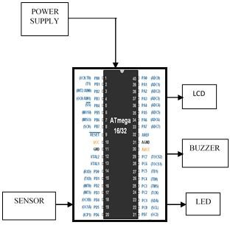

Fig 2: Block Diagram of ATmega32

1. *LCD*

It is combination of two states of matter, the solid and the liquid. LCD uses a liquid crystal to produce a visible image as in Fig 2. Liquid crystal displays are super-thin technology display screen that are generally used in laptop computer screen, TVs, cell phones and portable video games. LCD’s technologies allow displays to be much thinner when compared to cathode ray tube (CRT) technology.

1. *BUZZER*

The buzzer produces a same noisy sound irrespective of the voltage variation applied to it. It consists of piezo crystals between two conductors. When a potential is applied across these crystals, they push on one conductor and pull on the other. This, push and pull action, results in a sound wave. Most buzzers produce sound in the range of 2 to 4 kHz.

1. **RESULTS**

This paper is completed with the help of IR Sensors and the ATmega32 Microcontroller and all the necessary conditions are satisfied according to the hardware setup. As shown in Fig 3 to Fig 7.

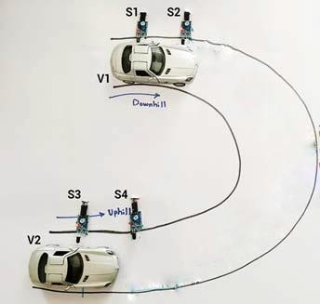Fig3: Scenario when S1, S2 and S3 are ON but S4 is OFF

Fig 3 shows the scenario when S1, S2 and S3 are ON but S4 is OFF so output on side 2 will be received by warning lights and buzzer.

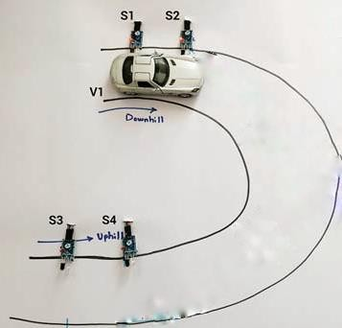

Fig4: Scenario when S1 and S2 are ON but S3 and S4 are OFF

Fig 4 shows scenario when S1 and S2 are ON but S3 and S4 are OFF so output on side 2 will be received by warning lights and buzzer.

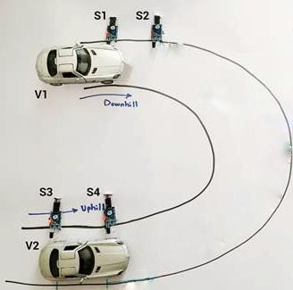

Fig 5 Scenario when S1, S3 and S4 are ON but S2 is OFF

Fig 5 shows the scenario when S1, S3 and S4 are ON but S2 is OFF so output on side 1 will be received by warning lights and buzzer.

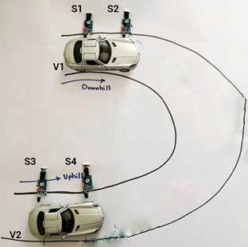Fig6: Scenario when S3 and S4 are ON but S1 and S2 are OFF

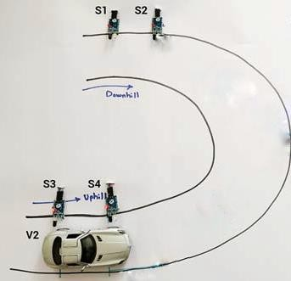Fig7: Scenario when all the sensors are ON

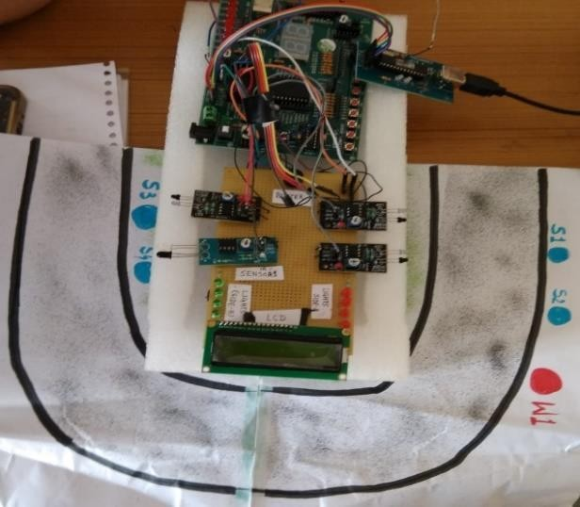Fig6 shows the scenario when S3 and S4 are ON but S1 and S2 are OFF so output on side 1 will be received by warning lights and buzzer. Fig 7 shows the scenario when all the sensors are ON, so output will be received on both sides of the road.

Fig 8 Screen shot of the proposed system

Proposed system screen shot is as shown in figure 8. The proposed system, as shown in the results, has performed accurately under various conditions prioritizing the vehicles negotiating a hairpin bend on a Hilly track, Ghats etc. This simple yet effective methodology will enable the driver to have a better sense of terrain and will drastically reduce road accidents in hairpin bends or other kinds of zero visibility turns.

1. **CONCLUSION AND FUTURE SCOPE**

In this study, we got to know about the accident which occurs on the road at Ghat section. We understand the causes and effect of accidents and then founded out a solution introducing a new technique to avoid such accident. The proposed collision avoidance system consisting of a microcontroller, IR sensors, warning LEDs and a convex mirror when implemented has proven to be more effective than just a normal traffic mirror setup. The systems, as shown in the results, have performed accurately under various conditions prioritizing the vehicles negotiating a hairpin bend on a Hilly track, Ghats etc. This simple yet effective methodology will enable the driver to have a better sense of terrain and will drastically reduce road accidents in hairpin bends or other kinds of zero visibility turns.

**REFERENCES**

1. Jessen Joseph Leo., R. Monisha., et.al. “Vehicle movement control and accident avoidance in hilly track”, IEEE Int. Conf. on Electronics and Communication Systems (ICECS), pp. 1-5, 2014.
2. Ki-Hyeon Kim., Dong-Hoon Yum., et.al. “Improving driver's visual field using estimation of curvature”, IEEE Int. Conf. on Control Automation and Systems (ICCAS).pp. 728- 731, 2010.
3. Duy Tran., Weihua Sheng.,et.al. “A Hidden Markov Model based driver intention prediction system”, IEEE Int. Conf. on Cyber Technology in Automation, Control, and Intelligent Systems (CYBER).pp. 115-120, 2015.
4. Jiang Yuying., Wu Yazhen., et.al. “A surveillance method for driver's fatigue and distraction based on machine vision”, IEEE Int. Conf. on Transportation, Mechanical, and Electrical Engineering (TMEE), pp. 727 – 730, 2011.
5. Ashutha K., Shetty Arpitha., et al., "Novel wireless data communication for fisherman", International journal of computer science and mobile computing (IJCSMC),Vol. 5, Issue 4, pp. 511-517, April 2016.
6. Ashutha K., Ankitha K., "Error Minimization in BCH Codes", International Journal Of Innovative Research In Electrical, Electronics, Instrumentation And Control Engineering (IJIREEICE), Vol. 4, Issue 5, pp. 402-405, May 2016.
7. R. S. Rakul S. Ravia K. N. Thirukkuralkani, “Implementation Of Vehicle Mishap Averting System Using Arduino Microcontroller”, International Journal of Engineering Research & Technology, Vol. 5 Issue 04, April- 2016.
8. EiEi Thwe, Theingi, “Design and Implementation Of Data Logger For Vehicle Safety”, International Journal of Engineering and Techniques - Volume 1 Issue 4, July – Aug 2015.
9. Engineersgarage.com, “atmega32” 2016 [online] Available: https[://www.](http://www.engineersgarage.com/electronic-)eng[ineersgarage.com/electronic-](http://www.engineersgarage.com/electronic-) componenets/atmega32-avr-microcontroller [Accessed: 4 Nov 2018]
10. Azosensors.com, “The Working Principle and Key Applications of Infrared Sensors”, 2018[online] Available: https[://www.](http://www.azosensors.com/article.aspx?ArticleID=339)azo[sensors.com/article.aspx?ArticleID=339](http://www.azosensors.com/article.aspx?ArticleID=339) .