IOT Based Smart Garbage Monitoring System

**Sahil Gupta1, Anurag Kumar2, Paras Madaan3, Radhika Mehta4**

*1 ,2 ,3 ,4Department of Electronics and Communication, Bhagwan Parshuram Institute of Technology, Delhi*

1[anuragmishra1504@gmail.com](mailto:anuragmishra1504@gmail.com),

***Abstract- With the increase in population, the garbage is also increasing with the rapid pace. The key issue issue in the waste management is the garbage bins that get overflowed in advance before the commencement of the next cleaning process. This leads to bad odor & environmental issues which is the cause of various diseases. In order to overcome from these issues, the work is to mount a garbage monitoring system. This paper proposes a smart garbage monitoring system which gets a signal using GSM whenever garbage gets filled and results will be monitored on the Think Speak website using IOT.***

***Keywords- Arduino UNO, GSM, IOT, Wi-Fi Module, Ultrasonic Sensor***

1. **INTRODUCTION**

Solid waste collection and disposal costs constitute 75-80% of a city's solid waste management budget [1]. Even a small improvement in the waste collection and transfer operations can lead to significant savings in costs. Trucks collect refuse from different parts of cities and transport to incinerators, landfills and transfer stations. These trucks spend a considerable amount of time travelling and waiting at disposal sites which could otherwise have been used for refuse collection. Waste Management is one of the major problems that the world faces. Research has shown that most of the health hazards spread because of the environmental conditions around people. The main reason of adverse environmental conditions is overflowing of a dustbin which causes health issues and poor conditions on roads. Proper maintenance becomes necessary for removal of garbage and waste. In order to avoid this hazardous scenario, this exposition proposes a Garbage Monitoring System using Arduino UNO with the addition of GSM technology. The process is upheld by Wi-Fi module, Ultrasonic Sensors, GSM & IOT Facilitation. The communication arises between web server and Arduino with the help of Wi-Fi Module. This system determines the depth of the garbage using Ultrasonic Sensor which can be monitored on Think Speak web server using Wi-Fi Module. The message is sent to the mobile using GSM technology. GSM technology is making the project more efficient as we need not to be active on think speak always.

The rest of the paper is organized as follows; section 2 discusses the related work, section 3 explains methodology and in section 4 results have been discussed followed by the conclusion drawn in the last section.

1. **RELATED WORK**

Bhat et al., have proposed a simulation-optimization model is described that helps to allocate trucks to disposal sites so as to reduce travelling and waiting time costs. This model can help city administrators to make long-term decisions relating to the number, capacities, and locations of waste disposal sites, routing of trucks, crew sizes etc. This model can also be of significant use to make short-term operational decisions, including those relating to diversion of trucks if their normal disposal site is not operational. Muhammad Ibrahim et al., [2] have proposed an Arduino-Based Smart Garbage Monitoring System in which they have used different sensors which are used for their respective roles. The two main sensors used are Level sensor and Tilt sensor which are used to analyze the level of garbage in the dustbin and the position of the dustbins respectively. After using these sensors, the system can become efficient as it is having one more advanced feature now to recognize the position of the dustbin. Along with that, this system is having one more advanced feature i.e. to route the map and on which basis the routing has been done. The graph will be monitored on web as well as it also depicts the location and status of the corresponding dustbin. The dustbin which is closest to schools and hospitals has highest priority and has to be clean before any other dustbin. This system is used to make cities clean. In addition to this, they have done data analysis on the basis of particular area. This is most effective criteria to reduce waste so far. As it are having powerful applications. It can implement smart cities. But it is expensive as well as it will need so many components and planning and plotting will also be required in this scenario.

Jetendra et. al [3] have proposed a Cloud Computing Based Garbage Monitoring System in which they have used Wireless Sensors to implement on the dustbin in order to depict the depth of the dustbin. Simultaneously, they have made their own Front End in order to analyze the level of garbage on the web server using Wi-Fi Module. Besides that, they have used some advanced technologies i.e. Machine Learning. They have used a different mobile application which gives the location of garbage by depicting the location of mobile. They have also recognized the shortest path to the dustbins on the webpage which can be time consuming as well. Along with that, they have also analyzed the location of garbage. Hence, this paper contains different applications which can be useful in order to maintain the public cleanliness. This is mainly used for making cities clean. Although, it is not cost efficient as it has made on long-scale. Sathish et al., [4] have proposed an IOT Based Smart Garbage alert system using Arduino UNO in which they have used RFID which is playing a vital role in the system. This will verify that dustbin gets empty after the completion of cleaning process as well as it analyze the graph on the webpage after getting the notification on LCD using IOT Facilitation. It contains GPRS Module as an advanced technology for tracking the location of dustbin. This process is upheld by an embedded module integrated with RFID & IOT Facilitation. This project is used for the management of MSL (Municipal Solid Leftover). Muyunda et al., have proposed a Real time Smart Dumpters Monitoring & Garbage collection system [5]. This process is upheld by using IF Frame Sensors and IOT Facilitation. This simply detects the height of garbage in dustbins using IF sensors. The IF sensors gives more precise results than ultrasonic sensors. All the data or updates of level of garbage in the dustbin are shown on the webpage in the form of graphs. Amponsah et al., in 2004 highlighted the primary issues of the collection, transport and disposal of solid waste, which is a highly visible and important municipal service, involves a large expenditure but receives scant attention [6]. This problem is even more crucial for large cities in developing countries due to the hot weather. A constructive heuristic which takes into account the environmental aspect as well as the cost is proposed to solve the routing aspect of garbage collection. The proposed system is based on a look-ahead strategy which is enhanced by two additional mechanisms.

Ravindra et al. highlighted the strength of municipal solid waste (MSW) [7] management includes the involvement of various public-private stakeholders including the Municipal Corporation of Chandigarh. Authors have proposed a MSW management based on system analysis approach the study proposes options for the improvement in current waste management practices in Chandigarh, which could also be adopted by other cities in developing world to reduce the adverse impact of MSW on environment and human health.

Brunner et al., in 2007 discussed the criteria for evaluation was economic parameters, and indicators as to whether the goals of waste management were reached [8]. Authors have identified that based on case studies; it was found that for regions spending 1-10 capita -1 year-1 for waste management, the `waste hierarchy' of prevention, recycling and disposal is not an appropriate strategy. The improvement of disposal systems is the most cost-effective method to reach the objectives of solid waste management. It is recommended that each region first determines its economic capacity for waste management and then designs its waste management system according to this capacity and the goals of waste management.

1. **METHODOLOGY**

The IOT Garbage Monitoring system is a very innovative system which will help to keep the cities clean. This system monitors the garbage bins and informs about the level of garbage collected in the garbage bins via a webpage and GSM module.

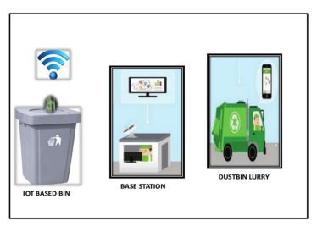

Fig1: Proposed IOT Garbage Monitoring system

For this the system uses ultrasonic sensors placed over the bins to detect the garbage level and compare it with the garbage bins depth. The system makes use of Arduino family microcontroller, LCD screen, Wi-Fi module for sending data and GSM as in Fig1. The LCD screen is used to display the status of the level of garbage collected in the bins whereas a web page is built to show the status to the user monitoring it. Fig 3 shows the flow chart for the proposed IOT based Smart Garbage Monitoring System.

The web page gives a graphical view of the garbage bins and highlights the garbage collected in order to show the level of garbage collected. The ESP8266 Wi-Fi Module works on AT commands. The baud rate of ESP8266 Wi-Fi Module is 9600. The ESP8266 is capable of connecting with Wi-Fi of any other device and after that it can able for hosting data on a webpage.

The servomotor is used for automatically open the lid of the dustbin. Here, ultrasonic senor is implemented to detect an object like hand. Arduino calculates the distance using ultrasonic sensor and if it is less than a predefined value. Arduino will activate the Servo Motor, it will open the lid. After certain time, the lid is automatically closed.

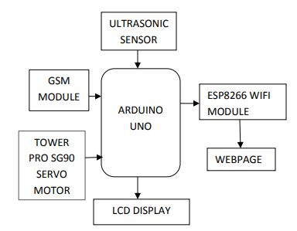

Fig 2: Block Diagram of IOT based Smart Garbage Monitoring System

The various IOT based Smart Garbage Monitoring System main components are as:

1. **Microcontroller**

It get information from sensor process on it. It compares the received data with the threshold level set and accordingly output is generated. In this project we are going to use Arduino Uno in which ATmega328P microcontroller is installed. ATmega328P has 14 digital input/output pins Of which 6 can be used as PWM outputs and 6 analog pins and has a 16 MHz quartz crystal, a USB Connection, a power jack, an ICSP header and a reset button.

1. **WI-FI Modem**

ESP8266 is Wi-Fi enabled system on chip (SoC) module developed by Espressif system.It is mostly used for development of IoT (Internet of Things) embedded applications. ESP8266 maximum working Voltage is 3.6V. It employs a 32-bit RISC CPU based on the Tensilica Xtensa L106 running at 80 MHz (or overclocked to 160 MHz). It has a 64 KB boot ROM, 64 KB instruction RAM and 96 KB data RAM. External flash memory can be accessed through SPI. ESP8266 module is low cost wireless transceiver that can be used for end-point IoT developments. To communicate with the ESP8266 module, microcontroller needs to use set of AT commands. Microcontroller communicates with ESP8266-01 module using UART having specified Baud rate.

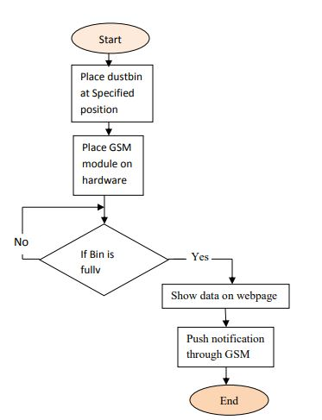

Fig 3: Flow Chart of IOT based Smart Garbage Monitoring System

1. **Ultrasonic Sensor**

The Ultrasonic Sensor sends out a high-frequency sound pulse and then times how long it takes for the echo of the sound to reflect back. The sensor has 2 openings on its front and other is end. One opening transmits ultrasonic waves and the other receives. Servo Motor: A servomotor is a rotary actuator that allows for precise control of angular position, velocity and acceleration. It consists of a suitable motor coupled to a sensor for position feedback.

1. **Think Speak Cloud**

Think Speak is an IOT analytics platform service that allows you to aggregate, visualize and analyze live data streams in the cloud. Think Speak provides instant visualizations of data posted by your devices to Think Speak. With the ability to execute MATLAB code in Think Speak you can perform online analysis and processing of the data as it comes in. Think Speak is often used for prototyping and proof of concept IOT systems that require analytics.

1. **GSM MODULE**

It is used to send message to the garbage depot, if the garbage is exceeds the set threshold level. With the help of GSM module interfaced, we can send short text messages to the required municipal office. GSM module is provided by sim uses the mobile service provider and send sms to the respective authorities as per programmed .It operates at either the 900 MHz or 1800 MHz frequency band.

1. **RESULTS**

Initially the connections have been established as per the circuit diagram in Fig 2. The software or the program has to be loaded onto the Arduino through USB port. 3. Finally, the result has been analyzed on the Think Speak cloud after receiving SMS on the phone by GSM which is shown in Fig 4.



Fig 4: SMS from GSM

Fig. 5 shows the screenshot of Think speak cloud on which a graph is plotted containing the Depth till which the dustbin is filled on y-axis vs Time on x-axis. Any update in this project is depicted on this cloud

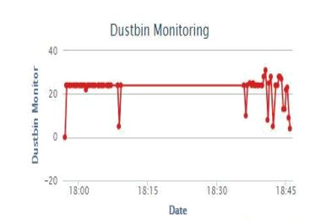

Fig 5: Think speak cloud monitoring

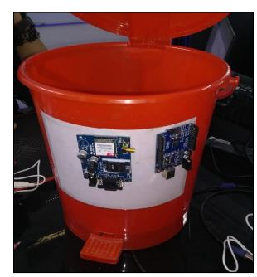

Fig 6: Automatically opening lid using Servo Motor

Fig 6 shows the lid of the dustbin is opened after detecting the position of hand from the ultrasonic sensor.

1. **CONCLUSION AND FUTURE SCOPE**

An efficient garbage monitoring system has been proposed which can be used to monitor the level of garbage in the dump. This data can be further used to plan garbage collection trips more efficiently, ultimately reducing overflowing bins and helping have better public sanitation.

**REFERENCES**

1. Bhat, Vasanthakumar N. "A model for the optimal allocation of trucks for solid waste management." Waste Management & Research 14, no. 1 (1996): 87-96.
2. Draz, Umar, Tariq Ali, Jamshaid Ali Khan, Muhammad Majid, and Sana Yasin. "A real-time smart dumpsters monitoring and garbage collection system." In 2017 Fifth International Conference on Aerospace Science & Engineering (ICASE), pp. 1-8. IEEE, 2017.
3. Joshi, Jetendra, Joshitha Reddy, Praneeth Reddy, Akshay Agarwal, Rahul Agarwal, Amrit Bagga, and Abhinandan Bhargava. "Cloud computing based smart garbage monitoring system." In 2016 3rd International Conference on Electronic Design (ICED), pp. 70-75. IEEE, 2016.
4. Kumar, N. Sathish, B. Vuayalakshmi, R. Jenifer Prarthana, and A. Shankar. "IOT based smart garbage alert system using Arduino UNO." In 2016 IEEE region 10 conference (TENCON), pp. 1028-1034. IEEE, 2016.
5. Muyunda, Namakambo, and Muhammad Ibrahim. "Arduino-based smart garbage monitoring system: Analysis requirement and implementation." In 2017 International Conference on Computer and Drone Applications (IConDA), pp. 28-32. IEEE, 2017.
6. Amponsah, Samuel Kwame, and Said Salhi. "The investigation of a class of capacitated arc routing problems: the collection of garbage in developing countries." Waste management 24, no. 7 (2004): 711-721.
7. Ravindra, Khaiwal, Kamalpreet Kaur, and Suman Mor. "System analysis of municipal solid waste management in Chandigarh and minimization practices for cleaner emissions." Journal of Cleaner production 89 (2015): 251-256.
8. Brunner, Paul H., and Johann Fellner. "Setting priorities for waste management strategies in developing countries." Waste Management & Research 25, no. 3 (2007): 234-240.