PV Applications in Battery Charging

**Monu Malik1, Ratna Dahiya2**

*1 ,2 Department of Electrical Engineering National Institute of Technology, Kurukshetra, India*

1msmalikmonu@msit.in, 2ratna_dahiya@nitkkr.ac.in

***Abstract- This paper represents the execution of lead acid battery by tracking the Maximum Power Point Tracking (MPPT) of PV panel cast-off and later is used for battery charging for stand-alone systems. This paper present the research gasps identified in different state-of-the-art algorithms used by different researchers. This paper presents an Incremental Conductance algorithm for tracking MPPT. For matching the PV panel impedance so that the lead acid battery used in the application will deliver maximum power SEPIC is employed. Hence at varying solar isolation V-I, P-V characteristics are plotted with varying the duty cycles as per the algorithm requirements and maximum power transfer is found at the output.***

***Keywords-, Maximum Power Point Tracking, Incremental Conductance Algorithm, Battery Charging, Single ended primary inductor converter (SEPIC), Photovoltaics.***

1. **INTRODUCTION**

Maximum power point tracking (MPPT) is an essential control technique to harvest the highest photovoltaic (PV) power under varying environmental conditions. Generally, MPPT algorithms are integrated into switching power converters, where the duty ratio of the converter is regulated to deliver maximum available power to the load. However, it has been recently reported that MPPT systems can exhibit various kinds of non-linear phenomena including sub-harmonic oscillations, quasi-periodicity, and chaos [1–3]. These behaviours have direct and serious implications on the reliability and efficacy of the MPPT systems. Unfortunately, the power electronics engineers are unaware of the underlying causes of these phenomena when it occurs in assumed mode of the stable operating region and continue to design the MPPT systems using small-signal averaging (SSA) technique. The SSA method is a linearised analysis technique, which cannot predict the exact switching dynamics of converter-based non-linear MPPT system. However, the principles of non-linear dynamics and bifurcation theory may provide better and more effective solution techniques for the MPPT system [2, 3]. It can offer additional advantages such as control and anti-control of chaos. This can be achieved by delimiting the system's parameter space for the desired mode of operation such as period-1 or chaotic mode. In normal PV applications, the MPPT systems are usually intended to operate in period-1 operation [4, 5]. However, there are existing real-life applications such as solar battery charger, wireless sensor networks, electric vehicles etc., where the chaotic mode of operation is necessary for spreading the spectra of output signals in order to avoid the problem of electro-magnetic interference (EMI) [6]. To operate the MPPT system in the chaotic mode for reduced EMI, the chaotic attractor must be robust under system parameter variations. A chaotic attractor is robust if, for its parameter values, there exists a neighbourhood in the parameter space with no periodic attractor and the chaotic attractor must be unique in that neighbourhood [7]. In a smooth dynamical system, which is everywhere differentiable, the periodic windows are dense in the parameter regions, where there are chaotic attractors [8]. Therefore, robust chaos is not expected to occur in smooth dynamical systems. In [7], it is presented that robust chaos can arise in non-smooth dynamical systems. In particular, one can envisage such a system as a piecewise smooth (PWS) systems, by dividing the phase space into two or more non-overlapping regions. In each region, the dynamical system is described by some smooth functions or maps, under discrete-time modelling that has continuous derivatives. These maps are different for different regions, and hence their derivatives are typically not continuous at the border between adjacent phase-space regions. When there is a fixed point on the border and it goes through a bifurcation as the parameter changes, there is a discontinuous change in the elements of the Jacobian matrix evaluated at the fixed point. Such a bifurcation is called border-collision bifurcation [9, 10]. It has been established mathematically that robust chaos can arise in the neighbourhood of borderline through non-smooth border-collision bifurcation [7]. Since real-life MPPT systems are under the class of PWS systems, the investigation on robust chaotic behaviour of such systems has great importance.

In the topical world the habit of using non-renewable foundation of energy has harshly enlarged. These bio - degradable forms identically as coal petroleum, natural gas, oil etc. has consequences as contamination consequentially pollution, smog, global warming, diminution of Ozone layer etc. Now it is time has reached that we have to think for some other alternative sources of energy which are pollution free, environmentally friendly, it can be achieved when there is a paradigm shift towards the renewable sources of energy which are provided to us by the nature in abundance, and are eco- friendly, pollution free and results in clean and green energy [11]. To encounter the levitation in the demand of the power, PV knowledge which is powerfully growing can be castoff, where solar isolation/ radiations can produce electricity directly. This research is basically grounded on two beliefs as, that for matching the PV panel impedance and to track maximum power SEPIC converter is used and harmless charging of le battery algorithm is used. Accordingly, the paper demonstrates the toil on MPPT algorithm for PV stand-alone system targeting to progress the power allocation from the PV panel [12]. The MPPT algorithm has worked in one of the stages of charging of lead acid battery. Here P& O can also be used but the only limitation with that particular algorithm is that it will work properly with changing environmental conditions as a result incremental conductance algorithm was established. It is created on the statistic that as conductance of the panel increases there is an equal amount of increase in instantaneous panel conductance at MPP. Diverse stages in the battery charging are also discussed. The rest of the paper is organized as follows; section 2 proposed incremental conductance algorithms, section 3 discusses algorithm for charging of battery and Results have been discussed in section 4 followed by conclusion and future.

1. **PROPOSED INCREMENTAL CONDUCTANCE ALGORITHM**

Incremental conductance Algorithm is created on the statistic that a comparative analysis is done between incremental Conductance and instantaneous Conductance. The comparative analysis is represented in Table .1

Table.1. MPP analysis

|  |
| --- |
| incremental Conductance = instantaneous Conductance MPP achieved |
| incremental Conductance > instantaneous Conductance MPP on left of the curve |
| incremental Conductance < instantaneous Conductance MPP on right of the curve |

The oscillations around the maximum power point found in some drawbacks are faced in P&O algorithm as the fluctuations around the MPP and calculation of maximum power point during changing isolations are overcome by Incremental Conductance algorithm. Flow table of proposed algorithm is revealed in fig.1. It can be tacited that when both incremental conductance and instantaneous conductance of the solar PV panel are analysed and compared then MPP is tracked. Value of constant Δ is known as the size if the increment. The value of K depicts how fast and efficiently the system is calculating the MPP [13]. If Δ is higher, better will be the tracking and vice- versa, but it will not operate at MPP rather it will oscillate around the value.

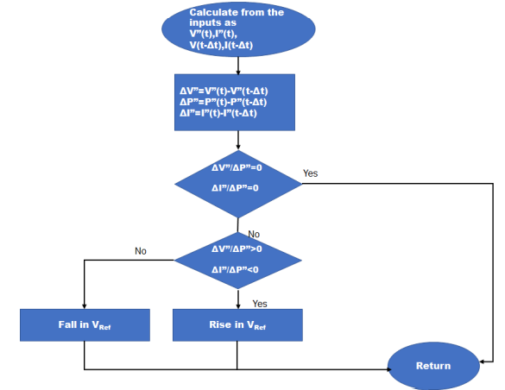

Fig 1: Flow Chart of Incremental Conductance Algorithm

1. **ALGORITHM FOR CHARGING OF BATTERY**

For extensive battery life it is essential that battery should be charged with best and safe algorithm and it should charge the battery rapidly also as sunlight is available to us for the specific period of time i.e. only for the day time and even solar panels used for the generation also produces the limited power. Flow chart that represents the algorithm for battery charging is shown in Fig.3.

The above described algorithm is divided in 4 stages: (a) Dribble/trickle charge (b) bulk/loose charge (c) overcharge and (d) float/drift charge.

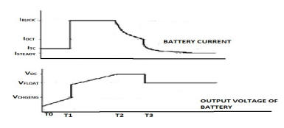

Fig 2: Current and Voltage Curves.

**STAGE I: TRICKLE/DRIBBLE CHARGE** At this stage the battery voltage has reached below the perilous discharge value VCHGENB. To make the battery to work above the voltage higher than VCHGENB, battery requires charging by a small amount of current welldefined by ITC for some hours. As the voltage in the battery builds up to reach the level of VCHGENB then it will proceed towards the 2nd stage.

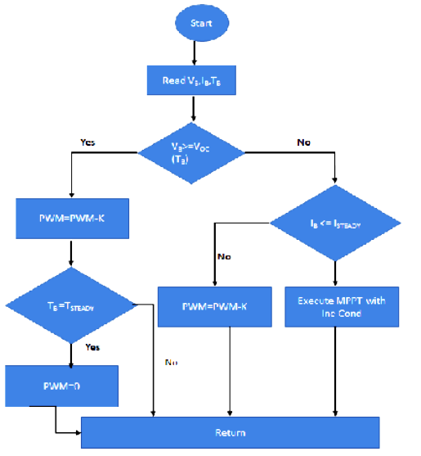

Fig 3: Algorithm of Battery Charging

**STAGE II: BULK/LOOSE CHARGE**

Maximum rated current IBUCK is applied to the battery at this stage so as to charge it completely, the battery as specified by the manufacturers. This current is applied till the battery voltage builds up to maximum value of overcharge voltage VOC.

**STAGE III: OVER CHARGE**

Here the battery is completely charged. The current decreases gradually when the current of the battery reduces IOCT, and it will proceed to the next stage.

**STAGE IV: FLOAT CHARGE**

It is the last stage in the battery charging in which persistent voltage VFLOAT is given to the battery so as to circumvent the auto discharging capabilities of the battery. If the discharging of the battery voltage reduces to 0.9 VFLOAT then algorithm will perform in the 2nd stage else it will get discharge and it may even go lower than the critical discharging value. At this 1st stage is not realized, as an alternative dipping of battery voltage less than the critical discharge voltage is circumvented by detaching load from the battery by implementing control algorithm. 4th stage isn’t executed as an alternative from 3rd stage nonstop 2nd stage is executed if the case a rises that battery voltage verves below finished charge voltage VOC.

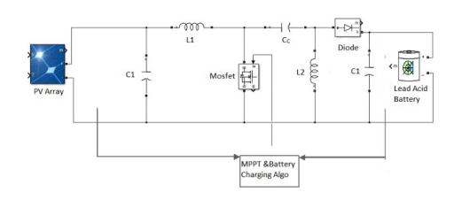

Fig.4 Battery Connected with PV array& SEPIC

1. **RESULTS AND DISCUSSION**

The working of SEPIC is reliant on the switching element called as MOSFET which is functioned by algorithm block as depicted from Fig 3. When saw-tooth wave acting as carrier compared with the reference voltage, PWM is generated. These reference voltages are speckled by algorithm block.

In this two algorithms are absorbed in the algorithm block as:

1. Safe Battery charging algorithm works on voltage and current particulars of battery
2. MPPT, will operate on V-I and P-V characteristics of the PV array with changing solar isolations.

It will change both the reference voltage signal and PWM signal according to the requirement. Fig 5 shows the simulation output of output voltage and current with time (ms).

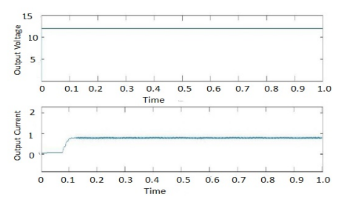

Fig 5: Simulation output of output1 voltage and current with time

Table 2. Results for Cycle1 and Cycle2 MOSFET

|  |  |  |
| --- | --- | --- |
| Cycle 1  MOSFET | ON | Inductor L1 is energized |
| OFF | Energy stored in capacitor CC will get transferred to inductor L1 |
| Cycle 2  MOSFET | ON | L1 get energised and charge is transferred to L2 |
| OFF | Power from L1 get transferred to CC |

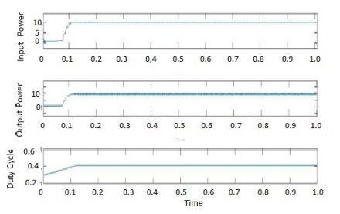

Fig.6 Simulation output of output1 voltage and current with time

Here in Fig.6 another output is represented with input power, output power and duty cycle w.r.t. time (ms).At last, the diode gets forward biased when the power from L2 is provided to load through diode.

1. **CONCLUSION AND FUTURE SCOPE**

In this work maximum power point of the PV cell is obtained with Incremental Conductance algorithm and for matching the PV panel impedance so that the lead acid battery used in the application will deliver maximum power for this SEPIC is employed. Simulation results are also represented and by changing the duty cycle with inputs corresponding outputs are obtained.

**REFERENCES**

1. Xiong, X., Tse, C.K., Ruan, X.: ‘Bifurcation analysis of standalone photovoltaic-battery hybrid power system’, IEEE Trans. Circuits Syst. I, 2013, 60, (5), pp. 1354–1365.
2. Lim, Y.H., Hamill, D.C.: ‘Simple maximum power point tracker for photovoltaic arrays’, Electron. Lett., 36, pp. 997–999, 2000.
3. Maity, S., Sahu, P.K.: ‘Modeling and analysis of a fast and robust module integrated analog photovoltaic MPP tracker’, IEEE Trans. Power Electron., 31, (1), pp. 280–291, 2016.
4. Petrone, G., Spagnuolo, G., Vitelli, M.: ‘An analog technique for distributed MPPT PV applications’, IEEE Trans. Ind. Electron., 59, (12), pp. 4713–4722, 2012.
5. Selcan, D., Kirbis, G., Kramberger, I.: ‘Analog maximum power point tracking for spacecraft within a low earth orbit’, IEEE Trans. Aerosp. Electron. Syst.,52, (1), pp. 368–378, 2016.
6. Deane, J.H.B., Hamill, D.C.: ‘Improvement of power supply EMC by chaos’, Electron. Lett., 32, (12), p. 1045, 1996.
7. Banerjee, S., Yorke, J.A., Grebogi, C.: ‘Robust chaos’, Phys. Rev. Lett., 80, pp. 3049–3052, 1998.
8. Ott, E.: ‘Chaos in dynamical systems’ (Cambridge University Press, Cambridge, England, 2nd edn, 2002.
9. Banerjee, S., Ranjan, P., Grebogi, C.: ‘Bifurcations in two-dimensional piecewise smooth maps – theory and applications in switching circuits’, IEEE Trans. Circuits Syst. I, 47, (5), pp. 633–643, 2000.
10. Yuan, G., Banerjee, S., Ott, E., et al.: ‘Border collision bifurcations in the buck converter’, IEEE Trans. Circuits Syst. I, 45, (7), pp. 707–716, 1998.
11. Jose Antonio Barros Vieira, alexander Manuel Mota, ‘Maximum Power Point Tracker Applied in Batteries Charging with PV Panels’, IEEE Transactions, 2008.
12. Jose Antonio Barros Vieira, alexander Manuel Mota, ‘Implementation of Stand-alone Photovoltaic Lighting System with MPPT Battery Charging and LED current control’, IEEE Multi-Conference on systems and control yokohama, Japan, September 8-10, 2010.
13. M.Kaouane, A.Boukhelifa, A.Cheriti, ‘Design of a synchronous SEPIC DC-DC converter for stand-alone Photovoltaic system’, proceeding of the IEEE 28th Canadian conference on electrical and computer Engineering Halifax, Canada, May 3-6, 2015.