Entering CCL Scorecards

Before starting to add a scorecard, there are certain things that you must be aware of.

At the ground:

1) Ask your scorer at the match to be diligent in keeping the scores. His carelessness will be your nightmare.

2) All information on the scorecard is important and is used to maintain stats. Information such as fielder name, batsman that did not bat, umpires, fall of wickets, etc is also important info and must be tracked correctly, so please make sure that the player’s name is listed and spelt correctly on the scorecard. DO NOT use nicknames.

3) You must have the complete scorecard at hand. That means the scores of both innings – Both the batsmen’s analysis as well as the bowlers’ analysis.

4) Ask the umpires to tally the scorecards before signing the scores. If you are umpiring, do the same.

5) Make sure the paper scorecard before you tallies. The batsmen’s scores plus extras should add up to the total. Similarly the bowler’s runs given plus byes and leg byes should add up to the total. Some scorers add the byes and leg byes to the bowlers’ analysis. If you find this happening, separate them from the bowler’s analysis. It is better to get clarification from the two captains in case of a mismatch.

6) After the match get the scorecard from the other team or ask the captain to email it to you as soon as possible.

7) If you have new players or players that you have acquired from other clubs, please send me an email (kervyn@yahoo.com) so that I can add/re-assign them to your club/team roster before you start with the online scorecard entry.

Before entering the scorecard online:
Please make sure that you have taken care of the list as mentioned in the above section “At the ground”.

You need to know which week’s scorecard you are adding. The week information can be found under ‘League Schedule’, on the website: http://coloradocricket.org/schedule.php?schedule=40&ccl_mode=1

Please go thru your list of players on the CCL website and make sure they are listed.
http://www.coloradocricket.org/players.php
Or make sure that the players are listed under your team page: (http://coloradocricket.org/teams.php)

If you do not see them listed there or not assigned to your team, please contact the web team immediately to make that change.

PLEASE DO NOT ADD/RE-ASSIGN PLAYERS WITHOUT CONFIRMING WITH THE WEB TEAM.

You must have the complete scorecard at hand. That means the scores of both innings – Both the batsmen’s analysis as well as the bowlers analysis. Review an existing scorecard online (http://www.coloradocricket.org/scorecardfull.php?game_id=543&ccl_mode=4) or the screenshots below (Pg 2 and 3) to see what fields are necessary. If you do not have this information, STOP.
Once you start adding a scorecard you have to enter the complete scorecard in one session – THERE IS NO OPTION TO MODIFY AN EXISTING SCORECARD. All three data entry screens must be completed.

For Regular Cricket: The link to enter CCL Scorecards is http://coloradocricket.org/submit
For Tennis Cricket: The link to enter CCL Scorecards is http://tennis.coloradocricket.org/submit

You should try to use FIREFOX as the browser to add scorecards. Other browsers will not refresh the data. In fact a record will be added to the database if you hit the refresh button. So never hit the refresh button if you are using a browser other than firefox.
NOTE: THE BUG STILL EXISTS EVEN IF YOU USE FIREFOX. SO AVOID THE “REFRESH” BUTTON ON YOUR BROWSER.

Most of the columns have drop downs. Sometimes you get to a dropdown and don’t see the correct value in the drop down. This usually will happen with new players. Don’t leave the column blank.
NOTE: If you don’t find the player, substitute him with someone else, and contact the web team to make the change accordingly.

Currently the dropdowns are filtered to show only names of players belonging to the team that is batting or fielding.

Other than that, the screens are self explanatory. If in doubt ask someone.

If you make a mistake contact Kervyn Dimney (kervyn@yahoo.com)

If there are more than a few ( 3 or more ) corrections, the webmasters will delete the scorecard and you will have to re-enter it all over.

SAMPLE ENTRY SCREENS:

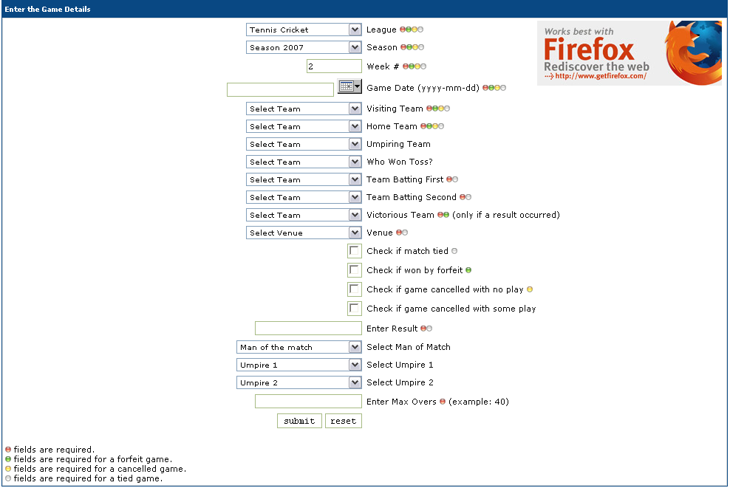

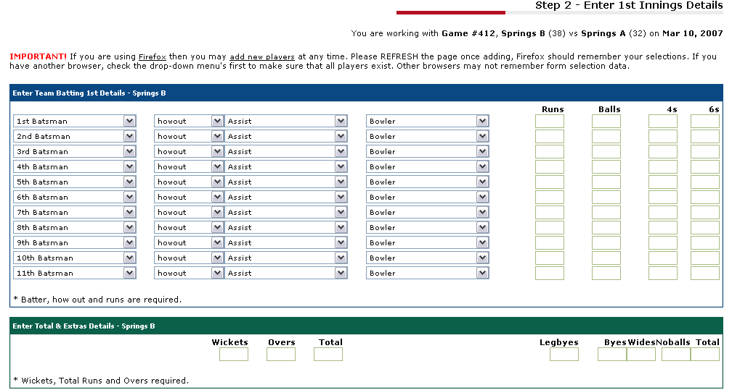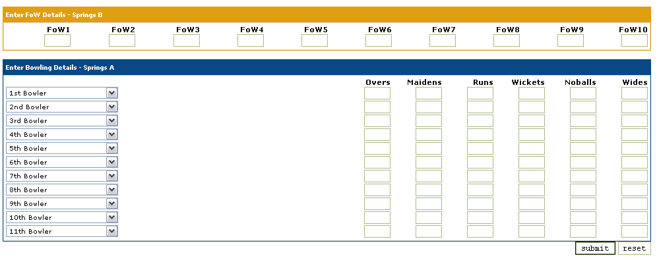
SUMMARY:

- Make sure you have the complete scorecard for both innings
- Make sure all 22 players are currently on the database. If not, request that players be added to the database. Take care to not make duplicate entries for the players.
- Add the scorecard on the three screens.
- Review for errors and let the webmaster know if you make any mistakes.

The web team consists of: Kervyn – kervyn@yahoo.com

