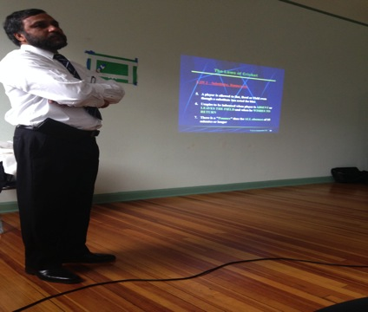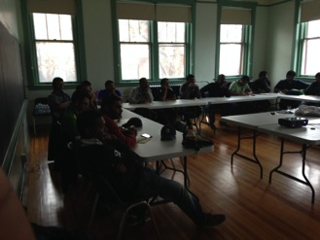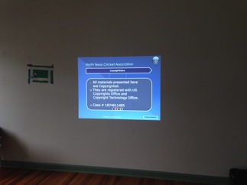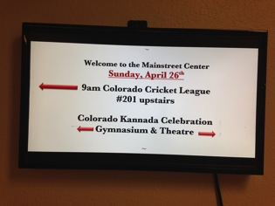

*

Second year in a row Colorado Cricket League has been consciously investing on improving the quality of umpiring. Thanks to League Management Committee and all the constituent clubs for contributing towards this cause. The $100 included as part of the CCL Membership goes a long way in securing a trip from a renowned

4/26/2015

# Anwer Shahabuddin

Umpiring Clinic

Level 1

Umpire like Anwer Shahabuddin to take time off his busy schedule and come spend a day with us in the beautiful Rocky Mountain State.

This year amidst challenges with the schedule, CACU did a fantastic job securing a weekend day dedicated for this Level 1 clinic. This time of the year Colorado springs with activities. All the venues in and around the city of Denver was booked. EC managed to book the Main Street Center classroom that turned out to be an ideal location for this clinic. Nestled in the old town of Parker, it provided easy accessibility for members. The facility could seat 25 people and the turn out was fantastic. Typical of a April spring day, it was cold, rainy, dark and cloudy day. The 20 plus members who pushed themselves to get on the feet, out of the bed and drive all the way here and for some all the way from Fort Collins, EC and CACU really want to thank you for the effort. Without your participation this would not have been successful. Ben George from CACU deserves a special mention for working with EC coordinated this event with the help of Hardik and Ramesh. The room was all setup and ready to go for the 9:00 AM start. Answer himself was there by 8:15 AM. He does take this job seriously. Because of the rain and weather related delay, the event was postponed to start at 9:30 AM. By then we had a room full of people and the quorum was well set.

The material was the same as last year. The ICC Blue Book and Rules & Regulations is followed. Anwer is part of the ECB-ACO organization. There was presentation material, videos and displays to explain the 42 rules of cricket and a lot of discussion pertaining to practical and local rules followed (<http://en.wikipedia.org/wiki/Laws_of_cricket>). The class and interactive session went on for almost 6 hours that included a Pizza lunch break. After the classroom session the participants where given a set of questions. They originally were supposed to get 19 right which was lowered to 16 by Anwer considering various parameters including precedence.



Anwer personally took the answer sheets, takes it home and corrects and verifies them before publishing the results. The results for this round was out May 1st and duly distributed to clubs/league. Out of 21 participants, 15 passed. Congratulations to them who passed. You should be able to conduct umpiring seminars within your clubs to certify CCL umpires (not Level 1). Those who cleared, you should have a * against your name in CCL website so CACU can track the premium differential that CACU will credit individuals/clubs at the end of the season. Please see below the table with the list of those who passed

2015 Level 1 Umpiring Test. Good luck to others and hope can organize these multiple times through the season next year.