Incident Description | Unable to access the QuickBooks company file | Affected Users | Single Primary User
Date and Time of Incident | 16 FEB 2026 at 09:03 PM | Prepared Date | 20 FEB 2026
Environment | Windows RDS + Google Drive + QuickBooks Desktop 2024 | Prepared By | Geo Thomas
Incident Status | Closed | Incident closed Date | 19 FEB 2026

1. Incident Summary
The ticket was initially raised to request a QuickBooks 2024 update on server NRD06-A due to limited remaining user logins. After the update was successfully completed, the user reported a new issue within the same ticket on 16 February 2026: they were unable to open company files hosted on Google Drive from the server, encountering Error 6000, -83 and Error -6123, 0. However, the same company files opened successfully on the user’s local desktop and also when copied to the server’s local profile. This behavior indicated that the issue was related to an environmental access problem rather than company file corruption.
2. Impact Assessment
The incident had a very low operational impact, as a workaround was already provided that allowed users to copy the company file to their server profile and promptly resume work. Although the issue affected access to QuickBooks Desktop 2024 by preventing company files hosted on Google Drive from being opened via the server, there was no complete service outage. Financial operations faced minimal risk of disruption due to the availability of the workaround. The issue was isolated specifically to server-based access through the mapped Google Drive and did not impact QuickBooks operations on local desktop systems.

3. Reason for Major Incident (P2) Declaration
This incident was not declared a P2 Major Incident because its impact was limited to a specific user and server context rather than affecting multiple users or the broader environment. The issue was isolated to accessing company files through the server via Google Drive mapping, while core QuickBooks services remained fully operational. There was no widespread multi-user outage, and users were able to continue their work using the provided workaround of copying the company file to the server’s local profile. Additionally, there was no evidence of data corruption, as the same files opened successfully on local desktops and when accessed locally on the server. Given the limited scope, availability of a functional workaround, and absence of system-wide disruption, the criteria for a P2 Major Incident were not met.

4. Symptoms Observed
- QuickBooks Error 6000, -83 (Access/Network related issue)
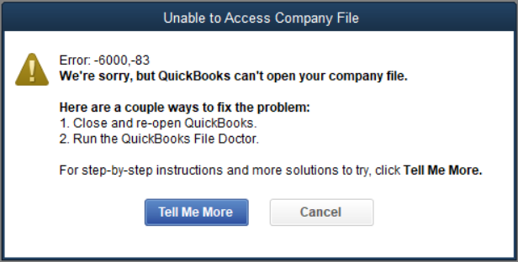

- QuickBooks Error -6123, 0 (Network descriptor or connection issue)
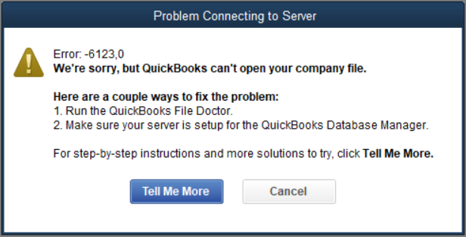

Observations:
- Files open from:
  - Server local profile → Working
- Files fail from:
  - Google Drive mapped location on server → Error

5. Incident Timeline & Chronology
Event | Date & Time
Ticket created for QB update | 14 Feb 2026
QB 2024 updated on NRD06-A | 14 Feb 2026
File access issue reported | 16 Feb 2026 – 09:03 PM IST
Initial troubleshooting & session logout plan | 17 Feb 2026
Server restarted & QBW handles verified cleared | 17 Feb 2026
File copy to server profile tested – successful | 17 Feb 2026
Infrastructure-level issue suspected | 17 Feb 2026
Escalation communication sent | 17 Feb 2026
Remote access coordinated | 19 Feb 2026
QuickBooks & Google Drive reinstalled | 19 Feb 2026
Issue resolved | 19 Feb 2026
Ticket closed | 19 Feb 2026

6. Data collection
The following validations were performed:
- QuickBooks updated to latest release
- All users logged out of server
- Server reboot completed
- Resource Monitor checked for active QBW file handles
- Verified file integrity by copying locally
- Verified issue across multiple company files
- Checked Google Drive mapped drive behavior
- Observed file open success via download folder
- Reviewed file lock handlers
- Tested post deallocation of QB processes

7. Identify Possible Causes:
Initial suspected causes included:
- QuickBooks update issue
- Company file corruption
- Network descriptor (.ND) corruption
- Permission restriction
- Google Drive sync or mapping issue
- File lock by another process
- Antivirus/EDR interference
- Credential token mismatch

8. Root Cause Statement
What Failed
QuickBooks Desktop on the RDS server was unable to properly access company files stored in Google Drive due to a corrupted or unstable Google Drive for Desktop integration and QuickBooks network communication layer.
What Was Confirmed
- Company files were intact
- No corruption detected
- Files opened successfully when:
  - Copied locally
  - Opened from desktop
- Issue reproduced across multiple files in same Google Drive location

Root Cause (Confirmed)
Corruption/misalignment in the Google Drive for Desktop sync client combined with QuickBooks network descriptor dependencies resulted in QuickBooks failing to establish stable file communication when accessing company files via mapped Google Drive path.
Reinstallation of:
- QuickBooks Desktop
- Google Drive for Desktop
Resolved the issue completely.

9. Why This Happened Now (Trigger Analysis)
The issue was likely triggered due to:
- QuickBooks 2024 update interaction with existing Google Drive mapping
- Cached credential/token inconsistency
- Corrupted Google Drive sync metadata
- Persistent stale file handle references
- Layered architecture (QB → Windows → Mapped Drive → Google Sync Engine → Cloud)
Unlike the previous SMB-based file lock incident, this case involved a cloud-synced mapped drive layer.

10. 5-Why Analysis
Problem: QuickBooks could not open company file from Google Drive on server.
- Why?
QuickBooks reported 6000 and -6123 errors.
- Why?
File communication failed through mapped Google Drive path.
- Why?
Google Drive sync client was not properly handling file locks/metadata.
- Why?
Sync metadata/cache likely corrupted after update.
- Why?
No validation or reset of Google Drive client post QuickBooks update.
Root Cause
Corrupted Google Drive sync layer and QuickBooks communication dependency mismatch on the RDS server.

11. Environmental Change Review
Area | Change
Network | No
Firewall | No
OS / Patch | No
QuickBooks Version | Yes (Updated to latest 2024 release)
Google Drive Client | No (Pre-existing installation)
Permissions | No change

12. Contributing Factors
The contributing factors to this incident included the cloud-mapped drive architecture using Google Drive for Desktop, which can introduce file access and synchronization complexities in server environments. QuickBooks’ reliance on a stable file locking mechanism further increased sensitivity to any latency or permission inconsistencies associated with cloud-hosted storage. The RDS multi-user environment added another layer of dependency on consistent network and profile configurations. Additionally, there was a lack of proactive validation testing following the application update, which may have delayed early detection of the access issue. Cached Google Drive authentication tokens could also have contributed to access inconsistencies, along with a potential interaction from the antivirus layer affecting file communication. Finally, limited immediate remote access during troubleshooting may have slowed comprehensive environmental verification.

13. Resolution Summary (Incident Management)
- Ensured all users logged out
- Restarted server
- Verified no active QBW handles
- Validated file integrity
- Coordinated with user for remote session
- Reinstalled QuickBooks Desktop
- Reinstalled Google Drive for Desktop
- Re-mapped drive
- Verified file open success from Google Drive
- Confirmed resolution with user
Service restored successfully on 19 Feb 2026.

14. Corrective & Preventive Actions
Following this incident, the post–QuickBooks update validation checklist will be enhanced to include a file open test from mapped drives, ND and TLG file validation, and a sync client health check to ensure stability in cloud-integrated environments. Cloud storage best practices will be standardized by ensuring company files are marked as “Available Offline” and avoiding streamed-only access mode to prevent file locking and access conflicts. Additionally, a Google Drive cache health check SOP will be implemented, along with a Credential Manager review after major updates and a mandatory QuickBooks File Doctor assessment prior to escalation. Documentation will also be updated to record this as a known issue—highlighting potential instability between QuickBooks and Google Drive mapping in an RDS environment—and an OEM escalation path will be clearly defined should the issue recur.

15. Lessons Learned
Cloud-synced drives introduce additional abstraction layers between the application and the physical storage, which increases troubleshooting complexity when access issues arise. File-based accounting applications are particularly sensitive to synchronization metadata, latency, and file locking mechanisms, making them more prone to errors in cloud-mapped environments. Updates to core applications can also indirectly impact third-party integrations, even when no direct changes are made to the storage platform. This incident reinforces the importance of performing local validation before assuming file corruption, as environmental factors are often the root cause. Additionally, securing early remote access during incident handling can significantly reduce diagnosis time and accelerate resolution.

16. Conclusion
This incident was not due to file corruption or QuickBooks core malfunction. The issue originated from instability in the Google Drive for Desktop sync client on the RDS server after QuickBooks update. Reinstallation of both components restored normal functionality.
*** End of the Document ***

