Retirement Savings Guidelines

|  |  |  |
| --- | --- | --- |
| Savings Goal (x Salary) | | |
| Age | Fidelity1 | Alt3 |
| 25 | 0x | 0x |
| 30 | 0.5x | 0.4x |
| 35 | 1x | 1.4x |
| 40 | 2x | 2.8x |
| 45 | 3x | 4.4x |
| 50 | 4x | 6.3x |
| 55 | 5x | 8.4x |
| 60 | 6x | 10.7x |
| 67 | 8x | 13.9x |

Creating a retirement savings plan can be a challenging endeavor. Really, we want answers to the following questions:

1. How much money do I need to retire?
2. How do I plan my lifetime savings to reach this goal?

Answering these questions is no simple task. It involves financial planning over a time range of several decades and includes many unknown parameters including: investment returns, inflation, taxes, and Social Security changes. If you are actively managing your retirement funds (or trying to estimate the performance of someone else who is managing them) you also have to understand how (and why) retirement investments change over time and build a plan that adapts to include these changes. The mathematics involved can be very complicated, but this brief fact sheet will summarize some key results to help everyone plan for retirement.

# Question 1: How much money do I need to retire?

The answer to this question depends on how much money you will require in retirement and how long you expect to live. Fidelity financial advisors1 suggest that you plan on retiring at age 67 (the age required to earn full Social Security benefits), spending 85% of your pre-retirement income during retirement, and living about 25 years to the age of 92. Under these assumptions, they also suggest that you retire with 8 times your final, pre-retirement savings. For someone who retires making $60,000 this would be $480,000.

It is important to note that these advisors are assuming that you withdrawal full Social Security benefits. Currently, this would provide about 40%2 of your pre-retirement income, meaning that your savings are only required to provide 45% to reach a total of 85%. If you take a more pessimistic view and assume that your savings will be required to cover all of your retirement costs, the goal from Fidelity would nearly double to 15.11 times your final earnings (or $906,667 in the example of someone making $60,000).

Fidelity does not provide much detail about how they arrived at this number nor do they assess the risk that you might reach this savings goal and still run out of money during retirement. For a better understanding of the risk, we must turn to quantitative analysts3 who provide us with the following table. This table depicts the probability of survival (PoS, i.e. probability of not running out of money) during retirement given different withdrawal rates and time spans:

|  |  |  |  |  |  |  |  |  |  |  |
| --- | --- | --- | --- | --- | --- | --- | --- | --- | --- | --- |
|  | Annualized Withdrawal Rate (as a % of Initial Portfolio Value) | | | | | | | | | |
| Payout Period | 3% | 4% | 5% | 6% | 7% | 8% | 9% | 10% | 11% | 12% |
| 15 Years | 100 | 100 | 100 | 100 | 95 | 85 | 72 | 59 | 46 | 35 |
| 20 Years | 100 | 100 | 99 | 91 | 79 | 65 | 51 | 40 | 29 | 21 |
| 25 Years | 100 | 99 | 92 | 80 | 66 | 53 | 40 | 30 | 21 | 14 |
| 30 Years | 100 | 96 | 86 | 72 | 58 | 45 | 34 | 24 | 17 | 11 |

The Fidelity assessment implies a 5.6% withdrawal rate over 25 years which the table indicates will provide a 80-92% probability of covering the entire retirement period. That seems a little bit low. If we instead aim for a 99% probability we must limit our withdrawals to 4% of the balance at retirement. This increases the savings goal to 11.25 times final earnings ($675,000) or 21.25 times final earnings if we expect to cover 100% of our retirement ($1,275,000).

In summary, the savings goal differs based upon your tolerance for risk during retirement. The following table summarizes the different savings targets for the various levels of risk discussed:

|  |  |  |  |  |  |
| --- | --- | --- | --- | --- | --- |
|  | Fidelity Baseline  (Most Risky) | 99% PoS | No Social Sec. | 99% PoS + 50% Security | 99% PoS + No Social Sec. |
| Social Security Benefits  (% of pre-retirement earnings) | 40% | 40% | 0% | 20% | 0% |
| Withdrawal Rate | 5.60% | 4% | 5.60% | 4% | 4% |
| Savings Target  (% of final earnings) | **8 x** | **11.25 x** | **15.11 x** | **16.25 x** | **21.25 x** |
| Savings Target for Someone Making $60k at Retirement | $480,000 | $675,000 | $906,600 | $975,000 | $1,275,000 |

Notice that an extra scenario was added for an investor that expects Social Security benefits to be cut in half by the time he or she retires. This seems a little bit more realistic than assuming it will not be there at all. If this investor still wants to maintain a 99% probability of his/her savings lasting throughout retirement the savings goal becomes 16.25 times final salary (or $975,000). Ultimately, we should expect the savings target to be between 11.25 and 16.25 times your final salary.

# Question 2: How do I plan my lifetime savings to reach this goal?

The table at the beginning of this paper shows Fidelity’s suggested savings plan required to retire with 8 times your final salary. As before, they do not provide much detail about how these targets were obtained. They also continue to make assumptions that seem a bit optimistic, including:

* Saving 6% at age 25 and then increasing by 1% each year until you reach 12% at age 31 and continue to contribute this amount.
* 3% employer matching of savings
* 1.5% annual increase in salary
* 5.5% average annual portfolio growth rate

This last assumption seems to be the most dangerous, since any planning that uses an average rate of return is ignoring the variations in returns and the risks of making less than the average return.

Again, we can look at the work of quantitative analysts3 to provide more detail and build a savings plan that protects us against more of the risks inherent in our investments. The following results come from an analysis of a market with 3 potential investments:

|  |  |
| --- | --- |
| Investment | Avg. Return |
| Stocks (S&P 500) | 8.64% |
| Bonds (long-term, 20 year, Treasury bonds) | 2.88% |
| T-Bills (short-term, 30 day, Treasury Bills) | 0.72% |

All returns are inflation-adjusted, and they are also simulated with the variance/risk relevant to each investment. The simulation continues the earlier assumption of an investor who requires 85% of his pre-retirement income during retirement and is only willing to plan on Social Security delivering half of its currently promised benefits. The investor begins saving when he is 25 years old, contributing 15% of his salary to savings. This 15% matches the final savings level in the Fidelity assessment (12% savings with a 3% matching from employer), but it could be obtained in multiple ways (example: saving 10% with employer matching of 5%). The optimal savings plan under these assumptions (and providing a 95% probability of not running out of money during retirement) is shown in the charts below:

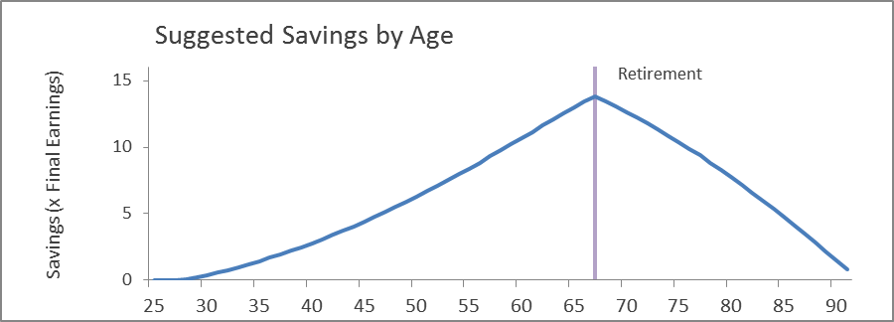

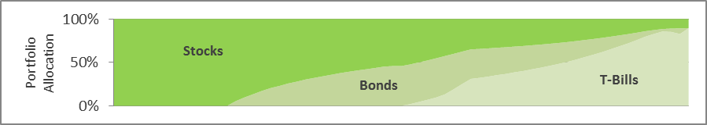

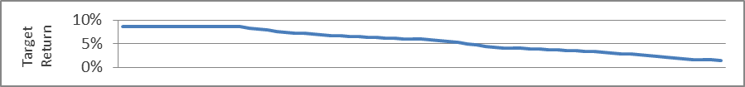

The savings goals for this plan are included in the table at the beginning of this fact sheet (in the column labeled “Alt”). This savings plan starts out similar to the Fidelity plan, but the savings target quickly increases (due to the larger potential returns on stocks) and has a final savings target of 13.9 times salary instead of just 8. The middle graph also shows how the optimal solution is expected to vary its investments over time: investing entirely in high-risk/high-reward investments early in life and later moving towards more conservative, risk-adverse investments. In retirement, the risk-profile is substantially reduced so that the accumulated savings will last throughout retirement.

It is interesting to note how this investment advice compares with that given by traditional retirement-based investment funds. The chart below shows the portfolio allocations recommended by Merrill Lynch:

SOURCE: Merrill Lynch Retirement Date Fund 2050 Prospectus4

The investment profile is similar. It begins with a large allocation in stocks and moves slowly into bonds and cash. Whether one is investing one’s own money or leaving it to professional investors to manage the allocation of investments, the above allocation guidelines provide an overall view of how retirement savings should be allocated among potential investments. These guidelines, combined with the savings amounts and targets by age provide a basic plan for any investor to use and against which progress towards one’s goal can be measured.

# Conclusion

While retirement plans can (and should) be tailored to every individual, this brief fact sheet presents a quick overview for a hypothetical investor. This investor is rather conservative, and requires a 95-99% chance of making it through retirement on his savings. He also is conservative in that he only expects half of the promised Social Security benefits to be available to help him achieve this goal. The result is a savings target of 13.9 times final earnings and a savings plan that begins saving 15% of his income at age 25. While the 15% savings for retirement does match the Fidelity assumptions, it might seem a bit high to some. In fact, one can still attain the same retirement goals by only saving 10% of their salary, but they will have to begin at age 20 instead of age 25.

We have also looked at how retirement investments should be allocated among different asset classes, beginning with high-risk/high-reward investments in stocks at an early age and moving into safer investments as retirement approaches. This is good advice in general and provides a solid baseline for investment decisions. Most investors who take an active interest in their retirement and actively manage their own investments will be tempted to make more targeted investments in specific stocks or funds that they believe will increase their returns. Personally, I think this should be encouraged, especially at an early age when the goal is to take on as much risk/reward as possible. However, it is important to keep in mind that if your savings do fall short of your savings goals, you will need to make up the difference by increasing your savings contributions each year. Also, if you do manage to receive returns in excess of those outlined here, you can choose to either reduce your annual savings for retirement or decide to retire early.

The baseline case outlined above is rather conservative and is built to include the possibility of extremely poor returns. It is very likely that if you follow this savings plan you will obtain savings in excess of the goals above. The average investor who follows this plan can actually expect to leave about 8 times his pre-retirement salary to his estate if he reaches the age of 92. Half of the investors will even leave behind more than that (assuming they don’t realize this before-hand and spend it in retirement). Ultimately, the best advice is to plan wisely and be conservative in your estimates. Use the savings goals in this fact sheet to see how you are doing in saving for retirement and adjust your savings accordingly. If you do this, you will likely find that you have more money than you need in retirement and you can choose to either spend lavishly or leave behind wealth for future generations.

# References

1 Carrns, Ann. Suggested Retirement Savings Goals by Age. NY Times Blogs. September 12, 2012. <http://bucks.blogs.nytimes.com/2012/09/12/suggested-retirement-savings-goals-by-age/?_php=true&_type=blogs&_r=0>

2 Social Security Agency. Social Security Benefits Amounts. <http://www.ssa.gov/oact/cola/Benefits.html> Accessed: July 12, 2014.

3 Rogers, Daniel. Optimizing Retirement Portfolios. [unpublished, email author for a copy: bodhi.root@gmail.com].

4 Merrill Lynch. Retirement Date Fund 2050 Prospectus.