Persistence of Returns

# Overview

Modern Portfolio Theory (and other methods of stock assessment) require us to estimate the average expected return on an asset as well as the volatility of those stocks. While the mean return and standard deviation can easily be obtained from historical data, we have to ask whether these are relevant to future performance. Of course, we frequently hear in stock analysis that “past performance is not necessarily indicative of future results.” This begs the question: can historical returns be used to estimate future ones? This analysis will show that the answer is a pretty emphatic “no.” However, volatility of a stock does seem to be more persistent. A similar analysis is performed for alpha and beta to determine if past performance can be used to estimate future results. The result is similar in that beta persists across year, but alpha does not.

# Data

Historical data from 2008 to the present for stocks in the S&P 500 was obtained from Yahoo. Adjusted closing prices which account for dividends and splits were used. Daily returns were calculated both using arithmetic and logarithmic returns.

# Average Returns and Standard Deviations

First, we took two sample years (2015 & 2016) and calculated the average daily return and standard deviation of returns for the 469 stocks in the data set. Results are plotted below with the market portfolio (The S&P 500) plotted in red:

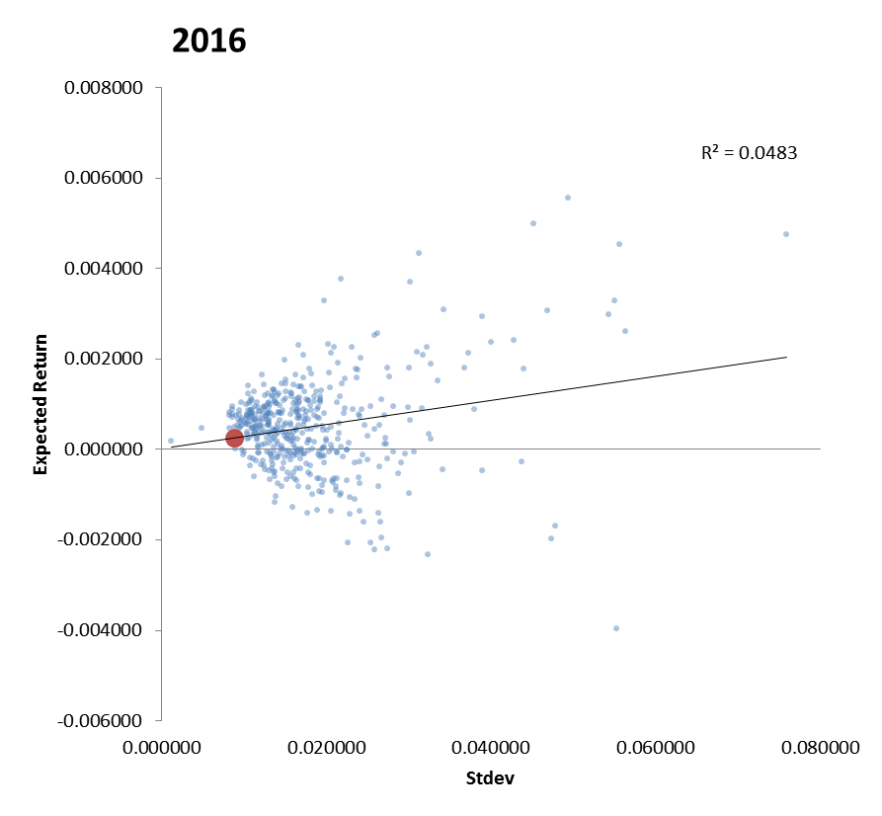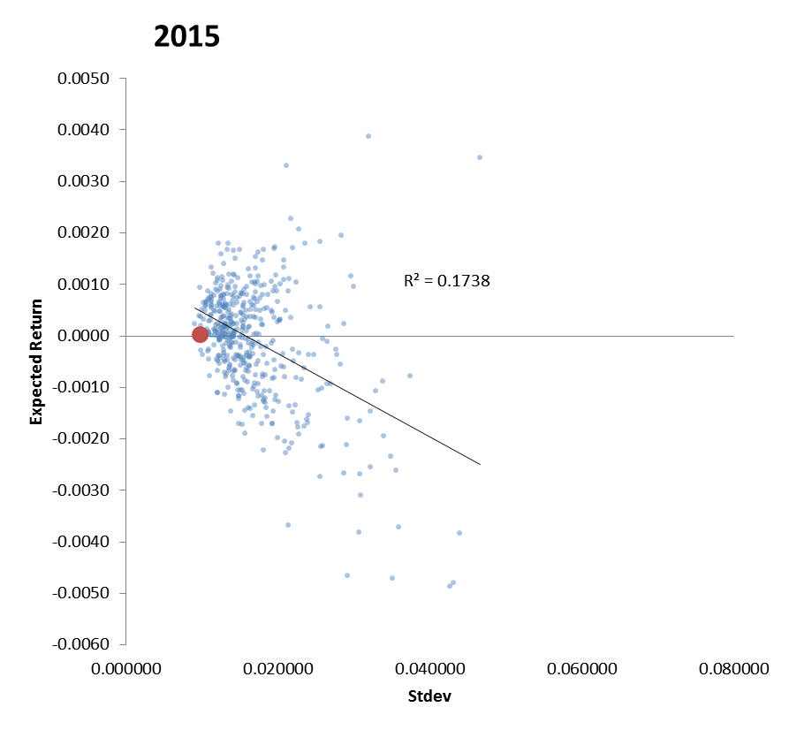

Note that the market portfolio does have very low variability (due to its large diversification). Its return is also just about equal to the average return of all assets. When we order stocks from largest to smallest returns, the market portfolio ranks 245 out of 469 in 2016 and 290 out of 469 in 2015. Neither of these years show a strong correlation between average returns and volatility.

When we compare the stock returns and volatility between the two years we see the following:

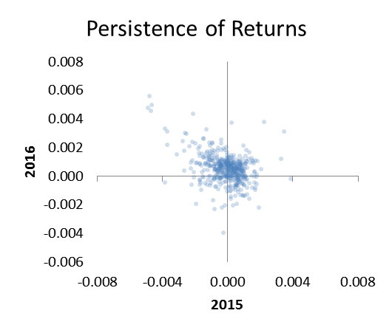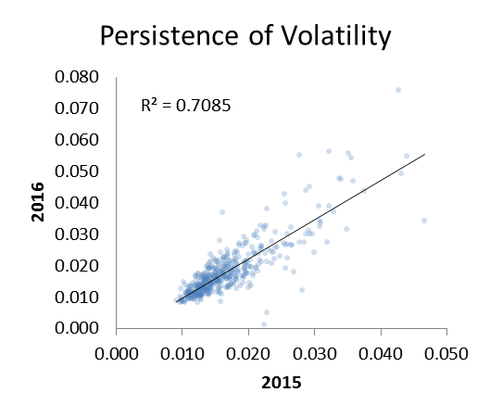

Individual stock returns from 2015 do not appear to be correlated with 2016 returns at all. If anything, there might signs of a negative correlation as we do see a long tail in the second quadrant corresponding with stocks that had negative returns in 2015 and positive returns in 2016. Unlike returns, volatility does seem to be very persistent between years. The correlation is 0.7085, implying that last year’s volatility can be predictive of this year’s.

The same analysis was repeated for all years in the data set. First, we find that correlation between average returns and volatility is spurious, appearing positive in some years, negative in others, and rarely exceeds 0.4 in magnitude:

*Table 1: Average Returns, Standard Deviations, and Correlation between them*

|  |  |  |  |  |  |  |  |
| --- | --- | --- | --- | --- | --- | --- | --- |
| Year | Stocks | Avg. Return | Avg. Stdev | Correlation |  | Year | Annualized Return |
| 2007 | 449 | 0.00048 | 0.01819 | 0.0832 |  | 2007 | 12.7% |
| 2008 | 453 | -0.00115 | 0.03982 | -0.2179 |  | 2008 | -25.0% |
| 2009 | 456 | 0.00195 | 0.03157 | 0.6066 |  | 2009 | 62.7% |
| 2010 | 459 | 0.00098 | 0.01856 | 0.3289 |  | 2010 | 27.9% |
| 2011 | 466 | 0.00024 | 0.02178 | -0.3575 |  | 2011 | 6.3% |
| 2012 | 469 | 0.00082 | 0.01590 | 0.2866 |  | 2012 | 22.7% |
| 2013 | 469 | 0.00134 | 0.01406 | 0.3775 |  | 2013 | 39.7% |
| 2014 | 469 | 0.00060 | 0.01384 | -0.0582 |  | 2014 | 16.2% |
| 2015 | 469 | -0.00009 | 0.01677 | -0.4169 |  | 2015 | -2.1% |
| 2016* | 469 | 0.00050 | 0.01813 | 0.2197 |  | 2016 | 13.4% |
| Avg. | 463 | 0.00057 | 0.02086 | 0.0852 |  | Avg | 17.4% |

* Partial year

The correlation between years is shown in the table below. As we saw with the sample years (2015 & 2016), volatility – as measured by the standard deviation – is highly persistent between years. Last year’s volatility does seem to be a related to this year’s. However, the average return is not related in this way. In half the years, the correlation is negative. This is especially true in 2009 and 2016, two years that occurred after large losses in the market. In these years, large losses actually appear to be indicative or large recoveries the following year.

*Table 2: Correlation of Mean and Std. Deviation with Previous Year*

|  |  |  |  |  |  |  |
| --- | --- | --- | --- | --- | --- | --- |
|  |  | Arithmetic Returns | |  | Logarithmic Returns | |
| Year | Stocks | Mean | Stdev |  | Mean | Stdev |
| 2008 | 449 | -0.1369 | 0.5201 |  | -0.0118 | 0.4925 |
| 2009 | 453 | -0.5338 | 0.8612 |  | -0.5346 | 0.8639 |
| 2010 | 456 | 0.2287 | 0.7215 |  | 0.0974 | 0.7226 |
| 2011 | 459 | -0.0464 | 0.8485 |  | -0.0412 | 0.8511 |
| 2012 | 466 | -0.0127 | 0.8042 |  | -0.0170 | 0.8062 |
| 2013 | 469 | 0.0821 | 0.8284 |  | 0.0212 | 0.8245 |
| 2014 | 469 | 0.0603 | 0.7730 |  | 0.0245 | 0.7673 |
| 2015 | 469 | 0.3268 | 0.7213 |  | 0.3608 | 0.7327 |
| 2016* | 469 | -0.3896 | 0.8417 |  | -0.2584 | 0.8476 |
| Avg |  | -0.0468 | 0.7689 |  | -0.0399 | 0.7676 |

# Analysis of Alpha & Beta

Modern Portfolio Theory proposes that an asset’s return is correlated with beta rather than its own volatility. Beta is a measurement of how volatile a stock is in comparison with the market. It is estimated by performing a regression of a stock’s returns against the market’s returns using the formula:

$$R_{a}-R_{f}=α+β\left(R_{M}-R_{f}\right)+ϵ$$

$R_{a}-R_{f}$ Excess return of asset ($R_{a}$) versus risk-free rate ($R_{f}$)

$R_{M}-R_{f}$ Excess return of the market ($R_{M}$) versus risk-free rate ($R_{f}$)

$α,β$ Regression constants

$ϵ$ Residual error

To simplify this, I performed the regression using daily returns and setting $R_{f}=0$. Daily, risk-free returns are close enough to zero that this shouldn’t be too bad. Histograms for alpha and beta values in 2015 are below. The median alpha was 0.0002733 (corresponding to a 7.07% annualized return). I’m not sure what to make of this. Theoretically, this should be zero, and 7.07% is too high for it to be trying to estimate the risk-free rate. The median beta was 1.08, indicating that most stocks were slightly more volatile than the market.

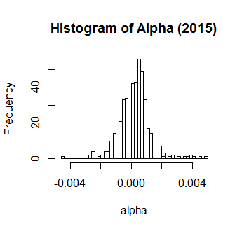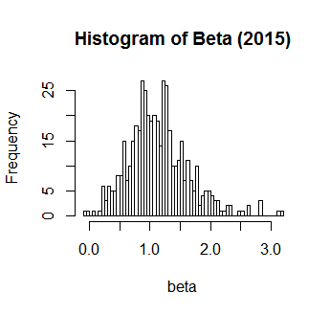

Scatter plots for alpha, beta, avg. returns, and the standard error of residuals are below:

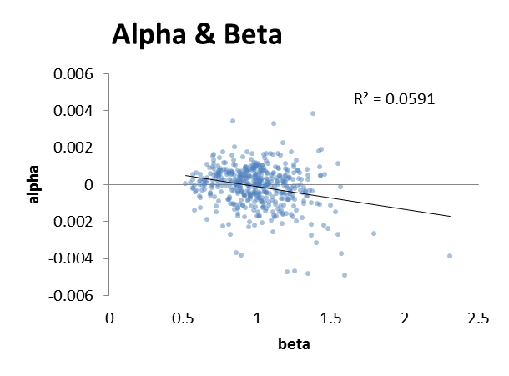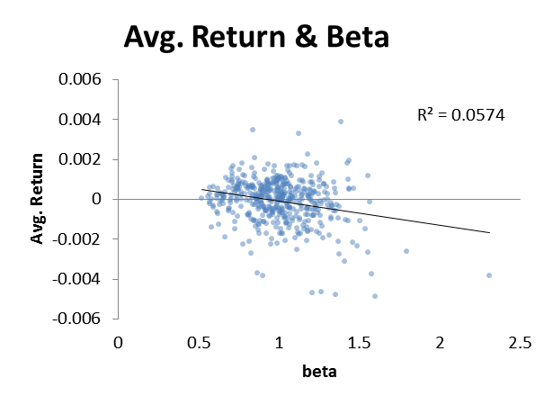

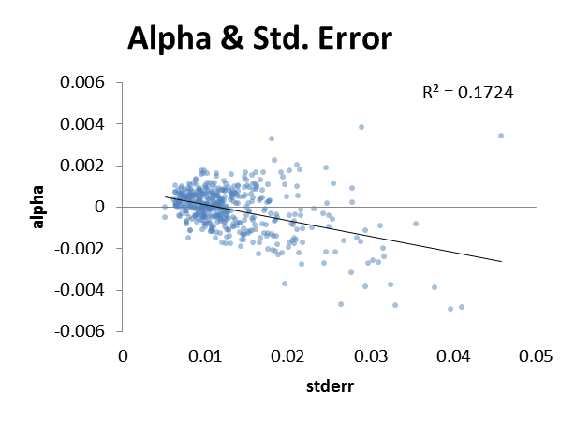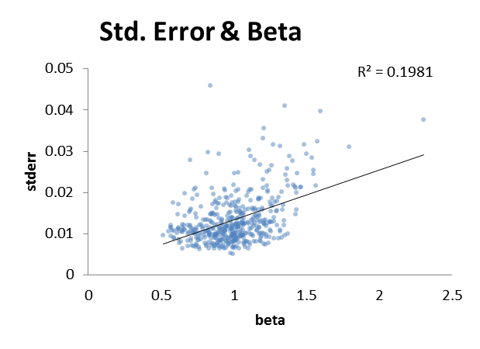  
Notice that the plots of alpha versus beta and average returns versus beta are nearly identical. This is to be expected, since alpha should just be the difference between the average return of the stock and those of the market portfolio. However, the relationship that we might expect between risk and return does not appear. In 2015, increased risk was associated with lower returns. This is the opposite of what MPT predicts but may be explained due to negative returns in the market that year and a high degree of correlation of individual asset returns with the market.

Once again, we perform this analysis for each of the years in the dataset and get the following results:

*Table 3: Average values of Alpha and Beta*

|  |  |  |  |  |  |  |  |
| --- | --- | --- | --- | --- | --- | --- | --- |
|  |  |  |  |  |  | Annualized | |
| Year | Stocks | Avg. Alpha | Avg. Beta |  | Year | Avg. Return | Avg. Alpha |
| 2007 | 468 | 0.0003 | 1.0197 |  | 2007 | 12.7% | 7.4% |
| 2008 | 468 | 0.0006 | 1.0832 |  | 2008 | -25.0% | 15.3% |
| 2009 | 468 | 0.0007 | 1.2266 |  | 2009 | 62.7% | 20.6% |
| 2010 | 468 | 0.0004 | 1.1040 |  | 2010 | 27.9% | 10.1% |
| 2011 | 468 | 0.0001 | 1.1123 |  | 2011 | 6.3% | 3.2% |
| 2012 | 468 | 0.0002 | 1.0933 |  | 2012 | 22.7% | 6.1% |
| 2013 | 468 | 0.0002 | 1.0819 |  | 2013 | 39.7% | 5.1% |
| 2014 | 468 | 0.0001 | 1.0409 |  | 2014 | 16.2% | 3.3% |
| 2015 | 468 | -0.0001 | 1.0009 |  | 2015 | -2.1% | -2.6% |
| 2016 | 468 | 0.0002 | 1.1373 |  | 2016 | 13.4% | 5.6% |
| Avg. | 468 | 0.0003 | 1.0900 |  | Avg. | 17.4% | 7.4% |

*Table 4: Correlation between Alpha, Beta, and Residual Error*

|  |  |  |  |  |  |  |
| --- | --- | --- | --- | --- | --- | --- |
| year | Stocks | Alpha/Beta | Alpha/Stderr | Beta/Stderr | Avg. Return / Beta | Avg. Return / Stderr |
| 2007 | 468 | 0.0110 | 0.0712 | 0.4574 | 0.0565 | 0.0937 |
| 2008 | 468 | 0.2444 | 0.1549 | 0.7755 | -0.2234 | -0.1972 |
| 2009 | 468 | 0.1104 | 0.3476 | 0.7352 | 0.5182 | 0.6018 |
| 2010 | 468 | 0.1036 | 0.1550 | 0.4803 | 0.3108 | 0.2519 |
| 2011 | 468 | -0.4230 | -0.2509 | 0.4530 | -0.3957 | -0.2392 |
| 2012 | 468 | 0.0068 | 0.1364 | 0.4835 | 0.2694 | 0.2575 |
| 2013 | 468 | 0.0402 | 0.2251 | 0.3047 | 0.3803 | 0.3129 |
| 2014 | 468 | -0.2262 | -0.1195 | 0.4029 | -0.0445 | -0.0470 |
| 2015 | 468 | -0.2431 | -0.4152 | 0.4450 | -0.2396 | -0.4139 |
| 2016 | 468 | 0.0099 | 0.1501 | 0.6216 | 0.1320 | 0.2247 |
| Avg. | 468 | -0.0366 | 0.0455 | 0.5159 | 0.0764 | 0.0845 |

The correlation between alpha and any of these terms is spurious. The correlation of average returns to volatility (as measured by beta or std. error) is also inconsistent. The one relationship that appears to be persistent is that between beta and standard error. Beta measures the volatility of the stock relative to the market, and the standard error measures the variability remaining after accounting for the market fluctuations. The results above imply that stocks which are volatile are volatile on both measures.

Next, we look to address the question of persistence. Do last year’s values of alpha and beta help us predict this year’s? The chart below shows the results for 2008 through 2016. These match well with what we had seen earlier: while it is difficult to predict next year’s returns (or excess returns) based on last year’s, volatility (and volatility relative to the market) due appear to persist. If a stock’s movements were correlated with the market last year, they are likely to be correlated in a similar way this year. Similarly, if the residual error of the stock after accounting for this correlation was large last year (i.e. the stock was volatile), this is likely to be true this year as well.

*Table 5: Correlation of Alpha, Beta, and Residual Error with Previous Year*

|  |  |  |  |  |  |  |  |  |
| --- | --- | --- | --- | --- | --- | --- | --- | --- |
|  |  | Arithmetic Returns | | |  | Logarithmic Returns | | |
| year | n.stocks | Alpha | cor.beta | cor.sderr |  | cor.alpha | cor.beta | cor.sderr |
| 2008 | 468 | -0.1632 | 0.6938 | 0.4537 |  | -0.0579 | 0.6978 | 0.4310 |
| 2009 | 468 | -0.4008 | 0.8137 | 0.8394 |  | -0.4278 | 0.8199 | 0.8437 |
| 2010 | 468 | 0.1107 | 0.8216 | 0.6169 |  | 0.0374 | 0.8223 | 0.6138 |
| 2011 | 468 | 0.0187 | 0.8440 | 0.7352 |  | 0.0398 | 0.8441 | 0.7336 |
| 2012 | 468 | 0.0580 | 0.8247 | 0.8033 |  | 0.0696 | 0.8251 | 0.8012 |
| 2013 | 468 | -0.0577 | 0.7217 | 0.8236 |  | -0.0910 | 0.7247 | 0.8147 |
| 2014 | 468 | 0.0400 | 0.6681 | 0.7558 |  | 0.0253 | 0.6689 | 0.7450 |
| 2015 | 468 | 0.3341 | 0.7203 | 0.7215 |  | 0.3672 | 0.7209 | 0.7314 |
| 2016* | 468 | -0.3354 | 0.8105 | 0.8268 |  | -0.2022 | 0.8108 | 0.8308 |
| Avg | 468 | -0.0440 | 0.7687 | 0.7307 |  | -0.0266 | 0.7705 | 0.7272 |

# Additional Thoughts

Something we didn’t find in the results above was a relationship between risk and return. The scatter plots above are difficult to interpret, so in this section we break the stocks down into quintiles (5 groups of roughly equal size) based on different properties and look for relationship there. First, we look at average return versus volatility. In 2015, we find that stocks with larger volatility were actually bigger losers:

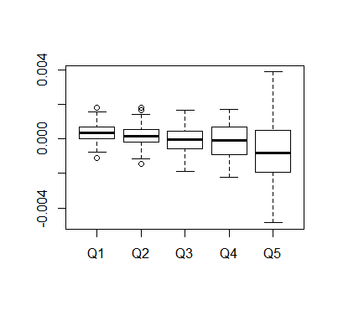

Volatility Quintile

Alpha versus volatility looks similar:

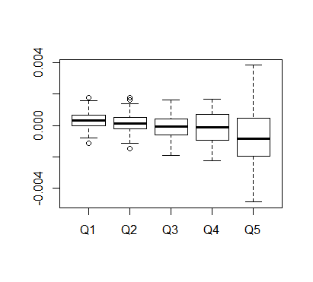

Volatility Quintile

Both of these charts show that the fifth quintile of volatility has an especially large range of returns. This might be one that we’d want to avoid if we are risk-averse, but it is also has the possibility to be the most profitable group of stocks. The range of returns in this group is more than double that of the others.

When we looked for a relationship between alpha and beta, we didn’t find one. This might actually be a verification of MPT, since it would theorize that the expected value of alpha should be zero. The plot below breaks the stocks into quintiles based upon beta. In all cases, the average value of alpha is near zero. Interestingly, we don’t see the high range of outcomes in the 5th quintile that we did when we looked at volatility alone.

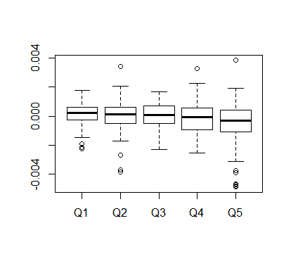

Beta Quintile