Statistical Significance of Stock Returns

# Overview

How does one measure the success of an investment strategy? Typically, we compare our returns to those of the market, and if we outperform the market, we declare our strategy a success. But what about statistical significance? Are superior returns in one year enough to be certain our method is sound, or is it possible that it was just luck? It turns out that there is a very good chance that superior returns in a single year are the result of luck. Even more, we find that the probability of luck being a big factor increases as the volatility of our stock picks increase. This paper will put superior stock returns to the test of statistical significance. We will find that most stock returns are not statistically different from zero. Superior performance in one year could very well just be the result of luck – especially if one is pursuing a risky strategy with volatile stocks. The result will be a framework for measuring the performance of investment strategies that takes into account both the risk (volatility) and return of the investment method and set a standard by which we can be confident that superior returns are a result of investment skill rather than pure luck. During the course of this analysis we will also encounter some stock returns that we can confidently assert to be positive and consistent over time. These will beg the question of whether a profitable investment strategy can be built by sifting through the noise and investing in these high-performing stocks.

NOTE: These weren’t the questions I set out to answer initially. At first, I was looking for relationships between stock market returns and volatility (as measured by standard deviation of returns, beta, and market-adjusted, residual error). I wasn’t finding the relationships that are predicted by modern portfolio theory. Return did not seem to correlate with any of these measures of risk. If this is true, then what purpose does volatility play in an analysis of stocks? Also, what is the goal of a superior investment strategy? Was it just to increase alpha, or did the volatility of the returns matter as well? Would I settle for a lower alpha if I also had lower volatility, or should I look for the highest returns even if they come with extreme volatility? It turns out that these questions are intimately related to the question of statistical significance – although I didn’t realize that at first. The method described in this paper relates stock returns and volatility in a very nice way that does not require us to assert a linear relationship between the two (which is good – since I couldn’t find evidence of any such relationship). It also provides a means of understanding why the stock market appears so chaotic and why investments that look great over one period can easily turn sour the next. Indeed, there is so much noise in the market that it is surprising that we are able to make any mathematically sound inferences at all. After doing this analysis, I’m pretty convinced that most financial commentators, speculators, and technical traders are just chasing their tails and trying to explain fluctuations that are mathematically no different from random noise.

**What Can We Learn from One Year of Stock Returns?**

If we are looking at how a stock performed over the past year and trying to make inferences about how it will perform next year, we are essentially trying to make conclusions from a single data point. Statistically, this is impossible. We might have more to say about a stock’s performance if we look at daily stock returns over that same year. In this case, we have about 252 data points which should lend some support to our conclusions. We can calculate the average return over the past year, and the standard deviation (volatility) of those returns. However, we might stop to ask ourselves: are these returns statistically significant? (Side note: we also might not stop to ask ourselves this. I went through 4 years of finance classes and I don’t remember this ever being discussed. The literature online – while it does exist if you dig for it – also is much more lacking than I would have expected).

The table below shows average daily returns and standard deviations of those returns for the top 10, bottom 10, and market (S&P 500) stocks in 2015. Student’s T test (df=251) is used to calculate a test statistic and P value indicating the probability that the sample mean (the average return) resulted was drawn from a distribution where the true mean was zero.

|  |  |  |  |  |  |  |  |
| --- | --- | --- | --- | --- | --- | --- | --- |
|  |  | Daily Returns | | | |  | Annualized |
| Rank | Symbol | Avg Return | Stdev | T Value | P Value |  | Avg Return |
| 1 | NFLX | 0.0039 | 0.032 | 1.926 | 0.055 | . | 164.99% |
| 2 | CSC | 0.0035 | 0.047 | 1.177 | 0.240 |  | 138.71% |
| 3 | AMZN | 0.0033 | 0.021 | 2.483 | 0.014 | * | 129.86% |
| 4 | NVDA | 0.0023 | 0.022 | 1.658 | 0.099 | . | 77.05% |
| 5 | CVC | 0.0021 | 0.023 | 1.438 | 0.152 |  | 68.11% |
| 6 | FSLR | 0.0019 | 0.028 | 1.089 | 0.277 |  | 63.30% |
| 7 | AVGO | 0.0018 | 0.026 | 1.131 | 0.259 |  | 58.26% |
| 8 | HRL | 0.0018 | 0.012 | 2.342 | 0.020 | * | 57.37% |
| 9 | EXPE | 0.0018 | 0.024 | 1.209 | 0.228 |  | 57.11% |
| 10 | VRSN | 0.0018 | 0.013 | 2.106 | 0.036 | * | 56.76% |
|  |  | … | … | … | … |  |  |
| 245 | GSPC | 0.0000 | 0.010 | 0.030 | 0.976 |  | 0.47% |
|  |  | … | … | … | … |  |  |
| 460 | MUR | -0.0027 | 0.026 | -1.705 | 0.089 | . | -49.93% |
| 461 | MU | -0.0031 | 0.031 | -1.594 | 0.112 |  | -54.31% |
| 462 | KMI | -0.0037 | 0.021 | -2.737 | 0.007 | ** | -60.53% |
| 463 | ATI | -0.0037 | 0.036 | -1.643 | 0.102 |  | -60.88% |
| 464 | FOSL | -0.0038 | 0.031 | -1.979 | 0.049 | * | -61.94% |
| 465 | FCX | -0.0038 | 0.044 | -1.387 | 0.167 |  | -62.10% |
| 466 | JOY | -0.0047 | 0.029 | -2.531 | 0.012 | * | -69.17% |
| 467 | SWN | -0.0047 | 0.035 | -2.127 | 0.034 | * | -69.54% |
| 468 | CNX | -0.0048 | 0.043 | -1.763 | 0.079 | . | -70.19% |
| 469 | CHK | -0.0049 | 0.043 | -1.810 | 0.072 | . | -70.77% |

Signif. codes:  0 ’***’ 0.001 ’**’ 0.01 ’*’ 0.05 ’.’ 0.1 ’ ’ 1

Even in this set of extreme returns, we see that only 12 out of 20 of these observations were statistically significant at the 0.1 level. Some of the stocks with the largest returns – such as CSC at 138% fail the test of significance. Instead, it appears possible – perhaps even probable – that these large returns are the result of large volatility and that we would be equally likely to see large losses in any given year.

Out of the entire sample of 469 stocks, we find that only 26 (5.5%) of the returns were statistically significant. These 26 stocks are shown below:

|  |  |  |  |  |  |  |
| --- | --- | --- | --- | --- | --- | --- |
|  | Daily Returns | | | |  | Annualized |
| Symbol | Avg Return | Stdev | T Value | P Value |  | Avg Return |
| KMI | -0.0037 | 0.021 | -2.737 | 0.007 | ** | -60.5% |
| JOY | -0.0047 | 0.029 | -2.531 | 0.012 | * | -69.2% |
| AMZN | 0.0033 | 0.021 | 2.483 | 0.014 | * | 129.9% |
| HRL | 0.0018 | 0.012 | 2.342 | 0.020 | * | 57.4% |
| SWN | -0.0047 | 0.035 | -2.127 | 0.034 | * | -69.5% |
| VRSN | 0.0018 | 0.013 | 2.106 | 0.036 | * | 56.8% |
| STZ | 0.0016 | 0.013 | 2.002 | 0.046 | * | 49.1% |
| RAI | 0.0017 | 0.013 | 1.982 | 0.049 | * | 52.1% |
| FOSL | -0.0038 | 0.031 | -1.979 | 0.049 | * | -61.9% |
| M | -0.0022 | 0.018 | -1.947 | 0.053 | . | -43.0% |
| NFLX | 0.0039 | 0.032 | 1.926 | 0.055 | . | 165.0% |
| GPS | -0.0019 | 0.016 | -1.913 | 0.057 | . | -38.0% |
| PSA | 0.0013 | 0.011 | 1.861 | 0.064 | . | 39.6% |
| SBUX | 0.0017 | 0.014 | 1.857 | 0.065 | . | 52.0% |
| BBBY | -0.0017 | 0.015 | -1.819 | 0.070 | . | -34.9% |
| CHK | -0.0049 | 0.043 | -1.810 | 0.072 | . | -70.8% |
| CMI | -0.0017 | 0.015 | -1.779 | 0.076 | . | -35.2% |
| TSS | 0.0017 | 0.015 | 1.770 | 0.078 | . | 52.2% |
| CNX | -0.0048 | 0.043 | -1.763 | 0.079 | . | -70.2% |
| EFX | 0.0014 | 0.013 | 1.718 | 0.087 | . | 42.2% |
| NOV | -0.0023 | 0.021 | -1.710 | 0.088 | . | -43.6% |
| MUR | -0.0027 | 0.026 | -1.705 | 0.089 | . | -49.9% |
| BEN | -0.0015 | 0.014 | -1.676 | 0.095 | . | -30.9% |
| DPS | 0.0012 | 0.012 | 1.659 | 0.098 | . | 35.5% |
| NVDA | 0.0023 | 0.022 | 1.658 | 0.099 | . | 77.1% |
| EQIX | 0.0015 | 0.014 | 1.657 | 0.099 | . | 46.1% |

The chart below illustrates the entire dataset of 469 stocks. Statistically significant returns are colored red, and the dashed lines show the thresholds for statistical significance. Notice that most stocks fall between the dashed lines, making it difficult for us to conclude that the majority of stock returns are anything other than random noise. In fact, we would expect just such a dispersion of results if the average return for all stocks was exactly zero, and we drew 252 completely random samples.

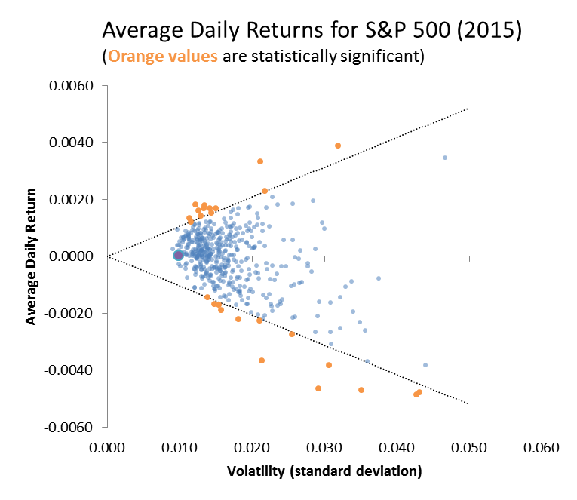  
Alpha and Beta

Another common technique in stock analysis is to measure “alpha” and “beta” for a stock. This is done by fitting a linear model to the stock returns (*R*), regressing them against returns from a market portfolio (*RM*):

NOTE: *RF* is the return of a risk-free asset.

The assumption is that most stocks move in accordance with the overall market – some swinging more violently than others. The coefficient $β$ captures this relationship with the market, and the coefficient $α$ is the average return after accounting for market fluctuations and volatility. The linear regression also provides methods to test for the statistical significance of the coefficients, so that we have yet another way to measure whether stock returns are significant.

When we perform this analysis on the same universe of stocks as the previous section (S&P 500, adjusted daily returns), we get some interesting results. First, every single $β$ is statistically significant. In fact, they are highly significant. The largest p value is 0.005189. Perhaps this should be expected since the market portfolio (the S&P 500 index) is formed from these very same stocks, but it really surprised me. When we examine alpha, we find that 64 out of 468 stocks (13.7%) are statistically significant. While this still isn’t a lot, it is 3 times more than what we found using just the average returns of the individual stocks. The chart below shows the universe of stocks as measured using alpha and beta coefficients. Note that there are no clear boundaries for statistical significance in this chart. The magnitude of alpha alone is not enough to tell us if it is significant or not. The significance depends upon the volatility of the stock returns, and more importantly, on the volatility of those returns after adjusting for market-wide effects.

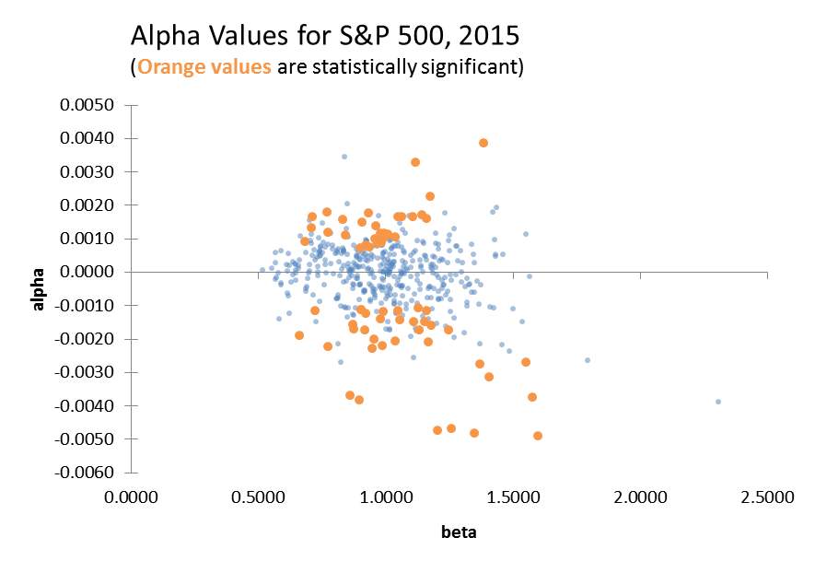

A table containing all 64 significant stocks is in the appendix. Examination will reveal that every stock which was statistically significant using just its return is still significant using this test. The alpha/beta analysis simply extends the set of significant returns. Conceptually, it improves the power of the test because it is able to explain away a portion of a stock’s variance using the market returns. This leaves the returns with lower volatility, higher t-scores, and a much more powerful test for significance. We will also see in the detailed chart that while we only had 1 stock previously which was significant at the .01 level, we now have 7. Each of the 26 stocks that were originally deemed significant, now have p values that imply even greater significance of these results.

# Expanding to 2 years of data

If we expand our analysis to include 2 years of data (2014-2015), we now have 504 daily returns that should increase the power of both significance tests. Indeed, when we measure just using each stock’s average returns and volatility, we now find that 57 out of 469 (12.15%) of stock returns are now statistically significant. The situation is diagrammed in the chart below

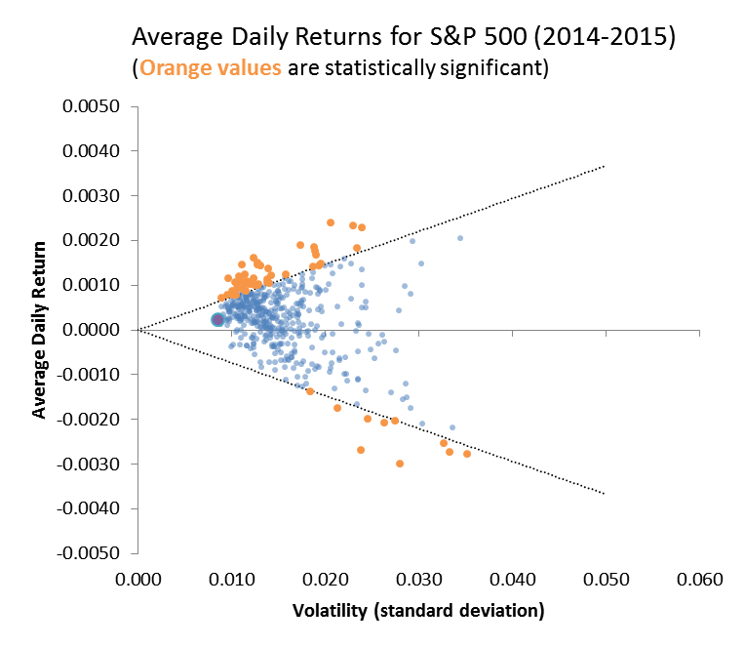

In the alpha/beta analysis, we find 74 out of 469 (15.8%) stocks with statistically significant values of alpha. This is only 10 more than last time, a modest increase when compared with the three-fold increase in significance using individual stock returns by themselves.

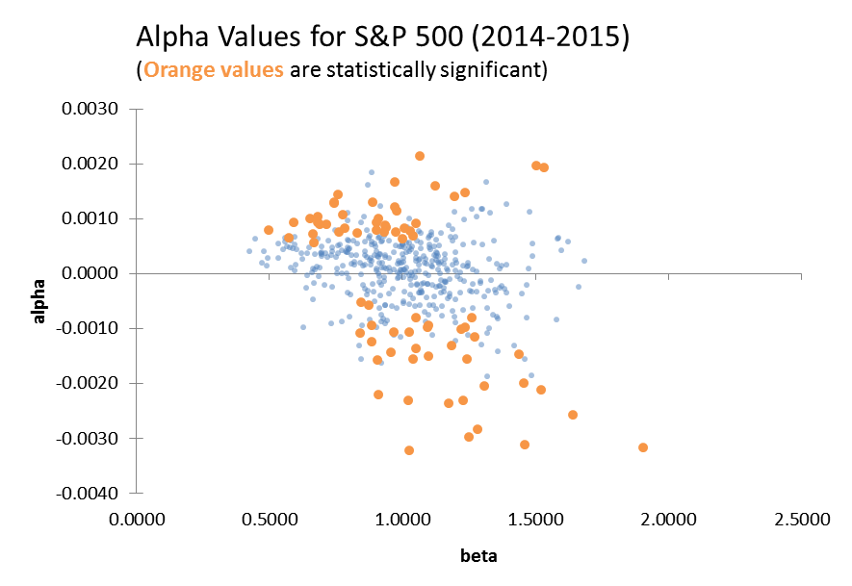

# 5 Years of Returns

The charts below show the same measurements using 5 years of daily returns, this is 1,258 returns occurring from 2011 to 2015.

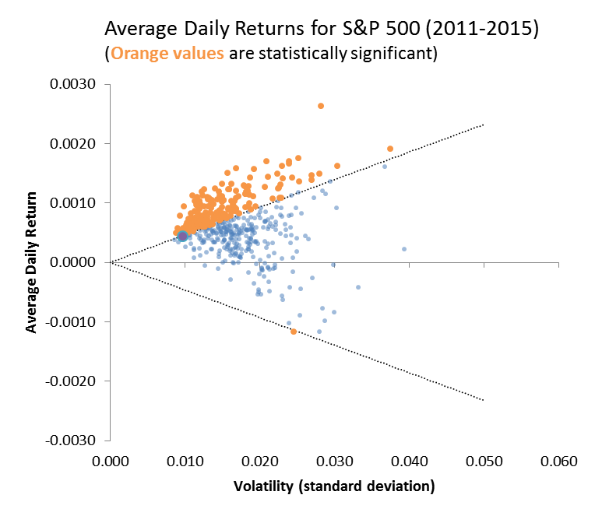

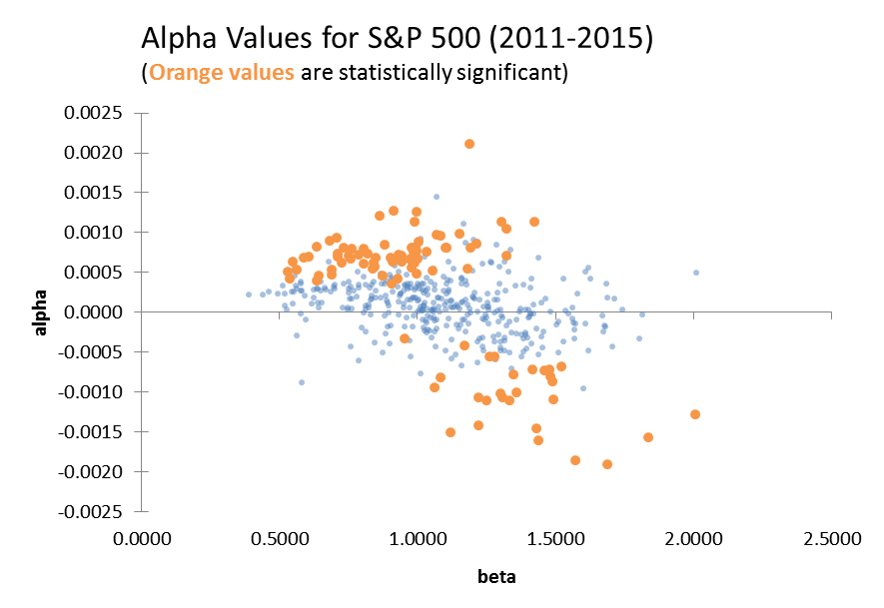

With 5 years of data we have 181 (38.6%) stocks that are statistically significant using the first test and 97 (20.7%) using the second test. The table below summarizes the results from all 3 time horizons:

|  |  |  |  |
| --- | --- | --- | --- |
| Time Horizon | Days | Significant Avg. Returns | Significant alpha |
| 1 year | 252 | 26 (5.5%) | 64 (13.7%) |
| 2 years | 504 | 57 (12.2%) | 74 (15.8%) |
| 5 years | 1,258 | 181 (38.6%) | 97 (20.7%) |

The number of stocks with returns that we can confidently assert to be non-zero increases almost linearly as we add data. However, the number of stocks with non-zero alpha begins to taper off. Conceptually, this makes sense. Stocks are expected to have positive, non-zero returns. As we collect more data we are able to verify that result with increasing confidence. In fact, at the five year range, the number of stocks with positive average returns dramatically increases. The charts for alpha do not show this slow drift upwards. Instead, there are just as many stocks over-performing on alpha as there are under-performing at the 5 year range. The conclusion is one that we would expect based upon efficient markets: if the expected value of alpha is zero, and increasing the number of samples will not discover more stocks with non-zero alpha. In fact, we would expect it to be difficult to sustain a positive or negative value of alpha over many years. The fact that we see 20% of the market with a statistically significant value of alpha over a 5-year time range is one that requires further investigating since it contradicts the conclusions of the efficient market hypothesis.

**The Sharpe Ratio**

It is difficult to run the statistical significance tests described above without realizing the similarity of our t-statistic to the Sharpe Ratio:

$$Sharpe Ratio=\frac{E[R-R_{F}]}{σ_{R}}=\frac{E[R]-E[R_{F}]}{σ_{R}}$$

The t-statistic used in the first test is proportional to this value if we set the risk-free rate to zero. This validates the assertion that stocks with higher Sharpe ratios are preferred to those with lower values. In fact, these stocks will have returns that are more statistically significant than those with lower values. We might even go so far as to say that the Sharpe ratio is in fact a test for significance of the returns.

Sharpe’s work also showed how we can take the stock or portfolio with the maximum Sharpe ratio and blend it with a risk-free asset to produce portfolios with risk/return profiles that outperform any other stock in the market. If anything, this work confirms the importance of the Sharpe ratio to asset analysis. It also leads one to wonder how this analysis might be extended to post-modern asset measurements such as the Sortino Ratio, Omega Ratio, or Upside Potential Ratio. While these measurements may not directly translate into tests for statistical significance, they do lead to more agreeable measures of asset returns that only penalize stocks for risk in terms of their losses. Perhaps the Sharpe Ratio could be used as a first-pass filter for a set of stocks. Only stocks that passed this filter, meaning we could be reasonably sure they have a non-zero average return, would then be considered for selection in a portfolio. The other measures which capture the tradeoff between risk and return could then be used to select from amongst these stocks.

# Conclusion and Next Steps

We have presented in this paper 2 methods for testing the statistical significance of stock returns. The first test is based on the stock’s daily returns and the volatility of those returns and is mathematically similar to the Sharpe Ratio. This test has increasing statistical power as we increase the length of time we observe stocks. This makes sense, since we expect stocks to have a positive, non-zero return. However, even over a 5 year time range, we are not able to produce an estimated daily return that is demonstrably non-zero for the majority of the market. This may be due to the average return changing over time. If this is the case, it means we are not trying to estimate a constant value. Instead, the target is changing each day/week/month/year, trending up and then trending down. While this likely contributes to some degree to the problem, it is still interesting to note that the majority of daily stock returns are indistinguishable from random noise.

The second statistical test is based on an alpha/beta model where we correlate a stock’s returns with the market and then try to estimate the stock’s returns after taking this correlation into account. Every single stock was found to have a statistically significant correlation with the stock market as a whole. 14-20% of the market was found to have a statistically significant value of alpha as well. This is in conflict with the efficient market hypothesis, and it begs the question of whether these above-average or below-average returns may be exploited by an investment strategy. An interesting next step would be to build portfolios based on statistically significant observed alphas and see if we are able to outperform the market. These portfolios may consist of just one stock or they may contain a collection. If the values of alpha persist over time, it should be possible to build portfolios that exploit this characteristic while minimizing variance.

The importance of including the variance/volatility of a portfolio in any analysis becomes clear in light of the above tests. Just as it is difficult to confirm that a stock’s return is non-zero when it has large variance, so it will also be difficult to assert that the result of a volatile investment strategy is non-zero (let alone positive) over the long-run. An investment strategy that reduces volatility while still hitting high returns will make a much more compelling case than a more volatile strategy when it is put to the test of statistical significance. For this reason, it is not enough to just produce high returns. It is definitely not enough to produce high returns for a single year, unless the volatility is low enough to be significant even over this short time frame. Mathematically, we must be able to assert that the results of our strategies are statistically significant and not the result of blind luck. The methods described in this paper present a way to do just that.

# Appendix: Stocks with statistically significant alpha values (2015)

|  |  |  |  |  |  |  |  |
| --- | --- | --- | --- | --- | --- | --- | --- |
|  | Coefficients | |  | P Value | | | |
| Symbol | alpha | beta |  | alpha |  | beta |  |
| KMI | -0.0037 | 0.8622 |  | 0.0031 | ** | 0.0000 | *** |
| HRL | 0.0018 | 0.7699 |  | 0.0036 | ** | 0.0000 | *** |
| BEN | -0.0015 | 1.1556 |  | 0.0038 | ** | 0.0000 | *** |
| AMZN | 0.0033 | 1.1193 |  | 0.0044 | ** | 0.0000 | *** |
| VRSN | 0.0018 | 0.9338 |  | 0.0051 | ** | 0.0000 | *** |
| JOY | -0.0047 | 1.2595 |  | 0.0055 | ** | 0.0000 | *** |
| SBUX | 0.0016 | 1.0497 |  | 0.0088 | ** | 0.0000 | *** |
| FISV | 0.0011 | 1.0401 |  | 0.0100 | * | 0.0000 | *** |
| STZ | 0.0016 | 0.8325 |  | 0.0101 | * | 0.0000 | *** |
| TSS | 0.0016 | 1.1088 |  | 0.0121 | * | 0.0000 | *** |
| EFX | 0.0014 | 0.9638 |  | 0.0142 | * | 0.0000 | *** |
| PSA | 0.0013 | 0.7092 |  | 0.0209 | * | 0.0000 | *** |
| RAI | 0.0017 | 0.7123 |  | 0.0223 | * | 0.0000 | *** |
| SWN | -0.0047 | 1.2052 |  | 0.0245 | * | 0.0000 | *** |
| BBBY | -0.0017 | 0.8747 |  | 0.0259 | * | 0.0000 | *** |
| CMI | -0.0017 | 0.9182 |  | 0.0283 | * | 0.0000 | *** |
| SNA | 0.0010 | 0.9606 |  | 0.0285 | * | 0.0000 | *** |
| NOC | 0.0011 | 1.0077 |  | 0.0293 | * | 0.0000 | *** |
| DPS | 0.0012 | 0.7751 |  | 0.0312 | * | 0.0000 | *** |
| JCI | -0.0011 | 0.9052 |  | 0.0315 | * | 0.0000 | *** |
| TYC | -0.0011 | 0.9052 |  | 0.0315 | * | 0.0000 | *** |
| M | -0.0022 | 0.7736 |  | 0.0325 | * | 0.0000 | *** |
| GPS | -0.0019 | 0.6636 |  | 0.0360 | * | 0.0000 | *** |
| NFLX | 0.0038 | 1.3844 |  | 0.0361 | * | 0.0000 | *** |
| R | -0.0017 | 1.2491 |  | 0.0364 | * | 0.0000 | *** |
| UNP | -0.0015 | 1.1113 |  | 0.0391 | * | 0.0000 | *** |
| EQIX | 0.0015 | 0.9067 |  | 0.0393 | * | 0.0000 | *** |
| FOSL | -0.0038 | 0.8979 |  | 0.0394 | * | 0.0000 | *** |
| CLX | 0.0009 | 0.6842 |  | 0.0395 | * | 0.0000 | *** |
| HD | 0.0011 | 1.0002 |  | 0.0414 | * | 0.0000 | *** |
| MUR | -0.0028 | 1.3726 |  | 0.0447 | * | 0.0000 | *** |
| MCD | 0.0011 | 0.8429 |  | 0.0483 | * | 0.0000 | *** |
| CHK | -0.0049 | 1.5993 |  | 0.0520 | . | 0.0000 | *** |
| NVDA | 0.0022 | 1.1760 |  | 0.0547 | . | 0.0000 | *** |
| VMC | 0.0016 | 1.1602 |  | 0.0554 | . | 0.0000 | *** |
| NOV | -0.0023 | 0.9474 |  | 0.0567 | . | 0.0000 | *** |
| PGR | 0.0008 | 0.9235 |  | 0.0623 | . | 0.0000 | *** |
| CNX | -0.0048 | 1.3511 |  | 0.0644 | . | 0.0000 | *** |
| ATI | -0.0037 | 1.5770 |  | 0.0687 | . | 0.0000 | *** |
| CINF | 0.0007 | 0.9383 |  | 0.0702 | . | 0.0000 | *** |
| SPLS | -0.0022 | 0.9861 |  | 0.0710 | . | 0.0000 | *** |
| PVH | -0.0020 | 0.9540 |  | 0.0725 | . | 0.0000 | *** |
| VIAB | -0.0021 | 1.0399 |  | 0.0729 | . | 0.0000 | *** |
| HST | -0.0014 | 1.0583 |  | 0.0732 | . | 0.0000 | *** |
| ORLY | 0.0012 | 0.9944 |  | 0.0733 | . | 0.0000 | *** |
| WDC | -0.0021 | 1.1705 |  | 0.0740 | . | 0.0000 | *** |
| ROP | 0.0008 | 0.9704 |  | 0.0744 | . | 0.0000 | *** |
| MU | -0.0031 | 1.4061 |  | 0.0745 | . | 0.0000 | *** |
| PAYX | 0.0007 | 0.9028 |  | 0.0782 | . | 0.0000 | *** |
| PKI | 0.0009 | 0.9829 |  | 0.0787 | . | 0.0000 | *** |
| GOOGL | 0.0017 | 1.0646 |  | 0.0793 | . | 0.0000 | *** |
| MRO | -0.0027 | 1.5522 |  | 0.0809 | . | 0.0000 | *** |
| NKE | 0.0012 | 0.9797 |  | 0.0826 | . | 0.0000 | *** |
| LM | -0.0011 | 1.1296 |  | 0.0832 | . | 0.0000 | *** |
| IP | -0.0012 | 1.0493 |  | 0.0855 | . | 0.0000 | *** |
| KSU | -0.0017 | 1.1333 |  | 0.0861 | . | 0.0000 | *** |
| CTL | -0.0014 | 0.9804 |  | 0.0863 | . | 0.0000 | *** |
| NTAP | -0.0016 | 0.8728 |  | 0.0882 | . | 0.0000 | *** |
| PCAR | -0.0012 | 1.1601 |  | 0.0884 | . | 0.0000 | *** |
| OI | -0.0016 | 1.1780 |  | 0.0886 | . | 0.0000 | *** |
| WMT | -0.0012 | 0.7249 |  | 0.0951 | . | 0.0000 | *** |
| ADM | -0.0012 | 0.9909 |  | 0.0974 | . | 0.0000 | *** |
| FOXA | -0.0012 | 0.9220 |  | 0.0974 | . | 0.0000 | *** |
| VLO | 0.0017 | 1.1435 |  | 0.0982 | . | 0.0000 | *** |

**Appendix: Random Return Chart**

Comparison of actual stock returns with random returns that have a mean of zero but the same standard deviation as the actual stocks. There are actually more statistically significant returns in the random noise than there are in the actual data.

