What Proportion of Stock Returns are due to Market Movements?

# Overview

It is common knowledge that individual stocks are influenced by the overall movement of the market. Large, exogenous factors such as macro-economic announcements, news stories, or changing market sentiment may impact all stocks in the market, driving individual stock returns higher or lower than they might otherwise be. But what percentage of an individual stock’s returns are due to these larger, market movements? A traditional alpha/beta regression may be used to answer this question. The results below will show that about 33.5% of a stock’s variance may be explained by the movement of the market as a whole. A confidence interval from 9.7% to 64.2% covers 98% of all stocks during the period measured.

# Alpha/Beta Regression

The Capital Asset Pricing Model assumes stock returns are related to the overall market (and risk-free interest rates) by:

$$R_{a}-R_{f}=β\left(R_{M}-R_{f}\right)+α+ϵ$$

$R_{a}-R_{f}$ Excess return of asset ($R_{a}$) versus risk-free rate ($R_{f}$)

$R_{M}-R_{f}$ Excess return of the market ($R_{M}$) versus risk-free rate ($R_{f}$)

$α,β$ Regression constants

$ϵ$ Residual error

We can simplify this by assuming that a risk-free asset returns a 0% return (an approximation which is suitable for daily stock returns). This gives:

$$R_{a}=α+β\left(R_{M}\right)+ϵ$$

Conceptually, this means that a stock’s returns $R_{a}$ are proportionate to those of the overall market $R_{M}$. The proportion is determined by the coefficient $β$. The model also allows for a stock to consistently over- or under-perform expectations by amount $α$. Alpha is also known as the “risk-adjusted return” of the asset and can be used to measure a stock’s return after accounting for overall market effects. CAPM theory posits that alpha should be zero, but the goal of every investor is to find a way to increase alpha – that is, increase the returns they are earning on their investments relative to the expected returns based on the overall market.

# Analysis of a Single Stock

Analyzing a single stock in this way will be illustrative of the concept. This analysis examines daily stock returns for Kroger’s stock from the time period 2013 to 2016. These are compared to daily returns on the S&P 500 over that same time period. A scatter plot shows a visible correlation between these two:

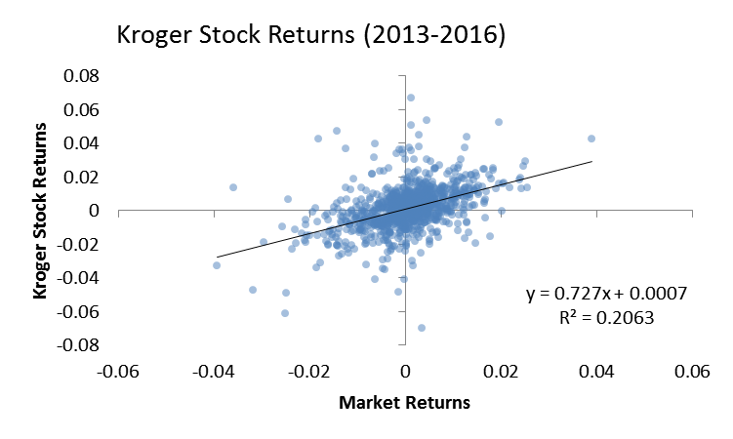

A linear regression in R yields the following:

Coefficients:

Estimate Std. Error t value Pr(>|t|)

(Intercept) 0.0007290 0.0003807 1.915 0.0558 . 🡨 alpha

Market 0.7269978 0.0461922 15.739 <2e-16 *** 🡨 beta

---

Signif. codes: 0 ‘***’ 0.001 ‘**’ 0.01 ‘*’ 0.05 ‘.’ 0.1 ‘ ’ 1

Residual standard error: 0.01175 on 953 degrees of freedom

Multiple R-squared: 0.2063, Adjusted R-squared: 0.2055

F-statistic: 247.7 on 1 and 953 DF, p-value: < 2.2e-16

The beta coefficient is 0.7269978 and is highly significant. This means that Kroger stock is in fact influenced by the overall market. For every 1% movement we see in the market, we would expect Kroger stock to move by about 0.727%. Kroger’s alpha is 0.073%, meaning that it is out-performing expectations during this time period. The p-value on this coefficient is not as strong as the beta coefficient, but it is still significant. All of this gives us confidence that the model is appropriate to be used for this stock.

The R-squared statistic is what we are really interested in here. At 0.2063, this tells us that 20.63% of the stock’s variance is explained by movement of the market. The remaining 79.37% can be attributed to factors specific to this stock.

# Analysis of Multiple Stocks

The analysis performed above was repeated for all stocks in the S&P 500 during the same time period (2013 to 2016). The plots below show the various summary statistics from these regressions for all of the stocks:

|  |  |
| --- | --- |
| Mean = 1.0580 Median = 1.0490  Min = 0.1651 Max = 2.0160  1st Qu = 0.8719 3rd Qu = 1.2410 | Mean = 0.0001111 Median = 0.0001340  Min = -.0021280 Max = 0.0020560  1st Qu = -.0001211 3rd Qu = 0.0003625 |
| Mean = 3.433e-06 Median = 0.000e+00  Min = 0.000e+00 Max = 1.628e-03  1st Qu = 0.000e+00 3rd Qu = 0.000e+00 | Mean = 0.4779000 Median = 0.4637000  Min = 0.0004372 Max = 0.9978000  1st Qu = 0.2078000 3rd Qu = 0.7187000 |
| Mean = 0.33500 Median = 0.32630  Min = 0.02127 Max = 0.68610  1st Qu = 0.23410 3rd Qu = 0.43290 |  |

These results show us several things:

* The average value of beta is 1 (most stocks move with the market on a 1-for-1 basis), although some move more and others less.
* Values of alpha are close to zero (the theoretical prediction) but slightly positive. Some stocks how much higher returns than can be explained by the market and others show much lower returns.
* P-values for beta are so low that we believe all stocks have some relation to the overall market. Even the 3rd quartile (75% of stocks) are showing p-values so low that they are indistinguishable from zero.
* P-values for alpha are all over the place. This implies that some excess returns are statistically significant, but the vast majority are not. The uniform distribution of p-values may even cause us to question whether those with low P-values are significant. It may just be that these low p-values are also the result of random chance.
* The R-squared average 0.335, implying that 33.5% of stock returns are explainable by movements of the market overall. Some are higher, and some are lower, but it is very rare to see stock’s that have less than 10% of their returns driven by the market overall.

This last point is the one that we are interested in. (The rest just give us more confidence in the appropriateness of this model across a wide range of stocks.) The average stock has 33.5% of the variance in its returns explained by movements in the overall market. A confidence interval from 9.7% to 64.2% covers 98% of all stocks in this assessment.