Simulated Trading of Stock Portfolios

# Background & Motivation

Assuming we have a way to predict stock returns, we still need a way to build a trading strategy out of those predictions. We will want to hold more than one stock at a time, and we will have to determine the appropriate times to buy and sell stocks based upon both our future expectations. In the absence of trading costs, this might be simple. We could just buy the stocks with the highest predicted returns each day, and there would be no penalty for frequently trading in and out of positions. However, with trading costs, we do have this penalty, and we may decide not to buy a stock even if it has a high predicted return. It may be more advantageous to hold stocks for longer periods of times to avoid the costs of high-frequency trading.

**Overview**

This paper will examine different ways to construct portfolios based upon expectations of future returns. We will use a simple model that attempts to buy whatever stocks have the highest expected return but which also imposes a minimum holding period so that we do not trade in and out of positions too quickly. This basic method will illustrate the devastating impact of high-turnover in the portfolio. An analytical method will be shown to estimate these costs and show that a trader investing $10,000 into a single stock can expect trading costs to eat away at least 28.4% of his profits if he trades daily. This falls to 5.1% for a weekly trader, 2.5% for a bi-weekly trader, and 1.3% for a monthly-trader. The table below shows the average trading costs for various trading frequencies and investment levels.

|  |  |  |  |  |  |  |  |  |
| --- | --- | --- | --- | --- | --- | --- | --- | --- |
| Days between trades | Trades per year | Avg. Dollars Invested in Each Stock | | | | | | |
| $1,000 | $5,000 | $10,000 | $20,000 | $30,000 | $40,000 | $50,000 |
| 1 | 250.0 | 247.9% | 28.4% | 13.3% | 6.4% | 4.3% | 3.2% | 2.5% |
| 2 | 125.0 | 86.5% | 13.3% | 6.4% | 3.2% | 2.1% | 1.6% | 1.3% |
| 3 | 83.3 | 51.5% | 8.7% | 4.3% | 2.1% | 1.4% | 1.0% | 0.8% |
| 4 | 62.5 | 36.6% | 6.4% | 3.2% | 1.6% | 1.0% | 0.8% | 0.6% |
| 5 | 50.0 | 28.3% | 5.1% | 2.5% | 1.3% | 0.8% | 0.6% | 0.5% |
| 6 | 41.7 | 23.1% | 4.3% | 2.1% | 1.0% | 0.7% | 0.5% | 0.4% |
| 7 | 35.7 | 19.5% | 3.6% | 1.8% | 0.9% | 0.6% | 0.4% | 0.4% |
| 8 | 31.3 | 16.9% | 3.2% | 1.6% | 0.8% | 0.5% | 0.4% | 0.3% |
| 9 | 27.8 | 14.9% | 2.8% | 1.4% | 0.7% | 0.5% | 0.3% | 0.3% |
| 10 | 25.0 | 13.3% | 2.5% | 1.3% | 0.6% | 0.4% | 0.3% | 0.3% |
| 11 | 22.7 | 12.0% | 2.3% | 1.1% | 0.6% | 0.4% | 0.3% | 0.2% |
| 12 | 20.8 | 10.9% | 2.1% | 1.0% | 0.5% | 0.3% | 0.3% | 0.2% |
| 13 | 19.2 | 10.1% | 1.9% | 1.0% | 0.5% | 0.3% | 0.2% | 0.2% |
| 14 | 17.9 | 9.3% | 1.8% | 0.9% | 0.4% | 0.3% | 0.2% | 0.2% |
| 15 | 16.7 | 8.7% | 1.7% | 0.8% | 0.4% | 0.3% | 0.2% | 0.2% |
| 16 | 15.6 | 8.1% | 1.6% | 0.8% | 0.4% | 0.3% | 0.2% | 0.2% |
| 17 | 14.7 | 7.6% | 1.5% | 0.7% | 0.4% | 0.2% | 0.2% | 0.1% |
| 18 | 13.9 | 7.2% | 1.4% | 0.7% | 0.3% | 0.2% | 0.2% | 0.1% |
| 19 | 13.2 | 6.8% | 1.3% | 0.7% | 0.3% | 0.2% | 0.2% | 0.1% |
| 20 | 12.5 | 6.4% | 1.3% | 0.6% | 0.3% | 0.2% | 0.2% | 0.1% |

In these conditions, a trader should consider:

1. Holding stocks for at least 1 month between trades
2. Investing such a large amount in each stock that trading costs are only a small percentage of expected returns (by my estimates this would require at least $50,000 per stock)
3. Using a trading platform that minimizes trade costs (such as Robin Hood with free trades)

**Simulation Setup**

The simulation used in this paper uses Adjusted Closing Prices from Yahoo! Finance as the source of stock data. The S&P 500 stocks are examined here, but this could be expanded if desired. We then pick a period of interest (in this case 2015-01-01 to 2016-10-13) and simulate portfolio returns over that time. An investor program is given the ability to trade at the closing price each day and may use whatever logic they’d like to make investment decisions. A trading cost can be imposed and will be subtracted from the investor’s cash balance each time they make a trade. Cash balance, asset positions, and asset valuations are tracked at each step in the simulation so that we can plot the value of the investor’s portfolio over time.

**Baseline Portfolio**

An investor buying the S&P 500 on 1/1/2015 and selling it on 10/13/2016 would have received a 4.31%. Because Dan is lazy (i.e. I didn’t have the S&P 500 in my data set), I chose an alternate baseline that purchased 1 share of every stock in the S&P 500. This portfolio tracked the index pretty well and earned 5.9% over the same time period. The total value of this portfolio over time is shown below. The second chart shows the percentage return that an investor would have made if he sold out of this position at each point in time. As shown, the investor would be up 2-3% from March to September of 2015. Then returns fall negative before going positive, falling again, and then returning to positive territory in April of 2016.

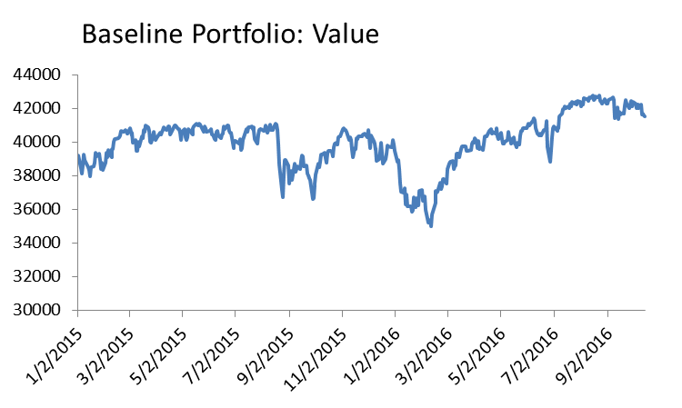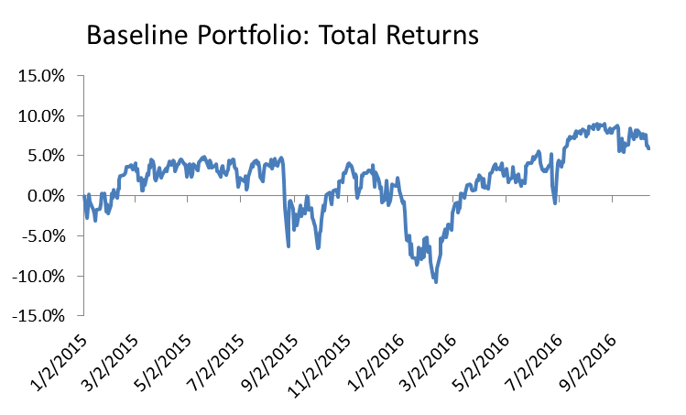

Another way to look at this is to examine the percentage change over smaller periods of time. Rolling 20-day returns are plotted in the charts below. The first chart uses simple returns and the second uses logarithmic returns. In both cases, the 20-day returns are annualized. (This is done using ${\left(1+r\right)}^{\frac{250}{20}}-1$ for simple returns and $\frac{250}{20}r$ for logarithmic returns.

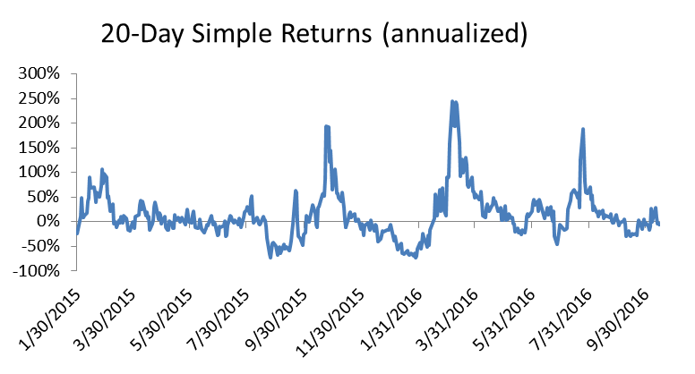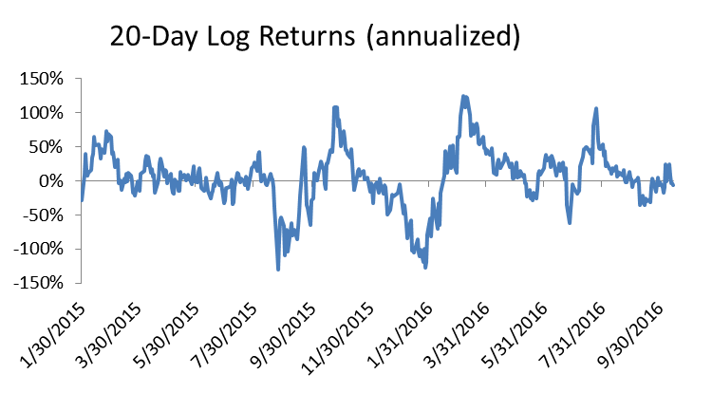

These charts provide a glimpse into why logarithmic returns are typically preferred over simple returns. In the simple returns chart we see high peaks and valleys that don’t look too low. One might look at this chart and think that the portfolio had large returns over this period instead of the paltry 5.9% it actually obtained. This is due to the asymmetric nature of returns. A 50% loss and a 200% gain leave us right back where we started, but a chart showing these would skew toward the positive. Taking the log returns eliminates this skewness. In the charts above, it produces a much more symmetrical view of returns showing periods of large losses (about 100%, annualized) balanced out by periods of large gains (again, about 100%, annualized).

For the remainder of this paper we will use the total value of portfolios, the percentage change over time, and the annualized log returns in our plots. We will not use simple returns. Our goal in the following sections will be to beat the baseline portfolio just described.

**The Roller Coaster Ride of a Kroger Investor in 2015-2016**

To illustrate the concept, let’s show what happened to an investor who invested $100,000 in Kroger stock on January 1, 2015. The first thing to note is that the investor could not have invested all of his money in Kroger at this point. The investor in the simulation bought 99972.35 worth of Kroger stock and had $27.65 left in cash holdings. This is because the stock was trading at a price higher than this, and the simulation is restricting the investor to buying whole shares. In this case, the impact of having 0.03% of his investment left in cash is negligible, but for investors with smaller bankrolls, the effect may be more significant. If we were only investing $100 and had $27.65 left in our account, we’d have 27% of our bankroll left out of the market. These “friction costs” for investors with smaller bankrolls can be investigated using this simulator. In this case, we have increased the bankroll to minimize these effects.

So what happened to our simulated investor? As the chart below shows: things started off pretty good. The stock climbed steadily toward a peak at the end of 2015. The investor was feeling pretty good about his 30% return before it started to fall and plunged into negative territory by the Fall of 2016. A slight up-tick at the end of the simulation saved this trader and left him with a near-flat return of 0.5% for his 2 year investment.

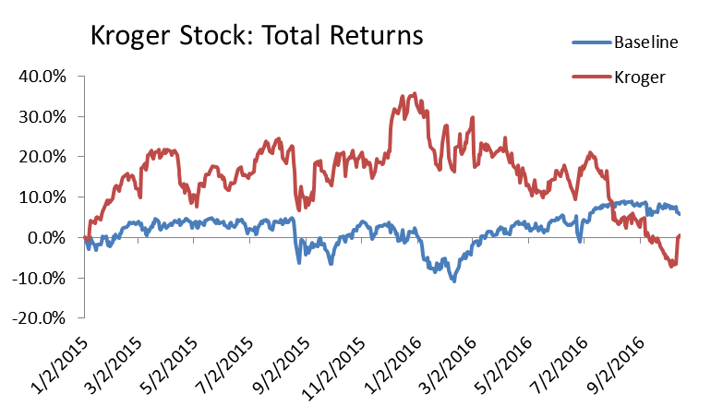

The following chart shows the 20-day returns over the same period, highlighting the periods of strong gains and large losses experienced by this stock. Interestingly, a couple of these movements appear to be in line with the market as a whole (plotted in blue) while others are moving on their own for reasons other than market influences.

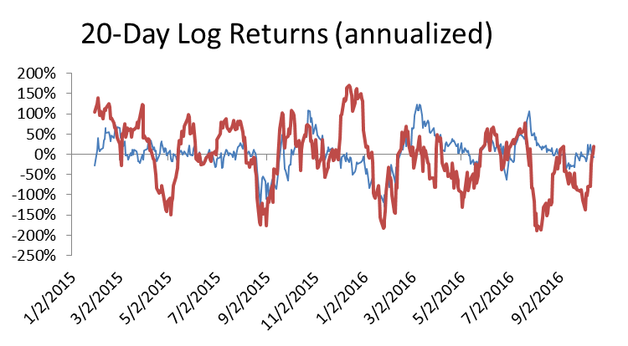

Overall, we would not be happy with this performance. We failed to out-perform the market over this time period. We also experienced much more volatility of returns during this period. If we attempted to adjust our returns to account for volatility and downside risk, we would be left with an even worse assessment of this stock’s performance.

**Estimating Future Returns from Historical Averages**

Finally, we will get to our real intent in this paper: to construct portfolios that trade in and out of positions over time. To do this we need some way to estimate future stock returns. A simple method is used that looks at the average historical return up to the market close yesterday and uses that to pick stocks today. All of the stock’s daily returns from January 1st 2013 to the present day are used to calculate average returns, and simple returns are used in this case. The top 10 stocks are selected each day and purchased.

The overall return for this investor is higher than the market: 10.0% versus 5.9%. As shown below, the pattern of returns closely matches those of the market. There are periods where this method actually does worse than the overall market, but it pulled ahead in the last couple of weeks. (Note: this method also out-performs the baseline when calculating risk-adjusted returns using either the Sharpe or Sortino ratios – as shown in the table next to the chart).

|  |  |  |  |  |  |  |  |  |  |  |  |  |  |  |  |  |
| --- | --- | --- | --- | --- | --- | --- | --- | --- | --- | --- | --- | --- | --- | --- | --- | --- |
|  | |  |  |  | | --- | --- | --- | | Measure | Trader | Base | | Avg Return | 5.3% | 3.2% | | Stdev | 22.0% | 15.0% | | Sharpe | 0.2397 | 0.2109 | | Sortino | 0.2215 | 0.1987 | |

The chart above assumes that the investor is allowed to trade each day for free. Next, we will instead charge the investor $5 each time he trades. Each day the investor has to exit his 10 positions and enter 10 new ones. To begin with, we will assume that the investor re-balances his portfolio daily, so even if he holds the same stocks two days in a roll he will be charged a trading fee for buying and selling to re-allocate his value as desired. The investor attempts to divide the portfolio value equally among the 10 stocks, investing 10% into each of them.

This daily trading destroys the investor’s positive returns. Instead of a good, 10% profit, we end up with a 14.3% loss. As shown below, the cost of daily trading steadily eats into this investor’s profits, causing the line to diverge toward the negative.

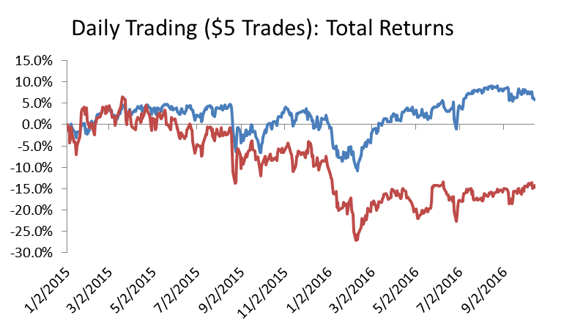

So what happens if we back off and only trade once per week? The following chart shows the results. By limiting trading costs, we reduce our losses and again obtain a profit. However, we only achieve a 3.8% return compared to the baseline portfolio’s 5.9%. Trading costs are still taking too much of our earnings.

|  |  |
| --- | --- |
|  | NOTE: This trader also changed the way it was calculating expected returns. Since we are trading every 5 days we calculate the average 5-day return on each stock (instead of the average 1-day return) and use this to select the top stocks in the market. Averages of simple returns are still used, and all data from 2013 onward is used in the average. |

If we back off and trade only once every 20 days our returns get better still. The chart below shows a 14.6% return for this method.

|  |  |
| --- | --- |
|  | NOTE: This trader also changed the way it was calculating expected returns. Since we are trading every 20 days we calculate the average 20-day return on each stock in the same manner described above. |

This is even better than we obtained trading every day with zero trading costs! In this case patience pays off. Not only do we benefit from lower trading costs, we also seem to be benefiting from more stable forecasts (since we’re forecasting 20-day returns instead of 1-day returns) and a tendency for stocks to better match this expected performance over a longer period. This same behavior was noticed when we did regressions of past returns against future returns. Historical 20-day returns averaged over a long period of time are statistically better predictors of 20-day future returns than when we try to make similar predictions at the daily level).

We can also try playing with different amounts of forecast history. The previous simulation required 250 days of returns to be present, but after that it would take as many returns as it could find, using all of the stock’s history if it was available. If we instead cap this at 250, forcing it to take a strict 250-day average we get even better results. The total return on the portfolio increases to 23.4%!

**Experimenting with Different Bankrolls**

The section above showed us how changing parameters such as trading costs, days between trades, and forecast ranges can have a substantial impact on results. We have not yet experimented with changes to the investor’s bankroll or the number of stocks held. So far, we have assumed the investor has $100,000 to invest and holds 10 stocks, investing approximately $10,000 in each stock (approximately, since the investor is restricted to holding an integer number of shares).

|  |  |  |  |
| --- | --- | --- | --- |
| Bank=$100,000  10 stocks at a time  (min,max)=(250,250) |  | Trade Cost | |
| Days between Trades | $0 | $5 |
| 1 | 0.0% | -22.2% |
| 3 | 12.1% | 4.2% |
| 5 | 12.2% | 7.4% |
| 10 | 12.5% | 10.0% |
| 20 | 24.8% | 23.4% |

Now, what happens to our returns if we have a smaller bankroll? Instead of $100,000, let’s give the investor $10,000 and see what happens. In this case, the investor will have about $1,000 to invest in each stock.

|  |  |  |  |
| --- | --- | --- | --- |
| Bank=$10,000  10 stocks at a time  (min,max)=(250,250) |  | Trade Cost | |
| Days between Trades | $0 | $5 |
| 1 | 0.3% | -98.7% |
| 3 | 11.5% | -64.2% |
| 5 | 11.6% | -33.9% |
| 10 | 11.9% | -13.3% |
| 20 | 22.5% | 9.9% |

The table above shows that even without trading costs we lose 1-2% of our returns due to having a smaller bankroll. This is due to the “frictions” of trading integer units of stock only. More of our money remains on the sidelines since we can’t fully invest it all, causing us to lose out on potential returns. A much bigger problem arises once we start charging for trades though. Now we start to see returns that were positive turn into large negatives. This is because trade costs have become a much larger factor. When we invested $10,000 into a stock, a $5 trade cost wasn’t much. When we only have $1,000 per stock, the $5 cost is 10 times larger on a percentage basis. We also have the impact of compound interest now working against us.

We can estimate the impact of this analytically in a few ways. First, we can just take the trading cost and multiply by the number of trades we expect to make in a year. If we trade daily, we would expect to make 250 trades in a year. At $5 a trade this would cost $1,250. If we are only investing $1,000, trading costs alone would completely obliterate our investment unless we were making enormous returns. Of course, the approach described above doesn’t take into account the compound effect of interest. To do this, we can take the interest rate of $5/$1,000 = 0.05% and compound it by the number of trades we make in a year. For a daily trader this becomes a compound annual growth rate of (1+.0005)^250-1 = 247.9%. Really, we are subtracting 0.05% each time we compound so a better result might be to look at how much our investment would shrink if we subtracted this amount each period. After 250 periods, we’d have a balance of (1-.0005)^250 = 28.6%. We’d lose 71.4% of whatever we had invested.

The table below uses the second approach as this better represents just how much an investment would need to earn in order to cancel out the effects of the trading costs. A stock with a 0.05% daily return (a $247.9% annual growth rate) would just break even if we only invested $1,000 and traded daily at a $5 cost per trade.

|  |  |  |  |  |  |  |  |  |
| --- | --- | --- | --- | --- | --- | --- | --- | --- |
| Days between trades | Trades per year | Avg. Dollars Invested in Each Stock | | | | | | |
| $1,000 | $5,000 | $10,000 | $20,000 | $30,000 | $40,000 | $50,000 |
| 1 | 250.0 | 247.9% | 28.4% | 13.3% | 6.4% | 4.3% | 3.2% | 2.5% |
| 2 | 125.0 | 86.5% | 13.3% | 6.4% | 3.2% | 2.1% | 1.6% | 1.3% |
| 3 | 83.3 | 51.5% | 8.7% | 4.3% | 2.1% | 1.4% | 1.0% | 0.8% |
| 4 | 62.5 | 36.6% | 6.4% | 3.2% | 1.6% | 1.0% | 0.8% | 0.6% |
| 5 | 50.0 | 28.3% | 5.1% | 2.5% | 1.3% | 0.8% | 0.6% | 0.5% |
| 6 | 41.7 | 23.1% | 4.3% | 2.1% | 1.0% | 0.7% | 0.5% | 0.4% |
| 7 | 35.7 | 19.5% | 3.6% | 1.8% | 0.9% | 0.6% | 0.4% | 0.4% |
| 8 | 31.3 | 16.9% | 3.2% | 1.6% | 0.8% | 0.5% | 0.4% | 0.3% |
| 9 | 27.8 | 14.9% | 2.8% | 1.4% | 0.7% | 0.5% | 0.3% | 0.3% |
| 10 | 25.0 | 13.3% | 2.5% | 1.3% | 0.6% | 0.4% | 0.3% | 0.3% |
| 11 | 22.7 | 12.0% | 2.3% | 1.1% | 0.6% | 0.4% | 0.3% | 0.2% |
| 12 | 20.8 | 10.9% | 2.1% | 1.0% | 0.5% | 0.3% | 0.3% | 0.2% |
| 13 | 19.2 | 10.1% | 1.9% | 1.0% | 0.5% | 0.3% | 0.2% | 0.2% |
| 14 | 17.9 | 9.3% | 1.8% | 0.9% | 0.4% | 0.3% | 0.2% | 0.2% |
| 15 | 16.7 | 8.7% | 1.7% | 0.8% | 0.4% | 0.3% | 0.2% | 0.2% |
| 16 | 15.6 | 8.1% | 1.6% | 0.8% | 0.4% | 0.3% | 0.2% | 0.2% |
| 17 | 14.7 | 7.6% | 1.5% | 0.7% | 0.4% | 0.2% | 0.2% | 0.1% |
| 18 | 13.9 | 7.2% | 1.4% | 0.7% | 0.3% | 0.2% | 0.2% | 0.1% |
| 19 | 13.2 | 6.8% | 1.3% | 0.7% | 0.3% | 0.2% | 0.2% | 0.1% |
| 20 | 12.5 | 6.4% | 1.3% | 0.6% | 0.3% | 0.2% | 0.2% | 0.1% |

This chart should really put fear into investors who are considering frequent trading on a low bankroll. Even if we only trade monthly, the impact to an investor who only puts $1,000 into each position would create a headwind that would cripple an investor who only managed to make the market return. The chart implies that $5,000-$10,000 is really required for each position and we still can’t trade more than once every 2-weeks if we want to keep these costs around 2-5%.

**Experimenting with Different Sized Portfolios**

We might also wonder what happens if we change the number of stocks that we invest in. The table below shows the results for a portfolio holding between 1 and 10 stocks:

|  |  |  |  |  |  |
| --- | --- | --- | --- | --- | --- |
|  | $100,000 Bankroll | |  | $10,000 Bankroll | |
| # of Stocks | $0 Trades | $5 Trades |  | $0 Trades | $5 Trades |
| 1 | 63.1% | 62.9% |  | 62.8% | 62.0% |
| 2 | 36.9% | 36.6% |  | 38.6% | 35.1% |
| 3 | 24.1% | 23.5% |  | 24.7% | 20.4% |
| 4 | 52.4% | 51.8% |  | 53.3% | 45.5% |
| 5 | 43.3% | 42.7% |  | 43.3% | 36.4% |
| 6 | 47.4% | 46.4% |  | 45.5% | 37.4% |
| 7 | 44.1% | 43.2% |  | 41.2% | 31.7% |
| 8 | 30.4% | 29.4% |  | 28.4% | 17.7% |
| 9 | 26.4% | 25.2% |  | 26.7% | 12.2% |
| 10 | 24.8% | 23.4% |  | 22.5% | 9.9% |

The portfolio formed only of 1 stock, that stock predicted to have the highest return, performed much better than the others. The returns do seem to fall though, implying that we might be better focusing our investments on a more limited portfolio. This would require more testing though to see if this trend persisted over different testing periods. We might just be seeing the effect of 1 or 2 good choices here.

For completeness, the list of stocks the simulation picked when we allowed a portfolio of 10 stocks were:

Date

1/2/2015 EW AVGO VRTX RCL SWKS MNK LUV EA AAL DAL

2/2/2015 EW AVGO MNST KR RCL SWKS MNK EA LUV AAL

3/3/2015 TSO EW AVGO FTR MNST KR SWKS MNK EA LUV

3/31/2015 TSO EW AVGO MNST VRTX SWKS MNK EA LUV HBI

4/29/2015 EW ABC AVGO MNST VRTX SWKS MNK EA LUV HBI

5/28/2015 NFLX TSO ABC AVGO MNST VRTX SWKS EA REGN UA

6/25/2015 NFLX HUM EW AVGO MNST VRTX SWKS MNK EA REGN

7/24/2015 NFLX TSO EW AVGO MNST CI DRI SWKS EA REGN

8/21/2015 NFLX TSO SEE AVGO MNST ROST SWKS EA REGN AMZN

9/21/2015 NFLX TSO CVC AVGO ORLY MNST SWKS EA VMC AMZN

10/19/2015 NFLX CVC TSO SBUX ORLY SWKS RAI EA VMC AMZN

11/16/2015 NFLX CVC TSO NVDA SBUX TSS EXPE EA VMC AMZN

12/15/2015 NFLX NVDA CVC TSO CSC TSS EA VMC AMZN VRSN

1/14/2016 NFLX CVC NVDA TSO CSC FSLR HRL VLO AMZN VRSN

2/12/2016 NFLX CVC NVDA GOOGL CSC FSLR HRL RAI EQIX AMZN

3/14/2016 NFLX CVC NVDA MAT CSC HRL RAI EQIX TSN AMZN

4/12/2016 NFLX CVC NVDA MAT CSC HRL EQIX RAI TSN AMZN

5/10/2016 CVC NVDA CSC EW HRL ARG NEM FB TSN AMZN

6/8/2016 NVDA CVC CSC EW ARG NEM EQIX FB AMZN TSN

7/7/2016 NVDA CVC CSC ARG NEM EQIX NI AMZN TSN O

8/4/2016 KLAC NVDA AMAT CSC NEM FCX NI TSN AMZN O

9/1/2016 NVDA AMAT CSC EW NEM CHK FCX CNX QEP TSN

9/30/2016 NVDA AMAT CSC JOY NEM CHK OKE WYNN CNX TSN

When we limited it to one stock it made the following selections:

Date Stock

1/2/2015 SWKS

8/21/2015 EA

10/19/2015 CVC

11/16/2015 NFLX

2/12/2016 CSC

**The Benefits of Consistency of Stock Portfolios**

One limitation in the simulations so far is that every time we have traded we have rebalanced the portfolio. This has even been the case when no substantial changes to the portfolio really needed to be made. The section above showed that even when we allowed to portfolio to be changed every 20 days, it was instead only changed 5 times during the simulation (about once every 90 days). Even if we had allowed daily trades, we would have only have traded the 1-stock portfolio 6 times during the simulation (about once every 75 days).

This was an oversight/simplification on my part in the coding. I went back to correct this so that the program only rebalanced the portfolio if changes had been made to the desired stocks in the portfolio. The table below shows the results:

|  |  |  |  |  |  |  |
| --- | --- | --- | --- | --- | --- | --- |
|  |  | $0 Trades |  | $5 Trades | | |
| # of Stocks |  | Rebalance 20 Days |  | Rebalance 20 days | Rebalance if Changed | Trade only changes |
| 1 |  | 62.8% |  | 62.0% | 62.7% | 62.7% |
| 2 |  | 38.6% |  | 35.1% | 38.6% | 33.5% |
| 3 |  | 24.7% |  | 20.4% | 22.8% | 20.7% |
| 4 |  | 53.3% |  | 45.5% | 46.3% | 49.6% |
| 5 |  | 43.3% |  | 36.4% | 35.4% | 44.1% |
| 6 |  | 45.5% |  | 37.4% | 37.0% | 44.6% |
| 7 |  | 41.2% |  | 31.7% | 31.7% | 36.9% |
| 8 |  | 28.4% |  | 17.7% | 17.7% | 27.6% |
| 9 |  | 26.7% |  | 12.2% | 12.1% | 24.1% |
| 10 |  | 22.5% |  | 9.9% | 10.3% | 21.5% |

We have already seen the “rebalance 20 days” columns before. This is the effect of doing a complete re-balance of the portfolio each trading opportunity, regardless of whether the stock holdings have changed or not. Since this method is allowed to trade once every 20 days, it is rebalancing every 20 days.

The “rebalance if changed” column shows the effect of doing a complete rebalance whenever a new stock is added or removed from the desired portfolio. This trader should be trading less and incurring fewer trading fees. In most cases we do see the returns improve or at least remain similar. Exceptions include portfolios with 5, 6, and 9 stocks. These actually did slightly worse with less rebalancing of the portfolio. I did not dive deep into this, but it is likely that there is a particular stock or two that benefit from having a different percentage of the portfolio allocated to them than what they would otherwise have. Either a large-gaining stock benefits from having its position cut or a large-losing stock benefits from having its position increased.

I also tested a method where instead of re-balancing the portfolio I only traded the stocks that changed. Whatever stocks were removed from the portfolio were sold, and the available cash balance was divided equally among new acquisitions when purchasing them. In most cases this improved upon the results of the previous method, but in some cases it did worse. Once again, there are some stocks that appear to be benefiting from periodic re-balancing, but in most cases the reduced trading costs outweigh these benefits.

One last variation I tried was to relax the 20-day trading interval. In the tables above, if the trader did not trade at his 20-day window he lost the ability to trade for the next 20 days. Relaxing this condition should allow the trader to buy new stocks as soon as they pop up on the radar, as long as he holds a position for at least 20 days. This actually caused the trader to do worse than in the stricter methods above:

|  |  |  |  |  |  |  |
| --- | --- | --- | --- | --- | --- | --- |
|  |  | $0 Trades |  | $5 Trades | | |
| # of Stocks |  | Rebalance 20 Days |  | Rebalance 20 days | Rebalance if Changed | Trade only changes |
| 1 |  | 62.8% |  | 62.0% | 52.8% | 52.8% |
| 2 |  | 38.6% |  | 35.1% | 67.6% | 65.7% |
| 3 |  | 24.7% |  | 20.4% | 18.1% | 13.9% |
| 4 |  | 53.3% |  | 45.5% | 29.3% | 32.5% |
| 5 |  | 43.3% |  | 36.4% | 36.3% | 41.9% |
| 6 |  | 45.5% |  | 37.4% | 29.7% | 38.7% |
| 7 |  | 41.2% |  | 31.7% | 27.2% | 34.0% |
| 8 |  | 28.4% |  | 17.7% | 17.7% | 27.6% |
| 9 |  | 26.7% |  | 12.2% | 10.7% | 23.0% |
| 10 |  | 22.5% |  | 9.9% | 7.3% | 19.2% |

Results are not different enough to be too troublesome, but it is interesting just how impactful changes in rebalancing strategies or trading windows can be on the results. Further investigation into this could be useful.

**Summary**

This paper has shown several ways in which a list of expected stock returns can be turned into actual trading strategies. Factors such as how often we are allowed to trade, how long we must hold a stock, and whether we periodically re-balance the portfolio can have significant impacts on our returns. This is especially true when we take into account trading costs. Trading costs can be devastating to investors with small bankrolls who trade frequently, encouraging them to take a longer view of the market and only adjust their portfolio periodically. We have also seen that consistency in stock selections can be helpful to these investors. A method that forecasts new stock picks each day will cause an investor to trade in and out of positions more quickly, incurring larger trading costs as a result. A method that is more consistent in its view (such as the one discussed here where years of stock returns are averaged and changes to top stock picks occur rather slowly) will cause us to trade less frequently even if we do examine the stock picks each day. Even when we trade every 20 days, we may not see changes from one trading window to the next and can instead stay the course with the current portfolio, avoiding even more trading costs. These effects help mitigate the effect of trading costs for the small bankroll investor and should encourage us to stay away from “day trading” (or even “once-a-week” trading) unless we believe we have the bankroll or amazing insights to overcome these costs.