Average Return Portfolios over 10 Years

# Background

In May we looked at a simple method for selecting stocks: average historical returns and picking a set of stocks with the highest returns. Two methods were examined, each picking the top 5 stocks based on 20-day returns over the past year. One method re-assessed and trading stocks every 5 days and another every 20 days. These were then compared to market returns from January 1 through May 10. The following results were observed:

|  |  |  |  |  |  |
| --- | --- | --- | --- | --- | --- |
|  |  | Log Returns | | | |
| Method | Return | Avg. Return | Stdev | Sharpe | Sortino |
| S&P 500 | 6.40% | 5.92% | 3.77% | 1.57 | 1.92 |
| Avg20(trade=20) | 19.17% | 17.54% | 19.28% | 0.91 | 1.02 |
| Avg20(trade=5) | 41.40% | 34.64% | 18.15% | 1.91 | 2.30 |

These simple methods out-performed the market by a substantial amount. On a risk-adjusted basis – as measured by the Sharpe and Sortino ratios – the method that traded every 20 days did not out-perform the market. However, the method that traded every 5 days did. This required further investigation to determine if these results hold up over longer periods of time.

This paper looks at the same method back-tested using 10 years of data. We find that performances of these models do not hold up over the long-term. The method that trades every 20 days actually loses money over the long-term. The method that trades every 5 days makes a negligible amount of profit compared to the market, but it also introduces such a large degree of risk and variance that we would not suggest using this method to select stocks.

# Baseline: S&P 500

First, we establish a baseline using the S&P 500. A trader who simply bought and held this index from 6/2/2008 through 5/10/2017 would have observed the following returns:

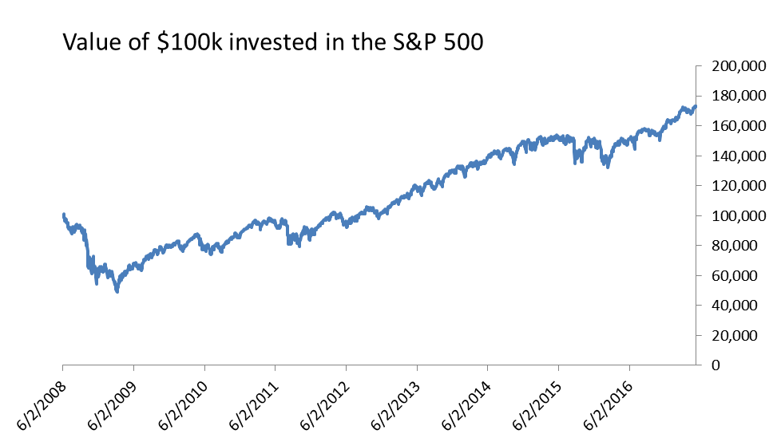

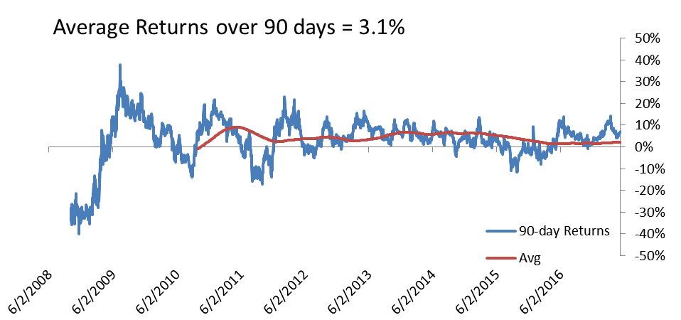

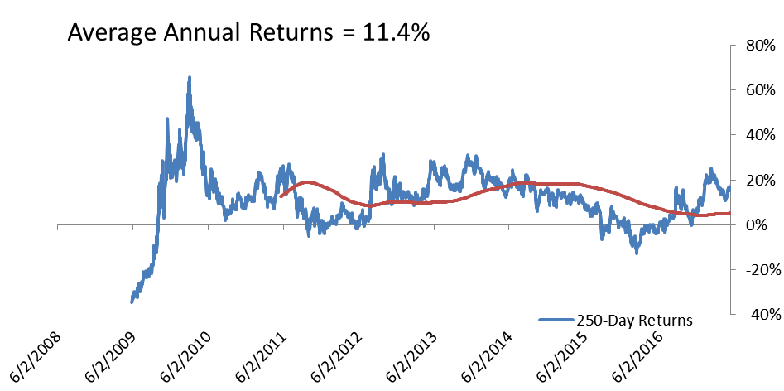

The portfolio grows in value from $100,000 to $173,005, but there were many fluctuations along the way. First, this data begins right in the middle of the financial crash of 2008. Losses begin at -40% for the first 90-days simulated. During the recovery, these rose to +40%. Afterwards, things settle down. There are several 90-day periods that see negative returns , but fewer periods lose money on an annual basis. Average 90-day returns were 3.1% and average annual returns were 11.4%. These are the numbers to beat.

# Average Return Portfolio, Trading Every 20 Days

Compared to the S&P 500, the average return portfolios are in for a crazy ride. As the charts below, this portfolio grew from $100,000 to a high of $600,000 before crashing back down to end at $99,253.

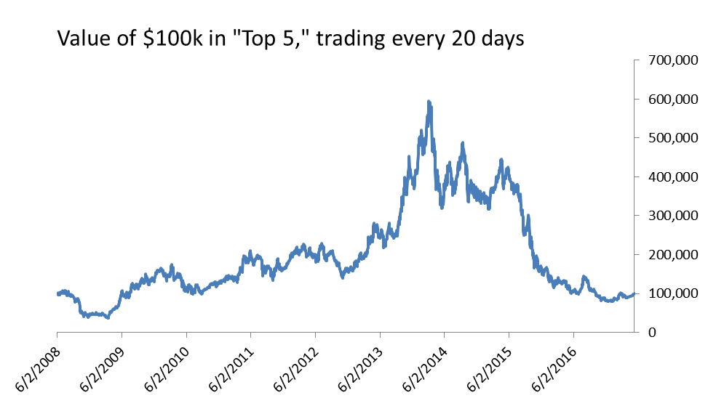

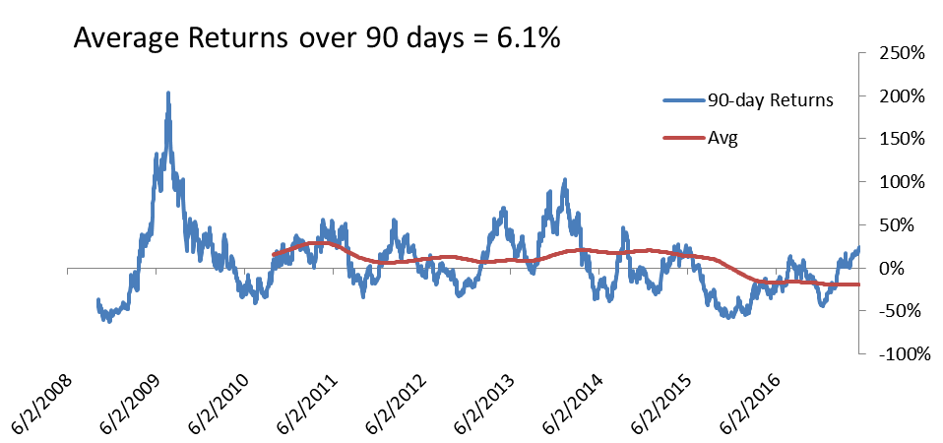

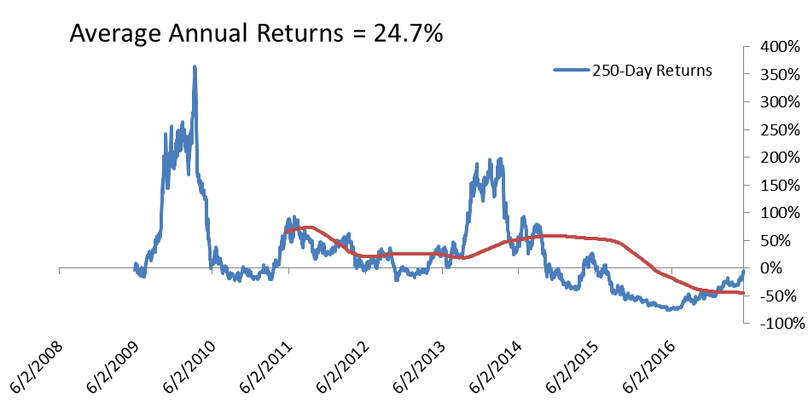

The long-term returns averaged 6.1% over a 90-day period or 24.7% over a 250-day period. However, there are many more periods of negative returns compared to the S&P 500. Overall, these periods of losses wiped out the large gains that were obtained in other periods.

# Average Return Portfolio, Trading Every 5 Days

This same portfolio selection method does better if we re-assess and re-balance the portfolio every 5 days instead of every 20 days. This portfolio increased to a maximum value of $700,000 before crashing again and finishing at $179,375. This method beat the S&P 500 by $6,370, hardly enough to really get excited about.

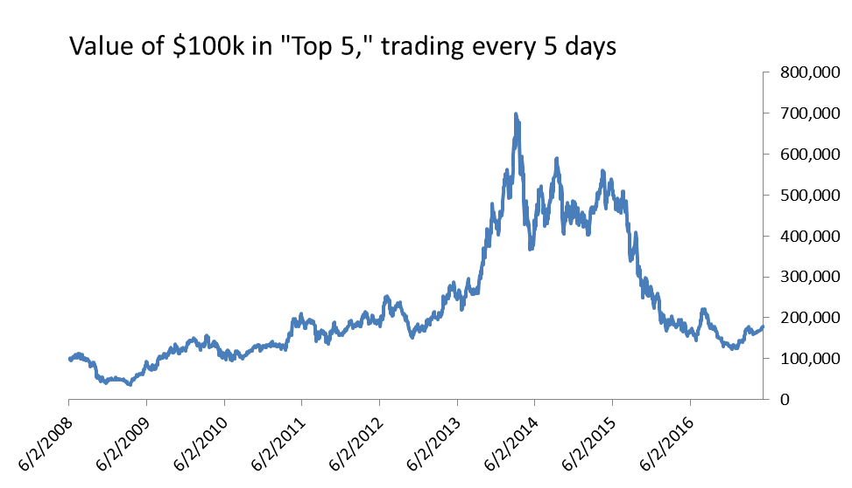

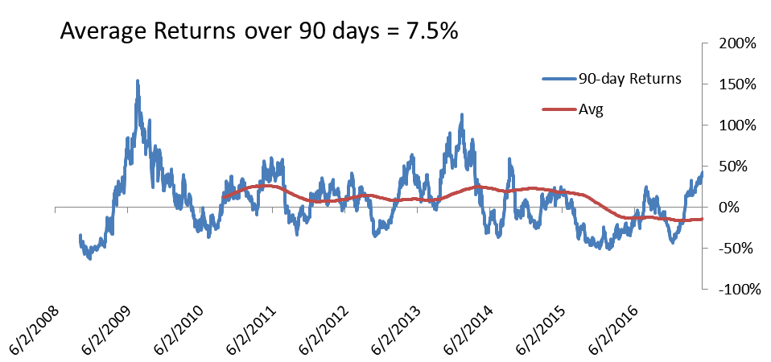

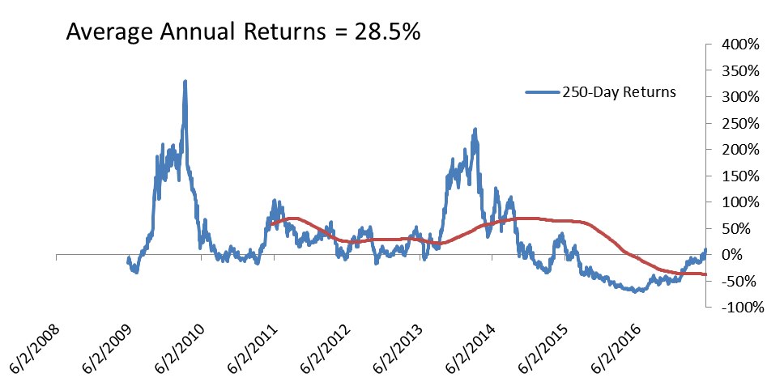

# Analysis

Summarizing the charts above, we get:

|  |  |  |  |  |  |  |  |
| --- | --- | --- | --- | --- | --- | --- | --- |
|  | Growth of $100k |  | Avg. Returns | |  | Avg. Log Returns | |
| Method |  | 90-Days | 250-Days |  | 90-Days | 250-Days |
| S&P 500 | $173,005 |  | 3.1% | 11.4% |  | 2.5% | 10.1% |
| Avg20(trade=20) | $99,253 |  | 6.1% | 24.7% |  | -0.1% | 5.5% |
| Avg20(trade=5) | $179,375 |  | 7.5% | 28.5% |  | 2.0% | 11.4% |

The average returns make it appear that the average return portfolios out-perform the market. However, we know that this is not the case since the value of portfolio that traded every 20-days was actually lower than the market returns. It is the log returns that actually matter in this case, as they give a better view of expected wealth growth over time than just the simple returns. Here, it appears that none of the portfolios out-perform the market over a 90-day period. The portfolio that trades every 5 days might still out-perform over 250-days, but not by much.

The table below give average returns and risk-adjusted metrics for the 90-day portfolios. The great variance in the average returns portfolio is penalized against them. Where they were already under-performing the market portfolio based on return alone they are performing even worse on the risk-adjusted Sharpe and Sortino ratios.

*90-Day Returns (starting 6/2/2008)*

|  |  |  |  |  |  |
| --- | --- | --- | --- | --- | --- |
|  |  | Log Returns | | | |
| Method | Avg. | Avg. Return | Stdev | Sharpe | Sortino |
| S&P 500 | 3.1% | 2.5% | 10.80% | 0.2337 | 0.1704 |
| Avg20(trade=20) | 6.1% | -0.1% | 35.13% | -0.0039 | -0.0037 |
| Avg20(trade=5) | 7.5% | 2.0% | 32.97% | 0.0604 | 0.0545 |

The period around 2008-2009 was a very turbulent time for stocks. Perhaps we should remove this from our data set. Even when we do this, the results are still similar:

*90-Day Returns (starting 6/2/2010)*

|  |  |  |  |  |  |
| --- | --- | --- | --- | --- | --- |
|  |  | Log Returns | | | |
| Method | Avg. | Avg. Return | Stdev | Sharpe | Sortino |
| S&P 500 | 3.9% | 3.7% | 6.20% | 0.5901 | 0.5265 |
| Avg20(trade=20) | 2.1% | -2.2% | 29.71% | -0.0741 | -0.0687 |
| Avg20(trade=5) | 5.1% | 1.0% | 28.35% | 0.0356 | 0.0327 |

The next two tables present similar data for 250-day periods:

*250-Day Returns (starting 6/2/2008)*

|  |  |  |  |  |  |
| --- | --- | --- | --- | --- | --- |
|  |  | Log Returns | | | |
| Method | Avg. | Avg. Return | Stdev | Sharpe | Sortino |
| S&P 500 | 11.4% | 10.1% | 12.0% | 0.8423 | 0.8324 |
| Avg20(trade=20) | 24.7% | 5.5% | 58.6% | 0.0940 | 0.1392 |
| Avg20(trade=5) | 28.5% | 11.4% | 53.4% | 0.2133 | 0.3219 |

*250-Day Returns (starting 6/2/2010)*

|  |  |  |  |  |  |
| --- | --- | --- | --- | --- | --- |
|  |  | Log Returns | | | |
| Method | Avg. | Avg. Return | Stdev | Sharpe | Sortino |
| S&P 500 | 11.0% | 10.1% | 8.1% | 1.2524 | 1.1291 |
| Avg20(trade=20) | 11.0% | -4.7% | 57.25% | -0.0817 | -0.0710 |
| Avg20(trade=5) | 18.5% | 3.6% | 53.37% | 0.6769 | 0.0592 |

While the method that traded every 5 days did out-perform the market in the first table, it did not do so on a risk-adjusted basis. When we omit the turbulent time periods from 2008-2009 it also fails to out-perform the market even on an unadjusted basis.

# Summary

Ultimately, the average return portfolio does not look like a good way to invest money. While there are periods of time where this method is very profitable (such as 2009-2014, where a portfolio increased in value by 7x) these profits are erased in periods of times were the method performs poorly (such as 2015-2016 where it lost 80%). Even without adjusting for risk, the long-term gains using this method are negligible or non-existent when comparing to the rest of the market. On a risk-adjusted basis, the method performs even worse since it is increasing risk and variance substantially without increasing returns.

Further investigation would be needed to try and determine what separates the good periods from the bad periods. Perhaps a stock’s historical return is still a good input that can be used in a prediction model as long as it is combined with other criteria or when some method is used to determine when this input is no longer going to produce good results. I’d suggest the next analysis be one that attempts several different models to predict a stock’s return. A method based on historical averages could be one option, while something more advanced such as an AR or ARIMA model could also be an option. We could even try to calibrate linear models using historical returns at different intervals (i.e. returns over the last 30 days, 90 days, and 250 days could all be parameters to the linear model). Each of these methods should be tested to see which performs the best historically, and that method could then be used to predict the future and make stock selections. We may also try to take into account the forecast error or expected variance of our predictions. Then we can build portfolios that not only attempt to maximize return but also minimize risk.

# Appendix: Importance of Examining Log Returns

During this analysis I once again made the mistake of looking at average returns without taking the logarithm first. By the end of the analysis I realized once again why this is a bad idea and why log-returns are better. The following charts illustrate this point:

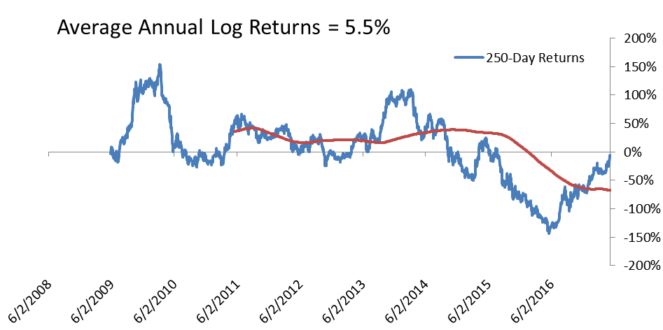

These charts show average annual returns calculating as a simple average and as an average of log returns. The first chart shows an average return of 24.7%. There are periods of very high returns, and the losses don’t really look that bad. This is because we have not taken the logarithm. Profitable returns have no upward limit (and we do see returns as high as 350%), but losses are limited to 100%. A 50% gain followed by a 50% loss is also a net loss, but this is not captured well in these charts.

The log chart does a better job of lowering the peaks and increasing the troughs. This chart shows much more clearly how painful the losses can be. Expectations are also tempered. Instead of expecting a 24.7% return, we are now looking at a 5.5% return. To explain the difference: if you were just to pick a random date and guess what the 250-day return would be, 24.7% is a good guess. It is the expected value. However, if you were to actually invest money and measure your return, you wouldn’t get a 24.7% return. The losses would bring your returns down to 5.5%. This is a better measure of the return you would actually expect to get.

Maybe next time I’ll remember that, and I won’t get too excited when I see average returns of 24.7% (as I did when I started this analysis).