P/E Ratios and S&P 500 Returns

# Introduction

I remember hearing once that P/E Ratios explain 30% of the movement in the market. Last month, I came across [this article](https://www.cnbc.com/2017/07/31/theres-a-99-percent-chance-stock-market-returns-will-be-subpar-from-here.html) from CNBC offering further evidence using this chart:

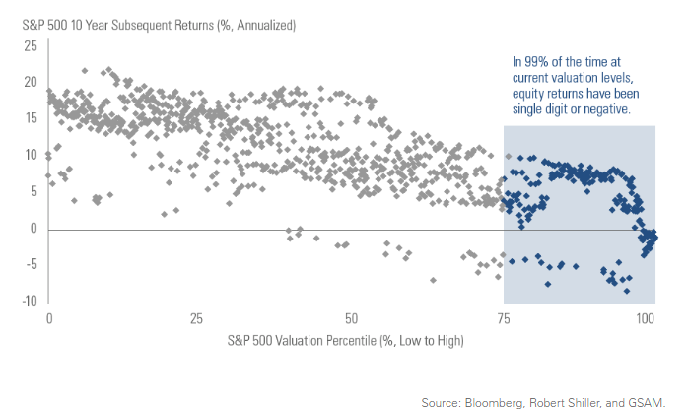

They used this chart as evidence that we should expect single-digit or negative returns in the S&P 500 over the next 10 years.

I’ve never been the type to trust other people’s data. I like to see it myself. So I downloaded P/E Ratio data for the S&P 500 and ran a simple regression. The results were surprising. I only had a limited 10-year sample, but during that time, the P/E Ratio explained 22% of the variation in stock market returns over a 24-month period. That wasn’t the surprising part. The surprising part is that they explain 76% of the variation of 30-month returns and 73% of the variation of 36-month returns! Wow! At current P/E levels of 28.96, this would lead us to expect the following returns:

18-month: - 4.11%

24-month: - 3.04%

30-month: - 2.50%

36-month: - 1.30%

42-month: - 1.32%

The following is a pretty simple analysis, so let’s see if I can keep this write-up brief.

# P/E Ratio Data

The P/E data I used came from: <http://www.multpl.com/shiller-pe/>. This site presents Robert Schiller’s 10-year, Cyclically Adjusted PE Ratio. It presents the super-useful graph below and also allows the user to download annual or monthly data. Monthly data was used in this analysis.

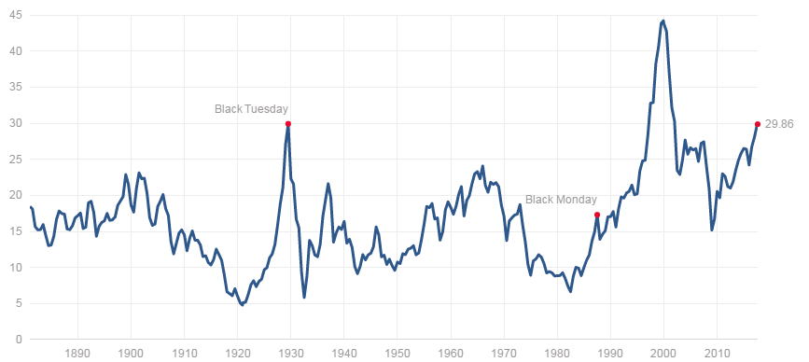

# Analysis

10-years of historical quotes for VOO (Vanguard’s S&P 500 index) were downloaded from Google via quantmod. These were joined with the P/E Ratio data and filtered to only include the 1st trading day of each month along with the P/E ratio from the end of the previous month. The following R code was then used to calculate returns over a given LEAD time (in months), plot these against P/E Ratios, and do a simple linear regression.

# NOTE: df.monthly contains columns named Date, Close, and PE.Ratio

LEAD <- 36

df.monthly$Return <- with(

df.monthly,

log(lead(Close, LEAD)/Close)) * 12/LEAD # annualized log returns

with(df.monthly,

plot(PE.Ratio, Return))

summary(lm(Return ~ PE.Ratio, data=df.monthly))

|  |  |
| --- | --- |
| **1 Month** | **6 Month** |
| **12 Month** | **18 Month** |
| **24 Month** | **30 Month** |

|  |  |
| --- | --- |
| **36 Month** | **42 Month** |

As can be seen in the plots above, the model is unable to predict 1-month or 6-month returns. However, at 12-months a correlation does start to appear, and it strengthens as we look at 18-, 24-, and 30-months. The table below provides R-squared, Adjusted R-Squared, and coefficients for each of the regressions. The 30-month prediction is the most accurate. The 24-month and 36-month predictions are also just as accurate. The high-powered models have similar coefficients, allowing us to estimate 24-month to 36-month returns with roughly the same formula.

|  |  |  |  |  |
| --- | --- | --- | --- | --- |
| Period | R-Squared | Adj. R2 | Intercept | Slope |
| 1-Month | 0.0007 | -0.01179 | 0.224669 | -0.004516 |
| 6-Month | 0.0866 | 0.07442 | 0.540115 | -0.018101 |
| 12-Month | 0.2257 | 0.2145 | 0.524288 | -.017922 |
| 18-Month | 0.5452 | 0.538 | 0.640713 | -.022832 |
| 24-Month | 0.7125 | 0.7075 | 0.591222 | -.020817 |
| 30-Month | 0.7578 | 0.753 | 0.560620 | -.019613 |
| 36-Month | 0.7309 | 0.7249 | 0.502556 | -.017265 |
| 42-Month | 0.517 | 0.5046 | 0.406384 | -.013169 |

These coefficients were used to produce the predicted returns in the introduction. The model is predicting a -2.5% return over the next 30 months.