**Inferring Expected Returns from Option Prices**

# Overview

Since college, I’ve wondered if there’s a way to infer future expectations about stocks from options prices. Options prices should be tied to future expectations of the underlying stock’s price (I think… although this isn’t an input into the Black-Scholes equation), and the variety of strike prices should tell us something about the distribution at various future price points. This paper presents a simple model for doing just that. I don’t know if this is really good or not, but it seems interesting.

# Data & Approach

The following screenshot shows options prices for the VOO on 8/5. The options expire on 9/15 (30 trading days in the future), and the current price of VOO was 227.26.

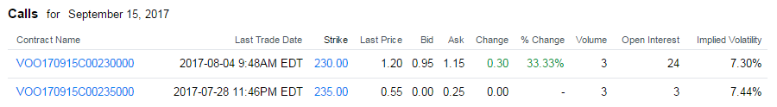

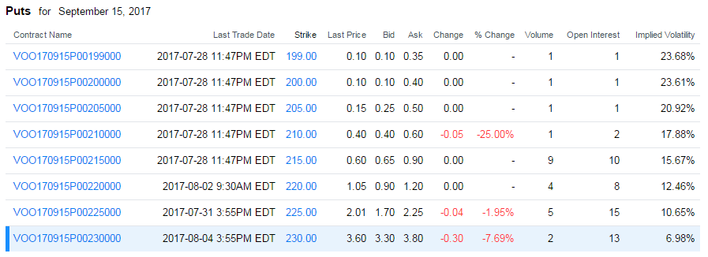

The goal of this analysis is to fit a simple distribution of the form shown below to this:



We will divide the distribution into intervals defined by the strike prices of the various options. We then want to calculate the probability that the future price will fall into each of these bins.

# Estimating the Extreme Values

To begin, we look at the extremes. The ask price on a 235 call option is $0.25. This means that the expected payoff of this option should be about $0.25. A trader buying the option would thus have a zero expected profit. (NOTE: Theory predicts that the expected profit should be near-zero. There are two sides to each trade and neither should have an advantage over the other. The buyer is thus essentially loaning money to the seller, and the return to the buyer should be the risk-free interest rate over the holding period of the option. We’ll just assume that is near-zero since the options are short-term options.) The payoff on the option depends on its price. It is:

|  |  |
| --- | --- |
| Case | Payoff |
| S <= 235 | 0 |
| S > 235 | S – 235 |

The expected payoff of the option is thus:

$$E[S-235 | S >235]*Pr⁡(S>235)+0*Pr⁡(S≤2350)=$$

$$E[S-235 | S >235]*Pr⁡(S>235)=\$0.25$$

So how do we build a distribution with an expected value of $0.25? If we define an interval from 235 to 240 with a constant probability for all points in between, the expected payoff if the price exceeds 235 is $2.50. That is:

$E[S-235 | S >235]=E[S|S>235]-235=237.5-235=2.50$

Note that we are assuming there is zero probability of the stock price exceeded 240. The expected value is then 237.5 and the payoff on the option is $2.50. In order to make this worth $0.25, the probability of the price exceeding 235 must be 10%.

$$E[S-235 | S >235]*Pr⁡(S>235)=0.25$$

$$2.50*Pr⁡(S>235)=0.25$$

$\operatorname{Pr}\left(S>235\right)=.25/2.50=0.1$ = 10%

A more realistic estimate might be that the stock could increase as high as 285. The expected payoff is then the midpoint of the interval (260) minus the lower range (235), which is $25. To provide an expected value of 0.25, the probability in this interval would need to be 1%. Alternately, we might build an interval that extends all the way to 335. The midpoint is then 285. The payoff is $50, and the inferred probability is 0.5%. As we can see, the choice of how wide we make this interval can change the probability quite a bit. However, we’ll see later that this might influence our results less than we’d expect.

We’ll proceed using the 235 to 285 interval, implying that the probability for the price exceeding 235 is 1%. We can perform this same operation on the other extreme using the put option with a strike price of 200. Its current price is $0.40. If we build an interval from 150 to 200, the expected in-the-money payoff is $25, and the inferred probability of landing in this interval is $0.40 / $25 = 0.016 = 1.6%.

# Estimating the Internal Intervals

Now that we have the tails estimated, we can proceed to estimate the internal intervals. This gets a little bit trickier. Let’s examine the interval from 230 to 235. If we bought a 230 call option for $1.15 and sell a 235 option for $0.25, the cost of this spread will be $0.90. The payoff will depend on the price of the stock:

|  |  |
| --- | --- |
| Case | Payoff |
| S <= 230 | 0 |
| 230 <= S < 235 | S - 235 |
| S > 235 | 5 |

Notice that our profit is capped at $5.00 if the price exceeds 235. We also know the probability of the price exceeding 235. We calculated that earlier and estimated it to be 1%. So the value of this option derived from this case is $5.00 * 1% = $0.05. This leaves $0.85 to be explained by the case where the price falls between 230 and 235. If the price falls between 230 and 235, the expected price is 232.50 and the expected value is $2.50. In order to make this outcome worth $0.85, the probability of the stock’s price falling within this interval must be 34%. More formally:

$$\operatorname{Pr}\left(S>235\right)*5+\operatorname{Pr}\left(230≤S≤235\right)E\left[S-230 \right| 230≤S<235]+Pr⁡(S>230)*0=$$

$$0.01*5 +\operatorname{Pr}\left(230≤S≤235\right)2.50 + 0=0.90$$

$$\operatorname{Pr}\left(230≤S≤235\right)=\frac{.90-.05}{2.50}=.34=34\%$$

If we had a call option at a strike price of 225, we could repeat this process. We now know the probability of S exceeding 230. It’s the probability of it exceeding 235 (1%) added to the probability of it falling in the range of 230 and 235 (34%), which is 35%. However, we don’t have a call option at a strike price of 225. Instead, we have to go to the other end of the distribution and look at the price of puts.

We already have the probability of the price falling below 200 (1.6%). We can construct a spread by buying the 205 put for $0.50 and selling the 200 put for $0.40. The cost of the spread is thus $0.10 and $0.08 of that is accounted for by the probability of the price falling below 200 ($5.00 * .016 = $0.08). If the price falls between 200 and 205, the expected payoff is $2.50. To make this worth $0.02, the inferred probability is .02 / 2.50 = 0.008 = 0.8%.

Repeating this process produces the following table:

|  |  |  |  |  |  |  |  |  |  |  |
| --- | --- | --- | --- | --- | --- | --- | --- | --- | --- | --- |
| Strike Price Range | | |  | Using Call Options | | |  | Using Put Options | | |
| Min | Mid | Max |  | Spread  Cost | Pr(S>x2) | Pr(x1<S<x2) |  | Spread  Cost | Pr(S<x1) | Pr(x1<S<x2) |
| 150 | 175.0 | 200 |  |  |  |  | | 0.40 | 0.000 | 0.016 |
| 200 | 202.5 | 205 |  |  |  |  |  | 0.10 | 0.016 | 0.008 |
| 205 | 207.5 | 210 |  |  |  |  |  | 0.10 | 0.024 | 0.000 |
| 210 | 212.5 | 215 |  |  |  |  |  | 0.30 | 0.024 | 0.072 |
| 215 | 217.5 | 220 |  |  |  |  |  | 0.30 | 0.096 | 0.000 |
| 220 | 222.5 | 225 |  |  |  |  |  | 1.05 | 0.096 | 0.228 |
| 225 | 227.5 | 230 |  |  |  |  |  | 1.55 | 0.324 | 0.000 |
| 230 | 232.5 | 235 |  | 0.90 | 0.01 | 0.34 |  |  |  |  |
| 235 | 260.0 | 285 |  | 0.25 | 0.00 | 0.01 |  |  |  |  |

Finally, we are able to infer the probability distribution for each of the intervals we have defined. Now comes the fun part: we can use this distribution to calculate the expected price of the asset. We have:

|  |  |
| --- | --- |
| Mid-Point | Probability |
| 175.0 | 0.0160 |
| 202.5 | 0.0080 |
| 207.5 | 0.0000 |
| 212.5 | 0.0720 |
| 217.5 | 0.0000 |
| 222.5 | 0.2280 |
| 227.5 | 0.0000 |
| 232.5 | 0.3400 |
| 260.0 | 0.0100 |

These probabilities do not add to 100%. Instead, they add to 67.4%, but we can normalize the distribution so that they do add to 100%. This is the same as doing a weighted average using the probabilities as the weights. The expected value in this case is $225.67. If correct, the market is expecting the price to fall from its current price of $227.26 by $1.59. Since these options expire on September 15, we would also assume that this is the date of the predicted price.

# Sensitivity to End Points

Earlier, we had to make an arbitrary decision about how far to extend the ends of our distribution beyond the highest call option and the lowest put option. We created intervals that were $5, $50, and $100 wide. The expected price of $225.67 was obtained using widths of $50. If we increase these to $100, the expected price becomes $225.69. This does not have much effect. If we decrease the width to $5, it becomes $221.85. Bringing the endpoints in too closely really skews the inferred distribution as well. The following table shows the different distributions based on end-point width:

|  |  |  |  |
| --- | --- | --- | --- |
| Mid-Point | $100-interval | $50-interval | $5 interval |
| 175.0 | 0.0080 | 0.0160 | 0.1600 |
| 202.5 | 0.0240 | 0.0080 | 0.0000 |
| 207.5 | 0.0000 | 0.0000 | 0.0000 |
| 212.5 | 0.0560 | 0.0720 | 0.0000 |
| 217.5 | 0.0000 | 0.0000 | 0.0000 |
| 222.5 | 0.2440 | 0.2280 | 0.1000 |
| 227.5 | 0.0000 | 0.0000 | 0.1000 |
| 232.5 | 0.3500 | 0.3400 | 0.1600 |
| 260.0 | 0.0050 | 0.0100 | 0.1000 |

In general, we would not expect to see many intervals with a zero probability of occurring. This would lead us to prefer the wider intervals over the smaller ones. Some realistic boundary based upon the time-frame being examined would make sense. If you’re looking at 1-month options it would make sense to take the largest 1-month movement observed in the stock to set the upper and lower endpoints of the distribution.

# Fidelity Data versus Yahoo Data

Fidelity offered slightly different prices for these same options:

|  |  |  |
| --- | --- | --- |
| Call Price (Ask) | Strike | Put Price (Ask) |
| 23.00 | 205 | 0.35 |
| 18.10 | 210 | 0.45 |
| 13.30 | 215 | 0.65 |
| 8.70 | 220 | 1.05 |
| 4.60 | 225 | 1.8 |
| 1.15 | 230 | 3.8 |
| 0.20 | 235 | 8.5 |
| 0.15 | 240 | 13.2 |
| 0.10 | 245 | 18.5 |
| 0.10 | 250 | 23.4 |

The predicted price based on the put option was $228.33. Predicting off the call options gave an expectation of $230.77. However, the distributions of both of these were far from ideal, and I don’t know a good way of combining them:

|  |  |  |  |
| --- | --- | --- | --- |
| Mid |  | Probability using calls | Probability using puts |
| 180.0 |  |  | 0.014 |
| 207.5 |  | 0 | 0.012 |
| 212.5 |  | 0 | 0.028 |
| 217.5 |  | 0 | 0.052 |
| 222.5 |  | 0 | 0.088 |
| 227.5 |  | 0.700 | 0.412 |
| 232.5 |  | 0.300 | 0.668 |
| 237.5 |  | 0 | 0 |
| 242.5 |  | 0 | 0 |
| 247.5 |  | 0 | 0 |
| 275.0 |  | 0.040 | 0 |
| Total |  | 1.040 | 1.247 |

I also calculated the expectation using the bid price of the put options rather than the asking price. The resulting expectation was $221.09. Averaging this with the estimate using call prices gives $224.71. A method that uses the mid-point of the bid and ask prices might be a good approach to this. I don’t know how to reconcile the differences between call and put options, but using the mid-point might make these differences smaller.