Do Stock Repurchases Improve Future Returns?

# Overview

Greg mentioned a few weeks ago that he had found a source for corporate stock buyback announcements. Many believe that these are positive signals for a stock’s future performance. There are several reasons for this:

1. Companies would typically only buy their own stock if they believed it to be undervalued. Companies know their business better than anyone else. If they believe the stock to be undervalued there’s a good chance it really is.
2. The corporate buyback (especially when it’s a significant amount) is a new agent in the market – a buying force that isn’t typically there. This should increase upside pressure based simply on supply and demand.
3. The buyback removes shares from the market, and (assuming earnings remain constant), increases reported earnings per share. This looks better on quarterly announcements and may draw other buyers to the stock as well.

All of these reasons make a lot of sense to me. A cursory examination of the literature shows many academics arguing about this effect. One study in particular said that this wasn’t a particularly strong signal because it only resulted in a 10-25% increase in stock price during the next quarter. (That seems like a pretty damn good return to me!) (TODO: insert links).

My examination was limited to 141 stock repurchase events from 136 unique companies during the early part of 2018. This limitation was imposed because I could only find buyback information for 2018 and recent buybacks were not useful since there was not yet enough data to perform the analysis. Analysis of these events did reveal strong returns in the 90 days after a buyback announcement. Cumulative returns averaged 10-15% during that time, outperforming the market by 6-8%. Early results are promising. Overall, I’m still spooked by current market conditions. I’d feel better about this analysis if we could reproduce it with more historical data. I’d especially be interested in how well it performed during the market crashes of 2008 and 2001 as an indicator of whether it is safe to pursue this strategy at this time.

# Data

Stock repurchase information as pulled from “marketbeat.com”:

<https://www.marketbeat.com/stock-buybacks/>

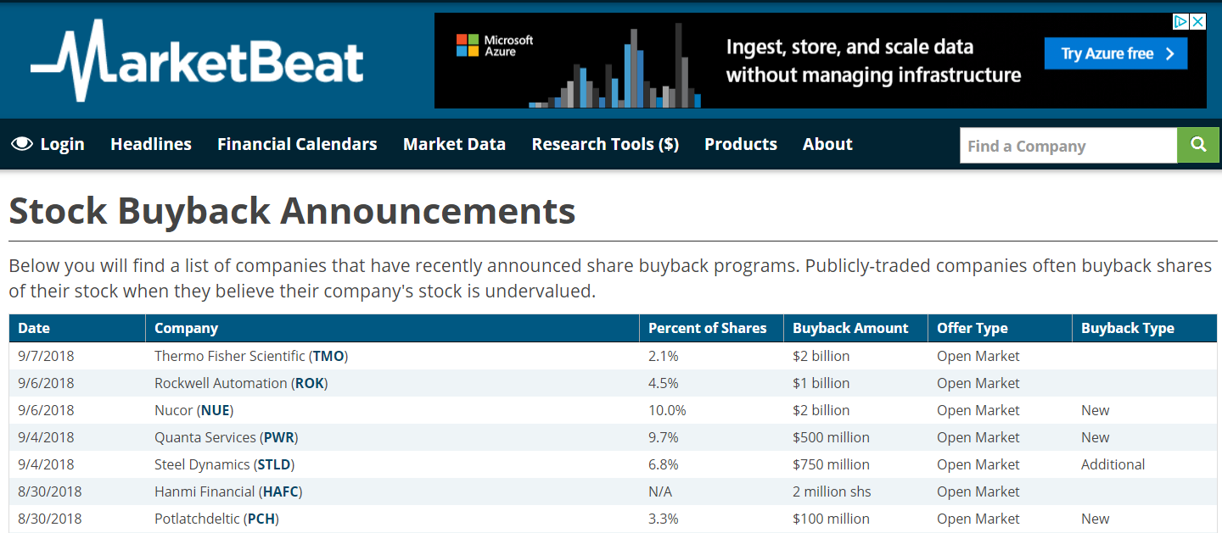

Data only goes back to the beginning of 2018. It can easily be copied into a spreadsheet and saved as a CSV for processing. The only data used in this analysis was the company’s stock symbol and repurchase date. We did not examine the percent of shares purchased, the buyback amount, or buyback type (although these could be interesting in future analyses).

Stock data was obtained from my “alphavantage” data which pulls 10 years of stock history for the Russell 3000 stocks with closing prices adjusted for dividends and splits.

There were 200 buyback events in the MarketBeat data. The stock data I had covered 167 of these events.

**Analysis**

Stock data for each event was pulled and analysis was limited to the 90 days before and 90 days after the event. If we did not have at least 10 days of data prior to and after the event, that event was dropped. Cumulative stock returns were recorded after the event. This simply took adjusted closing price of a stock on a post-event day and divided it by the adjusted open price on the day after the event was announced (and then subtracted 1). Initially, we calculated pre-event stock returns by dividing the open price on a pre-event day by the closing price on the day before the event (and subtracting 1). This was found to be somewhat confusing to interpret in the plots. For this reason we swapped the numerator and denominator in the pre-event calculation so that we are looking at the pre-event stock price as a percentage of the price just before the event. This makes the metric more consistent for both pre- and post-event data since they are now both relative to the price just before or just after the event. We excluded the actual day of the event form this analysis since we do not know if the buyback announcement was made before market hours on that day.

In addition to the stock’s actual price and return we also calculate a market-adjusted value that subtracts the performance of the market (as measured by VOO). This will tell us if a stock outperformed the market or not during these events.

If we plot data for each event separately we get this overwhelming spaghetti plot:

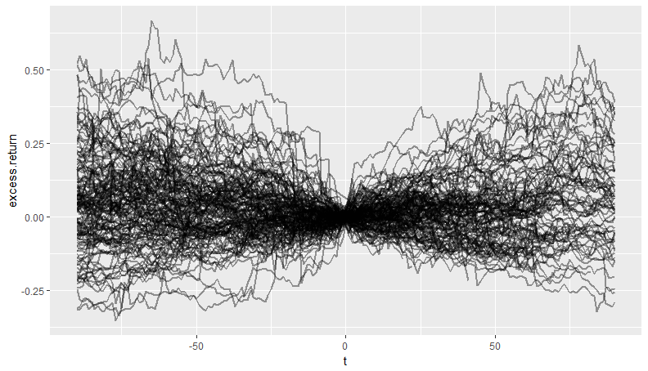

It is important to note that not every stock follows the same pattern. Some start high and fall. Some start low and continue to rise. Some are V-shaped, either up or down. There is still a large amount of uncertainty and error when investing in these stocks.

When we condense this chart down to an average we get the following:

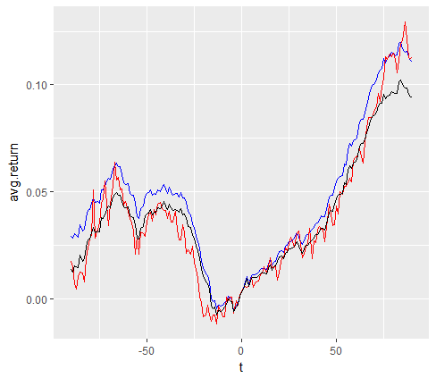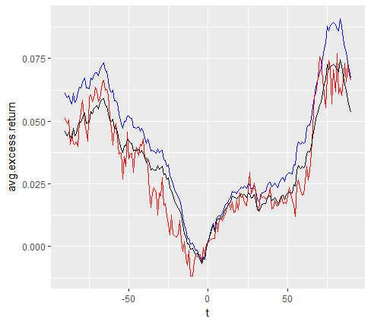

Legend: BLUE = average return, RED = median return, BLACK = log mean return.

Regardless of whether we use the mean, log mean, or median returns we see similar trends. The typical stock falls by about 5% in the 50 days prior to the buyback announcement. After the announcement the stock rises, delivering a 5% return after 50 days and a 10-15% return after 90 days. (We actually notice a slight rise in stock price just prior to the announcement in some of these metrics – which might be indicative of advanced knowledge or insider trading of the event.)

Even on the market-adjusted returns (right plot), we­ see excess returns of about 2.5% after 50 days and 7.5% after 90 days. This does seem to indicate a profitable trading strategy. If we could achieve these results every quarter we might expect as much as a 30% annual return.

**Verifying Results**

The same analysis was repeated using a minimal requirement of 80 days before and after the event. This limited us to only 67 events from 67 unique companies where we had sufficient data. The results are plotted below and are very similar to the previous analysis. The market adjusted returns are actually even a little bit better in this analysis.

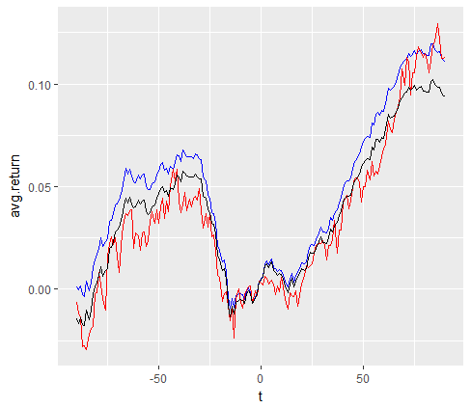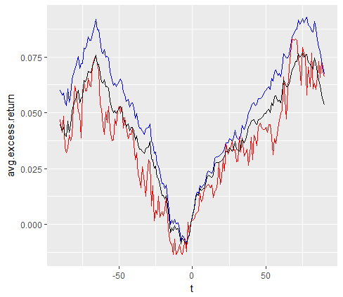

**Conclusion**

Initial results look very positive. It would be helpful to confirm these results with more historical data. It would also be helpful to look at how this strategy performs on the eve of market turmoil (ala 2000-2001 or 2007-2008) or at the end of a bull market cycle – since I believe that more accurately captures where we are at today. It also would be interesting to calculate risk-adjusted returns to ensure that we are not simply out-performing the market for reasons due to excess risk or volatility in these stocks. This is a distinct possibility since our stocks were drawn from the Russell 3000 and we compared against an S&P 500 index. The stocks in our universe are likely to be smaller-cap and more volatile than the market index we used for comparison.