Predicting and Profiting from increasing Market Volatility

Over the past 20 years market volatility (as measured by the VIX) has been a bumpy ride with periods of large spikes followed by relatively low and stable periods. Yet even in those low and stable periods, increases of 10-20% in volatility are common. This paper asks whether it is possible to predict and profit off these periods of increasing volatility. One method we’ll look at in particular is buying both a call and a put option. The value of these options should rise and fall with market volatility – assuming the underlying market price of the asset does not move. If it does move, there may even be a chance to profit from this movement.

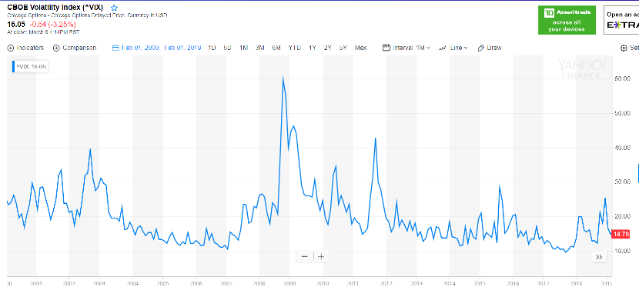

But first, we’ll need some options data…

# Estimating Options Prices using the S&P 500 and VIX

Options are notoriously difficult to work with. It is hard to find data, and even when you do, the variety of strike prices makes the data about 20 times more difficult to work with than simple stock data. To overcome these problems, we will try to estimate the value of options using the VIX. The VIX is the volatility index which should represent the implied volatility on 30-day options for the S&P 500. Now this is not always exact. For example, on 2/8/2018 we observed the following data points:

* S&P 500: 270.47
* VIX: 15.72%

An option with a strike price of 271, expiring on 1/17/2020 had an implied volatility of 16.46%. This is slightly higher than the VIX, but it still might be close enough for us to use the VIX in estimating implied volatility and thus option prices. If we try to value this option using the Black Scholes model we get the following:

|  |  |  |
| --- | --- | --- |
|  | Call Option | Put Option |
| Actual Price | 16.68 | 15.95 |
| Black Scholes (implied volatility) | 17.48 | 16.95 |
| Black Scholes (VIX) | 16.71 | 16.18 |

In theory, the Black Scholes model using implied volatility from the actual option price should produce the same exact value as the actual price (since it’s the same method used to calculate the implied volatility from the actual price). Ours likely differs due to differences regarding treatment of the time horizon and the risk-free rate. For reference, our calculation was:

X <- 270.47 # S&P 500

S <- 271 # strike price

sigma <- .1646 # implied volatility

#sigma <- .1572 # VIX

today <- as.Date("2019-02-08")

expire <- as.Date("2020-01-17")

Time <- as.integer(expire - today) / 365

GBSOption(TypeFlag="c", S, X, Time, r=0, b=0, sigma=sigma)

GBSOption(TypeFlag="p", S, X, Time, r=0, b=0, sigma=sigma)

While not exact, the combination of the VIX and the current value of the S&P 500 does allow us to estimate the value of options at any strike price. This is handy since the actual option price data is not available. The estimation will be used throughout this paper as we model S&P 500 options and trading strategies.

# Estimating Profitability of Trading Strategies

To get familiar with the options we’ll examine and their basic dynamics, let’s continue with the sample option we tried to price in the earlier section that had a strike price of 271. At 15.72% volatility the Black Scholes model estimated the value of this call option as $16.71. If nothing changes, the value of this option will fall to $11.52 after 6 months. This is the time value of the option eroding away. The chart below shows the price of the option for various volatility levels. The black line is the value of the option today. The red line is the value in 6 months.

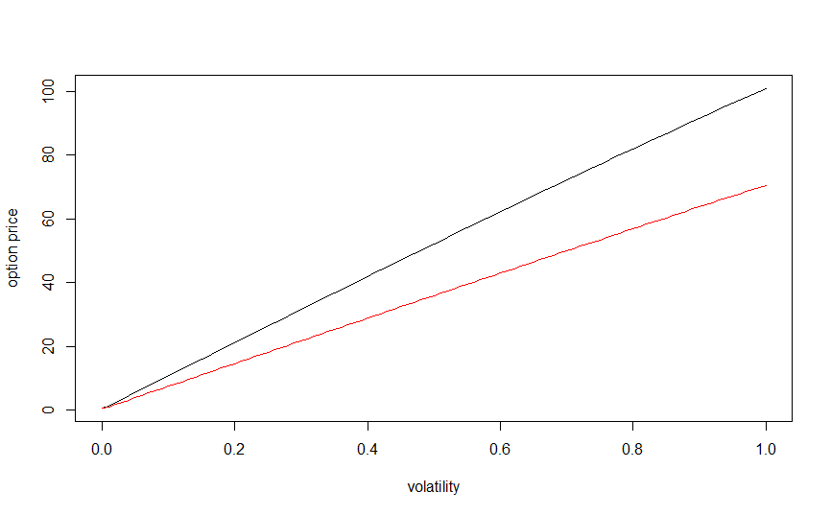

If we could somehow predict that market volatility was going to double in the next 6 months, what would that be worth to us? The charts below show the percent profit on such a strategy if we buy a call option and a put option at various starting volatilities:

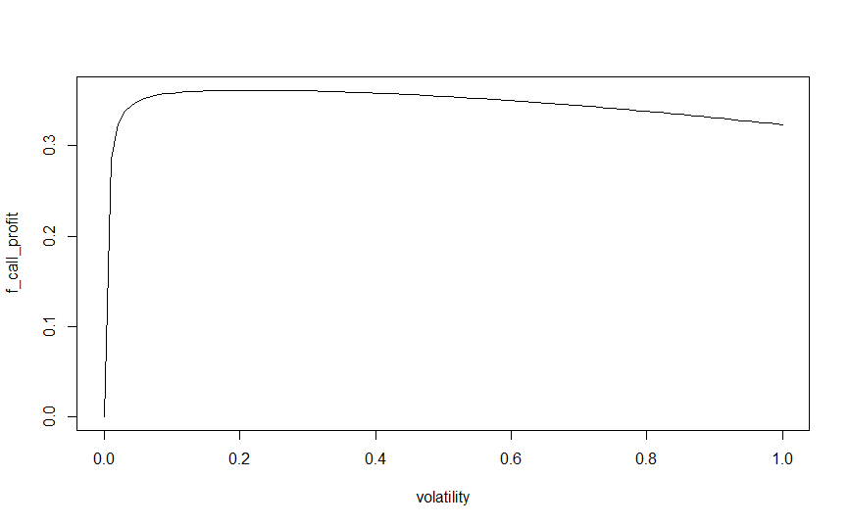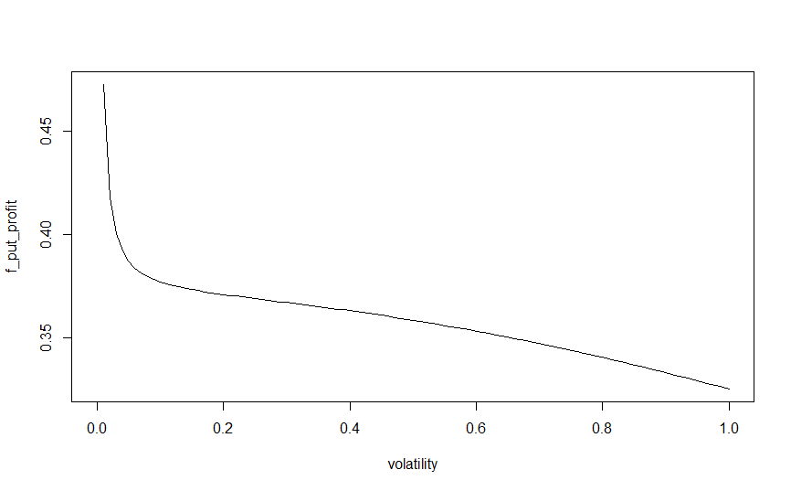

The shapes of the curves are different, but at normal volatility levels (between 15 and 40) the expected returns are around 35-37%. If you buy 1 call and 1 put, the call option dominates and you end up with the following shape and a similar return:

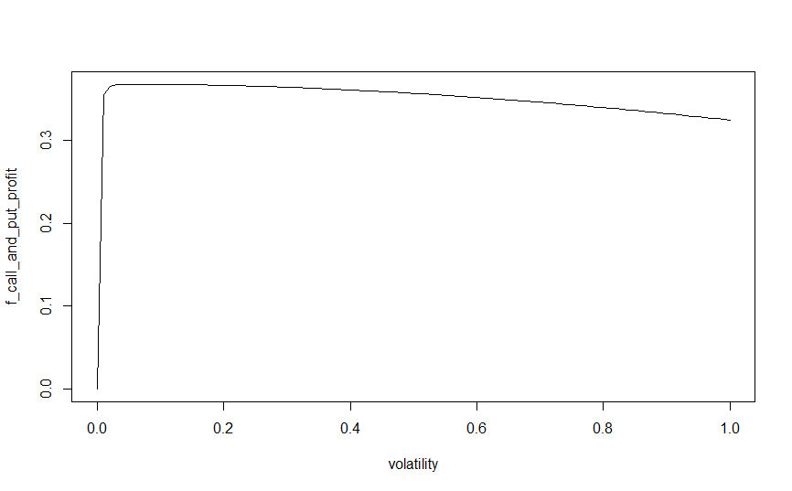

Being able to make this much in just 6 months (or even in 12 months) would be quite an accomplishment.

The chart below shows similar curves for increases of 50%, 60%, 70%, 80%, 90%, and 100%:

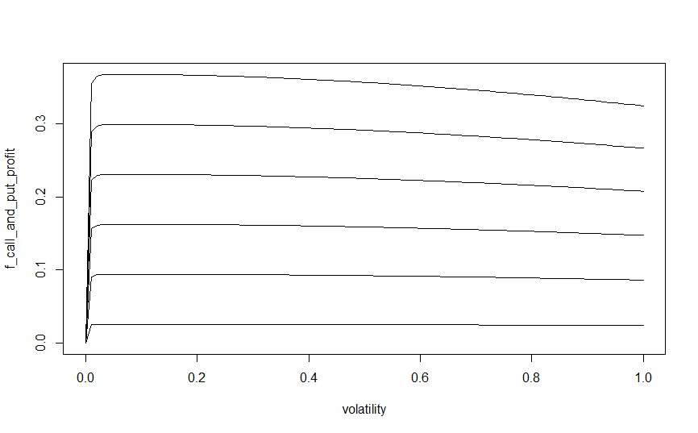

At a 50% increase we are only looking at profits of around 2.6%. This is hardly great, but there may be ways to improve upon these results based upon sell triggers or if we can profit from the movement of the underlying asset’s price.

The curves below show the impact of the underlying asset’s price on the value of options. If volatility remains unchanged over the 6 month period we can expect the returns shown below:

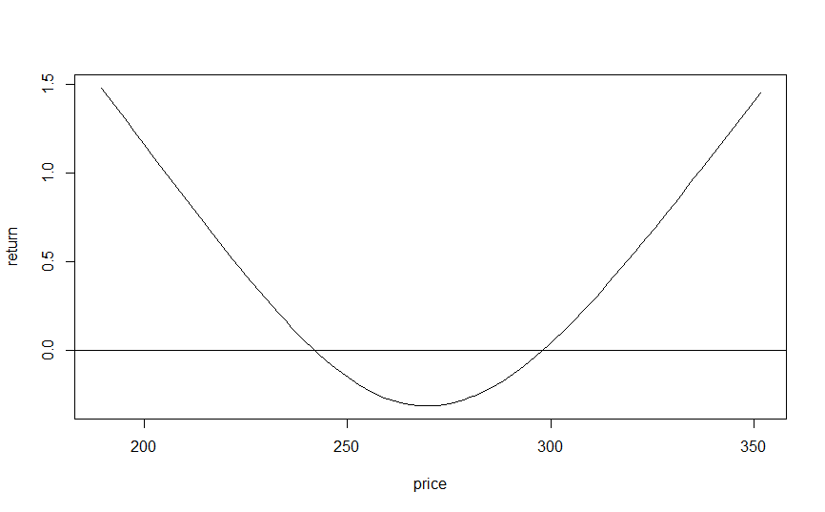

As one would expect, if the price moves up or down substantially we profit from holding 1 call option and 1 put option. However, if the price remains near its current price, we end up with a negative return.

As before, we have plotted curves that show the impact of volatility increasing by 50%, 60%, 70%, 80%, 90%, and 100%. These are shown below with the original constant volatility line for reference:

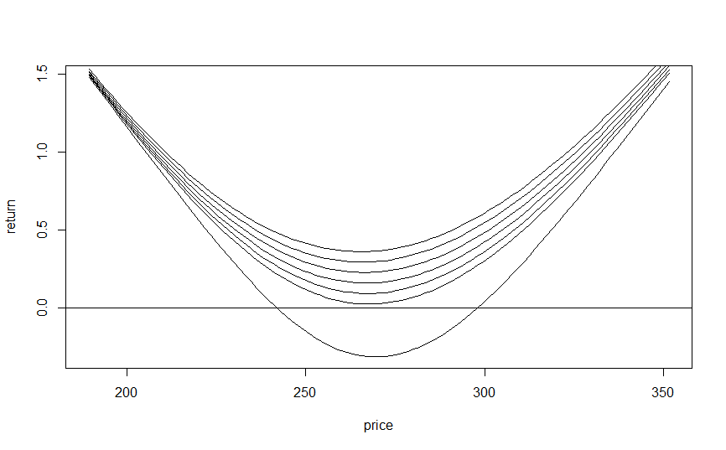

If volatility increases 50%, the strategy of holding 1 call and 1 put option becomes profitable at all price points. As the underlying asset price increases or decreases, the strategy becomes more and more profitable.

If we simulate random returns on the stock using the current value as the mean and the VIX as the standard deviation, we observe the following returns after holding the options for 6 months:

|  |  |  |  |  |  |  |
| --- | --- | --- | --- | --- | --- | --- |
| Volatility Scenario | Min | 1st Q | Median | Mean | 3rd Q | Max |
| Stays constant | -31.59% | -27.73% | -14.87% | 0.23% | 13.88% | 459.53% |
| Increase 50% | 2.38% | 4.99% | 13.85% | 26.15% | 34.92% | 459.58% |
| Doubles | 36.08% | 38.07% | 44.88% | 55.25% | 61.70% | 460.46% |

# Determining Realistic Targets

Is it realistic to expect that we could see a 50-100% increase in volatility? Keep in mind that we don’t have to hold an option the full 6 months. We can set a target that says we will sell as soon as we hit an X% increase. In this case, what really matters is the maximum increase over the period being examined. If the maximum is greater than our target, we assume our sell trigger would be invoked. The histogram below shows maximum volatility increases over periods of 6 months:

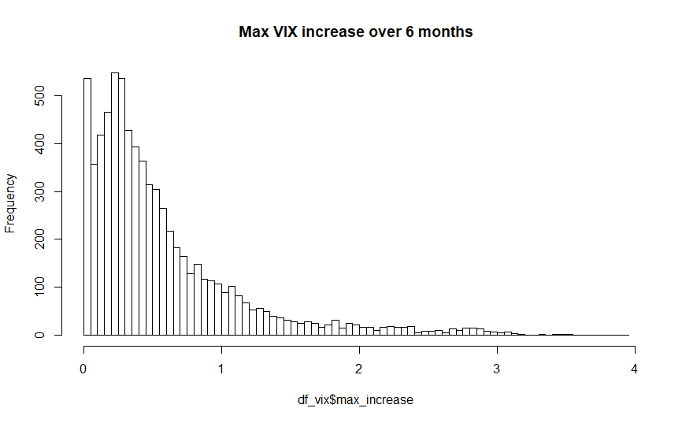

Min. 1st Qu. Median Mean 3rd Qu. Max. NA's

0.0000 0.2036 0.3922 0.5684 0.7288 3.9117 119

The average max increase is 56.84%. The median is 39.22%. Increases in this range are in fact likely to happen just by random chance.

It’s tempting to look at the VIX historical charts and think that a low level in the VIX will help you predict periods when it is likely to spike. The chart below examines this relationship by plotting the initial VIX levels with the max increase observed over the next 6 months:

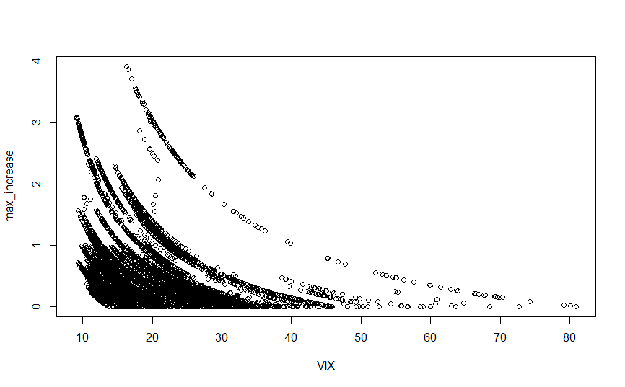

While it is definitely more likely to see large increases when the VIX is below 30, it is hard to say the returns at 30 will be much different than returns at 15 or 20. We do see that when the VIX is below about 14, it is practically guaranteed to at least increase. But there are still plenty of times where the current level is the maximum observed over the 6 months, resulting in a max_increase of 0.

The chart below summarizes the one above by showing summary statistics for when the VIX is at or below a given level. The red line is the mean. The blue is the median. The black lines are the minimum, 1st quartile, and 3rd quartile. The maximum has been left off as it is hard to see at the current scale.

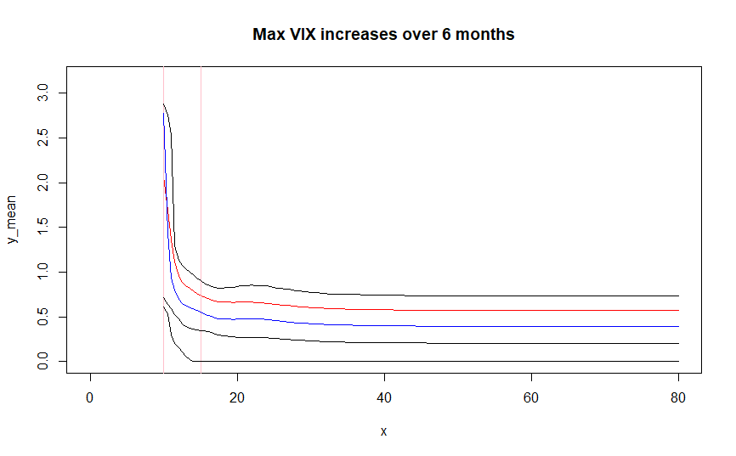

We can see that we would predict larger increases when the VIX is below 14. But beyond this, the distribution is relatively stable and not impacted by current VIX levels.

The chart below shows the probability of hitting various sell targets given that we start at a VIX level at or below the value on the X axis:

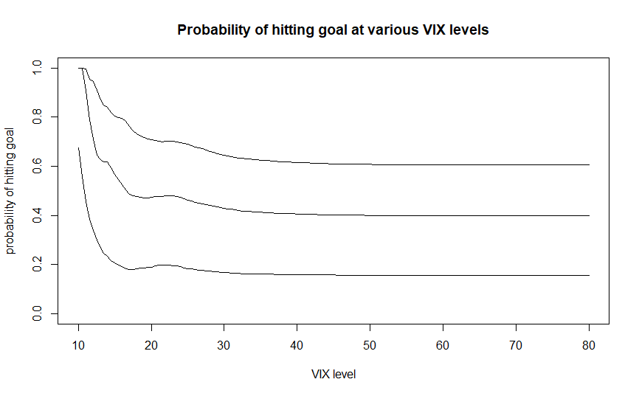

The 3 lines represent sell targets of 30%, 50%, and 100% increases. The chances of observing a 100% increase are relatively low, hovering around 18%. The chances of observing a 50% increase are about 44%. The chances of observing a 30% increase are about 65%. Of course, we also see that these probabilities rise considerably if we are starting at low VIX levels below 14.

# Simulating Trading Results

I created a simulation to test the profitability of a trading strategy that buys 1 call option and 1 put option and sells when a pre-determined profit is achieved. As a baseline, I simulated the result of holding the options for 6 months and then selling. The average return on this strategy was -4.89%. Simulation results are below. The chart on the right shows average profitability on a 250 rolling window.

*Buy And Hold Results*

|  |  |
| --- | --- |
| profit days_held  Min. :-0.67430 Min. :125  1st Qu.:-0.27240 1st Qu.:125  Median :-0.14197 Median :125  Mean :-0.04886 Mean :125  3rd Qu.: 0.07900 3rd Qu.:125  Max. : 2.44027 Max. :125 |  |

I then ran the simulation such that the options were sold as soon as they hit a 30% return or until 6 months, whichever came first. This simulation achieved an average return of 8.19%. On average, the options were sold after 84 days (about 4 months).

*Sell Trigger: 30%*

|  |  |
| --- | --- |
| profit days_held  Min. :-0.67430 Min. : 1.00  1st Qu.:-0.22033 1st Qu.: 36.00  Median : 0.28204 Median :125.00  Mean : 0.08192 Mean : 84.69  3rd Qu.: 0.34799 3rd Qu.:125.00  Max. : 0.89842 Max. :125.00 |  |

If we lower the target to 20%, the mean return is 8.78% and on average the options are held for 67 days (3 months).

*Sell Trigger: 20%*

|  |  |
| --- | --- |
| profit days_held  Min. :-0.67430 Min. : 1.00  1st Qu.:-0.15778 1st Qu.: 16.00  Median : 0.21372 Median : 56.00  Mean : 0.08779 Mean : 66.99  3rd Qu.: 0.25705 3rd Qu.:125.00  Max. : 0.81064 Max. :125.00 |  |

If we lower the target to 10% the mean return is 7.47% and on average the options are held for 41 days (2 months).

*Sell Trigger: 10%*

|  |  |
| --- | --- |
| profit days_held  Min. :-0.67430 Min. : 1.00  1st Qu.: 0.10349 1st Qu.: 5.00  Median : 0.12162 Median : 17.00  Mean : 0.07465 Mean : 41.42  3rd Qu.: 0.15472 3rd Qu.: 72.00  Max. : 0.81064 Max. :125.00 |  |

Taking these results into consideration, the 10% trigger seems to be the most attractive. If this can make 7.47% in 2 months we should expect nearly 6 times that per year. These results are superior to the others examined so far. In fact, if we take the average profit and average days held for each method we obtain the following estimates of annualized returns:

|  |  |
| --- | --- |
| Strategy | Annualized Return |
| Buy and Hold | -9.53% |
| Sell trigger of 30% | 26.17% |
| Sell trigger of 20% | 36.89% |
| Sell trigger of 10% | 54.42% |