MDM2 – Case Study: Intelligent Systems in Production
One‑Page Proposal
Team | Team 1
Members | Yu Han · Melisa Subasi · Meron Hagos · Alejandro Rivas
Roles & Cases | Team lead and core code: Yu Han. Work packages are shared by all four members.
Project Title | Binary Classification of AOI Alarms into True Defects and False Calls: A Second Check of AOI Results with Supervised Machine Learning
GitHub Repository URL | https://github.com/bodhi584/aoi-false-call-classification
Contact Email | han.yu@stud.th-deg.de · melisa.subasi@stud.th-deg.de · meron.hagos@stud.th-deg.de · alejandro.rivas@stud.th-deg.de
Industrial Application (target domain/use‑case) | Second check of AOI results in electronics assembly (SMT soldering): after automated optical inspection (AOI), every flagged board goes to manual inspection. Lecture example: “Siemens – Quality Control and Defect Detection” (p. 18). Current problem: on 21 Oct 2026 Siemens and NVIDIA announced an “AI second check of AOI results” in the Siemens electronics factory in Erlangen, targeting about 40 % fewer false calls.
Keywords (3–6) | automated optical inspection, false calls, second check, supervised machine learning, binary classification, electronics assembly
Submission Date (YYYY‑MM‑DD) | 2026-10-23
Gant Chart | 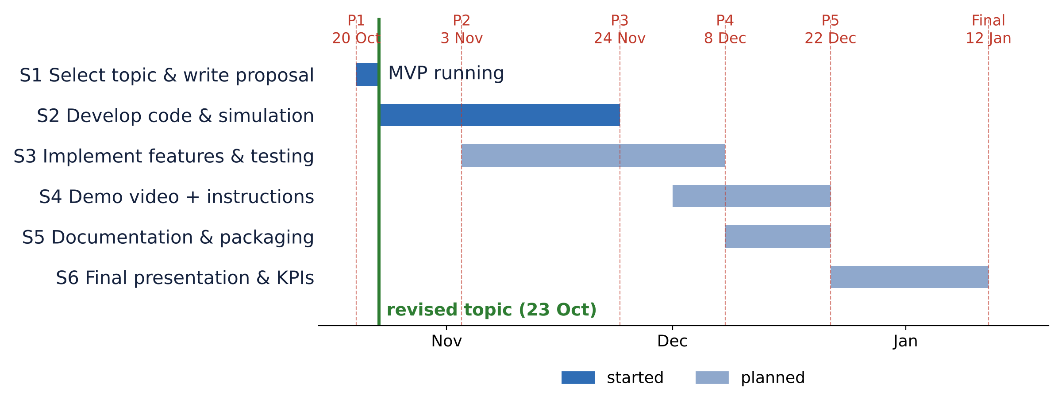
1) Problem Statement & Measurable Outcomes (3–4 sentences) | After soldering, an AOI camera system checks every solder joint against fixed limits and sends flagged boards to manual inspection. In real Siemens production data about 98 % of the flagged boards are false calls, so operators check thousands of good boards. Input: the AOI alarm (one flagged board, about 70 AOI measurements per flagged solder joint) → System: binary classification (supervised machine learning) trained on past manual-inspection results → Output: for each AOI alarm, true defect (manual inspection) or false call (skip manual inspection). Measurable outcomes (positive class = true defect): recall ≥ 99 % (at most 1 % of true defects classified as false call) and specificity ≥ 20 % (false calls correctly classified; baseline 6.4 %).
2) Motivation & Industrial Relevance (2–3 sentences) | Key motivation: fewer manual re-inspections of false calls (operator time, throughput), while true defects are still caught. Siemens is working on this problem in its Erlangen electronics factory (Oct 2026).
3) Related Work Snapshot (2–3 key references) | Pfab et al. (2024) published the Siemens AOI data. Albayari et al. (2025) used XGBoost, random forest and neural networks on the same data with a random split. Gap addressed: evaluation in time order, as in operation, with a fixed minimum recall for true defects.
4) Method & Feasibility (≤6 sentences) | Methodology: CRISP-DM. Data: Siemens AOI data (Mendeley, CC BY-NC 3.0), 440,274 flagged solder joints on 39,742 boards from 132 days, about 70 measurements each, labelled by manual inspection. Three classification models for the same binary task are compared (scikit-learn): logistic regression (baseline), random forest, and a neural network with one hidden layer (lecture p. 12, 17). Simulation: day-by-day simulation on the recorded production days (walk-forward evaluation); each day is classified by a model trained on earlier days only. MVP running: in time order, at 99 % recall, specificity is 1.8–6.4 % (14–18 % with a random split). Deliverables: Python software prototype, notebook, tests on GitHub, demo video, report (IEEE template).
5) Milestones & Timeline (short table/list) | P1 23 Oct · S1 select topic & write proposal: proposal + tech stack + MVP  P2 3 Nov · S2 develop code & simulation: core code + baseline sim; test plan + report  P3 24 Nov · S3 implement features & testing: unit/CI status; issues board  P4 8 Dec · S3 implement features & testing: full evaluation, error analysis  P5 22 Dec · S4 demo video + instructions; S5 documentation & packaging  Final 12 Jan · S6 final presentation & KPIs, report
6) Risks & Ethics (1–2 sentences) | Simulation-only environment with anonymised Siemens data (no personal data, non-commercial licence for course use), so there is no physical machinery or privacy risk. Main risks: one production line, 132 days and operator labels only, and the line changes over time, so 99 % recall may not hold on later days (fallback: report what works and why).

