MDM2 – Case Study: Intelligent Systems in Production
One‑Page Proposal
Team | Team 1
Members | Yu Han · Melisa Subasi · Meron Hagos · Alejandro Rivas
Roles & Cases | Team lead and core code: Yu Han. Work packages are shared by all four members.
Project Title | Binary Classification of AOI Alarms into True Defects and False Calls: A Second Check of AOI Results with Supervised Machine Learning
GitHub Repository URL | https://github.com/bodhi584/aoi-false-call-classification
Contact Email | han.yu@stud.th-deg.de · melisa.subasi@stud.th-deg.de · meron.hagos@stud.th-deg.de · alejandro.rivas@stud.th-deg.de
Industrial Application (target domain/use‑case) | Second check of AOI results in electronics assembly (SMT soldering): after automated optical inspection (AOI), every flagged board goes to manual inspection. Lecture example: “Siemens – Quality Control and Defect Detection” (p. 18). Current problem: on 21 Oct 2026 Siemens and NVIDIA announced an “AI second check of AOI results” in the Siemens electronics factory in Erlangen, targeting about 40 % fewer false calls.
Keywords (3–6) | automated optical inspection, false calls, supervised binary classification, decision threshold selection, concept drift adaptation
Submission Date (YYYY‑MM‑DD) | 2026-10-23 (revised 2026-11-04 after P2)
Gant Chart | 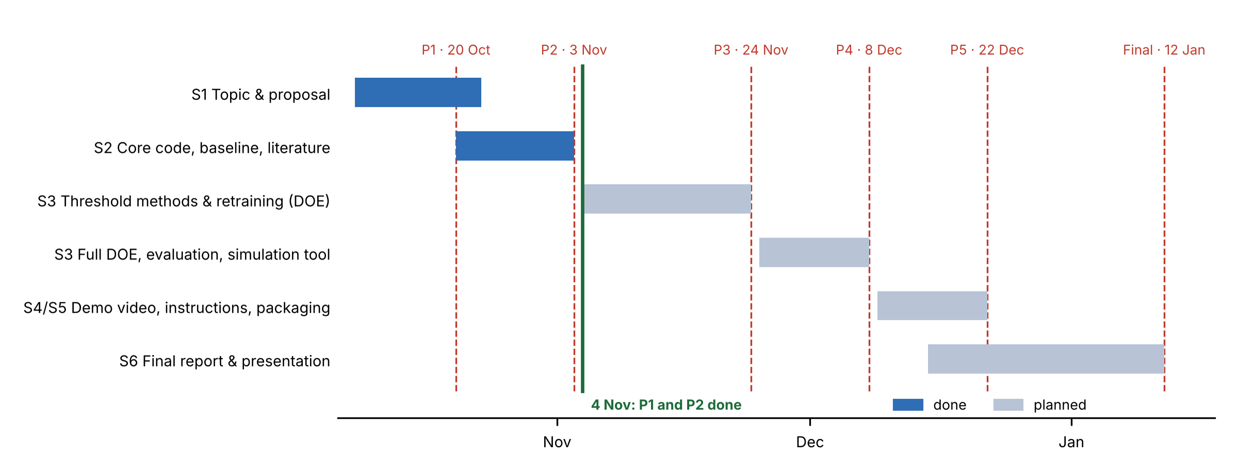
1) Problem Statement & Measurable Outcomes (3–4 sentences) | After soldering, AOI checks every solder joint against fixed limits and sends every flagged board to manual inspection; about 99 % of the flagged joints are false calls (Siemens data). A machine-learning second check trained once meets the targets on a test set, but on later production periods it misses 5–15 % of the true defects (Pfab & Rothering 2025). Input: Siemens AOI data in time order (70 measurements + 5 categories per flagged joint, label from manual inspection) → System: supervised binary classifier with decision threshold selection and concept drift adaptation (retraining) → Output per later period. Measurable outcomes: missed true defects ≤ 1 % (hard quality limit) and false calls released ≥ 40 % (expected 40 % to the 80–90 % reached on the test set).
2) Motivation & Industrial Relevance (2–3 sentences) | On later periods the published second check still releases 40–78 % of the false calls, so the saving in manual work is large; what fails is the 1 % limit for missed defects. Siemens targets 40 % fewer false calls with an AI second check in its Erlangen electronics factory (Oct 2026).
3) Related Work Snapshot (2–3 key references) | Pfab et al. (2024): the Siemens AOI data. Pfab & Rothering (2025): second check in time order, fails on later periods; names threshold setting and drift handling as next steps but tests neither. Methods: Neyman–Pearson threshold (Tong et al. 2018), concept drift adaptation (Gama et al. 2014). Gap: both next steps are untested for AOI.
4) Method & Feasibility (≤6 sentences) | Methodology: supervised binary classifier (random forest, balanced random forest, as in Pfab & Rothering) with two adaptation strategies: decision threshold selection (Neyman–Pearson threshold, prior shift adjustment) and concept drift adaptation by retraining (periodic, drift-triggered). Data: Siemens AOI data (Mendeley, CC BY-NC 3.0), 440,274 flagged joints, 39,742 boards, 132 days. Design of experiments: threshold method 3 × retraining schedule 6 × training window 2 × model 2 = 72 settings × 10 seeds, compared with the baseline. Feasibility: our reimplementation reproduces the problem (balanced random forest: 7.5 % missed on later periods, same as the paper). Tech stack: Python, pandas, scikit-learn, imbalanced-learn, matplotlib, pytest, GitHub Actions. Deliverables: core code, simulation tool with threshold and retraining as settings, report, demo video.
5) Milestones & Timeline (short table/list) | P1 20 Oct (revised 23 Oct, 4 Nov) · proposal, tech stack, MVP  P2 3 Nov · core code + baseline (reproduces Pfab & Rothering), test plan (DOE), bibliography report  P3 24 Nov · threshold methods and retraining, first factors against the baseline; unit tests and CI; issues board  P4 8 Dec · full design of experiments, evaluation; simulation tool  P5 22 Dec · demo video, run instructions, packaging  Final 12 Jan · final presentation and report
6) Risks & Ethics (1–2 sentences) | Simulation-only, anonymised Siemens data (no personal data, non-commercial licence), so no physical or privacy risk. Main risks: one line and 132 days; released joints get no manual label in production (the simulation assumes labels arrive later); the Neyman–Pearson threshold needs at least 299 true defects; a negative result is possible and is reported.

