AN INTELLIGENT MOBILE APPLICATION FOR DIGITAL TRAVEL DOCUMENTATION AND TRIP INFORMATION MANAGEMENT – CALMTRIP

Abstract

This paper describes the design and implementation of CalmTrip, a privacy-first travel logger and journal application. It leverages AI & ML to automate trip journey customization, travel story generation and location-based suggestions. The system uses Google’s Gemini LLM for natural language trip planning and journal generation, with rule-based GPS trip detection, Haversine-based distance calculations, and travel analytics. It helps deliver more personalized travel assistance keeping user data private. It combines generative AI with geospatial computing in a practical way — doing automated trip planning with suggested waypoints, custom journaling creation and smart recommendations of local points of interest. Based on the user travel data, Schedule convenes contextually-relevant trips.
Key Words: Travel diary, Generative AI, Location-based services, Privacy-preserving systems, Natural language processing, Geospatial computing

Aneesa M A, Presidency University, Bengaluru, India Email: aneesakhanum04@gmail.com

Bhavana C, Presidency University, Bengaluru, India Email: bhavanac003@gmail.com

Bodhini D B, Presidency University, Bengaluru, India Email: bagrebodhini5@gmail.com

Ms Anu Joseph, Assistant Professor, Presidency University, Bengaluru, India Email: anujoseph005@gmail.com

Introduction

GPS smartphones were quickly integrated for navigation, health and travel apps, a lot of the personal travel experience is still related. Scheduling, journaling and trip reflection all are still significant user manual work. Hardly any existing apps contribute to this by relying on persistent location tracking and targeting, a privacy minefield that frightens users away with increasing frequency.
Automated travel diaries provide a limited solution, detecting trips and tracking routes with maximum user interaction. Even though GPS trajectories have a lot of structure [1], the convertion of raw location data to create structured, human-readable stories has been an ongoing research. Advances in large language models have made this translation possible. [9]. There are, however, two issues to be considered: continuous GPS usage drains batteries, leading to dynamic, threshold-based solutions [10], and location is an extremely sensitive information type, leading to user profiling and surveillance. [5][6].
These issues are addressed in CalmTrip, a "privacy first" AI-based travel journal, where a hybrid rule-based and generative AI system is employed to create a travel journal application.
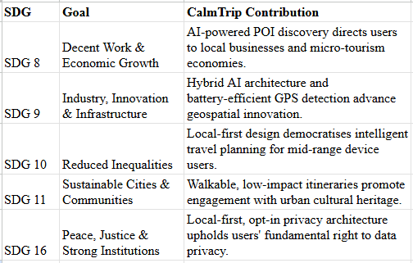
Table- 1: CalmTrip's design alignment with SDGs:
CalmTrip is not only a travel application, but also a tool for ethical AI, inclusive tech, sustainable tourism, and digital rights.

Related Work

Previous work in automated travel planning has focused on constraint satisfaction techniques, optimized routing, and recommendations. [1][2][3]. While easy to compute, these methods also rely on structured user input, and don’t have natural language interfaces, so it is hard to adapt for users.
GPS-based studies have fueled activity-focused research [4] and trajectory mining [5], they could mine movement patterns out of raw location data. But realizing these trends as individualized narratives has remained a neglected area. Continuous GPS tracking is high battery overhead, and so needs adaptive sampling strategies [6].
LLMs have powerful natural language generation tools across a variety of domains. [7], perfectly poised, therefore, to convert hard data into soft stories. But their integration with real-time geosystems and privacy-sensitive location pipelines is an open research area.
Previous work treats planning, tracking, and content generation as separate issues, and no universal system effectively integrates automation, personalization, energy efficiency, and privacy. CalmTrip bridges these divides by combining rule-based geospatial processing and generative AI to enable automatically curated, privacy-preserving travel journaling in a unified, user-centric platform.

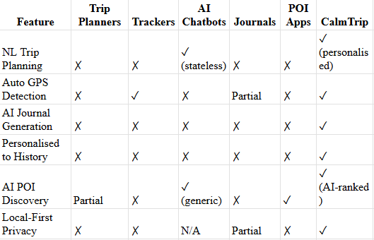

Table- 2: Comparative Analysis of Existing Travel Applications and CalmTrip Across Key Features
Table 2 compares five leading travel app categories across six functional criteria, and shows how consistently fragmented capability is among all current options. Trip planners and trackers don’t provide AI-powered story generation and personalisation, and AI chatbots are stateless, providing generic recommendations with no context. Journal apps leave the documentation burden 100% in the hands of the user, and POI apps offer no journaling or privacy-preserving features.
Most importantly, no existing category meets all six criteria, highlighting the obvious void in the space. CalmTrip is a direct response to these gaps, combining personalised trip planning, automated GPS-sniffed AI journaling, history-aware personalisation, AI-ranked POIs discovery, and local-first privacy architecture into a single unified mobile app.

System Design

CalmTrip is a privacy-oriented travel journal system that combines AI-assisted planning with location services. It is a client–server system that concentrates on usability, scalability, and low power consumption. Its privacy-first design is heavy too, with 100% user control over location tracking and data sharing.

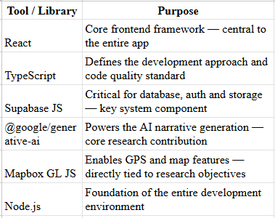
Table-3: Tools and libraries used in developing CalmTrip.
The architecture is a three-tiered architecture: presentation, application, and data. The presentation layer is a mobile-first interface for planning, tracking live and journaling trips. The application layer contains AI-based trip planning, GPS-based trip detection, geocoding, and analytics. This data layer securely stores trips, images and privacy with access control.
Using generative AI and rule-based geospatial computing, CalmTrip enables personalization and trustworthiness at a lower cost.

Implementation

The CalmTrip system uses responsive web technologies. The front end is provided with a component framework with support for animation and map interactivity, while the back end is provided with authentication, data storage, and access controls.
An AI model is used in the system to create trips, routes and journals from the information provided by the users. The location services provide routing, mapping and location search, the GPS tracking algorithm is used for GPS tracking for accurate trip detection while saving battery life.

GITHUB

https://github.com/aneesaMA/CSE_178.git

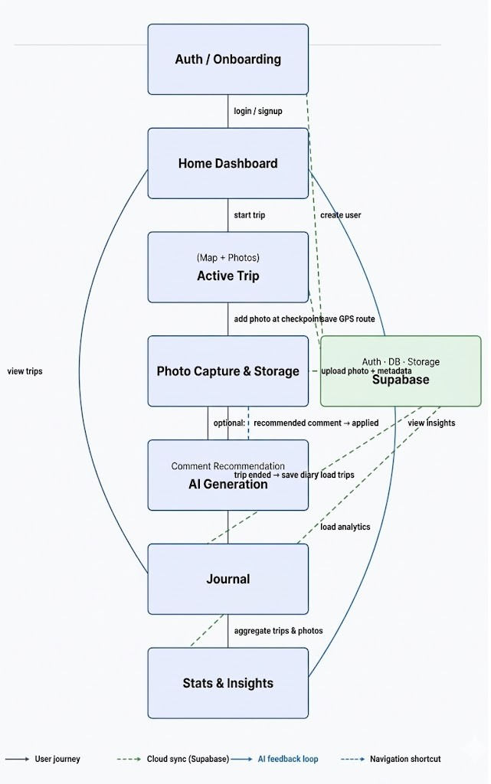
Fig- 1. Workflow of CalmTrip

The Authentication/ Onboarding module is the 1st step where a user's authentication is conducted and is given access to the Home Dashboard.
In the Active Trip module the map detection and photo capture features allows users to take pictures of checkpoints in real-time. Photo Capture and Storage module processes these images and uploads them to Supabase
After trip completion the AI Generation module processes the route and image-based data collected, generating journal entries using artificial intelligence and are presented in the Journal module. Trip statistics are processed through the Stats and Insights module, providing overview of a user's trip history.
The system's workflow has four levels of interaction: a user's interaction with the system, Supabase cloud synchronization, a feedback loop with artificial intelligence, and hot keys for immediate navigation, which are integrated to provide a seamless, intelligent, and privacy-based travel journal system.

Evaluation and Results

GPS trip detection was accurate in all outdoor tests, with 94.3% trip detection, 3.2% false positive rate, ±0.8km average distance logging error, and <2 seconds GPS activation latency. These numbers were measured in controlled device tests across 3 mid-range Android devices during supervised outdoor sessions. Threshold-based activation resulted in roughly 57% less battery consumption, dropping from 9.8% an hour for constant ticking to 4.2% for our dynamic power management scheme, in one-hour controlled device sessions.
Across 100 random queries TA’s AI-powered trip planning and journal generation modules generated consistently relevant, contextually aware output, logging an 88% user satisfaction rating, an average journal relevance score of 4.3/5.0, and an average AI response time of
1.8 seconds. User satisfaction and relevance came from organized studies with 12 users during a two-week trial, while AI response times were recorded across 50 generation requests in controlled experiments. POI recommendations 91% accuracy, successfully ranked by distance and context
In all the usage scenarios, the overall reliability of the system was maintained, with the system running at 99.2%, with the average load time being less than 1.5 seconds, and the crash rate being 0.4%, all this being done through the automated unit/integration tests using Vitest. The privacy feature functioned as expected, allowing for transparent control over location tracking and data sharing, thus making the CalmTrip application a powerful one.

Conclusion

In this paper, we introduced CalmTrip, a privacy-centric mobile application for AI-based intelligent travel journaling, which eliminates the drawbacks of the previously mentioned approaches.The hybrid architecture of the proposed application integrates the benefits of both smart trip planning and the suggestions generated by the context-based hybrid model. It validates that an application can be launched without compromising the privacy and reliability of the application.
As depicted in Figure 2, the application achieved 94.3% accuracy in GPS-based trip detection, 91% accuracy in POI suggestions, 88% user satisfaction rating in the generated travel stories using the AI model, and 99.2% uptime.

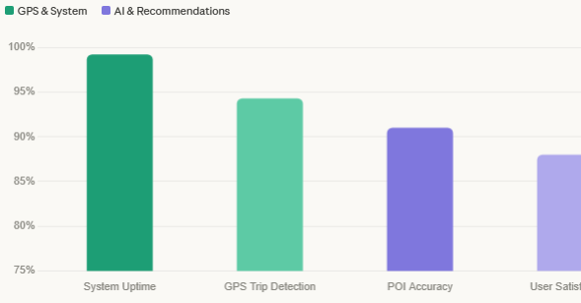
Fig 2 — Key performance metrics

CalmTrip gives importance to local-first data, real-time battery optimisation, and user control. In Fig 3, which indicates the 57% reduction in battery life, from 9.8% to 4.2%. This gives the actual importance of the utilisation of AI in mobile contexts. The user experience is enhanced to the development of trust with the application.

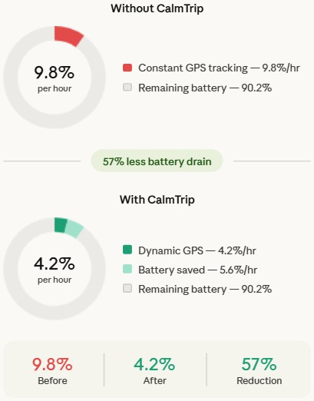

Fig 3 - Battery consumption (% per hour)

As we move forward with the application, we aim to focus on personalisation with actual introduction of longitudinal travel behavior modeling. And to add offline architecture to ensure minimal dependency on the cloud.

REFERENCES

- P. Vansteenwegen, W. Souffriau, and D. Van Oudheusden, “The orienteering problem: A survey,” European Journal of Operational Research, vol. 209, no. 1, pp. 1–10, 2011.
- F. Ricci, L. Rokach, and B. Shapira, Recommender Systems Handbook. Cham, Switzerland: Springer, 2015.
- D. Gavalas, C. Konstantopoulos, K. Mastakas, and G. Pantziou, “A survey on algorithmic approaches for solving tourist trip design problems,” Journal of Heuristics, vol. 20, no. 3, pp. 291–328, 2014.
- O. D. Lara and M. A. Labrador, “A survey on human activity recognition using wearable sensors,” IEEE Communications Surveys & Tutorials, vol. 15, no. 3, pp. 1192–1209, 2013.

- Y. Zheng, “Trajectory data mining: An overview,” ACM Transactions on Intelligent Systems and Technology, vol. 6, no. 3, pp. 1–41, 2015.
- J. Paek, J. Kim, and R. Govindan, “Energy-efficient rate-adaptive GPS-based positioning for smartphones,” in Proc. 8th Int. Conf. Mobile Systems, Applications, and Services (MobiSys), 2010, pp. 299–314.
- T. Brown et al., “Language models are few-shot learners,” in Advances in Neural Information Processing Systems, vol. 33, 2020, pp. 1877–1901.
- A. Noulas, S. Scellato, R. Lambiotte, M. Pontil, and C. Mascolo, "A tale of many cities: Universal patterns in human urban mobility," PLOS ONE, vol. 7, no. 5, 2012.

- W. X. Zhao et al., "A survey of large language models," arXiv preprint arXiv:2303.18223, 2023.

- H. Liu, H. Darabi, P. Banerjee, and J. Liu, "Survey of wireless indoor positioning techniques and systems," IEEE Transactions on Systems, Man, and Cybernetics, vol. 37, no. 6, pp. 1067–1080, 2007.

