**Practical no 5:Pricing Calculator.**

**Estimate workload costs by using the Pricing calculator**

## Define your requirements

Before you run the Pricing calculator, you need a sense of what Azure services you need.

For a basic web application hosted in your datacenter, you might run a configuration similar to the following.

An ASP.NET web application that runs on Windows. The web application provides information about product inventory and pricing. There are two virtual machines that are connected through a central load balancer. The web application connects to a SQL Server database that holds inventory and pricing information.

To migrate to Azure, you might:

* Use Azure Virtual Machines instances, similar to the virtual machines used in your datacenter.
* Use Azure Application Gateway for load balancing.
* Use Azure SQL Database to hold inventory and pricing information.

Here's a diagram that shows the basic configuration:

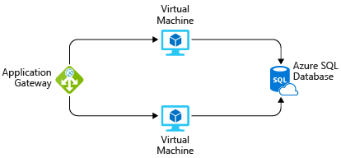

In practice, you would define your requirements in greater detail. But here are some basic facts and requirements to get you started:

* The application is used internally. It's not accessible to customers.
* This application doesn't require a massive amount of computing power.
* The virtual machines and the database run all the time (730 hours per month).
* The network processes about 1 TB of data per month.
* The database doesn't need to be configured for high-performance workloads and requires no more than 32 GB of storage.

## Explore the Pricing calculator

Let's start with a quick tour of the Pricing calculator.

1. Go to the [Pricing calculator](https://azure.microsoft.com/pricing/calculator/).
2. Notice the following tabs:
3. 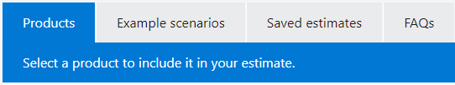
   * **Products** This is where you choose the Azure services that you want to include in your estimate. You'll likely spend most of your time here.
   * **Example scenarios** Here you'll find several reference architectures, or common cloud-based solutions that you can use as a starting point.
   * **Saved estimates** Here you'll find your previously saved estimates.
   * **FAQs** Here you'll discover answers to frequently asked questions about the Pricing calculator.

## Estimate your solution

Here you add each Azure service that you need to the calculator. Then you configure each service to fit your needs.

### Add services to the estimate

1. On the **Products** tab, select the service from each of these categories:

| **Category** | **Service** |
| --- | --- |
| Compute | **Virtual Machines** |
| Databases | **Azure SQL Database** |
| Networking | **Application Gateway** |

1. Scroll to the bottom of the page. Each service is listed with its default configuration.

### Configure services to match your requirements

1. Under **Virtual Machines**, set these values:

| **Setting** | **Value** |
| --- | --- |
| Region | **West US** |
| Operating system | **Windows** |
| Type | **(OS Only)** |
| Tier | **Standard** |
| Instance | **D2 v3** |
| Virtual machines | **2** x **730 Hours** |

Leave the remaining settings at their current values.

1. Under **Azure SQL Database**, set these values:

| **Setting** | **Value** |
| --- | --- |
| Region | **West US** |
| Type | **Single Database** |
| Backup storage tier | **RA-GRS** |
| Purchase model | **vCore** |
| Service tier | **General Purpose** |
| Compute tier | **Provisioned** |
| Generation | **Gen 5** |
| Instance | **8 vCore** |

Leave the remaining settings at their current values.

1. Under **Application Gateway**, set these values:

| **Setting** | **Value** |
| --- | --- |
| Region | **West US** |
| Tier | **Web Application Firewall** |
| Size | **Medium** |
| Gateway hours | **2** x **730 Hours** |
| Data processed | **1 TB** |
| Outbound data transfer | **5 GB** |

Leave the remaining settings at their current values.

Let's say that:

* You run two sets, or banks, of 50 virtual machines (VMs) in each bank.
* The first bank of VMs runs Windows Server under Hyper-V virtualization.
* The second bank of VMs runs Linux under VMware virtualization.
* There's also a storage area network (SAN) with 60 TB of disk storage.
* You consume an estimated 15 TB of outbound network bandwidth each month.
* There are also a number of databases involved, but for now, you'll omit those details.

Recall that the TCO Calculator involves three steps:

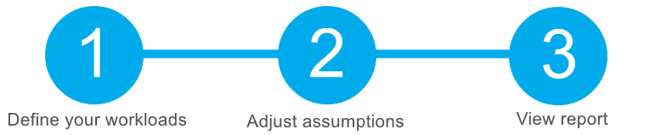

## Define your workloads

Enter the specifications of your on-premises infrastructure into the TCO Calculator.

1. Go to the [TCO Calculator](https://azure.microsoft.com/pricing/tco/calculator).
2. Under **Define your workloads**, select **Add server workload** to create a row for your bank of Windows Server VMs.
3. Under **Servers**, set the value for each of these settings:

**Setting**

**Value**

Name

**Servers: Windows VMs**

Workload

**Windows/Linux Server**

Environment

**Virtual Machines**

Operating system

**Windows**

Operating System License

**Datacenter**

VMs

**50**

Virtualization

**Hyper-V**

Core(s)

**8**

RAM (GB)

**16**

Optimize by

**CPU**

Windows Server 2008/2008 R2

**Off**

1. Select **Add server workload** to create a second row for your bank of Linux VMs. Then specify these settings:

**Setting**

**Value**

Name

**Servers: Linux VMs**

Workload

**Windows/Linux Server**

Environment

**Virtual Machines**

Operating system

**Linux**

VMs

**50**

Virtualization

**VMware**

Core(s)

**8**

RAM (GB)

**16**

Optimize by

**CPU**

1. Under **Storage**, select **Add storage**. Then specify these settings:

**Setting**

**Value**

Name

**Server Storage**

Storage type

**Local Disk/SAN**

Disk type

**HDD**

Capacity

**60 TB**

Backup

**120 TB**

Archive

**0 TB**

1. Under **Networking**, set **Outbound bandwidth** to **15 TB**.
2. Select **Next**.

## Adjust assumptions

Here, you specify your currency. For brevity, you leave the remaining fields at their default values.

In practice, you would adjust any cost assumptions and make any adjustments to match your current on-premises environment.

1. At the top of the page, select your currency. This example uses **US Dollar ($)**.
2. Select **Next**.

## View the report

Take a moment to review the generated report.

Remember, you've been tasked to investigate cost savings for your European datacenter over the next three years.

To make these adjustments:

1. Set **Timeframe** to **3 Years**.
2. Set **Region** to **North Europe**.

Scroll to the summary at the bottom. You see a comparison of running your workloads in the datacenter versus on Azure.

Select **Download** to download or print a copy of the report in PDF format.

Great work. You now have the information that you can share with your Chief Financial Officer. If you need to make adjustments, you can revisit the TCO Calculator to generate a fresh report.