**Practical no 8:**

**Create a storage blob**

## Create a storage account

In this task, we will create a new storage account.

1. Sign in to the Azure portal at [https://portal.azure.com](https://portal.azure.com/learn.docs.microsoft.com)
2. Select Create a resource.
3. Under Categories, select Storage.
4. Under Storage Accounts, select Create.
5. On the Basics tab of the Create storage account blade, fill in the following information. Leave the defaults for everything else.

**Setting**

**Value**

Subscription

Concierge Subscription

Resource group

[sandbox resource group name]

Storage account name

create a unique storage account name

Location

default

Performance

Standard

Redundancy

Locally redundant storage (LRS)

1. Select Review + Create to review your storage account settings and allow Azure to validate the configuration.
2. Once validated, select Create. Wait for the notification that the account was successfully created.
3. Select Go to resource.

## Work with blob storage

In this section, you'll create a Blob container and upload a picture

1. Under Data storage, select Containers.

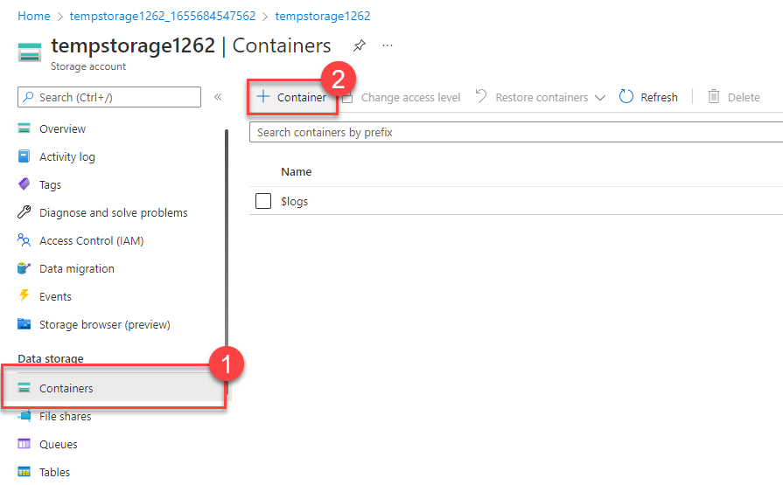

1. Select + Container and complete the information.

**Setting**

**Value**

Name

Enter a name for the container

Public access level

Private (no anonymous access)

1. Select Create.
2. Back in the Azure portal select the container you created, then select Upload.
3. Browse for the image file you want to upload. Select it and then select upload.
4. Select the Blob (file) you just uploaded. You should be on the properties tab.
5. Copy the URL from the URL field and paste it into a new tab.

You should receive an error message similar to the following.

Copy

<Error>

<Code>ResourceNotFound</Code>

<Message>The specified resource does not exist. RequestId:4a4bd3d9-101e-005a-1a3e-84bd42000000 Time:2022-06-20T00:41:31.2482656Z</Message>

</Error>

## Change the access level of your blob

1. Go back to the Azure portal
2. Select Change access level
3. Set the Public access level to Blob (anonymous read access for blobs only)

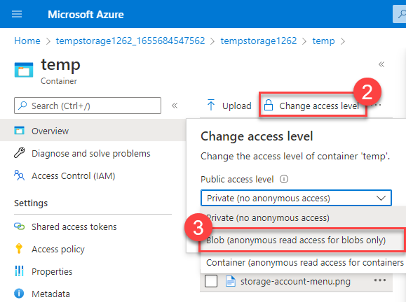

1. Select OK
2. Refresh the tab where you attempted to access the file earlier.

Congratulations - you've completed this exercise. You created a storage account, added a container to the storage account, and then uploaded blobs (files) to your container. Then you changed the access level so you could access your file from the internet.

## Clean up

The sandbox automatically cleans up your resources when you're finished with this module.

When you're working in your own subscription, it's a good idea at the end of a project to identify whether you still need the resources you created. Resources that you leave running can cost you money. You can delete resources individually or delete the resource group to delete the entire set of resources.