Azure Storage Account

An Azure Storage Account is a secure account, which provides you access to services in Azure Storage.

The storage account is like an administrative container, and within that, we can have several services like blobs, files, queues, tables, disks, etc.

And when we create a storage account in Azure, we will get the unique namespace for our storage resources.

That unique namespace forms the part of the URL.

The storage account name should be unique across all existing storage account name in Azure.

### **Creating and configuring Azure Storage Account**

**Step 1:** Login to your Azure portal home screen and click on "Create a resource". Then type-in storage account in the search box and then click on "Storage account".

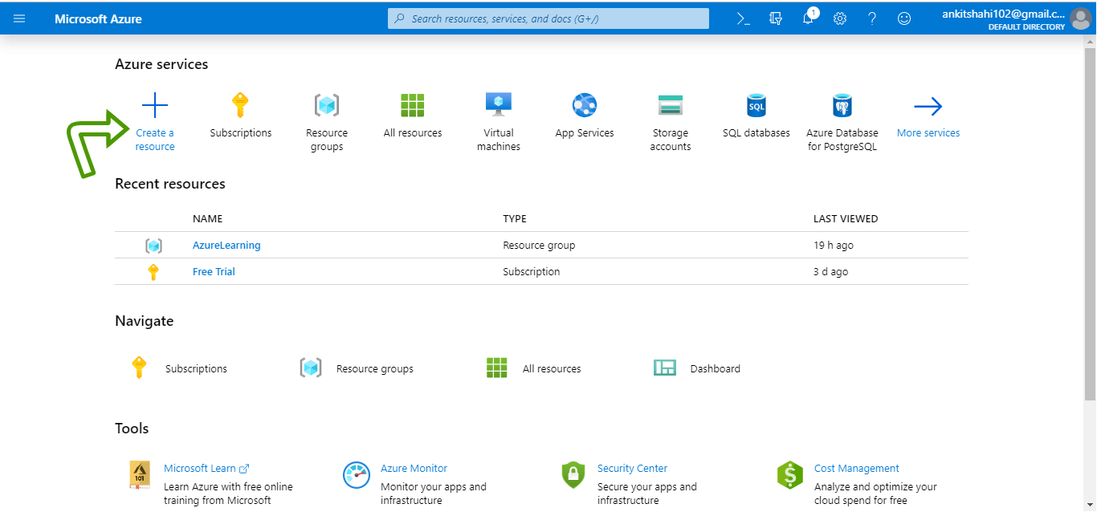

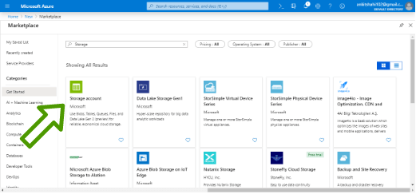

**Step 2:** Click on create, you will be redirected to Create a storage account window.

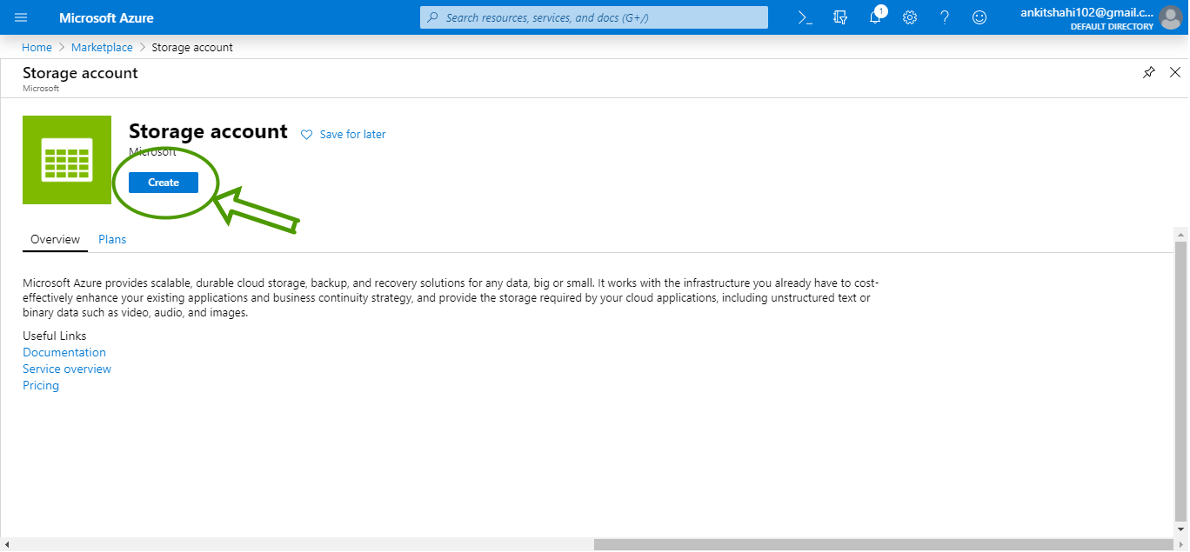

**Step 3:** First, you need to select the subscription whenever you are creating any resource in Azure, and secondly, you need to choose a Resource Group. In our case, the subscription is "Free Trail".

Use your existing resource group or create a new one. Here we are going to create a new resource group.

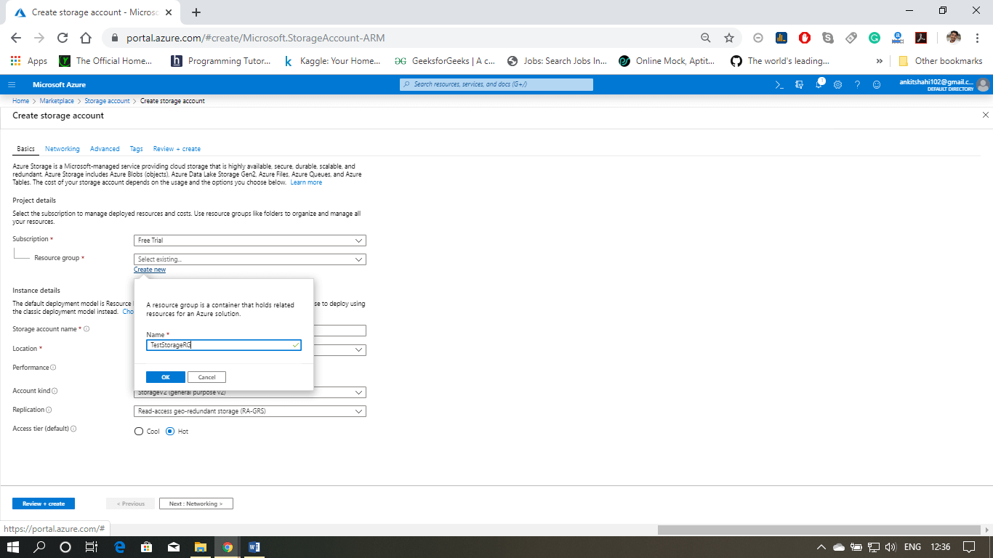

**Step 4:** Then, fill the storage account name, and it should be all lowercase and should be unique across all over Azure. Then select your location, performance tier, Account kind, Replication strategy, Access Tier, and then click on next.

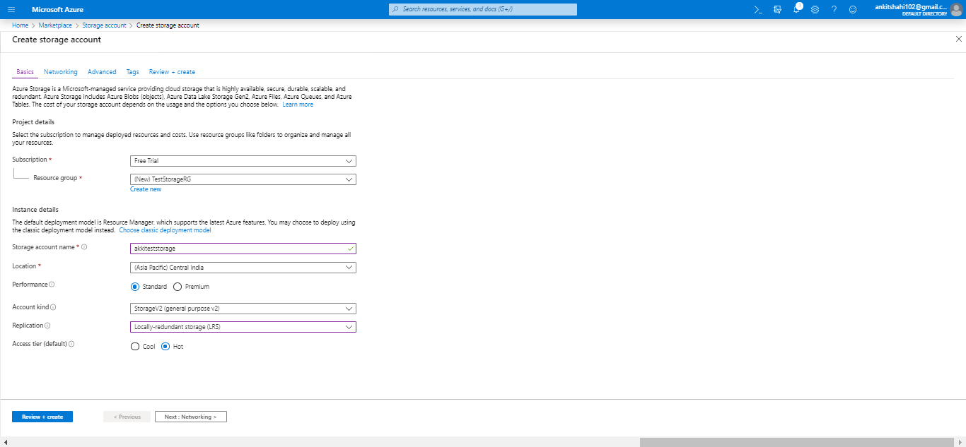

**Step 5:** You are now on the Networking window. Here, you need to select the connectivity method, then click next.

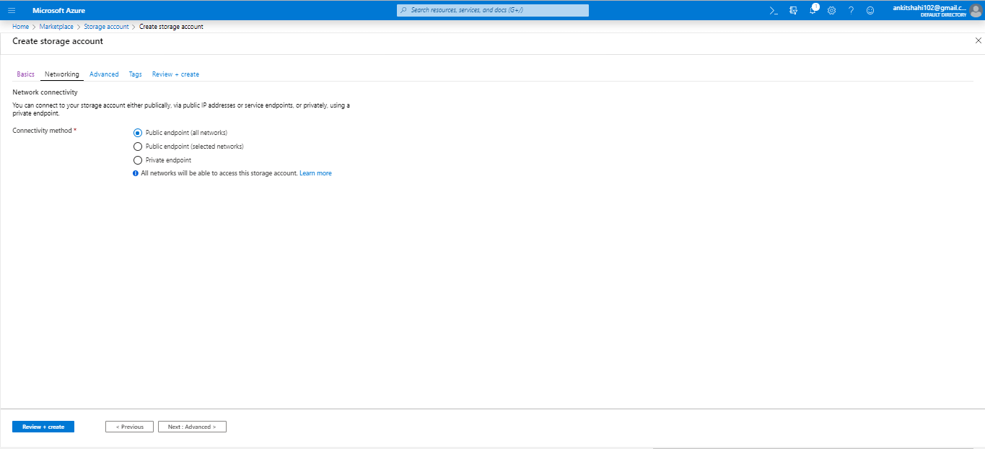

**Step 6:** You are now on the Advanced window were you need to enable or disable security, Azure files, Data Protection, Data lake Storage and then click next.

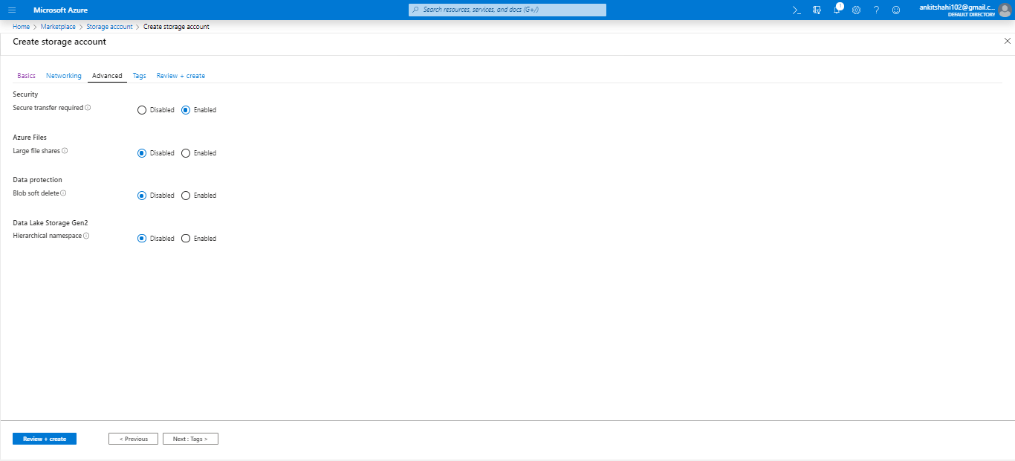

**Step 7:** Now, you are redirected to the Tags window, where you can provide tags to classify your resources into specific buckets. Put the name and value of the tag and click next.

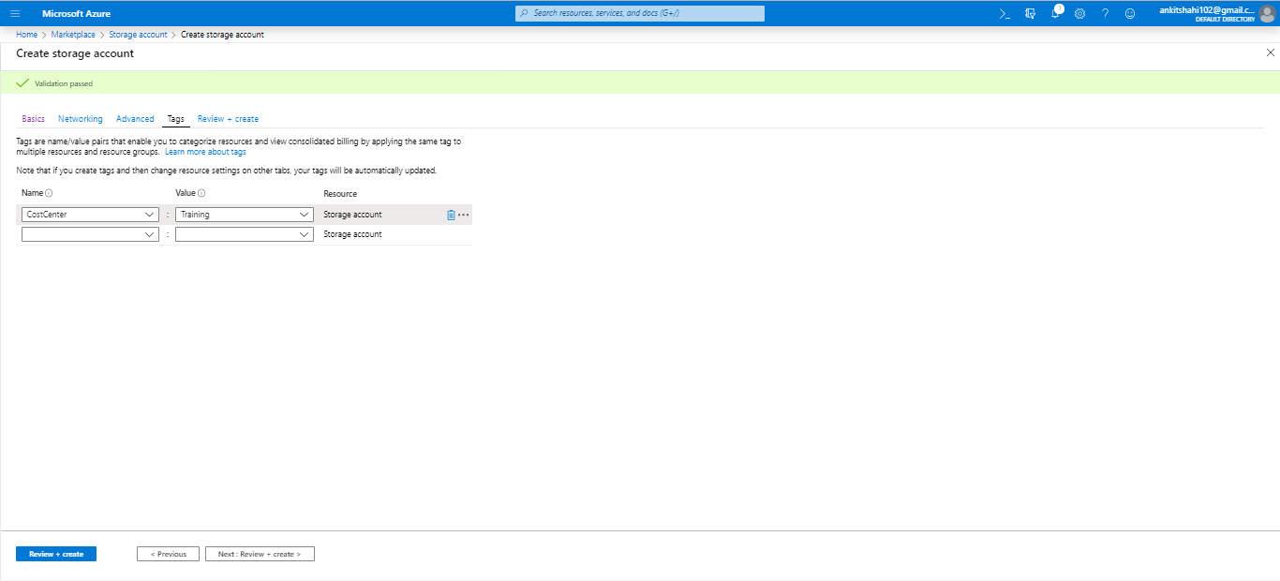

**Step 8:** This is the final step where the validation has been passed, and you can review all the elements that you have provided. Click on create finally.

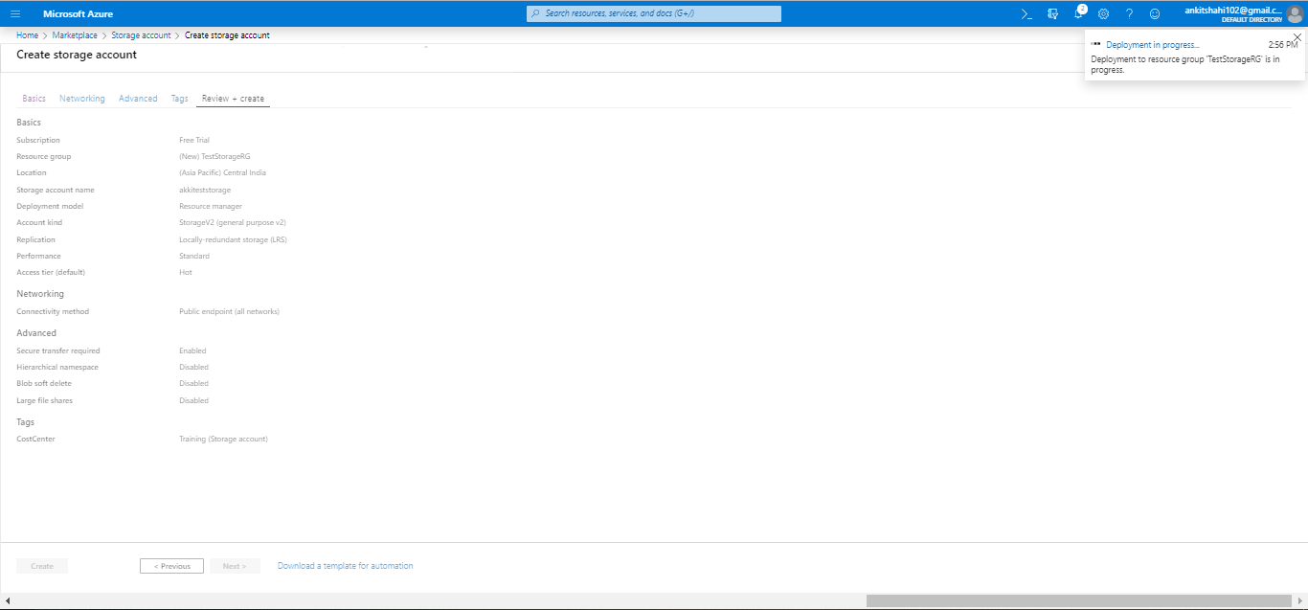

Now our storage account has been successfully created, and a window will appear with the message "Your deployment is complete".

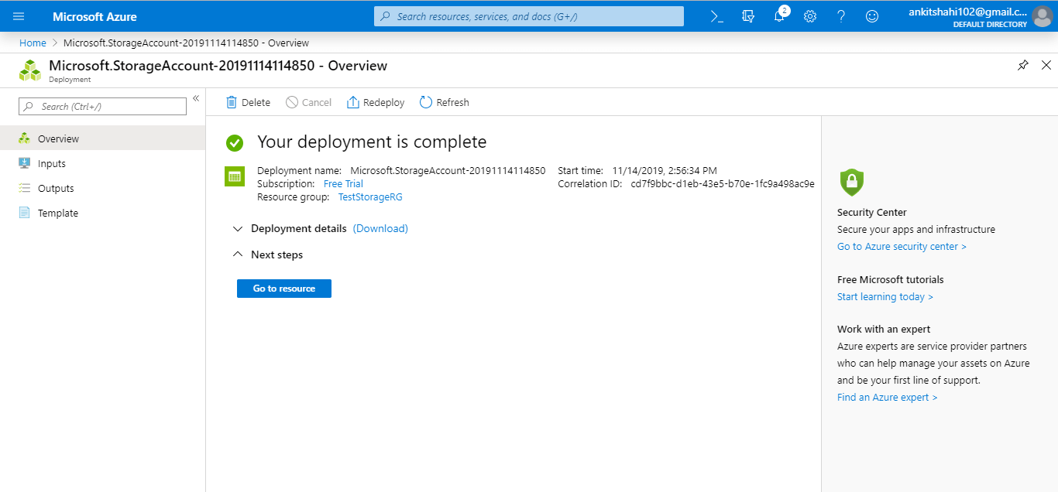

Click on "goto resource", then the following window will appear.

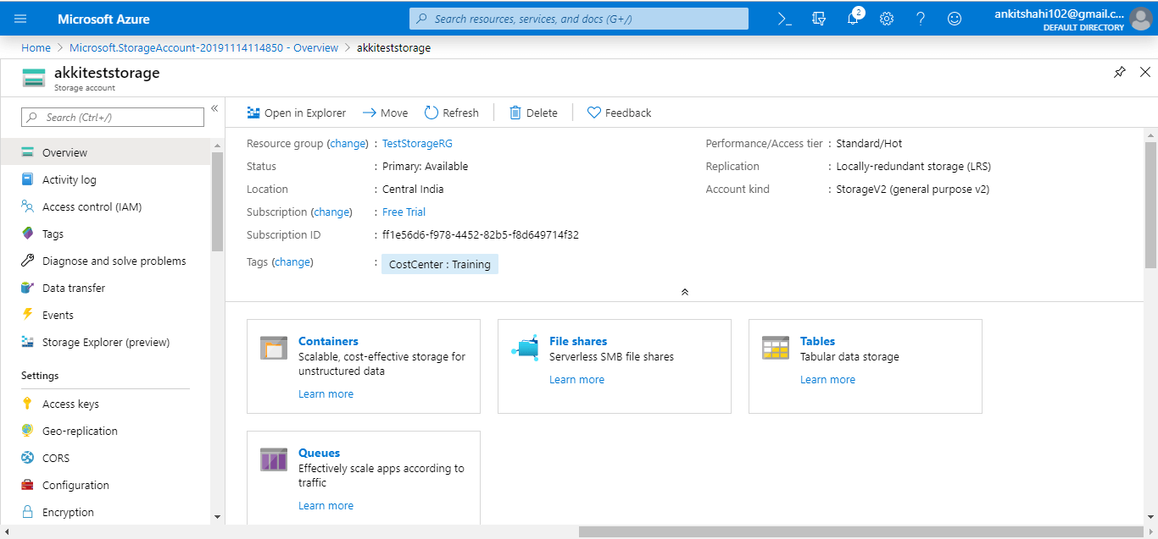

You can see all the values that you have selected for different configuration setting when creating the storage account.