@startuml
package "package 'Process'" <<Rectangle>> {
class “Process::SubProcess” {
.. Static Methods ..
{static} + runSubProcess(command: String[, name: String][, check: Integer][, read: Integer][, readtimeout: Integer][, timeout: Integer][, profiling: Boolean][, debug: Boolean])
.. Constructors ..
{static} + new([name: String][, command: String][, check: Integer][, read: Integer][, readtimeout: Integer][, timeout: Integer][, profiling: Boolean][, debug: Boolean])
+ DESTROY()
.. Administration Methods ..
+ setArrProcess([name: String][, command: String][, check: Integer][, read: Integer][, readtimeout: Integer][, timeout: Integer][, profiling: Boolean][, debug: Boolean])
+ set([name: String][, command: String][, check: Integer][, read: Integer][, readtimeout: Integer][, timeout: Integer][, profiling: Boolean][, debug: Boolean])
+ setName(String)
+ setCommand(String)
+ setReadTimeout(Integer)
+ setTimeout(Integer)
+ setProfiling([Boolean])
+ setDebug([Boolean])
+ Launch()
+ Check()
+ Read()
+ Wait([check: Integer][, timeout: Integer])
+ Run([check: Integer][, timeout: Integer])
+ Terminate()
+ Kill()
+ freeResources()
+ clearErrors()
.. Consultation Methods ..
+ getProcessID() : Integer
+ getName() : String
+ getNameComplete() : String
+ getCommand() : String
+ getReadTimeout() : Integer
+ getTimeout() : Integer
+ isRunning() : Boolean
+ getReportString() : RString
+ getErrorString() : RString
+ getErrorCode() : Integer
+ getProcessStatus() : Integer
+ getExecutionTime() : Float
+ isProfiling() : Boolean
+ isDebug() : Boolean
}

note right of “Process::SubProcess::Group”
RString : Reference to String (\String)
end note

class “Process::SubProcess::Group” {
.. Constructors ..
{static} + new()
+ DESTROY()
.. Administration Methods ..
+ add([“Process::SubProcess”])
+ setCheckInterval(Integer)
+ setReadTimeout(Integer)
+ setTimeout(Integer)
+ setProfiling([Boolean])
+ setDebug([Boolean])
+ setQuiet([Boolean])
+ Launch()
+ Check()
+ checkiProcess(Integer)
+ Wait()
+ Run()
+ Terminate()
+ Kill()
+ freeResources()
+ clearErrors()
.. Consultation Methods ..
+ getiProcess(Integer) : “Process::SubProcess”
+ getCheckInterval() : Integer
+ getReadTimeout() : Integer
+ getTimeout() : Integer
+ getProcessCount() : Integer
+ getRunningCount() : Integer
+ getFreeCount() : Integer
+ getFinishedCount() : Integer
+ getReportString() : RString
+ getErrorString() : RString
+ getErrorCode() : Integer
+ isProfiling() : Boolean
+ isDebug() : Boolean
+ isQuiet() : Boolean
}

class “Process::SubProcess::Pool” {
.. Constructors ..
{static} + new()
.. Administration Methods ..
+ add([“Process::SubProcess”])
+ setMinProcessCount(Integer)
+ setMaxProcessCount(Integer)
+ waitFirst()
+ waitNext()
.. Consultation Methods ..
+ getFreeProcess() : “Process::SubProcess”
+ getFinishedProcess() : “Process::SubProcess”
+ getMinProcessCount() : Integer
+ getMaxProcessCount() : Integer
}

“Process::SubProcess::Group” “1" *-up- "n" “Process::SubProcess” : manages
“Process::SubProcess::Group” <|-right- “Process::SubProcess::Pool”
}
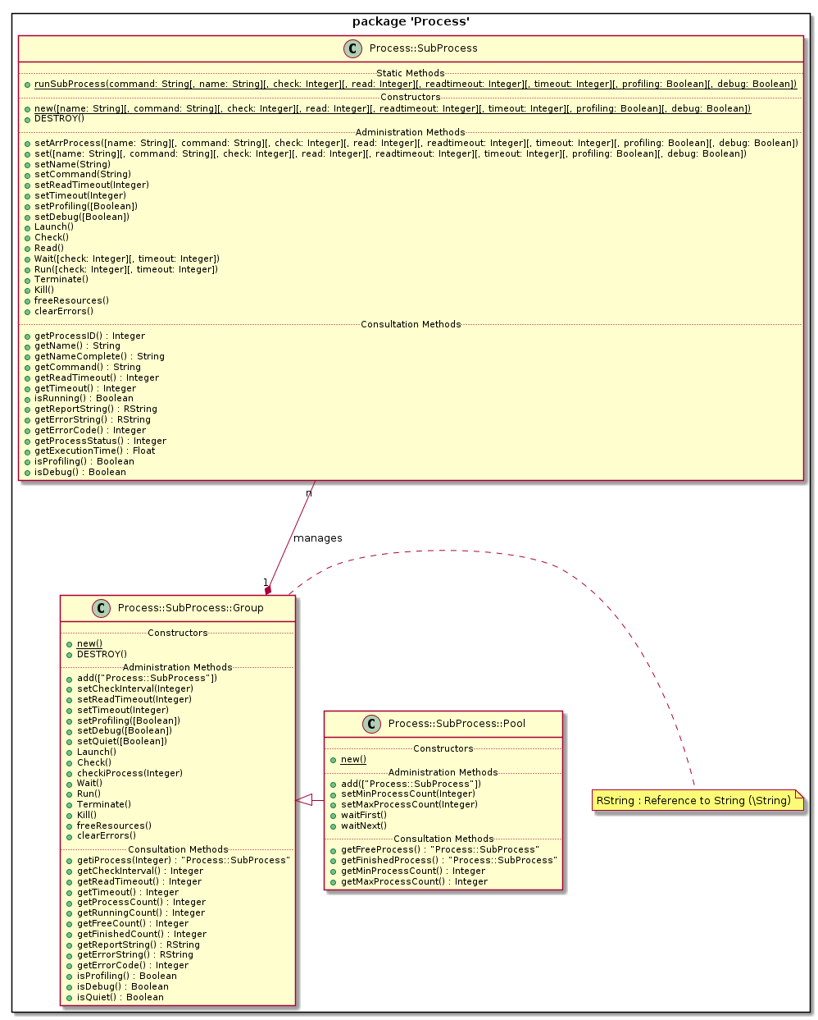
@enduml

