@startuml
package "unit 'pointerhash'" <<Rectangle>> {

class TPLPointerHashList {
.. Properties ..
{field} +Capacity : Integer [rw]
{field} +Count : Integer [r]
{field} +Duplicates : TDuplicates [rw]
{field} +GrowFactor: Integer [rw]
{field} +KeyData[skey: string] : Pointer [rw] (default)
{field} +LoadFactor : Integer [rw]
__
.. Constructors ..
+Create()
+Create(icapacity: Integer)
+Create(icapacity: Integer; ifactor: Integer)
+Destroy()
.. Administration Methods ..
+setLoadFactor(ifactor: Integer)
+setGrowFactor(ifactor: Integer)
+setCapacity(icapacity: Integer)
+Add(const skey: string; ppointer: Pointer) : Boolean
+setValue(const skey: string; ppointer: Pointer)
+removeKey(const skey: string)
+Clear()
.. Consultation Methods ..
{method} +getValue(const skey: string) : Pointer
{method} +hasKey(const skey: string) : Boolean
{method} +moveFirst() : Boolean
{method} +moveNext() : Boolean
{method} +getCurrentKey() : string
{method} +getCurrentValue() : Pointer
}

TPLPointerHashList "1" *-- "1" TDuplicates : uses
TPLPointerHashList -[hidden]> TDuplicates
enum TDuplicates {
dupIgnore
dupAccept
dupError
}
note right of TDuplicates : from Types.TDuplicates

TPLPointerHashList "1" *-- "n" TPLPointerNodeList : contains
class TPLPointerNodeList {
.. Properties ..
{field} +GrowFactor : Integer [rw]
__
.. Constructors ..
+Create()
+Create(iindex: Integer)
+Create(iindex: Integer; ifactor: Integer)
+Destroy()
.. Administration Methods ..
+setGrowFactor(ifactor: Integer)
+addNode(pnode: PPLHashNode) : PPLHashNode
+addNode(ihash: Cardinal; pskey: PAnsiString; ppointer: Pointer) : PPLHashNode
+setValue(ihash: Cardinal; pskey: PansiString; ppointer: Pointer)
+setValue(pskey: PAnsiString; ppointer: Pointer)
+unsetIndex(iindex: Integer)
+removeNode(pnode: PPLHashNode) : Boolean
+removeNode(ihash: Cardinal; pskey: PAnsiString) : Boolean
+removeNode(pskey: PAnsiString) : Boolean
+reindexList()
+Clear()
.. Consultation Methods ..
+getNode(iindex: Integer) : PPLHashNode
+searchNode(ihash: Cardinal; pskey: PAnsiString) : PPLHashNode
+searchNode(pskey: PAnsiString) : PPLHashNode
+searchValue(ihash: Cardinal; pskey: PAnsiString) : Pointer
+searchValue(pskey: PAnsiString) : Pointer
+searchIndex(ihash: Cardinal; pskey: PAnsiString) : Integer
+searchIndex(pskey: PAnsiString) : Integer
+getLastIndex() : Integer
}

note right of TPLPointerNodeList
PAnsiString : Pointer to String
end note

TPLPointerNodeList "1" *-- "n" TPLHashNode : contains
class TPLHashNode << (S,#FF7700) >> {
+skey : String
+ihash : Cardinal
+pvalue : Pointer
+ibucketindex : Integer
+inodeindex : Integer
}
hide TPLHashNode methods
note right of TPLHashNode
Structure that stores
the Key and its Data
end note

note bottom of TPLHashNode
PPLHashNode : Pointer to TPLHashNode
end note

}
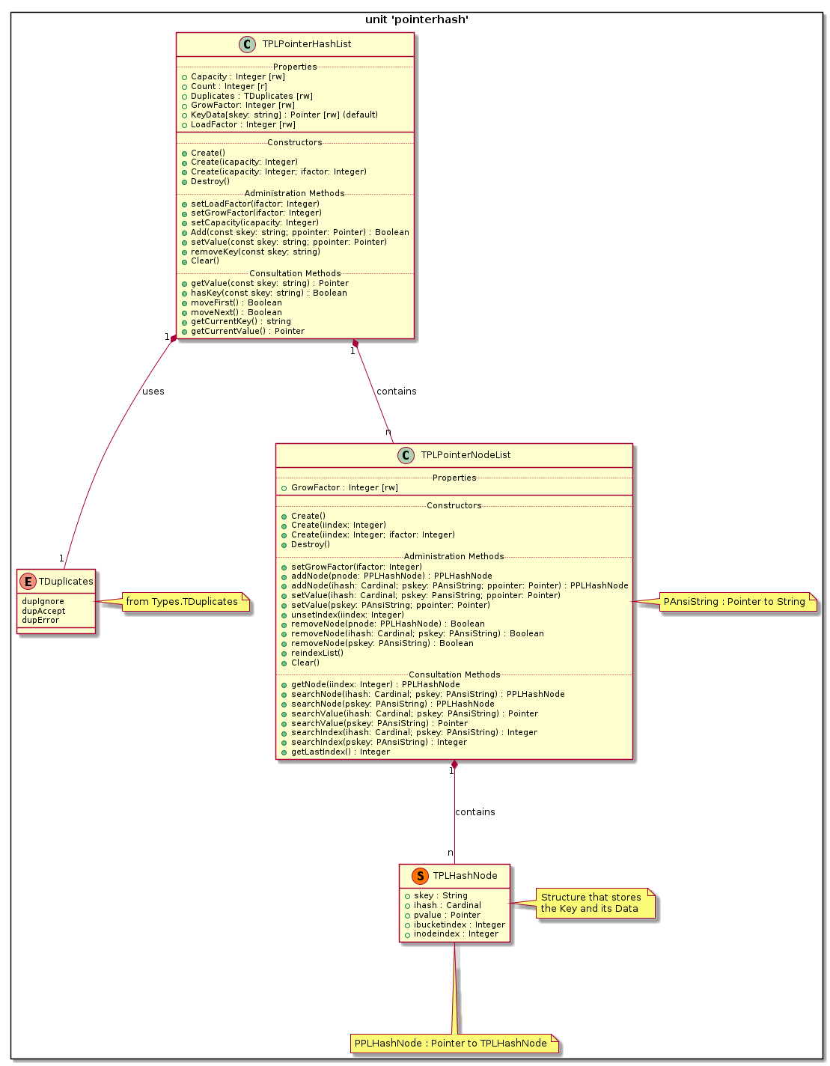
@enduml

