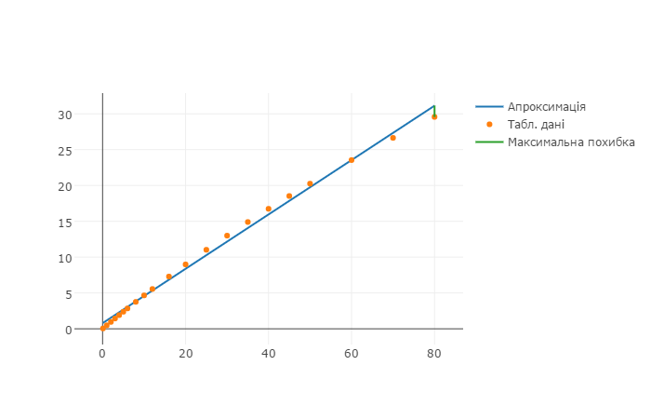C:\Users\bodya\Desktop\diplom-text\plot.emf