**Countries analyser**

Bohdan Kyryliuk

267855

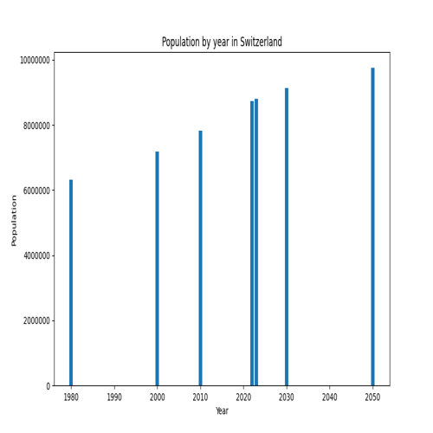

Maximal population by year:   
1980: 982372466 in China   
2000: 1264099069 in China   
2010: 1348191368 in China   
2022: 1425887337 in China   
2023: 1428627663 in India   
2030: 1514994080 in India   
2050: 1670490596 in India   
Minimal population by year:   
1980: 733 in Vatican City   
2000: 651 in Vatican City   
2010: 596 in Vatican City   
2022: 510 in Vatican City   
2023: 518 in Vatican City   
2030: 561 in Vatican City   
2050: 731 in Vatican City   
Average population by year:   
1980: 18984616   
2000: 45254085   
2010: 75099320   
2022: 109173735   
2023: 143548160   
2030: 180062765   
2050: 221549044   
Maximal area: ('Russia', 17098242.0)  
Minimal area: ('Vatican City', 0.44)  
Maximal density: ('Macau', 21402.7052)  
Minimal density: ('Greenland', 0.138)  
Maximal growthRate: ('Syria', 0.0498)  
Minimal growthRate: ('Ukraine', -0.0745)