**Team-Mates**

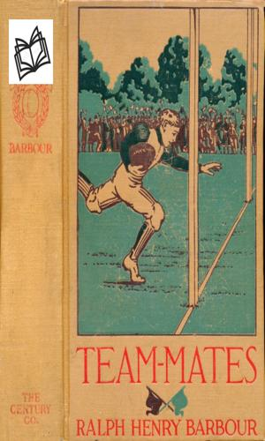

Ralph Henry Barbour

Bohdan Kyryliuk

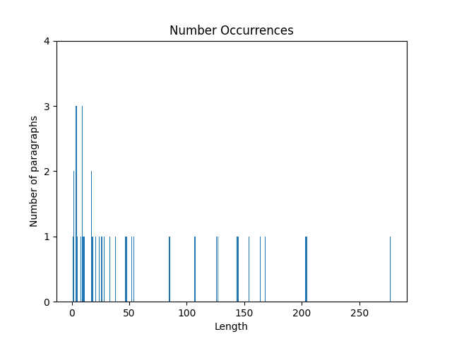

The plot shows the distribution of lengths of paragraphs in the first chapter (how many paragraphs of the given length are in the first chapter)  
  
Number of paragraphs: 38  
Number of words: 2405  
Minimal number of words in a paragraph: 1  
Maximal number of words in a paragraph: 277  
Average number of words in paragraphs: 63