Dokumentasi Tournament Manager

# GitHub

<https://github.com/kennethmanuel/Projek-UTS-PBD>

# Team

160419041 Kenneth Manuel Lieyanto

160419107 Margareta Yubella M.M.K.

160419133 Jehuda Rivaldo Soetiyono

# ER Diagram

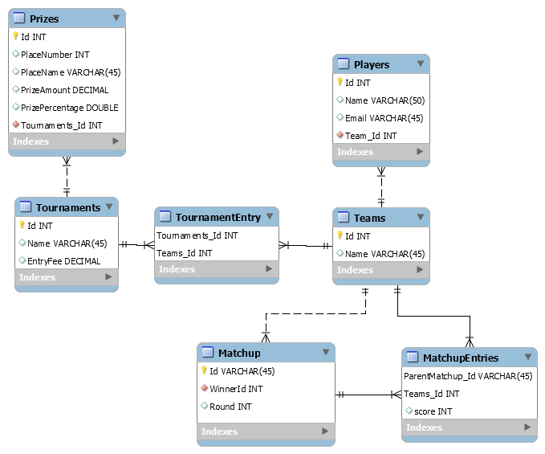

# Class Diagram

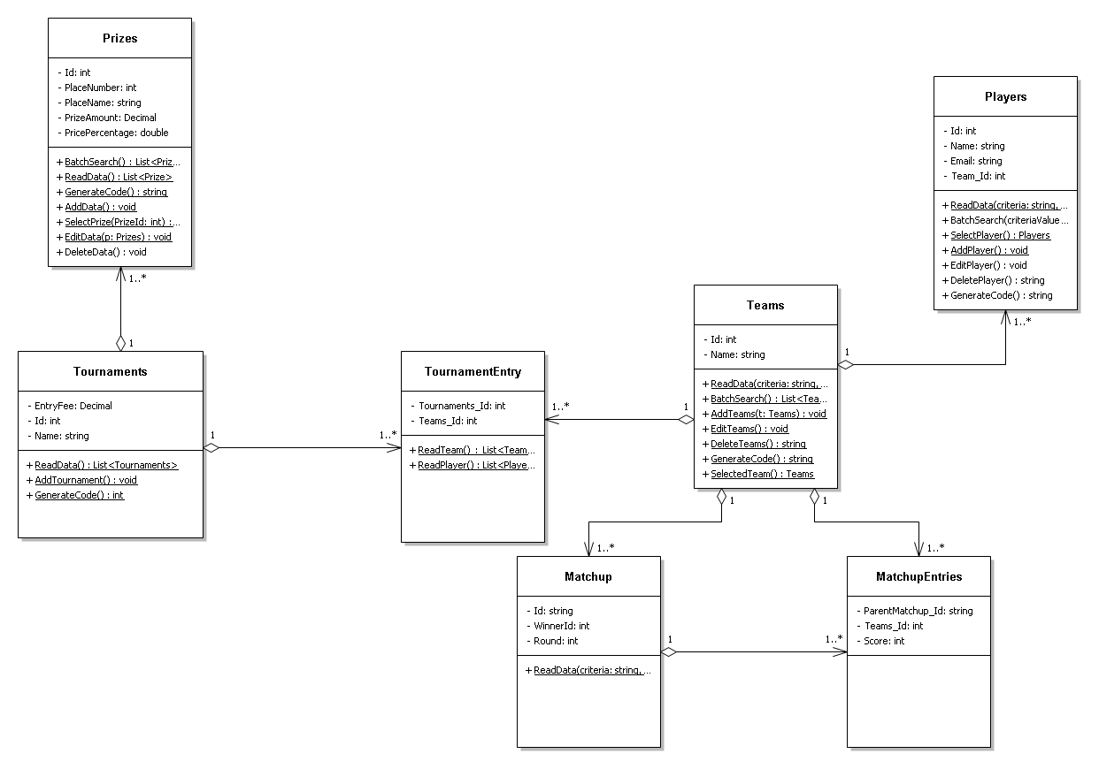

# Link video presentasi/demo

<https://www.youtube.com/watch?v=emH-8EmCbMw>