SPFilezilla homepage : <https://archive.codeplex.com/?p=spfilezilla>

Inspired by FileZilla, the free FTP client, SPFileZilla allows you to browse and manage SharePoint as if it were an FTP Server (download/upload/delete/rename).

**The version here has been modified to allow a recursive check-in of files, instead of querying a full list of checked out files at once.**

A query for a full list of checked out files raise an error if the document library contain more than the max limit threshold for a view.  
But opening recursively all subfolders to identify the checked out files work well, while taking more time.

If you need to bulk check-in files in a document library with too much items, you may access the new feature that way:

* After logged in, go to the folder you need to check in
* Right-click on the menu and open “Recursively Check-In” as shown below:

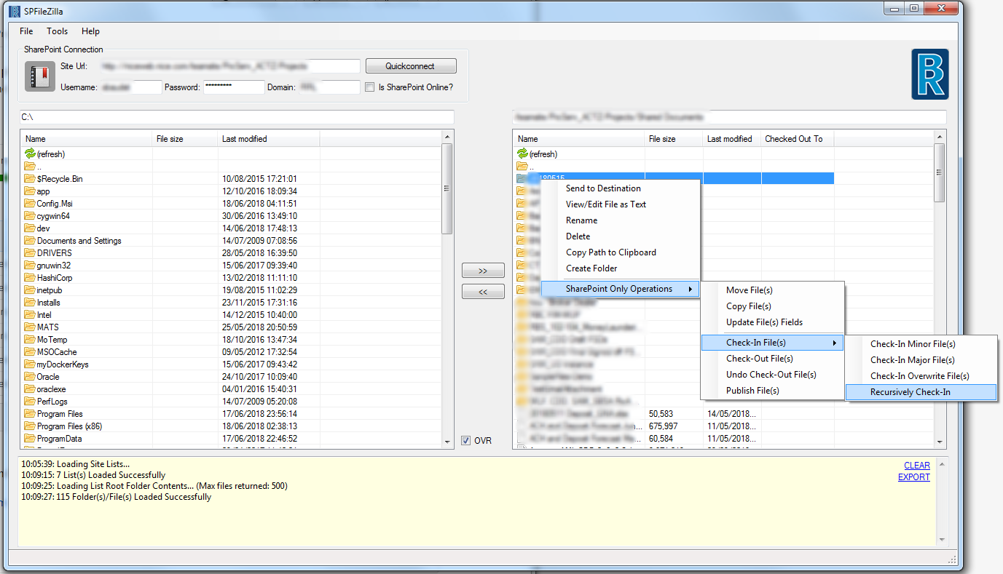

The rest of SPFilezilla is unchanged and still provide with useful tools, as described in its homepage:

**SPFileZilla = FileZilla for SharePoint!**  
  
Inspired by FileZilla, the fantastic free FTP client, SPFileZilla allows you to navigate and manage SharePoint as if it were an FTP Server. Browse site lists, document libraries, folders, and files. Download and upload files and folders, including support for nested folders hierarchies. Create new folders, rename existing files and folders, and delete files and folders. Also, you can copy paths to files and folders to your clipboard. Drag and drop folders/files into the application to upload to SharePoint.  
  
**Not just for Admins, any user who uploads/downloads documents from a SharePoint Library can use this tool too!**  
  
**Source code moved to Github:**  
<https://github.com/bandrben/SPFileZilla2013>  
  
**Latest release for 2013 supports uploading large files (over 2 MB) to SPOnline.**  
  
**Supports OneDrive for Business too (how'd that happen!?)**  
  
**Exclusive Features**  
These are my favorite features, added recently that make this tool essential.

* Includes a Property Bag editor and Text editor. This saves time, no need to fire up SharePoint Designer.
* Overwrite (OVR checkbox in main window) makes it super easy to do incremental bulk uploads to a SharePoint Library when OVR is turned off (which will skip existing files).
* Bulk operations like Move, Copy, Check-out, Check-in, etc. can be performed on entire Document Libraries (right click menu actions).
* File system dates are preserved when uploading to SharePoint (created and modified).

**New Release 9/22/2015**

* Added Property Bag editor (for current SPWeb loaded), available from Tools menu at top of application.
* Supports lists with large number of items, app.config file set to only pull down first 500 files when reading large lists, so you can open large lists and upload new files into them.
* More file operations on SharePoint files act recursively when a folder is selected, including bulk updating file field data, moving files, copying files, check-in minor/major/overwrite, check-out, undo check-out, and publish files.
* File system create and modified dates are preserved when uploading to SharePoint libraries.

**New Release 4/13/2015**

* Can turn on/off "overwrite" setting when uploading/downloading files, "copy to", and "move to" operations. Default is overwrite=on. Look for "OVR" checkbox in main form window. When OVR is turned off (unchecked), files will be skipped if they already exist. Great for incremental uploads to a library/folder.
* Text editor available to view/edit files on the fly in both File System and SharePoint, can edit on the fly files in Doc Libraries. Available in right-click menu. Change background color of window, change text size too. Use this to live edit files in your doc libraries (like CSS, JS, HTML, ASPX files). Another reason not to fire up SharePoint Designer.

**New Release 6/18/2014**

* Created a new release, SPFileZilla2013, for SharePoint 2013 and SharePoint Online (also backward compatible for SharePoint 2010)
* Resolved SharePoint Online authentication issues, using latest SharePointOnlineCredentials Class.
* When using SharePoint Online auth, a common error occurs if a required DLL is missing on your machine, see here for more information: <http://tomaszrabinski.pl/wordpress/2013/03/18/sharepointonlinecredentials-and-msoidclil-dll-file-not-found-exception/>

**New Features Added as of 12/30/2013** SharePoint File right-click menu actions:

* Move file(s)
* Copy file(s)
* Update File(s) Fields: update one or more files at the same time, update one or more field values at the same time too
* Publishing: check-in (minor, major, overwrite), check-out, undo check-out, publish

SPFileZilla is compatible with SharePoint 2010 and 2013, including SharePoint Online (Office 365), and supports claims based authentication and mixed mode authentication. Uses the SharePoint Client Object Model, no magic.  
  
SPFileZilla allows you to save your SharePoint connections using the built-in profiles feature. Name your profiles, set up once and use as often as you like. Or, use the Quick Connect feature to connect directly to a SharePoint site without saving a profile.  
  
After connecting to a SharePoint site, all the lists that inherit from the document library content type are available to browse and manage. Open a list and you can then browse its folders and files. Refresh directories and navigate deeper or back to parent directories.  
  
Never manage your SharePoint Documents using a browser again! Unless you like waiting for IE “open in explorer” mode. Or, if you prefer to upload multiple files using a specific browser. Or, if you prefer to upload your files (but not download!) using SharePoint Designer. I specifically built this program after developing “SharePoint Hand”, otherwise known as carpal tunnel of the mouse fingers.   
  
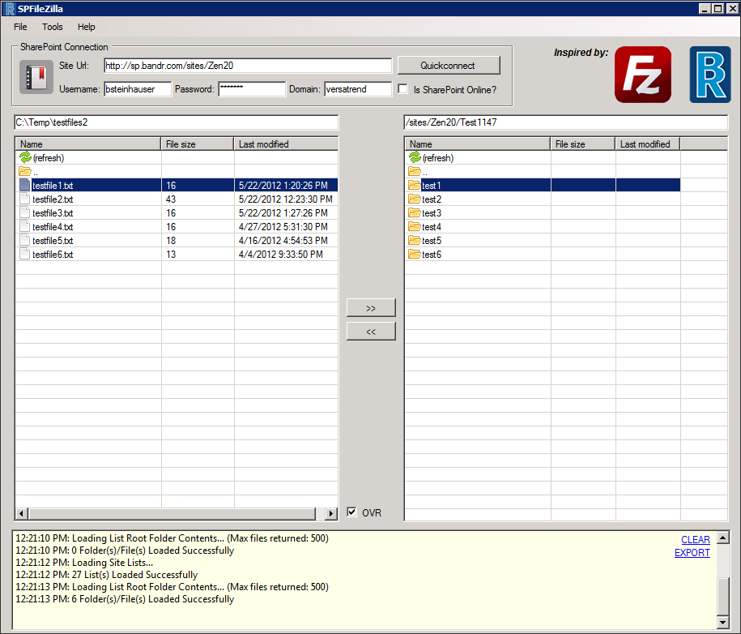  
  
Brought to you by the creator of [SPCAMLQueryHelper](https://spcamlqueryhelper.codeplex.com/). I hope you enjoy this program and find it as useful as I do!  
  
A product by **Ben Steinhauser**, brought to you by **B&R Business Solutions**, [http://www.bandrsolutions.com](http://www.bandrsolutions.com/).  
  
SPFileZilla is inspired by FileZilla, [https://filezilla-project.org](https://filezilla-project.org/).

# Screenshots

**SPFileZilla Main application window, features include**

* File menu with profile management, exit button, and about page
* SharePoint quick connection box (instead of using profiles)
* Profile button to open and manage saved profiles
* Click the file system path textbox to open a windows folder browser
* After a SharePoint site is loaded, its lists are loaded in the right window (only lists that inherit from document library content type)
* Status window shows messages and errors
* Right click menu available in both left and right windows

  
  
  
**SPWeb Property Bag editor**  
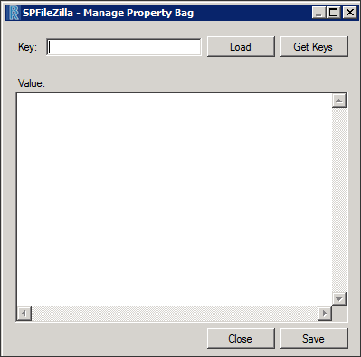

* enter a property bag key, click "Load" to get its value, make changes to the value and click "Save".
* click "Get Keys" to load all the property bag keys in current SPWeb, they are dumped in main program log window in alpha order.

**Live file editor**  
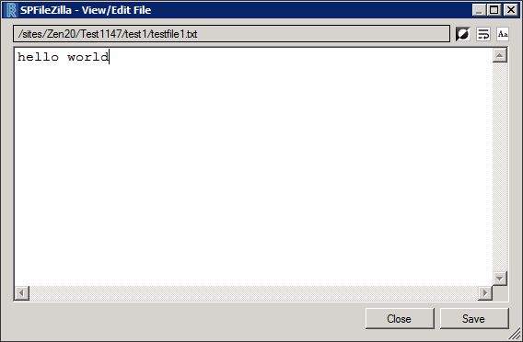

* icons on top right are for changing background color, text wrap, and text size (in order).
* make changes and click "Save", editor stays open for further changes as needed.
* ASCII encoding text editor setting in app.config file.

**SharePoint List Browsing**

* Refresh the directory contents
* Navigate "up" to parent directory
* Select one or more files/folders
* Open sub folders
* Double-click files to copy to file system
* Right click files and folders for further actions
* Sort folder contents by clicking column headers (name, size, last modified date)
* Drag/drop folders and files to upload

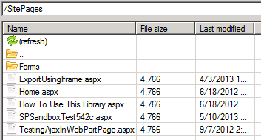  
  
  
**SPFileZilla Right Click Menu**

* Both left and right windows have a right click menu
* You can rename files and folders
* Delete files and folders
* Create new folders
* Send to Destination (SharePoint from File System and vice-versa)
* Copy path to clipboard

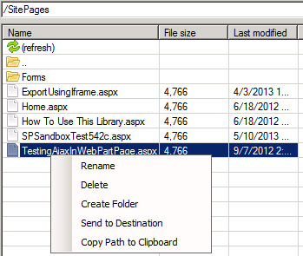  
  
  
**SharePoint File specific right click menu actions**

* Bulk file actions: move, copy, update file field values (using dialog), check-in (major, minor, overwrite), check-out, undo check-out, publish

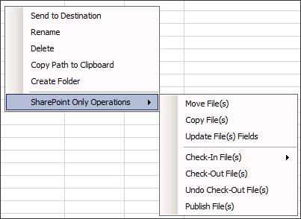  
  
  
**SharePoint File Update File(s) Fields action**

* Update one or more files at the same time
* Update one or more field values at the same time
* Dropdown list prefilled with all available listitem field names, select a field and click the "add field" button
* Using the grid, enter field names and field values

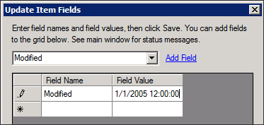  
  
  
**SharePoint Site Profiles**

* Save and manage connections to SharePoint sites
* Specify a profile name, site url (SPWeb), username, password, domain (optional if connecting to SharePoint Online)
* SharePoint Online profiles should have the checkbox checked for "Is SharePoint Online", since a special API is used to handle the Claims Authentication

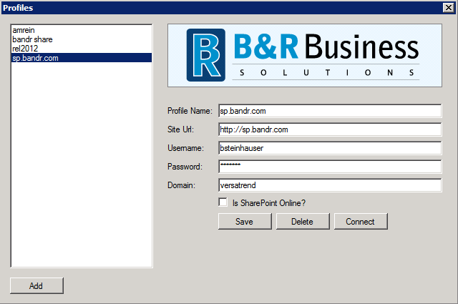  
  
  
**About Window**

* Further SPFileZilla information, credits, special thanks.

