Codebook for DataTidy

Autogenerated data summary from dataMaid

2018-10-12 09:53:09

# Data report overview

The dataset examined has the following dimensions:

|  |  |
| --- | --- |
| Feature | Result |
| Number of observations | 40 |
| Number of variables | 20 |

# Codebook summary table

|  |  |  |  |  |  |
| --- | --- | --- | --- | --- | --- |
| Label | Variable | Class | # unique values | Missing | Description |
|  | **ActivityLabel** | character | 6 | 0.00 % |  |
|  | **SubjectNumber** | numeric | 30 | 0.00 % |  |
|  | **tBodyAccMagMean** | numeric | 40 | 0.00 % |  |
|  | **tBodyAccMagStd** | numeric | 40 | 0.00 % |  |
|  | **tGravityAccMagMean** | numeric | 40 | 0.00 % |  |
|  | **tGravityAccMagStd** | numeric | 40 | 0.00 % |  |
|  | **tBodyAccJerkMagMean** | numeric | 40 | 0.00 % |  |
|  | **tBodyAccJerkMagStd** | numeric | 40 | 0.00 % |  |
|  | **tBodyGyroMagMean** | numeric | 40 | 0.00 % |  |
|  | **tBodyGyroMagStd** | numeric | 40 | 0.00 % |  |
|  | **tBodyGyroJerkMagMean** | numeric | 40 | 0.00 % |  |
|  | **tBodyGyroJerkMagStd** | numeric | 40 | 0.00 % |  |
|  | **fBodyAccMagMean** | numeric | 40 | 0.00 % |  |
|  | **fBodyAccMagStd** | numeric | 40 | 0.00 % |  |
|  | **fBodyBodyAccJerkMagMean** | numeric | 40 | 0.00 % |  |
|  | **fBodyBodyAccJerkMagStd** | numeric | 40 | 0.00 % |  |
|  | **fBodyBodyGyroMagMean** | numeric | 40 | 0.00 % |  |
|  | **fBodyBodyGyroMagStd** | numeric | 40 | 0.00 % |  |
|  | **fBodyBodyGyroJerkMagMean** | numeric | 40 | 0.00 % |  |
|  | **fBodyBodyGyroJerkMagStd** | numeric | 40 | 0.00 % |  |

# Variable list

## ActivityLabel

|  |  |
| --- | --- |
| Feature | Result |
| Variable type | character |
| Number of missing obs. | 0 (0 %) |
| Number of unique values | 6 |
| Mode | “WALKING_UPSTAIRS” |

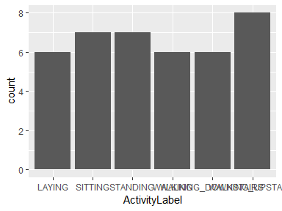

* Observed factor levels: "LAYING", "SITTING", "STANDING", "WALKING", "WALKING_DOWNSTAIRS", "WALKING_UPSTAIRS".

## SubjectNumber

|  |  |
| --- | --- |
| Feature | Result |
| Variable type | numeric |
| Number of missing obs. | 0 (0 %) |
| Number of unique values | 30 |
| Median | 15.5 |
| 1st and 3rd quartiles | 8.75; 22 |
| Min. and max. | 1; 30 |

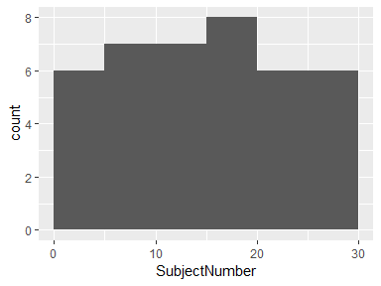

## tBodyAccMagMean

|  |  |
| --- | --- |
| Feature | Result |
| Variable type | numeric |
| Number of missing obs. | 0 (0 %) |
| Number of unique values | 40 |
| Median | -0.54 |
| 1st and 3rd quartiles | -0.62; -0.5 |
| Min. and max. | -0.98; -0.06 |

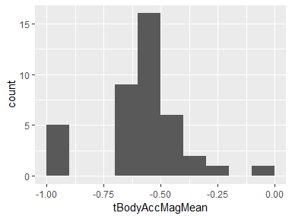

## tBodyAccMagStd

|  |  |
| --- | --- |
| Feature | Result |
| Variable type | numeric |
| Number of missing obs. | 0 (0 %) |
| Number of unique values | 40 |
| Median | -0.6 |
| 1st and 3rd quartiles | -0.66; -0.55 |
| Min. and max. | -0.97; -0.1 |

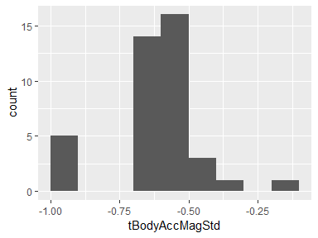

## tGravityAccMagMean

|  |  |
| --- | --- |
| Feature | Result |
| Variable type | numeric |
| Number of missing obs. | 0 (0 %) |
| Number of unique values | 40 |
| Median | -0.54 |
| 1st and 3rd quartiles | -0.62; -0.5 |
| Min. and max. | -0.98; -0.06 |

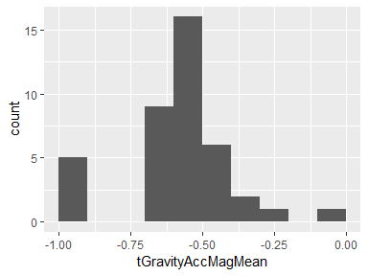

## tGravityAccMagStd

|  |  |
| --- | --- |
| Feature | Result |
| Variable type | numeric |
| Number of missing obs. | 0 (0 %) |
| Number of unique values | 40 |
| Median | -0.6 |
| 1st and 3rd quartiles | -0.66; -0.55 |
| Min. and max. | -0.97; -0.1 |

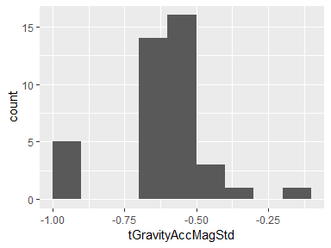

## tBodyAccJerkMagMean

|  |  |
| --- | --- |
| Feature | Result |
| Variable type | numeric |
| Number of missing obs. | 0 (0 %) |
| Number of unique values | 40 |
| Median | -0.66 |
| 1st and 3rd quartiles | -0.71; -0.58 |
| Min. and max. | -0.99; -0.15 |

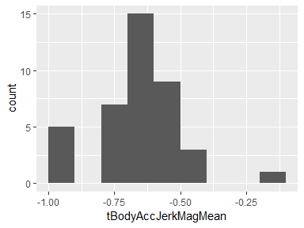

## tBodyAccJerkMagStd

|  |  |
| --- | --- |
| Feature | Result |
| Variable type | numeric |
| Number of missing obs. | 0 (0 %) |
| Number of unique values | 40 |
| Median | -0.63 |
| 1st and 3rd quartiles | -0.69; -0.56 |
| Min. and max. | -0.99; -0.09 |

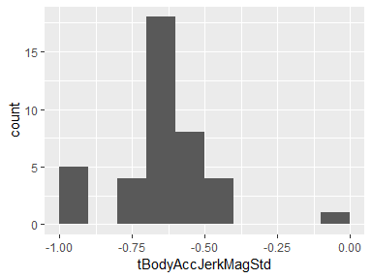

## tBodyGyroMagMean

|  |  |
| --- | --- |
| Feature | Result |
| Variable type | numeric |
| Number of missing obs. | 0 (0 %) |
| Number of unique values | 40 |
| Median | -0.62 |
| 1st and 3rd quartiles | -0.69; -0.55 |
| Min. and max. | -0.98; -0.18 |

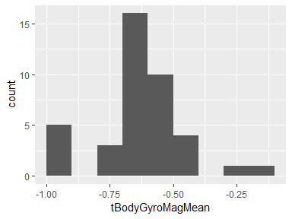

## tBodyGyroMagStd

|  |  |
| --- | --- |
| Feature | Result |
| Variable type | numeric |
| Number of missing obs. | 0 (0 %) |
| Number of unique values | 40 |
| Median | -0.68 |
| 1st and 3rd quartiles | -0.74; -0.61 |
| Min. and max. | -0.98; -0.2 |

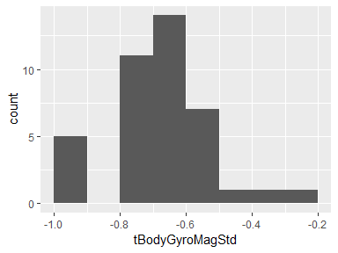

## tBodyGyroJerkMagMean

|  |  |
| --- | --- |
| Feature | Result |
| Variable type | numeric |
| Number of missing obs. | 0 (0 %) |
| Number of unique values | 40 |
| Median | -0.78 |
| 1st and 3rd quartiles | -0.83; -0.71 |
| Min. and max. | -0.99; -0.2 |

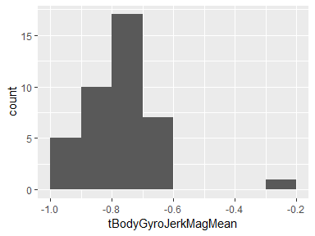

## tBodyGyroJerkMagStd

|  |  |
| --- | --- |
| Feature | Result |
| Variable type | numeric |
| Number of missing obs. | 0 (0 %) |
| Number of unique values | 40 |
| Median | -0.8 |
| 1st and 3rd quartiles | -0.86; -0.72 |
| Min. and max. | -0.99; -0.24 |

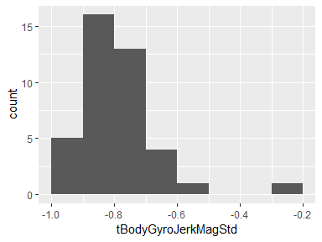

## fBodyAccMagMean

|  |  |
| --- | --- |
| Feature | Result |
| Variable type | numeric |
| Number of missing obs. | 0 (0 %) |
| Number of unique values | 40 |
| Median | -0.59 |
| 1st and 3rd quartiles | -0.66; -0.52 |
| Min. and max. | -0.98; -0.06 |

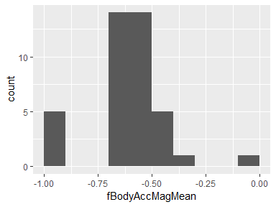

## fBodyAccMagStd

|  |  |
| --- | --- |
| Feature | Result |
| Variable type | numeric |
| Number of missing obs. | 0 (0 %) |
| Number of unique values | 40 |
| Median | -0.67 |
| 1st and 3rd quartiles | -0.71; -0.62 |
| Min. and max. | -0.97; -0.27 |

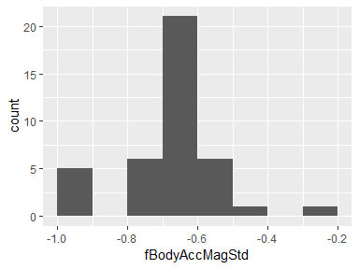

## fBodyBodyAccJerkMagMean

|  |  |
| --- | --- |
| Feature | Result |
| Variable type | numeric |
| Number of missing obs. | 0 (0 %) |
| Number of unique values | 40 |
| Median | -0.62 |
| 1st and 3rd quartiles | -0.68; -0.54 |
| Min. and max. | -0.99; -0.08 |

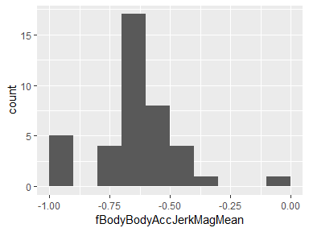

## fBodyBodyAccJerkMagStd

|  |  |
| --- | --- |
| Feature | Result |
| Variable type | numeric |
| Number of missing obs. | 0 (0 %) |
| Number of unique values | 40 |
| Median | -0.64 |
| 1st and 3rd quartiles | -0.69; -0.58 |
| Min. and max. | -0.99; -0.11 |

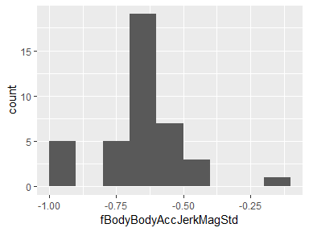

## fBodyBodyGyroMagMean

|  |  |
| --- | --- |
| Feature | Result |
| Variable type | numeric |
| Number of missing obs. | 0 (0 %) |
| Number of unique values | 40 |
| Median | -0.73 |
| 1st and 3rd quartiles | -0.77; -0.65 |
| Min. and max. | -0.99; -0.16 |

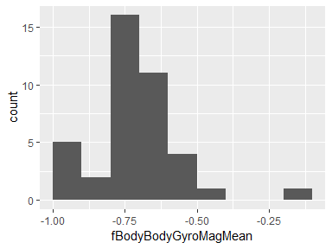

## fBodyBodyGyroMagStd

|  |  |
| --- | --- |
| Feature | Result |
| Variable type | numeric |
| Number of missing obs. | 0 (0 %) |
| Number of unique values | 40 |
| Median | -0.71 |
| 1st and 3rd quartiles | -0.77; -0.66 |
| Min. and max. | -0.98; -0.38 |

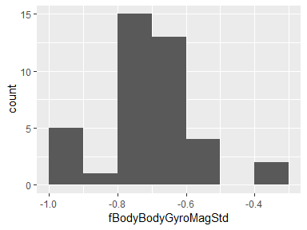

## fBodyBodyGyroJerkMagMean

|  |  |
| --- | --- |
| Feature | Result |
| Variable type | numeric |
| Number of missing obs. | 0 (0 %) |
| Number of unique values | 40 |
| Median | -0.8 |
| 1st and 3rd quartiles | -0.86; -0.72 |
| Min. and max. | -0.99; -0.25 |

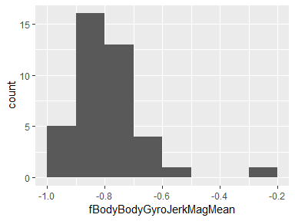

## fBodyBodyGyroJerkMagStd

|  |  |
| --- | --- |
| Feature | Result |
| Variable type | numeric |
| Number of missing obs. | 0 (0 %) |
| Number of unique values | 40 |
| Median | -0.81 |
| 1st and 3rd quartiles | -0.87; -0.74 |
| Min. and max. | -0.99; -0.27 |

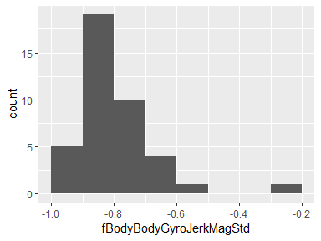

Report generation information:

* Created by Remko Logemann (username: remko).
* Report creation time: Fri Oct 12 2018 09:53:10
* Report was run from directory: D:/Prive/Coursera/DataScience/Course 3/Week 4
* dataMaid v1.2.0 [Pkg: 2018-10-03 from CRAN (R 3.5.1)]
* R version 3.5.0 (2018-04-23).
* Platform: x86_64-w64-mingw32/x64 (64-bit)(Windows >= 8 x64 (build 9200)).
* Function call: makeDataReport(data = DataTidy, mode = c("summarize", "visualize", "check"), smartNum = FALSE, file = "codebook_DataTidy.Rmd", checks = list( character = "showAllFactorLevels", factor = "showAllFactorLevels", labelled = "showAllFactorLevels", haven_labelled = "showAllFactorLevels", numeric = NULL, integer = NULL, logical = NULL, Date = NULL), listChecks = FALSE, maxProbVals = Inf, codebook = TRUE, reportTitle = "Codebook for DataTidy")