Lab 4: Introduction to Java
IT 1090C Computer Programming I
IT 6090C Java Programming
Prof. Jason Geanuracos
Fall 2025

Lab 4: Introduction to Java
20 points

Learning Goals:
- How java's numeric types, (int, and double), interact with the simple arithmetic operators (multiplication, addition, modulo, etc.).
- Code several of our previous pseudocode programs in java!
- Become comfortable with using IntelliJ IDEA IDE for our java programming
- Get used to submitting assignments in Canvas
- Use GitHub source control for your Java projects from within IntelliJ.

Lab
Complete the lab individually: submit all the work and screenshots as directed below.
Screenshot shortcut keys
- Windows: Alt + printScrn key puts image of desktop in clipboard. Then paste (ctrl+v) it into the document. You can also use Opt (Start) + Shift + s to bring up a cropping tool and paste that into your document. This may be easier. Also, you can hit Start + v to bring up the clipboard if you would like to screenshot multiple pictures and then paste all at once.
- Mac: Shift + Command + 3 or Shift + Command + 4 to capture a portion of the screen. Then, paste (command + v) it into the document.
You can get help from your classmates, myself, or a friend, but it is very important that each student completes the lab themselves using the JetBrains IntelliJ IDEA IDE. You want to be totally comfortable with creating java projects in IntelliJ and typing code into the IDE. The more work you put into these labs, especially early on, the larger the dividends they will pay in the long run.

Part 1: IntelliJ Project and Java Main File (2pts)

Instructions
Be sure to watch the lecture videos before you complete the lab. Refer to the videos if you have trouble and without delay. You can't proceed with the course if you can't use the IDE.
We are not allowed to use spaces in project names for GitHub so we will get in the habit of avoiding them in IntelliJ by using underscores "_".

- Create a new IntelliJ java project called Lab_04_Java_Variables use any java JDK 1.8 or later and don't select anything else on the initial screen. Note: Your instructor will demonstrate this in class and there is a Video that demos it. (See the support Videos linked within the Lab on Canvas.)
- Choose the Create Project from Template and the Command Line App template which will create a Main.java file. All your code will go in the main.java file within the main method.

- Add your project to GitHub: Go to the VCS (Version Control System) on the main menu bar in IntelliJ and choose "Share Project on GitHub”.
(The first time, IntelliJ will prompt you for your GitHub credentials and create a security link with GitHub that will allow you to use it from within IntelliJ. It will open a webpage with a link for you to click to confirm.)
Add a description "Init commit" to indicate that you are just creating the project and click "share".
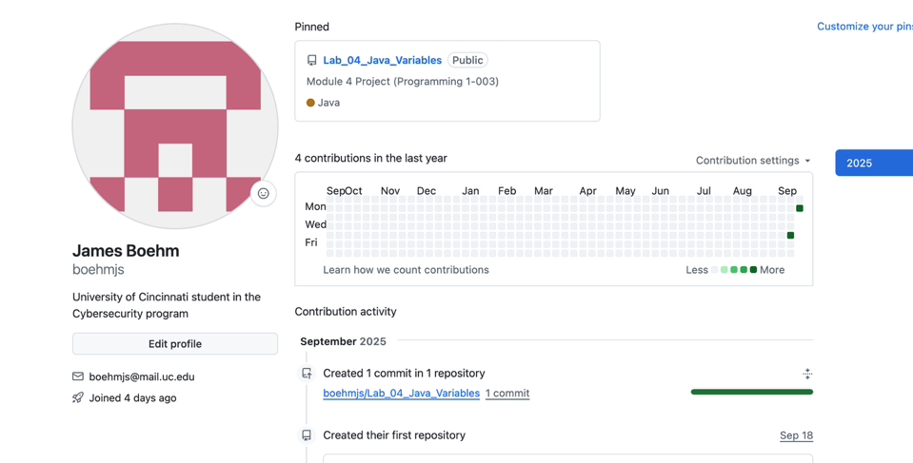
- Build constructive professional work habits by carefully rechecking your work; open your GitHub account in the Web browser and confirm that your project was created, and again after you update it confirm it got all your code.
Paste a screenshot of your project on GitHub.

Break
Take a break and check with your fellow learners. Was everyone able to create the project files correctly? If you are working solo, you can text someone or just go get a snack.

- Click the arrow next to the src folder in your project to expand it and you will see the main.java file that was created from the template. All your code goes in this file within the method called main. (This corresponds to the main() … return we had in pseudocode.)
- Within your file declare and initialize a series of numeric variables. Put them one per line like this example:
int intOperandA = 1:
next variable declaration here…
Here are the int (integer) variables to declare:
intOperandA, intOperandB, intSum, intProduct, intDifference, intQuotient, intModulo
You can set these to simple integer values of your own choice. Make them all different: 1 5, 13, 24, etc.

- In the same way, create a series of double value variables. (These have fractional values like 3.50.)
double doubleOperandA = 3.50; // This is a declaration and initial assignment
Create declarations again, one per line, for each of these.
doubleOperandA, doubleOperandB, doubleSum, doubleProduct, doubleDifference, doubleQuotient
Note: We do not usually include the type of variables i.e. "int", "double", "Boolean", etc in the name of the variables. I'm having you do that here this one time only so you can observe how the variable types effect the arithmetic operations.
- Now create assignment statements using your variables for each of these arithmetic operations for both the int and the double types:
+, -, *, /, % (that last one is remainder and is called modulo) create a 'complete sentence' output statement that displays the results of the operation and the two operands.

Example:
intSum = intOperandA + intOperandB; // Assignment that uses the arithmentic operator +
System.out.println("The sum using ints of " + intOperandA + " " + intOperandB + " is " + intSum); // Output statement
Notice how we include a space before and after each operator to increase readability.
Get in the habit of typing the code this way.
Get in the habit of typing the code this way.
Get in the habit of typing the code this way.
- Actually, before you do the of the remaining int statements, try running the program. Best to catch errors early.
Right click on your main.java file in the project view and choose Run main. Alternatively, you can run the program by clicking the run arrow on the top menu bar.
Do this with the int variables for each of the operations (+ sum, * product, - difference, / quotient, and % modulo.)
Again, run the program after you enter each new operation and its’ output statement. Test as you go!
- Now do the same thing with the double variables
- Size the output window so you can see the results of the println statements for these expressions and grab a screenshot of your desktop that shows this. Alternatively, and what often works better for me, copy the output window as text and paste it into this document.
Paste a screenshot or output copy here.

Important:
Seek help if you run into problems completing the assignment. Seek help from your instructor, the tutor, etc. Don't wait for help, you will fall behind. Often, writing out your question in an email will help you to diagnose what it is you are struggling with and allow your brain to attack it from a different angle. Sometimes you need sleep or a snack. Don’t program tired, you will tend to make more mistakes.
Completely test and debug your code before submitting it and the grading process is primarily simply confirming you completed the assigned work.
Screenshots or output copies must clearly show the work you were asked to complete. We use this to grade your work.

Did any of these results surprise you? (If not, take another look at the result of int division)

- OK complete this part by creating declarations and initializing each of these variables. Be sure to type the variable appropriately as boolean, int, double, or String.
Note: Choose meaningful names of your own for your variables and use camel case:

Example:
the cost of my lunch: double myLunchCost = 12.50;

the number of kids in your family:
the answer to is it raining?:
the price of a gallon of gas:
your favorite number:
your shoe size:
your birth month:
your full name:
(If you want, you can print these out with java statements but I'll make that optional so you can finish the lab during the session.)

double myLunchCost = 12.50;
System.out.println("The cost of my lunch is: " + myLunchCost);
Get another screenshot or copy of your editor window making sure I can read all your variable declarations.
Paste a screenshot or output copy here.
- Commit your Work to the Repo
- In IntelliJ, Click on GIT on the main menu bar and choose Commit. (Previously, this menu was VCS and it changed to GIT after you shared your project on GitHub.)
- On the popup screen use the dropdown on the submit button to Commit and Push. You have to enter commit text and it should be “Init” the first time. Continue to commit as you go, change the status to indicate the stage “Completed Part 1”, etc.
Typically, you commit several times as you write more code, but you Push at the end of your session to upload all the commits to the GitHub repository and back up your work. Be sure to make a final commit and push for all completed projects! You can also use the Commits to restore your project to a previous point like the undo function in an editor.

GitHub repo link
Add the link for the Lab_04_Java_Variables GitHub repo here
https://github.com/boehmjs/Lab_04_Java_Variables/tree/main

Part 2: Java Programs
Now code each of these programs. Since we can't do java input yet, just set the input value as a literal value in your code. I'll leave it to you to choose the values. Be sure to use clear and meaningful variable names with appropriate types! Try to pick values that make it easy for you to visually confirm the results of your program outputs.

Example:
We did an example where the user enters a number, and the program doubles it. Here is the code that I would put within the main() class of my IntelliJ project:
int myFavNum = 23; // Later we would input this but today we simulate that
int doubleNum = 0;

doubleNum = myFavNum * 2;

System.out.println("The number " + myFavNum + " doubled is: " + doubleNum);

When you run the code, you will see the println statement with the variable names replaced with the actual values.

Instructions
You will create a new IntelliJ Java Project for each of these programs using the specified names. You will add each program separately to GitHub src control.
Build constructive professional work habits by carefully rechecking your work; open your GitHub account in the Web browser and confirm that your project was created, and after you update it. Remember to use an underscore "_" instead of a space when naming files for GitHub.
Create a GitHub project for each program as with the previous one. Be sure to commit and push you project when completed.

Task 1 (3 pts):
Project Name: Lab_04_01_SalesTax
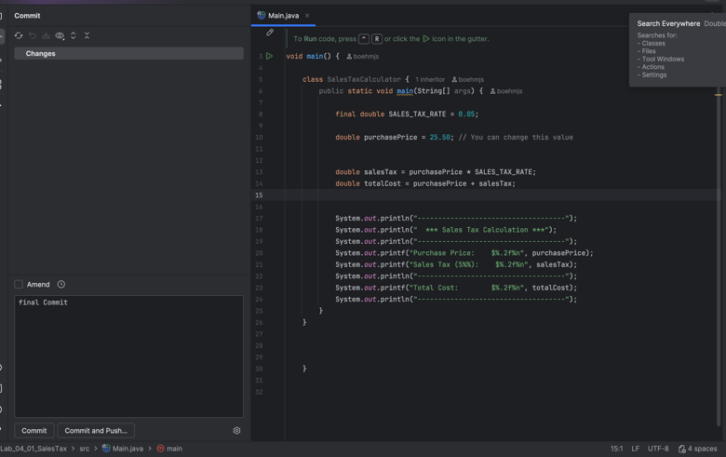
Given the price of a purchase the program computes and outputs a 5% sales tax. Be sure to use output statements that clearly display the price and the computed sales tax. (No conditions here, the sales tax is always the same rate.)

GitHub
- Remember to commit and push your project in GitHub.
- Post the link for this repository here:
https://github.com/boehmjs/Lab_04_01_SalesTax

Task 2 (3 pts):
Project Name: Lab_04_02_YearlyMaintenanceCost
A program that uses home maintenance costs for each of the four seasons and returns the total yearly maintenance costs. Again, be clear in the output by echoing the values for the seasonal costs when you display the combined total.
Paste screenshots of code and output for Task 2:
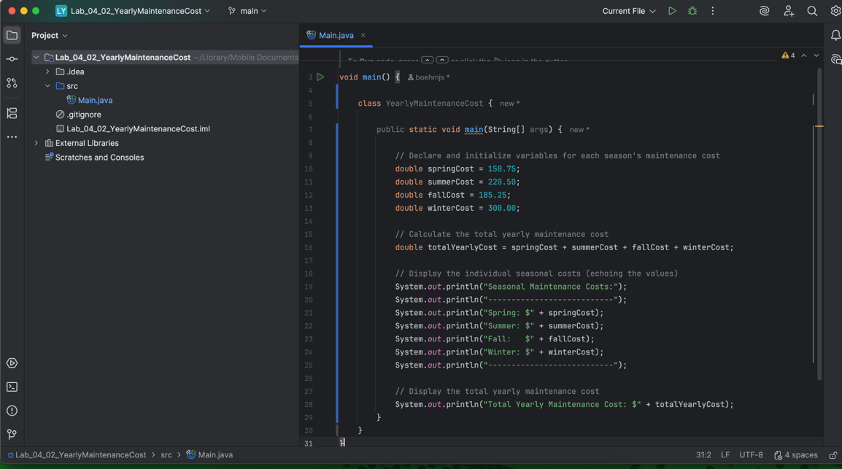

GitHub
- Remember to commit and push your project in GitHub.
- Post the URL link for this repository here:
https://github.com/boehmjs/Lab_04_02_YearlyMaintenanceCost

Task 3 (4 pts):
Project Name: Lab_04_03_MonthyCCBalance
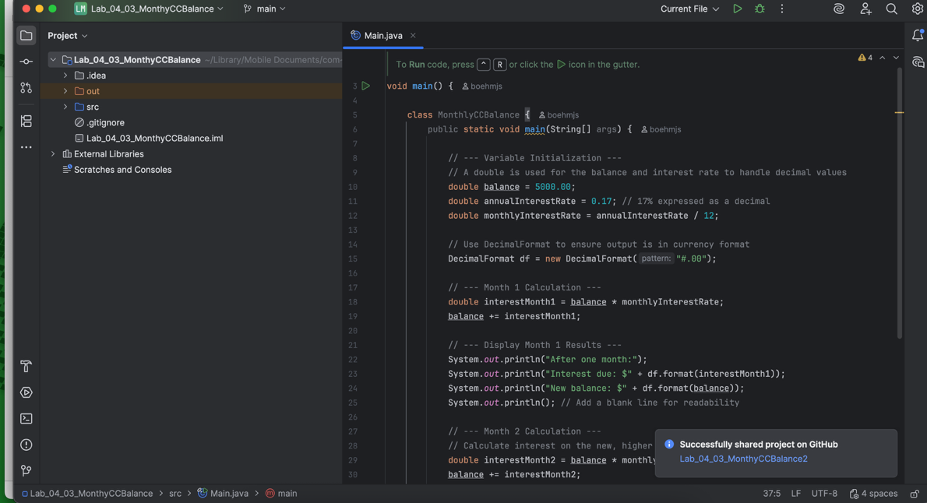
A program that starts with a credit card balance of $5000 and then calculates the interest at a rate of 17%. Assume the user does not make any payments. Display the interest due after one month and again after two months.

GitHub
- Remember to commit and push your project in GitHub.
- Post the URL link for this repository here:
https://github.com/boehmjs/Lab_04_03_MonthyCCBalance2

Task 4 (2 pts):
Project Name: Lab_04_04_EvenOdd
A program that takes an integer (java int) and uses the modulo function to indicate if the number is odd or even. Since we can't do input in java yet, just hard code the value for the input as a variable instantiation.
(Instead of inputting the value which we can't do yet, set the value in the code.
int numToExamine = 2;
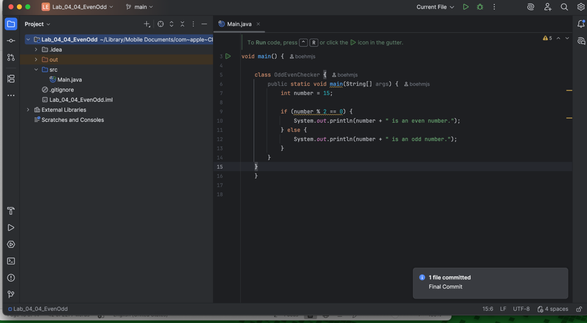
// program will then determine that since 2 mod 2 is 0 that numToExamine is Even.)

GitHub
Remember to commit and push your project in GitHub.
Paste the URL link for this repository here:
https://github.com/boehmjs/Lab_04_04_EvenOdd

Post-Lab: Double-check Your Work
Now that you have completed the four lab tasks, build constructive professional work habits by carefully rechecking your work, and abiding by the naming format and submission instructions. Now that we are using java you will have to submit all your work.
Although I won't run your code, because it is your job to test and debug it, I ask that you give me your entire project every time so I can run your code or examine it if I need to for grading. If you do something completely novel or way out of the box, I would like to take a closer look to understand new ways to solve problems. If you don't follow the submission directions, your work will not be graded.

Rename the file:
Use the YourLastname_YourFirstname_Lab04.docx format; remember to replace "YourLastname" and "YourFirstname" with your actual names.
The naming format will help us efficiently track and organize your files.

Submit
Submit to Canvas using the assignments mechanism to upload your document. Don’t submit a link to your document.

