Assignment: Lab 11 (Week 13)
Name: touch-ing yingyong ID: 6722782164

1. Stored procedure
place_order inserts one row into orders. CALL place_order(4, 2, 1) creates order id 4 for customer 4 (book 2, quantity 1).

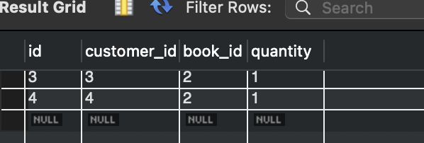
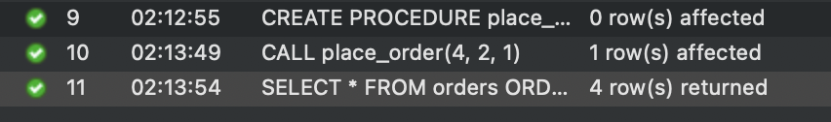

2. Stored function
order_count(p_customer) counts the rows in orders for that customer (READS SQL DATA). The SELECT calls it once per customer.

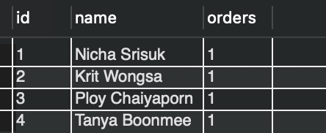

3. Trigger with a stock guard
The order for 2 copies of book 3 takes the stock from 3 to 1 with no UPDATE written by me; the trigger did it.
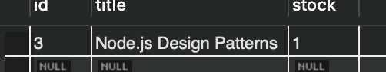

Ordering 3 copies of book 5 (only 1 in stock) fails with Error 1644 "not enough stock", and no order for book 5 exists.
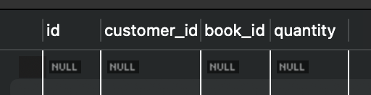

4. Trigger (reverse)
Deleting the book 3 order fires after_order_delete, which adds OLD.quantity back: the stock goes from 1 back to 3.
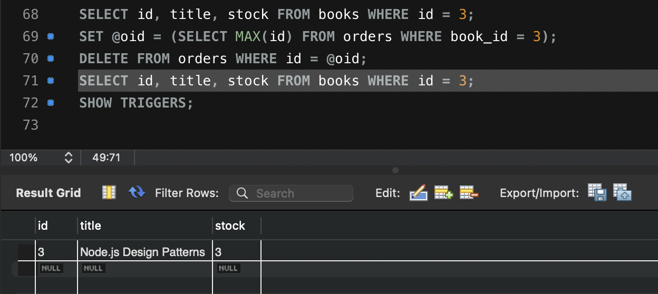

5. Use the routines from the web app
POST now makes one call, CALL place_order(?, ?, ?). SQLSTATE 45000 is mapped to 409 and a foreign key error to 404. DELETE keeps only the DELETE; the trigger restores the stock. GET /customers adds order_count(id) AS orders.
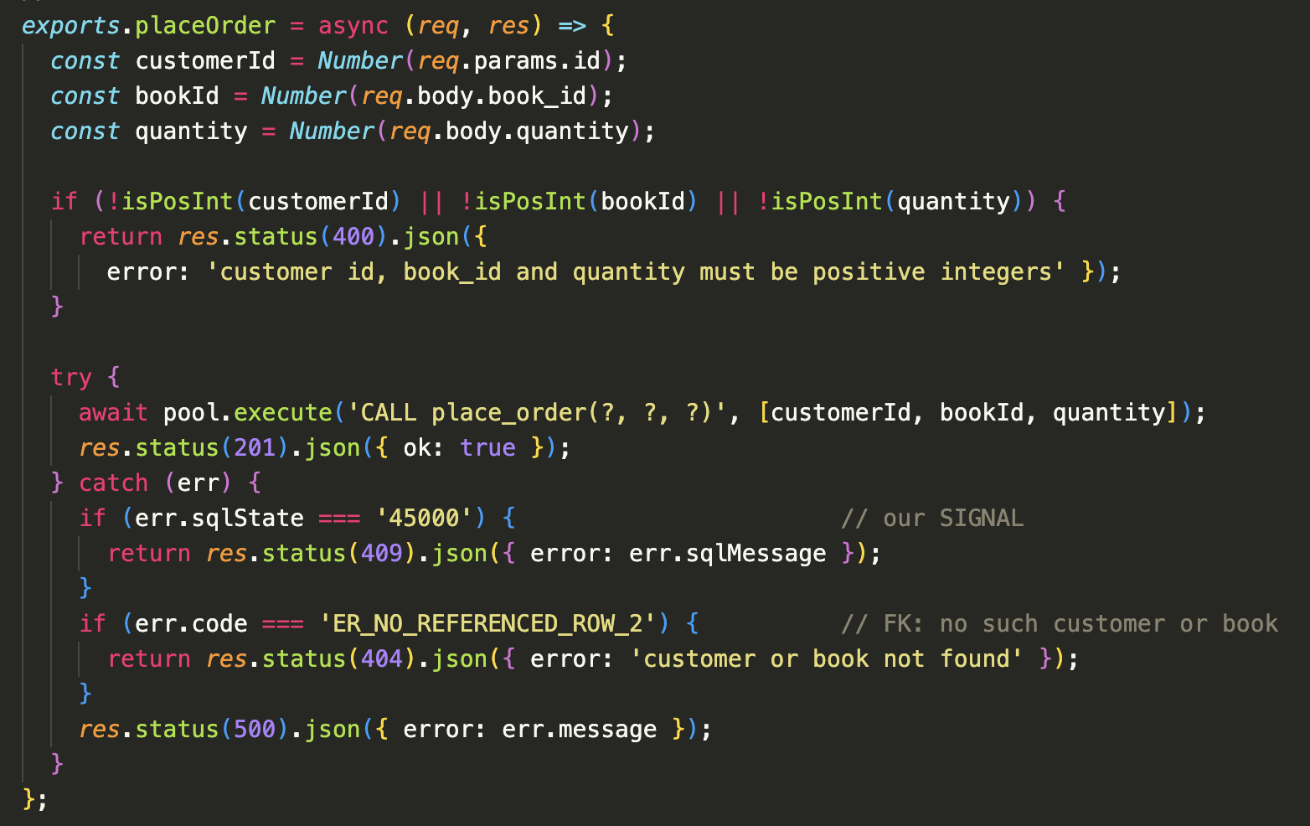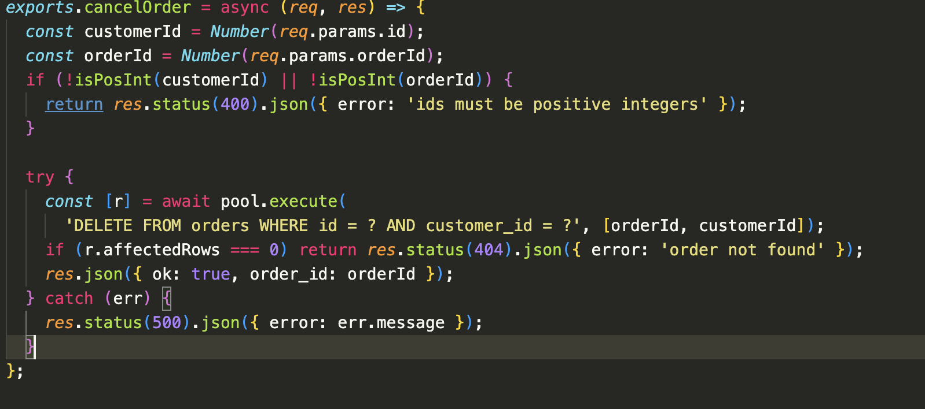
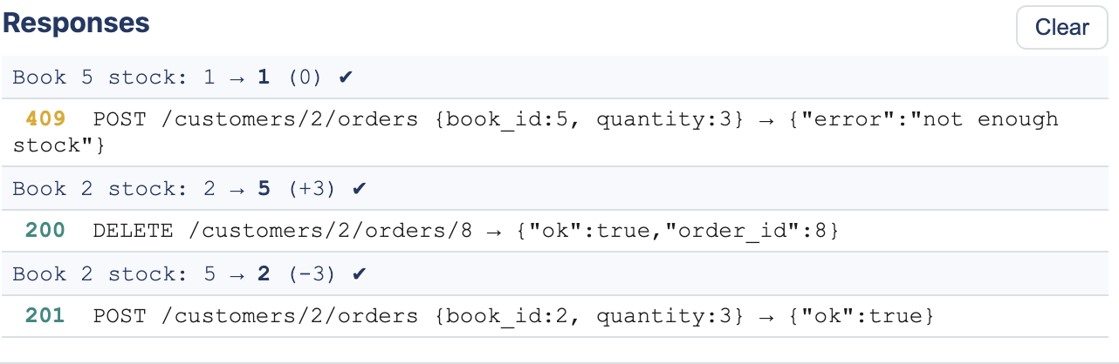

6. JSON column
books gets a JSON column attributes; every book stores {format, pages} built with JSON_OBJECT. Books 5 and 6 are ebooks.
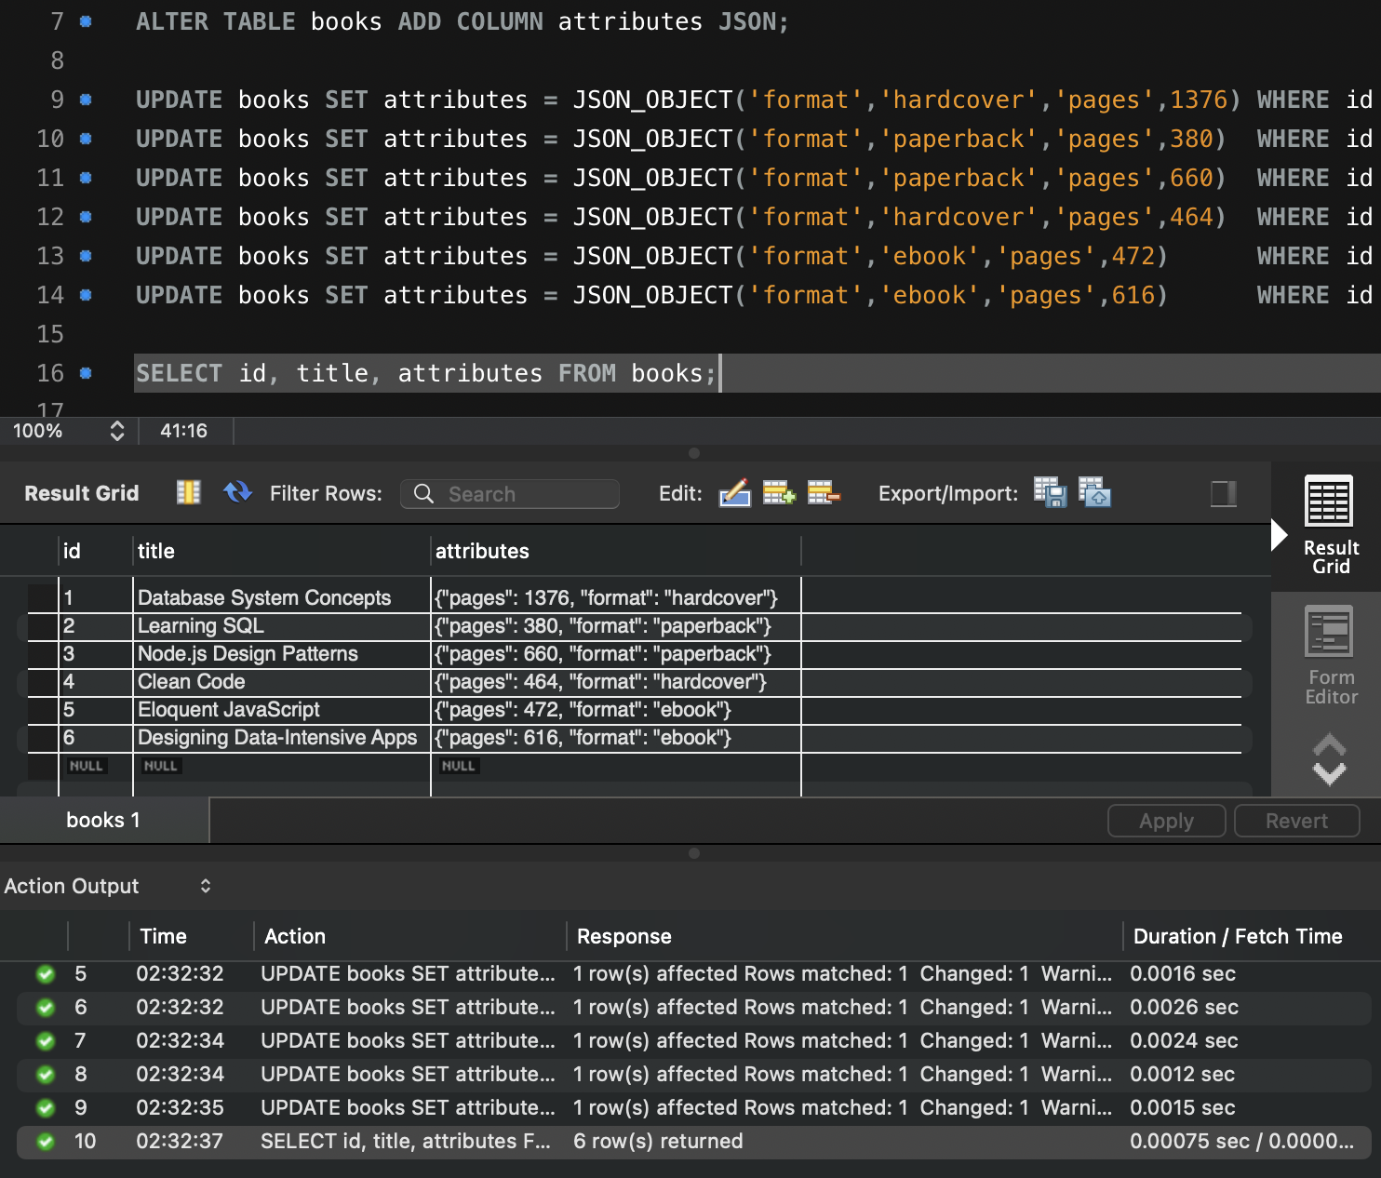

7. Query JSON
attributes->>'$.format' pulls the format out of the JSON as plain text; the second query uses it in WHERE to keep only the ebooks.
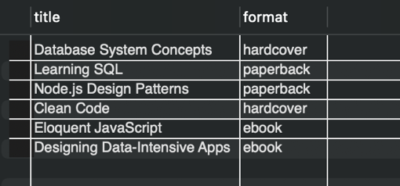
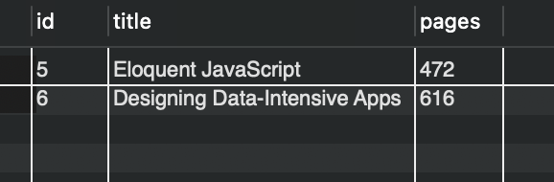

GET /books now returns format and pages, and GET /books?format=ebook adds WHERE attributes->>'$.format' = ? with the format passed as a parameter.
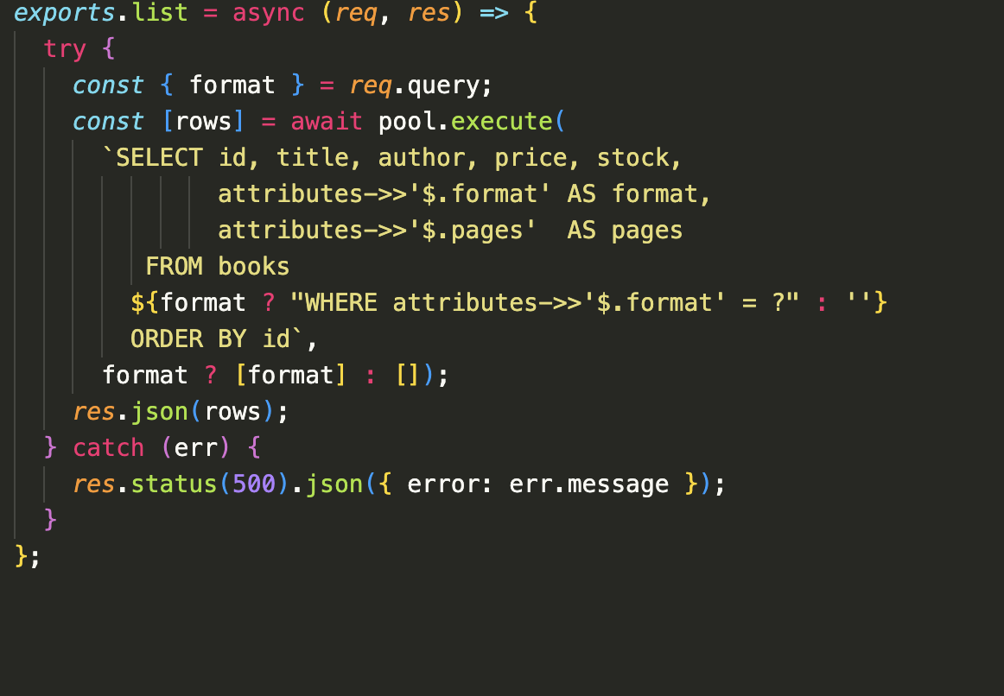
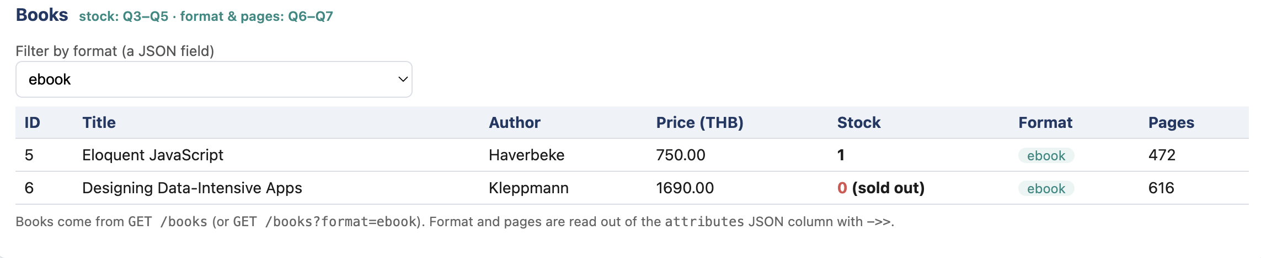

8. Short answer
(a) A good use for a trigger is keeping related data in step automatically: here every order reduces the stock and every cancel gives it back, no matter which app or query made the change, so the rule cannot be forgotten. The risk is that triggers are hidden side effects. Before Q5 was fixed, the Node code still updated the stock itself and the trigger did it again, so one order took the quantity off the stock twice, and nothing in the JavaScript showed why.
(b) I would choose a JSON column when the data is flexible or differs from row to row, like format and pages, which may not apply to every product and may get new fields later, and when it is mostly read together with its row. If the field is needed on every row, searched or joined often, or needs constraints and foreign keys, an ordinary column or a new table is better.

