CSS326 Database Programming Laboratory

Lab Assignment #6: Structuring a Web App
Student ID: 6722782164
Source code is submitted separately.

Overview
In Lab 5, my bookstore API lived in one big app.js file. For this lab I split it into smaller pieces, so each file has one job:
- db.js creates one shared connection pool to the bookstore database.
- routes/books.routes.js only says which URL goes to which function.
- controllers/books.controller.js holds the actual work: the SQL queries and the input checks.
- public/ holds the web page (index.html, main.js, style.css).
After that I added the missing parts of CRUD (update and delete) and built a simple page to use the API from the browser. Every query uses ? placeholders instead of putting values straight into the SQL.

Task 1: Pool and structure
I made db.js export a mysql2 pool, then moved the book routes into routes/books.routes.js. In app.js, the router is mounted at /books with one line, so app.js stays short. It only sets up Express, serves the public folder and starts the server.
To check that nothing broke after moving the code, I opened GET /books in the browser. It still returns all the books as JSON:
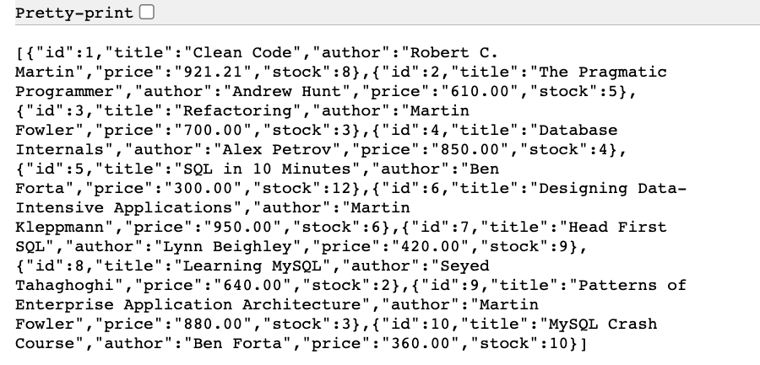
Figure 1: GET /books still works after the restructure

Task 2: Controllers
The logic for listing all books and getting one book now sits in the controller file (list and getOne). The route file just points to these functions and has no SQL in it.
For one book, I search by id. If the database gives back no rows, the book doesn't exist, so I send back 404 with the message "Book not found" instead of an empty result.
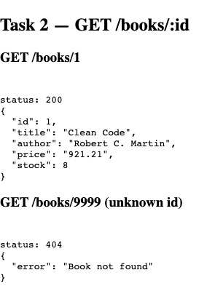
Figure 2: Book 1 is found (200), book 9999 does not exist (404)

Task 3: Checking input on POST /books
Before adding a new book, the create function checks the data that was sent:
- If there is no title, it stops and replies 400 with "Title is required".
- If the price is not a positive number (missing, zero, negative or text), it replies 400 with "Price must be a positive number".
- If both are fine, it inserts the book using ? placeholders and replies 201 with the new book's id.
This way, bad data never reaches the database. The screenshot shows both kinds of rejection, then a successful insert:
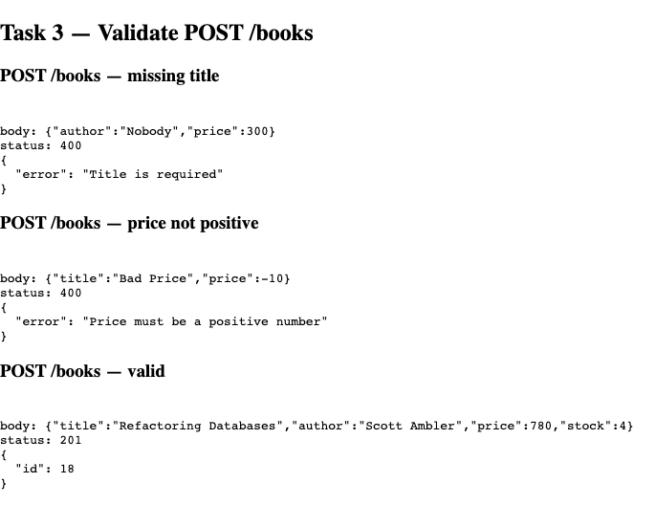
Figure 3: Two bad requests rejected with 400, one good request created with 201

Task 4: Updating with PUT
I added PUT /books/:id to change a book's price, its stock, or both. The function only updates the fields that were actually sent, so you can change just the stock without touching the price. The new values also get checked (price must be positive, stock must be a whole number of 0 or more).
MySQL tells us how many rows were changed (affectedRows). If it is 0, no book has that id, so I reply 404. Otherwise I reply with how many rows were updated.
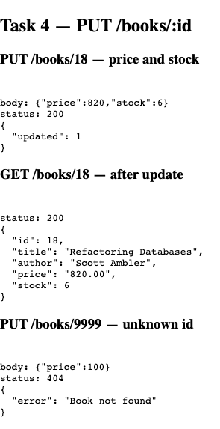
Figure 4: Book 18 updated (price 780 → 820, stock 4 → 6); unknown id 9999 gives 404

Task 5: Deleting with DELETE
DELETE /books/:id removes a book by its id. Like the update, it looks at affectedRows: if nothing was deleted, the book wasn't there, so it replies 404. If the delete worked, it replies 204 (success, with no content to send back).
In the screenshot, I delete book 18, check that it is really gone, and then try deleting it again, which correctly gives 404.
One extra thing I handled: some books already have orders, and the orders table points to them with a foreign key. MySQL won't let you delete those books. Instead of showing a confusing server error, the API replies 409 with "Cannot delete: this book has existing orders".
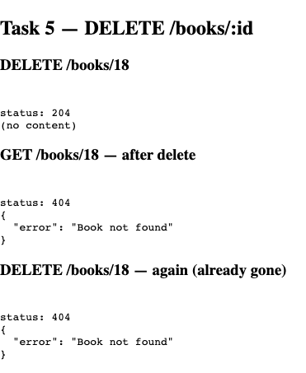
Figure 5: Delete succeeds (204), the book is gone (404), deleting again gives 404

Task 6: Web page, list and add
I built a page in the public folder. When it loads, main.js calls fetch('/books') and shows every book as a row with its title, author, price and stock.
At the top there is a form to add a new book. When you press Add book, the page sends the form data to POST /books as JSON and then reloads the list, so the new book shows up right away. If the server rejects the input (for example, an empty title), the error message is shown on the page.
For styling I kept it simple: spacing around everything, borders between rows, and coloured buttons.
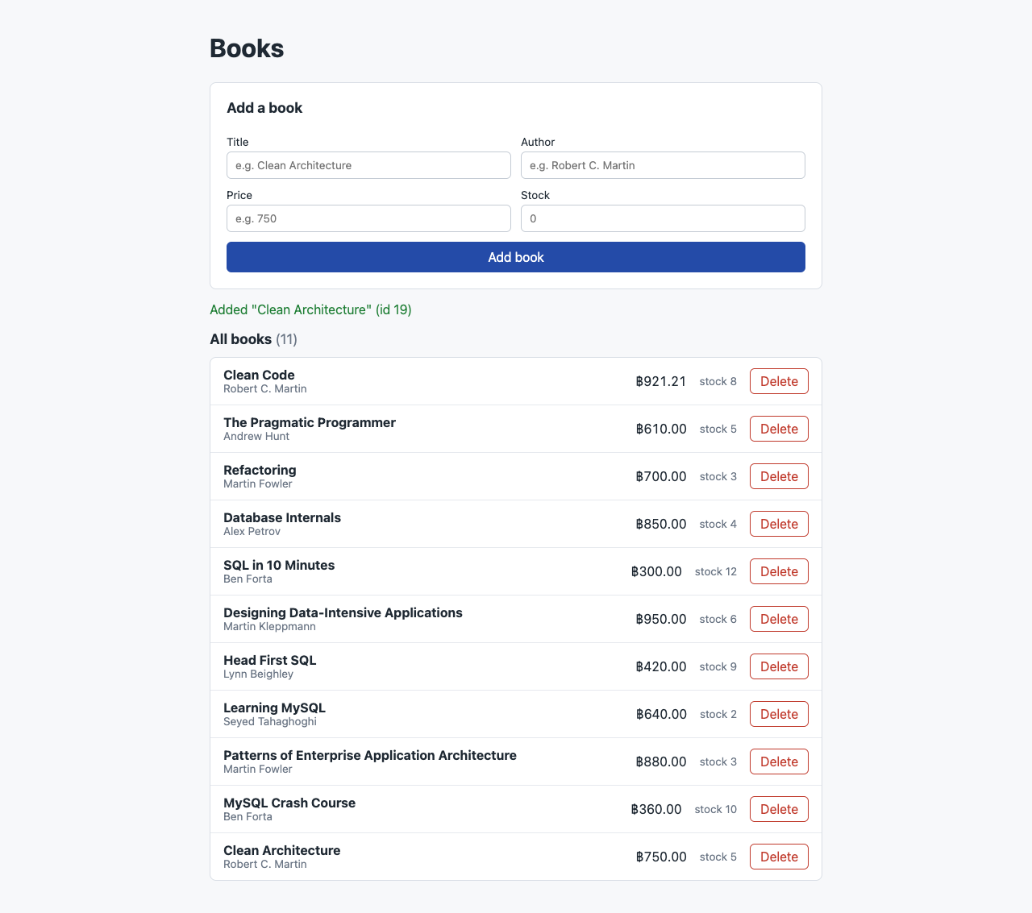
Figure 6: The page after adding "Clean Architecture" through the form (now 11 books)

Task 7: Web page, delete
Every row has a Delete button that stores the book's id. When you click it, the page sends DELETE /books/<id> and then reloads the list. I used one click listener on the whole list instead of one per button, so it keeps working after the list is redrawn.
Here I deleted "Clean Architecture", the book I added in Task 6. It is no longer in the list, and the count is back to 10:
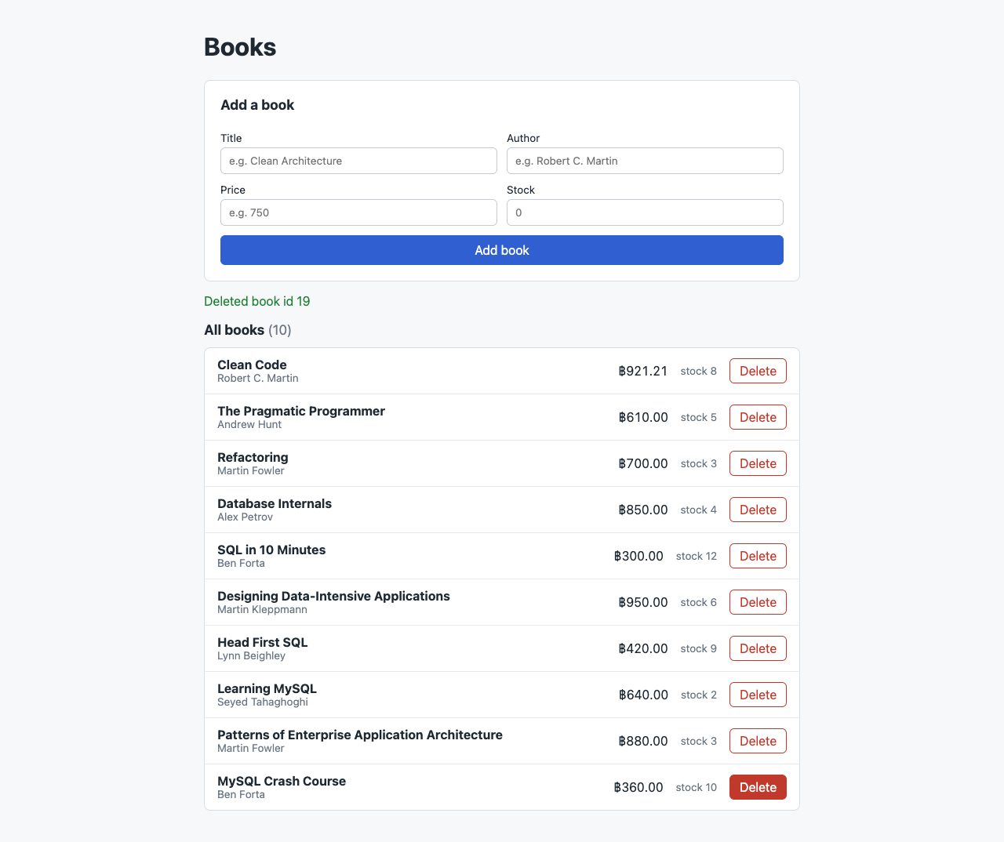
Figure 7: After clicking Delete, "Clean Architecture" is removed

Task 8: Short answer
Connection pool: opening a new database connection for every request is slow. A pool keeps a few connections open and reuses them, so requests are handled faster, and the number of connections stays under a limit so the database doesn't get overloaded.
Controllers in their own files: the route file only shows which URL goes where, and the controller holds the real logic. Because of this, each file stays small and easy to read, and I can fix or change a query without touching the routes or app.js.

