CSS326 Lab Assignment #9: Transactions
Student ID: 6722782164
Q1
In Part A I reduced book 1's stock by 2 and added an order, then used COMMIT, so both changes were saved. In Part B I ran the same statements with ROLLBACK, and the data looked exactly the same as before Part B, so nothing was saved.
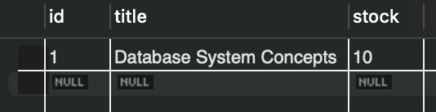
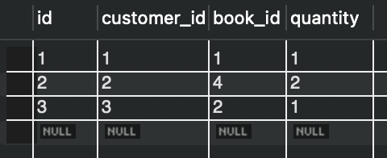
PART A
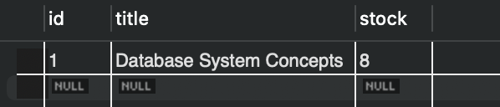
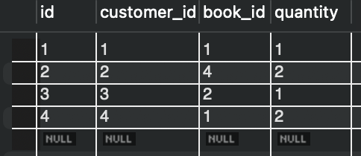
PART B
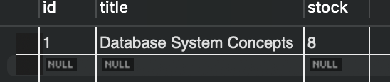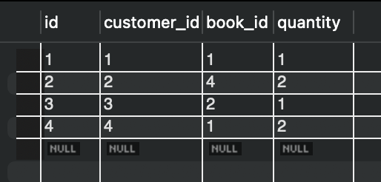
Q2
The route first checks that book_id and quantity are positive whole numbers, otherwise it returns 400. Then it gets one connection, starts a transaction, lowers the stock, inserts the order, and commits with a 201 reply.
Q3
The stock update only works when stock is enough (stock >= quantity). If not, it rolls back and returns 409, and no order is made. Here book 5 has 1 copy and I ordered 3, so the stock stayed 1.
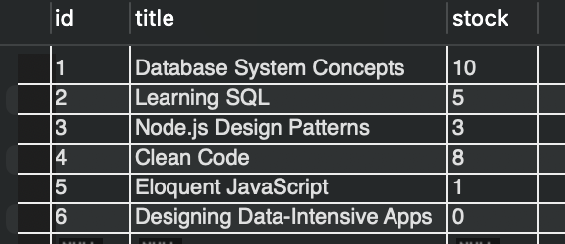
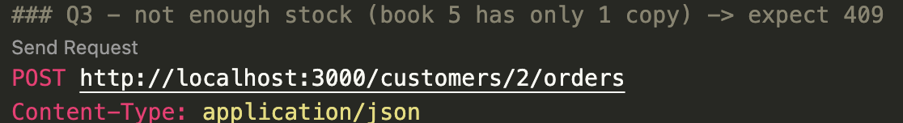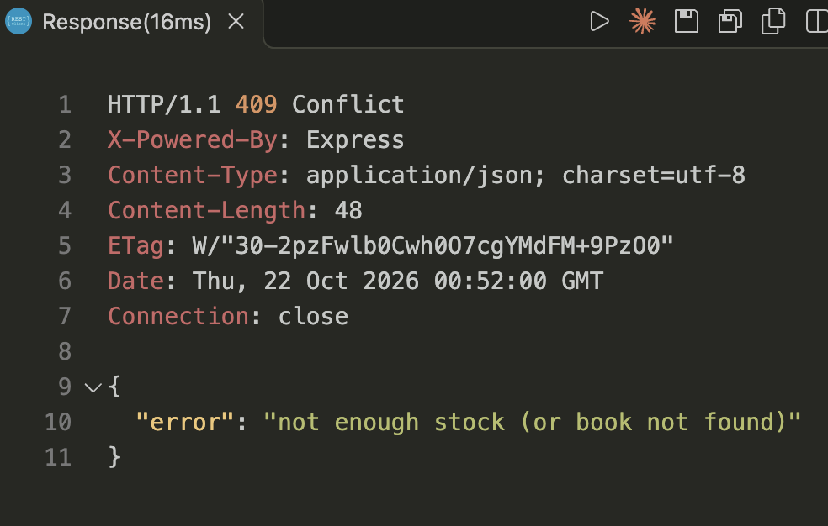

Q4
I ordered as customer 999, who does not exist, so the foreign key rejects the INSERT after the stock was already reduced. The code rolled back, and book 1's stock was 10 before and still 10 after.
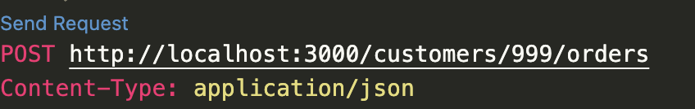
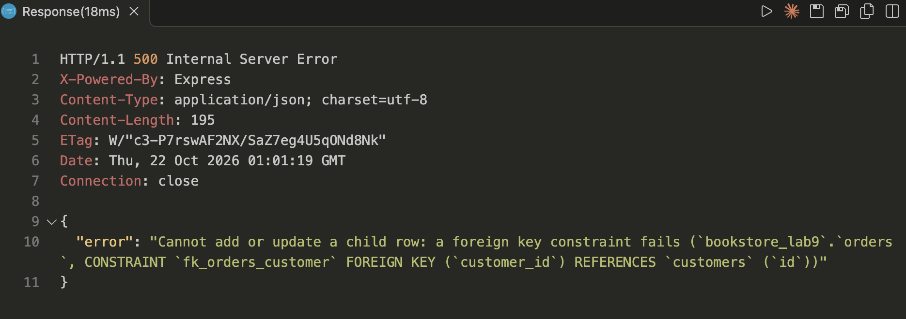
Q5
In one transaction, the route finds the order, deletes it, and adds the quantity back to the book's stock. If the order does not exist for that customer, it rolls back and returns 404.
Q6
Book 3 started with stock 3. After ordering 2 copies the stock was 1, and after cancelling that order it went back to 3.
Before order

Customer Ordered
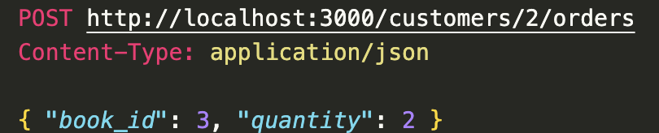
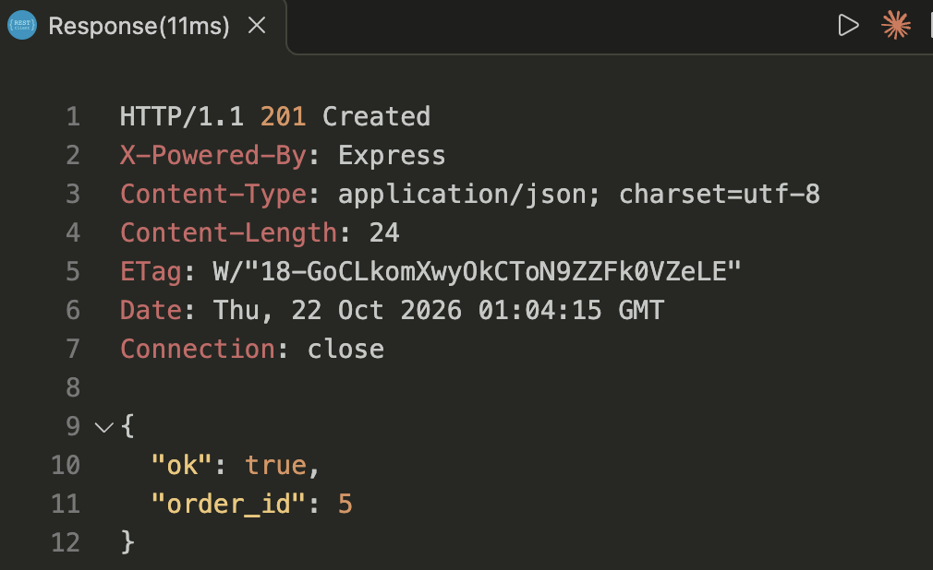
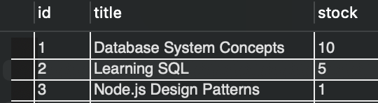

Cancel order
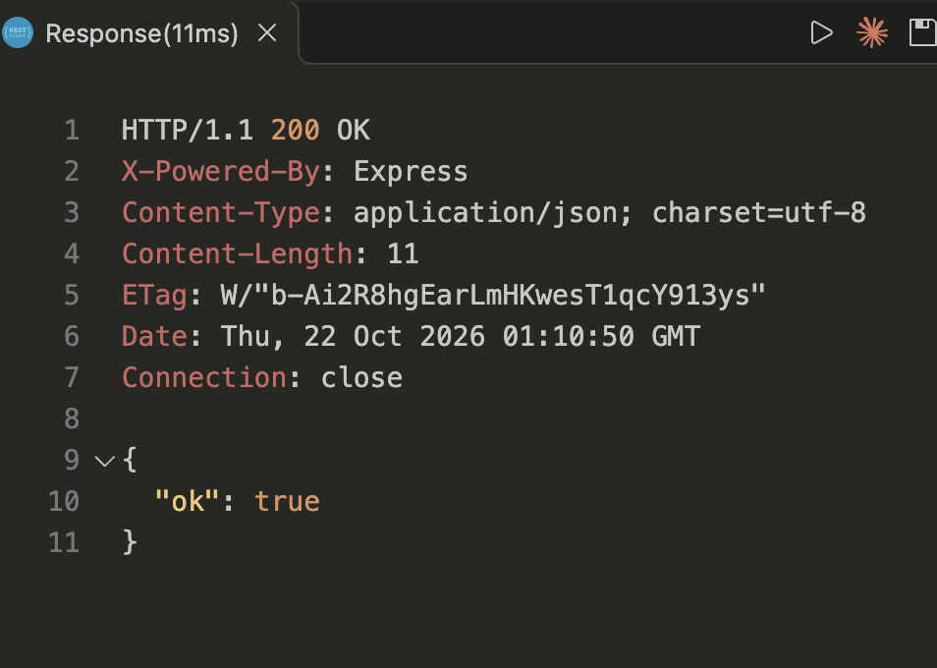

Q7
Atomicity means a set of steps either all happen or none of them happen. For example, in a bank transfer, taking money from one account and adding it to another must both succeed, or the money could be lost.
Q8
A transaction only works on one connection. If I use the pool directly, each query may use a different connection, so the rollback would not undo the earlier queries.

