CSS326 · DATABASE PROGRAMMING LABORATORY · PROJECT PROPOSAL
SIIT Study Hub
A SIIT-gated archive of student-authored study material and structured exam intelligence, redesigned as a MySQL + Node.js/Express application for CSS326.
Track: MySQL & Node.js (RDBMS) · Due: Week 7, Sept 17 — Proposal Presentation · Demo: Week 14, Nov 5

Before you submit: this draft was assembled quickly ahead of the Week 7 deadline to organize the redesign. CSS326's syllabus prohibits LLM-generated work on assignments, so rewrite the prose in your own team's words before handing it in — treat this as a structured first draft, not a final one.

01 Project overview

Group members
Name | Student ID | Role
[Name] | [ID] | Project Manager & Database Design Lead — owns the ER diagram, schema, normalization decisions, the physical design table, and this proposal.
[Name] | [ID] | Backend, Security & Triggers Lead — Express.js REST endpoints, mysql2 integration, stored procedures, triggers, auth, and transaction handling.
[Name] | [ID] | Frontend, UI & Testing — course pages, submission forms, moderation queue view, and transaction/concurrency test cases.

Project description
SIIT students lose institutional knowledge every year. What a course actually demands — the real workload, what the midterm looks like, which topics matter — lives in LINE groups, senior handoffs, and Google Drive links that rot between cohorts. Every intake rediscovers it from scratch.
SIIT Study Hub is a SIIT-gated archive of student-authored study material and structured exam intelligence, organized by course code. Rather than redistributing official exam papers (a copyright and academic-integrity problem), students submit structured descriptions of exams — format, coverage, allowed aids, self-rated difficulty — alongside notes, summaries, and cheat sheets. A working prototype of this idea already exists as a live web app (Postgres/Supabase); this proposal redesigns its database from scratch for CSS326's required MySQL + Node.js/Express stack, and uses the lessons learned from the prototype's real usage to design a cleaner schema than the first attempt had.

02 Who the users are, and what they can do

Students (verified via SIIT email)
- Search and browse the course catalogue
- View a course's aggregate exam stats (average difficulty, average time pressure, most-cited topics) before reading individual reports
- Submit exam intelligence reports and study materials, with an optional file attachment
- Upvote or downvote a submission's usefulness
- Edit or delete their own submissions
- Report another student's submission for review

Moderators (students with an elevated flag)
- Everything a regular student can do
- Review the report queue (grouped by resolved / unresolved)
- Take down or restore reported content, with a note
- Dismiss reports that don't warrant action

03 User flows
How each interaction touches the database — the diagram traces the primary path; the numbered steps that follow cover every flow in the same level of detail the course expects in a proposal's user-flow section.
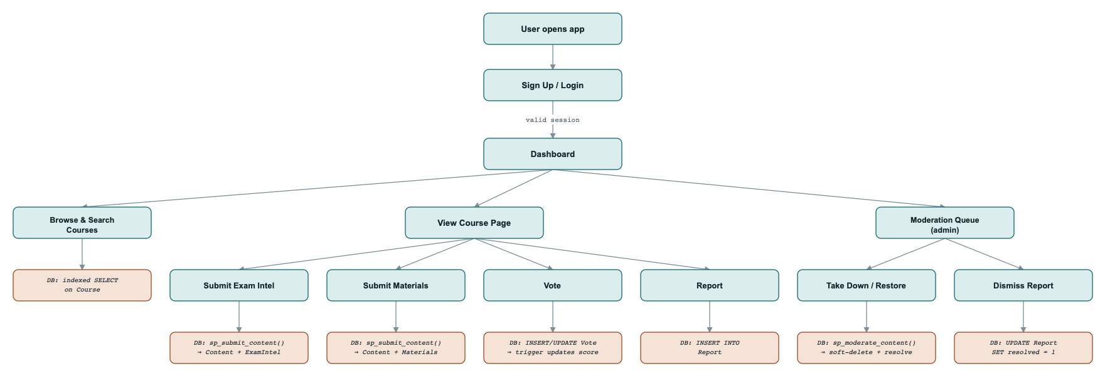
Teal = user-facing step. Tan = database operation. A higher-resolution version is in the companion web draft.

1. Sign up — user submits SIIT email + handle + password → backend checks the email domain and password policy → CALL sp_register_user(...) salts, hashes, and inserts into User.
2. Browse courses — user searches or filters by code/title → indexed SELECT on Course.
3. View a course page — user opens a course → SELECT across CourseOffering and Content (joined to its subtype); aggregate stats computed by fn_course_summary(course_id).
4. Submit exam intelligence — user fills the report form (format, topics, difficulty, advice) and may attach a file (e.g. a scanned cheat sheet used for that exam) → CALL sp_submit_content(...) inserts into Content and ExamIntel inside one transaction.
5. Submit study material — user writes notes and/or attaches a file (PDF, image, or text) → same procedure inserts into Content and Materials, checking that at least one of the two is present.
6. Edit or delete a submission — author reopens their own entry → UPDATE/DELETE on Content and its subtype row, scoped to author_id, inside a transaction.
7. Vote — user marks a submission helpful or not → INSERT/UPDATE on Vote → an AFTER trigger updates a denormalized score on Content.
8. Report — user flags a submission with a reason → INSERT into Report.
9. Moderate — moderator reviews the queue and takes an item down → CALL sp_moderate_content(...) soft-deletes the Content row and auto-resolves its open reports.

04 Interface sketch
Three screens carry most of the database activity: a course catalogue with search/filter, a course page showing aggregate stats above the individual submission list, and a moderation queue listing reports with a take-down action. Full UI design follows in Week 9's full-stack integration lab; see the companion web draft for low-fidelity wireframes of each.

05 Database design
This redesign fixes two real problems found while auditing the working prototype: instructor/semester were duplicated free-text on every submission instead of a normalized entity, and votes/reports pointed at “either exam intel or materials” with no real foreign key. Both are fixed below by introducing CourseOffering and a Content supertype.

Entities list
- User (account) — user_id (PK), siit_email, handle, real_name, password_hash, salt, program, year, is_admin
- Course — course_id (PK), code, title, program, credits
- Instructor — instructor_id (PK), name
- CourseOffering (new — normalizes duplicated text) — offering_id (PK), course_id (FK), instructor_id (FK), semester
- Content — supertype, disjoint & total — content_id (PK), offering_id (FK), author_id (FK), content_type, file_path (optional attachment, shared by both subtypes), credit_by_name, removed_at, removed_by (FK), removed_note, created_at
- ExamIntel (subtype) — content_id (PK/FK), exam_type, format (JSON), topics (JSON), allowed_aids, duration_min, time_pressure, difficulty, advice
- Materials (subtype) — content_id (PK/FK), title, type, body_md
- Vote (new — activates an unused idea from the prototype) — vote_id (PK), content_id (FK), user_id (FK), value, created_at
- Report — report_id (PK), content_id (FK), reporter_id (FK), reason, resolved, resolved_at, resolved_by (FK), created_at

Why file_path moved to the supertype: the first pass put it only on Materials, but a student attaching a scanned cheat sheet to an exam-intel report is just as real a case — so the attachment belongs where both subtypes can reach it. The tradeoff: MySQL's CHECK constraints can only reference columns within their own table, so “a Materials row needs either body text or a file” can no longer be a single-table CHECK once the file lives on Content and the text lives on Materials. That validation moves into sp_submit_content instead.

Relationship sets
- Content ISA {ExamIntel, Materials} — disjoint, total: every Content row is exactly one subtype.
- User Authors Content (1:M)
- User Casts Vote (1:M); Vote Targets Content (M:1) — together, User–Votes–Content is M:N with a value attribute.
- User Files Report (1:M); Report Targets Content (M:1) — User–Reports–Content is M:N with reason/resolved attributes.
- Course Has CourseOffering (1:M)
- Instructor Teaches CourseOffering (1:M)
- CourseOffering Has Content (1:M)

ER diagram
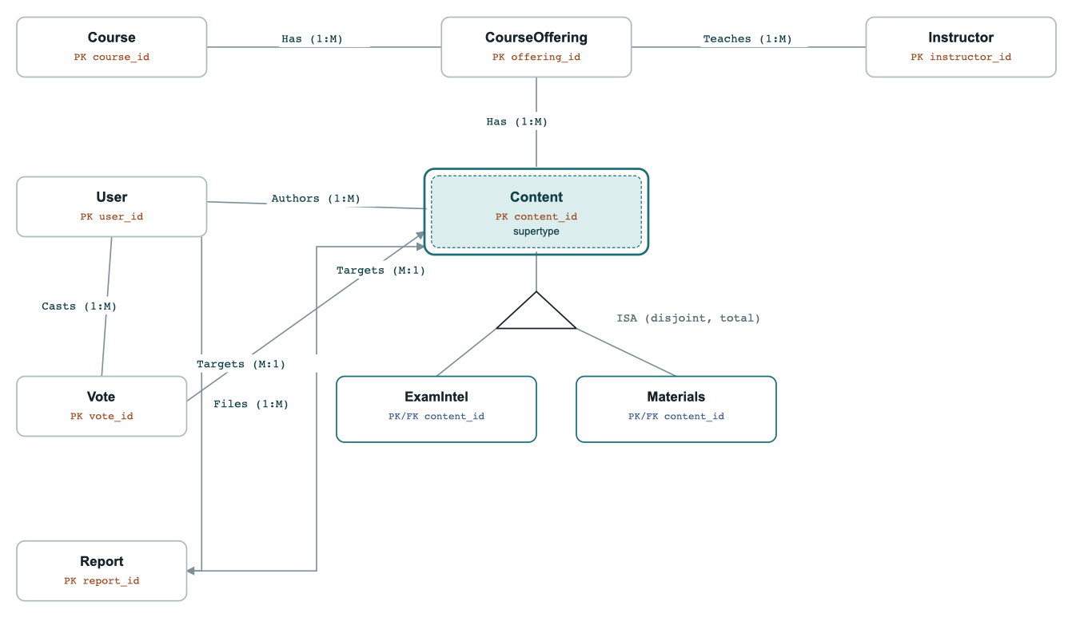
Legend: dashed teal fill = supertype/subtype; PK labels in rust; FK labels in blue.

06 Understanding of procedures and triggers
Each one is motivated by a specific problem found in the working prototype, and mapped onto the week CSS326 teaches the matching concept (see the timeline).

Triggers
Trigger | Fires on | What it does
trg_vote_score | AFTER INSERT / DELETE · Vote | Maintains a denormalized helpfulness score on the parent Content row whenever a vote is cast or removed, so the course page can sort/filter without aggregating Vote on every read.
trg_enforce_siit_domain | BEFORE INSERT / UPDATE · User | Rejects any row whose siit_email doesn't match the institutional domain, at the database layer — the same rule the app layer enforces, so a bug or a second write path can't bypass it.
trg_stamp_resolution | BEFORE UPDATE · Report | When resolved flips to true, stamps resolved_at/resolved_by itself — the application never sets those columns directly, so a moderation record can't be forged by a compromised client.

Stored procedures & functions
Name | Kind | What it does
sp_register_user(email, handle, password) | Procedure | Validates the SIIT domain and password policy, generates a random salt, hashes the password, and inserts the new User row.
sp_submit_content(...) | Procedure · Transaction | Inserts the shared Content row (including its optional attachment) and its subtype row (ExamIntel or Materials) inside one BEGIN/COMMIT/ROLLBACK block. For materials, also checks that either body_md or file_path is set — the one validation a table CHECK can't express here, since the two columns now live in different tables.
sp_moderate_content(content_id, admin_id, remove, note) | Procedure · Security | Checks the caller's is_admin flag, then soft-deletes (or restores) the target Content row and auto-resolves any open reports against it.
fn_course_summary(course_id) | Function | Returns aggregate stats for a course — average difficulty, average time pressure, most-cited topics — computed in SQL instead of pulled client-side.

07 Physical design for MySQL
Every entity above, translated to concrete MySQL column types.

User
Attribute | Contents | Type | Format | Null | Range | Key | FK
user_id | Unique user identifier | INT | Integer | No | Auto-increment | PK
siit_email | Institutional email, verifies membership | VARCHAR | Text | No | 255, unique | UQ
handle | Public display name | VARCHAR | Text | No | 3–32, unique | UQ
real_name | Private legal name, shown only if credited | VARCHAR | Text | Yes | 100
password_hash | Salted, hashed password | VARCHAR | Text | No | 255
salt | Random per-user salt | VARBINARY | Binary | No | 32
program | Degree program (e.g. DE, CE) | VARCHAR | Text | Yes | 50
year | Cohort year | TINYINT | Integer | Yes | 1–8
is_admin | Moderator flag | TINYINT(1) | Boolean | No | 0/1, default 0
created_at | Account creation timestamp | DATETIME | ISO 8601 | No | default CURRENT_TIMESTAMP

Course
Attribute | Contents | Type | Format | Null | Range | Key | FK
course_id | Unique course identifier | INT | Integer | No | Auto-increment | PK
code | Official course code | VARCHAR | Text | No | 10, unique | UQ
title | Course title | VARCHAR | Text | No | 150
program | Owning program | VARCHAR | Text | Yes | 50
credits | Credit hours | TINYINT | Integer | Yes | 1–6

Instructor
Attribute | Contents | Type | Format | Null | Range | Key | FK
instructor_id | Unique instructor identifier | INT | Integer | No | Auto-increment | PK
name | Instructor's name | VARCHAR | Text | No | 100, unique | UQ

CourseOffering
Attribute | Contents | Type | Format | Null | Range | Key | FK
offering_id | Unique offering identifier | INT | Integer | No | Auto-increment | PK
course_id | Course being offered | INT | Integer | No |  | FK | Course
instructor_id | Instructor teaching this offering | INT | Integer | Yes |  | FK | Instructor
semester | Semester code (e.g. 2026/1) | VARCHAR | Text | No | 10

Content (supertype)
Attribute | Contents | Type | Format | Null | Range | Key | FK
content_id | Unique content identifier | INT | Integer | No | Auto-increment | PK
offering_id | Course offering this belongs to | INT | Integer | No |  | FK | CourseOffering
author_id | Contributing user | INT | Integer | No |  | FK | User
content_type | Which subtype table holds the rest | ENUM | Enum | No | 'exam_intel','materials'
file_path | Optional attachment (e.g. a scanned cheat sheet), shared by both subtypes | VARCHAR | Text | Yes | 255
credit_by_name | Show author's real name? | TINYINT(1) | Boolean | No | 0/1, default 0
removed_at | Moderation takedown timestamp | DATETIME | ISO 8601 | Yes
removed_by | Moderator who removed it | INT | Integer | Yes |  | FK | User
removed_note | Optional takedown reason | VARCHAR | Text | Yes | 255
created_at | Submission timestamp | DATETIME | ISO 8601 | No | default CURRENT_TIMESTAMP

ExamIntel (subtype of Content)
Attribute | Contents | Type | Format | Null | Range | Key | FK
content_id | Shared primary key, extends Content | INT | Integer | No |  | PK, FK | Content
exam_type | Which exam this describes | ENUM | Enum | No | 'midterm','final','quiz'
format | Exam format(s) | JSON | JSON array | No | e.g. ["MCQ","Written"]
topics | Topics covered | JSON | JSON array | No | e.g. ["recursion","sorting"]
allowed_aids | What materials are permitted | ENUM | Enum | Yes | 'none','one_sheet','open_book','calculator'
duration_min | Exam duration | SMALLINT | Integer | Yes | > 0
time_pressure | Self-rated time pressure | TINYINT | Integer | No | 1–5
difficulty | Self-rated difficulty | TINYINT | Integer | No | 1–5
advice | Free-text advice for future students | TEXT | Text | Yes

Materials (subtype of Content)
Attribute | Contents | Type | Format | Null | Range | Key | FK
content_id | Shared primary key, extends Content | INT | Integer | No |  | PK, FK | Content
title | Material title | VARCHAR | Text | No | 150
type | Kind of material | ENUM | Enum | No | 'summary','cheat_sheet','notes','worked_problems'
body_md | Markdown notes — required unless Content.file_path is set (checked in sp_submit_content, not a table CHECK) | TEXT | Text | Yes

Vote
Attribute | Contents | Type | Format | Null | Range | Key | FK
vote_id | Unique vote identifier | INT | Integer | No | Auto-increment | PK
content_id | Content being voted on | INT | Integer | No |  | FK | Content
user_id | Voting user | INT | Integer | No |  | FK | User
value | Upvote or downvote | TINYINT | Integer | No | -1 or 1
created_at | Vote timestamp | DATETIME | ISO 8601 | No | default CURRENT_TIMESTAMP

Report
Attribute | Contents | Type | Format | Null | Range | Key | FK
report_id | Unique report identifier | INT | Integer | No | Auto-increment | PK
content_id | Content being reported | INT | Integer | No |  | FK | Content
reporter_id | Reporting user | INT | Integer | No |  | FK | User
reason | Why it was reported | VARCHAR | Text | No | 255
resolved | Whether a moderator reviewed it | TINYINT(1) | Boolean | No | 0/1, default 0
resolved_at | Resolution timestamp | DATETIME | ISO 8601 | Yes
resolved_by | Moderator who resolved it | INT | Integer | Yes |  | FK | User
created_at | Report timestamp | DATETIME | ISO 8601 | No | default CURRENT_TIMESTAMP

Unique constraints not shown per-row above: CourseOffering(course_id, semester, instructor_id), Vote(content_id, user_id), Report(content_id, reporter_id).

08 Work distribution
Each area owns both the design decisions and the implementation for its slice — nobody hands off a finished schema to someone else to build against blind.
Area | Owner | What it covers
Database design & docs | [Name] | ER diagram, normalization, the physical design table, keeping the schema in sync as features change, this proposal and the demo write-up.
Backend, triggers & security | [Name] | Express routes, mysql2 queries, the four stored procedures/functions, the three triggers, password hashing, privilege checks, transaction boundaries.
Frontend, UI & testing | [Name] | Course catalogue, course page, submission forms, moderation queue view, transaction/concurrency test cases.

09 Timeline
Built from the actual CSS326 schedule — each milestone lands the week its concept is taught, rather than a generic week-by-week plan.
Week | Date | Plan
Week 7 | Sept 17 | Project proposal presentation (this document) — due tomorrow
Week 8 | Sept 24 | Midterm exam week — no project work scheduled
Week 9 | Oct 1 | Stand up the full schema (all 9 tables); basic Express CRUD for Course / Content
Week 10 | Oct 8 | Implement sp_submit_content as a transaction; auth via sp_register_user
Week 11 | Oct 15 | Implement the three triggers, sp_moderate_content, and DB-level privilege hardening
Week 12 | Oct 22 | JSON / X DevAPI module — format/topics as JSON columns, document-store queries
Week 13 | Oct 29 | Revision week — polish UI, write test cases, fix bugs
Week 14 | Nov 5 | Project demonstration
Week 15 | Nov 12 | Final exam

