Project BMDC 2023 – Nóra – Erik

Models:

Drink order:

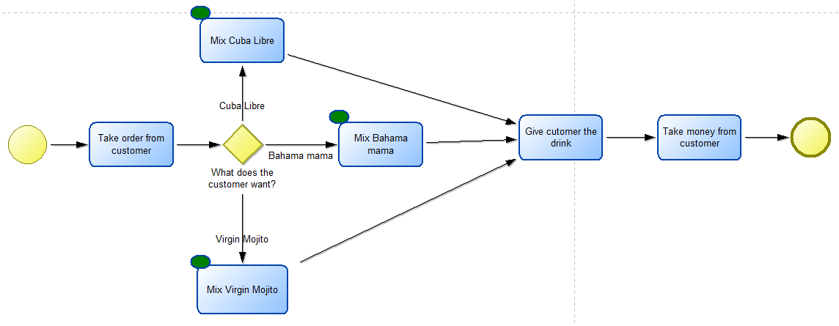

Cuba Libre:

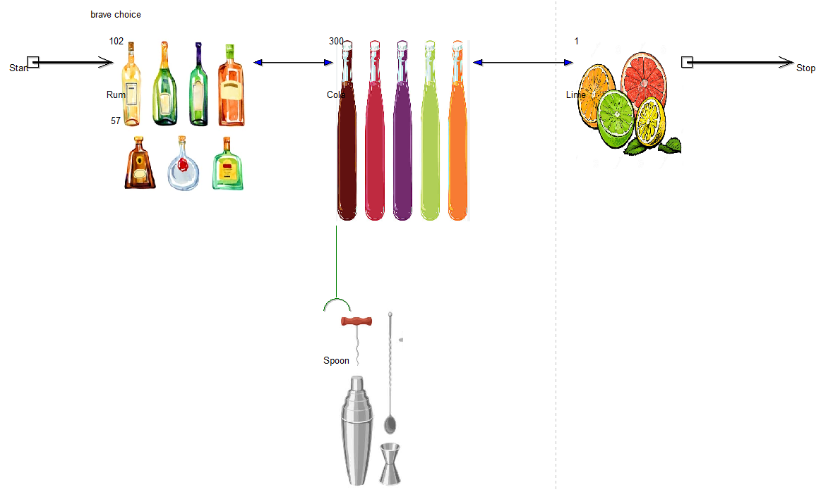

Bahama mama:

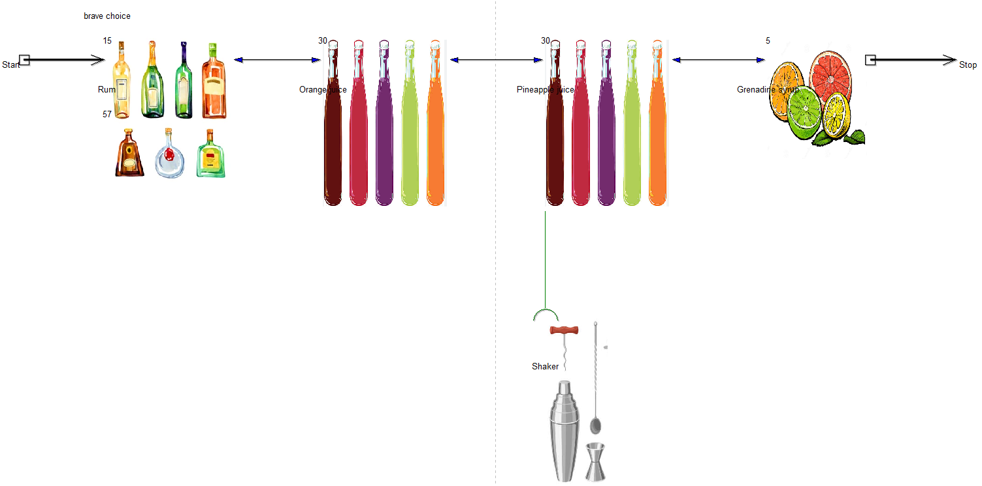

Virgin mojito:

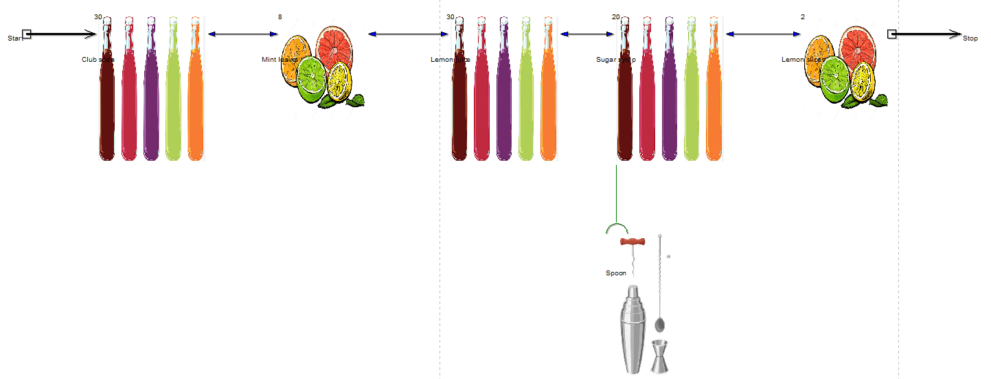

Metamodel:

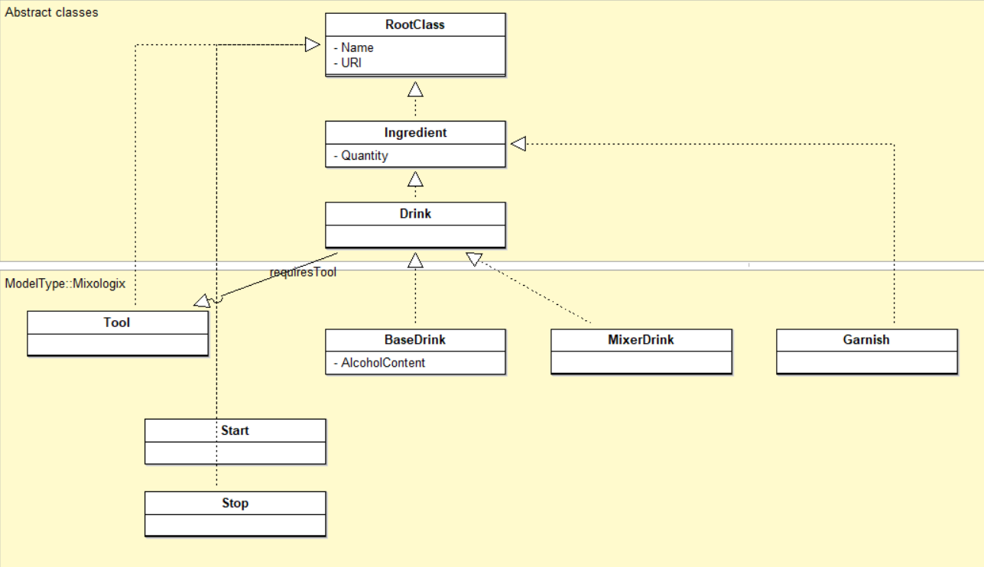

Queries:

Path query with minimum 3 slashes:

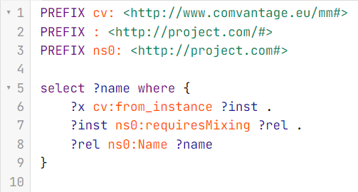

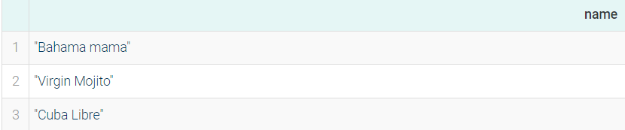

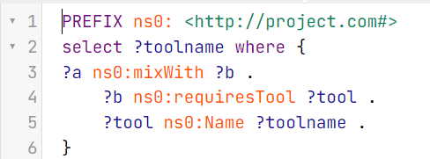

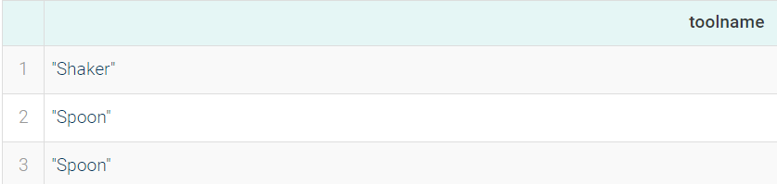

Query with OPTIONAL:

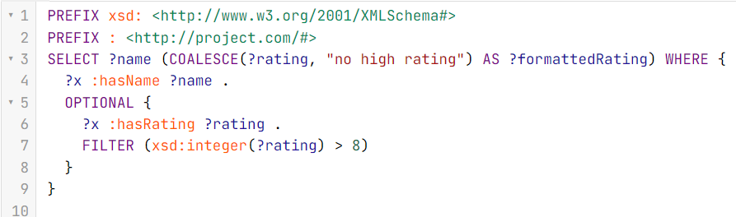

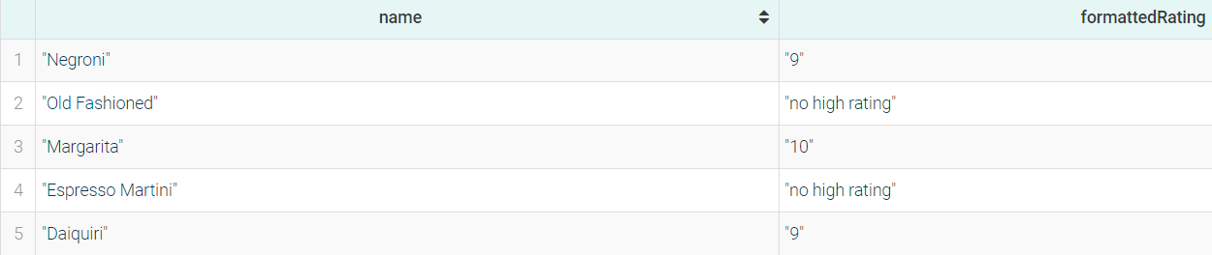

Reasoning query:

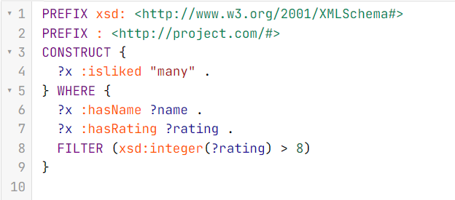

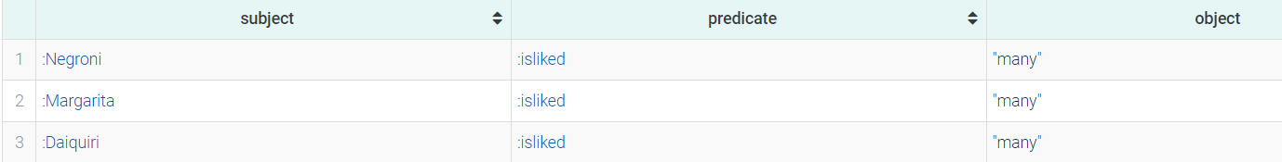

Query that uses the Lucene connector:

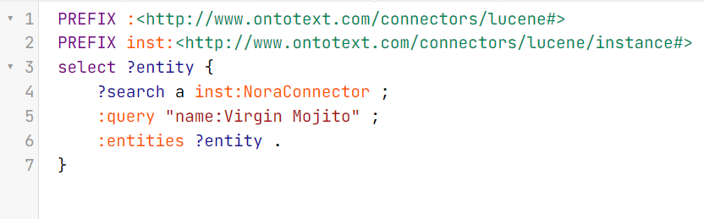

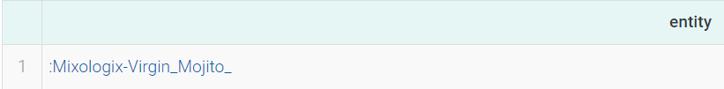

Query that uses the external data imported via OntoRefine:

