**Company analysis**

**Case Study 3**

**Chocompany**

**accomplished at the Business Informatics study program**

**of the University of Applied Sciences Technikum**

**Version 1.0**

**Project manager: Patrick Homm**

**Project team: Andreas Burger, Leonardo Fisic, Martin Wollner**

**Date: 2013-09-19**



**Important remark on the comments within this document:**

You will find additional information on the topics project management, business process modeling, software engineering and programming. These comments are held in red letters and can be seen as basic information on the single topics. ***You can remove these comments after you have finished the specific section in the project documentation!***

Moreover, you should be aware that the project documentation is not a static document but may change throughout the project phases. ***Please take into consideration that changes in a certain section may require to update other parts of the documentation as well!***

***A up-to-date project documentation is the key to a successful project…***

*The following literature has been used for creating this template:*

*ALLWEYER, T., 2005. Geschäftsprozessmanagement-Strategie, Entwurf, Implementierung, Controlling. Bochum: W3L-Verlag, Herdecke.*

*BEA et al., 2008. Projektmanagement. Stuttgart: Lucius & Lucius Verlag.*

*IDS SCHEER, 2006. ARIS Expert Paper -**Vom Geschäftsprozess zum Anwendungssystem. [Online] Verfügbar bei:*

*http://www.aris-user.de/download/ARIS_Expert_Paper_MDA_Andres_2006-05_de.pdf [Zugang am 12. April 2011].*

*GADATSCH, A., 2010. Grundkurs Geschäftsprozess-Management. Wien: Vieweg+Teubner GWV Fachverlage.*

*HARRANT, H. & HEMMRICH, A., 2004. Risikomanagement in Projekten. München, Wien: Carl Hanser Verlag.*

*GAREIS, R., 2006. Happy Projects. Wien: Manz Verlag.*

*REIS, M. & REIS,G., 2009. Praxisbuch IT-Dokumentation. München, Addison-Wesley Verlag.*

*WINKELHOFER, G., 2005. Management- und Projekt-Methoden. Berlin: Springer Verlag.*

Change Log

|  |  |  |  |
| --- | --- | --- | --- |
| **Version number** | **Date** | **Change** | **Person** |
| 1.0 | 2013-09-19 | creation | Andreas Burger |
|  |  |  |  |
|  |  |  |  |
|  |  |  |  |
|  |  |  |  |
|  |  |  |  |
|  |  |  |  |
|  |  |  |  |
|  |  |  |  |
|  |  |  |  |
|  |  |  |  |
|  |  |  |  |
|  |  |  |  |

Table 1: Change log

|  |  |  |
| --- | --- | --- |
| **Legend** | | |
| **State** | **W**  **R**  **F** | In work  In review  Released, freed version |
| **Versioning** | **0.1, 0.2**  **1.0**  **1.1, 1.2**  **2.0** | Not approved version  First released version  Extended first version  Second released version |

***Information: Enter the document history and the current state. Pay attention to the regular data maintenance. Use the above table “Legend” for the right description.***

Contact Persons

|  |  |  |  |  |
| --- | --- | --- | --- | --- |
| **Name** | **Organizational unit** | **Project role** | **Telephone** | **e-mail** |
| Vince Masuka |  | Ordering costumer | 01/12345678 | [vince.masuka@chocolate-heros.uk](mailto:vince.masuka@chocolate-heros.uk) |
| Patrick Homm |  | Project Manager | 01/12345678 | [patrick.homm@technikum-wien.at](mailto:patrick.homm@technikum-wien.at) |
| Andreas Burger |  | Project Member | 01/12345678 | [andreas.burger@technikum-wien.at](mailto:andreas.burger@technikum-wien.at) |
| Leonardo Fisic |  | Project Member | 01/12345678 | [leonardo.fisic@technikum-wien.at](mailto:leonardo.fisic@technikum-wien.at) |
| Martin Wollner |  | Project Member | 01/12345678 | martin.wollner@technikum-wien.at |
|  |  |  |  |  |
|  |  |  |  |  |
|  |  |  |  |  |
|  |  |  |  |  |
|  |  |  |  |  |
|  |  |  |  |  |
|  |  |  |  |  |
|  |  |  |  |  |
|  |  |  |  |  |
|  |  |  |  |  |

Table 2: Contact persons

***Information: Enter the contact persons with all necessary data. Pay attention to the regular data maintenance. Use the table above for the right description.***

# Company Description

**Table of Content**

Company Description 5

1 Introduction 6

2 Organigram 7

3 Value Added Chain Diagram 8

4 Process Description 9

4.1 Process Characteristics 9

4.2 Business Process Model and Notation (BPMN) Diagram 11

5 Figures 12

6 Tables 12

7 Glossary 12

# Introduction

Chocompany is an Austrian GmbH that offers all kind of chocolate products. It was founded by Vince Masuka in 2011. A first shop was opened in Vienna with 3 employees. With the idea to sell their own produced chocolate the company grew steadily and has now (2013) 13 employees in 5 departments (HR, distribution, marketing, purchasing, manifactoring).

The company wants to become famous with the web-based Chocoladitor. This is a software-system which give the customers the possibilty to design their own chocolate variations.

# Organigram

***Information: Create a organizational chart. A organizational chart of the organizational structure represents the system of the organizational units. It illustrates the task structuring (decomposing a complex task in subtasks) or rather the structure of the offices and departments (often pyramidal illustration) as well as the communication relationships between the organizational units. (economic glossary Gabler) The modeling of the organizaitonal structure supports the process modeling by summarizing homogenous and similar tasks in an organizational unit, which, in the context of process support, are involved as deparments, offices or persons.***

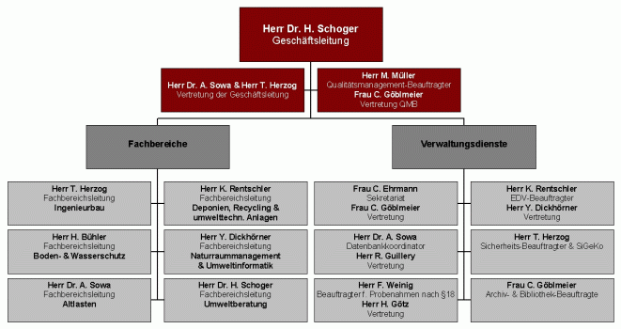

Figure 4: Organigramm of Chocompany

# Value Added Chain Diagram

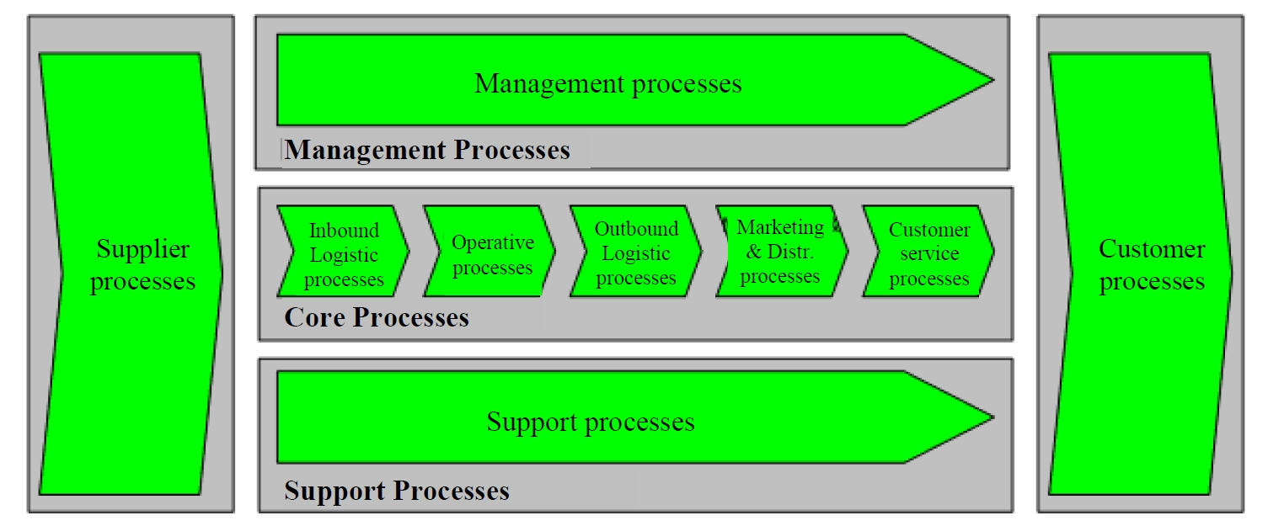

Figure 5: Value added chain diagram (VACD)

***Information: The value added chain diagram (VCD) points out the strategical importance of operational functions. The structure contains primary activities, which are involved in the creation and usage of operational output, and secondary activities, which have supporting character. Primary activities (primary process, core process) have a direct reference to product/output of the company. Typical are marketing, sales, logistics and customer service. Secondary activities (secondary processes, support processes) have no direct reference to product/output, nevertheless the primary processes could not be executed without the secondary processes. Examples are: human resources management (HR management), IT, accounting, etc. Also the management processes are displayed. For example the strategic planning, the financial planning and controlling, as well as the design of the process organization and structural organization, are part of them. The illustration of a process landscape of a company, with the help of the VCDs, enables the entrance in the process organization in a high level.***

# Process Description

## Process Characteristics

|  |  |
| --- | --- |
| **process name** | Order process |
| ***process id*** | 2.1 |
| **process description and purpose** | In this process the complete order process is defined. Starting with the customer input to the delivering of the ordered product(s). This process is the most important process in our company because we earn the mostly income with it. |
| **process owner** | Distribution department |
| **process input / process trigger** | The customer filled the cart and klicks wants to place an order. The input is the data of the costumer and the ordered products. |
| **process output / process outcome** | The ordered products are handed over to a shipping company |
| **first process step** | Checking availability of materials |
| **last process step** | Costumer is informed by mail about shipped products |
| **previous process** | Costumer registration |
| **following process** | - |
| **Interface to other processes** | - |

Table 3: Process Characteristics Order process

|  |  |
| --- | --- |
| **process name** | Administrate chocolate ingredients |
| ***process id*** | 2.2 |
| **process description and purpose** | This process describes how the chocolate ingredients are administrated by purchasing department. This process make sure that there are only products in the Chocoladitor that are in stock. Some new, groovy ingredients can be chosen by the customer. |
| **process owner** | Purchasing department |
| **process input / process trigger** | The process has to be started every day |
| **process output / process outcome** | All ingredients in stock are available in Chocoladitor |
| **first process step** | Check storage to determine all stored ingredients |
| **last process step** | Publish new ingredients to Chocoladitor |
| **previous process** | - |
| **following process** | - |
| **Interface to other processes** | Chocoladitor |

Table 4: Process Characteristics Order process

|  |  |
| --- | --- |
| **process name** | Produce new chocolate |
| ***process id*** | 2.3 |
| **process description and purpose** | This process describes how the chocolate ingredients are administrated by purchasing department. This process make sure that there are only products in the Chocoladitor that are in stock. Some new, groovy ingredients can be chosen by the customer. |
| **process owner** | Manufactoring department |
| **process input / process trigger** | A customer created a new chocolate variation and placed an order |
| **process output / process outcome** | The new chocolate is available |
| **first process step** | Get all ingredients from stock |
| **last process step** | New Chocolate is ready for sale |
| **previous process** | Order process |
| **following process** |  |
| **Interface to other processes** | Chocoladitor |

Table 5: Process Characteristics Order process

## Business Process Model and Notation (BPMN) Diagram

***Information: Describe here the necessary processes also in graphical form by means of BPMN Models. With it the activities or functions and their temporal-logical context, also labeled as control flow, are shown in an understandable way. The BPMN is a graphical modeling language for representing business processes of an organization in the course of business process modeling. In doing so it uses specific syntax rules, events and functions. Thus operational processes shall be systematized and parallelized. It is not only used for business process modeling in small and medium enterprises, but also for the evaluation and implementation of standard software, for the illustration of sequences by in-house development of software or as well to illustrate procedures in user trainings.***

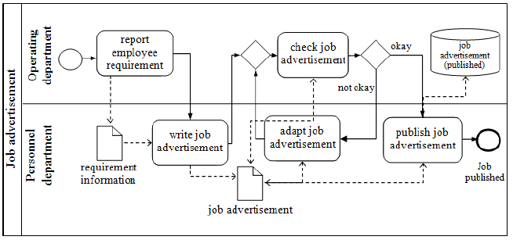

Figure 6: Sample of a BPMN diagram

# Figures

Figure 4: Example for an organigram 7

Figure 5: Value added chain diagram (VACD) 8

Figure 6: Sample of a BPMN diagram 11

# Tables

Table 1: Change log 3

Table 2: Contact persons 4

Table 3: Process Characteristics Order process 9

Table 4: Process Characteristics Order process 10

Table 5: Process Characteristics Order process 10

# Glossary

|  |  |  |
| --- | --- | --- |
| **Key concept or abbreviation** | **Explanation** | **Additional Information** |
|  |  |  |
|  |  |  |
|  |  |  |
|  |  |  |
|  |  |  |
|  |  |  |
|  |  |  |