Tipping points in diversified farming systems

2021-03-23

The emergence and impact of tipping points are of great interest in both social and ecological research. Despite widespread recognition of the importance of feedbacks between human and environmental systems, it is often assumed that observed nonlinear dynamics in these coupled systems are the result of dynamics in either the underlying human or environmental processes. Using the adoption of diversified farming practices as a case study, we show how bistability in ecosystem states and corresponding ecosystem services can emerge purely from the temporal feedbacks between human decisions and ecological responses. We leverage interview data to inform a stylized model, and show how understanding the temporal mechanisms of tipping points in social-environmental systems is critical to designing effective policy interventions in sustainable agriculture.

# Introduction

Both ecosystems and social systems can change states abruptly as the result of crossing critical thresholds. These critical thresholds (tipping points), or states of a system were small perturbations can trigger large responses, have garnered extensive academic and public attention (Gladwell (2006); Rockström et al. (2009)). Theories of ecological multistability have long described tipping points (Beisner, Haydon, and Cuddington (2003); Scheffer et al. (2001)) and explored how management impacts stability landscapes of social ecologica systems (Horan, Fenichel, Drury, et al. (2011a)). Tipping points in natural systems are generally assumed to stem from complex ecological processes like population dynamics and species interactions (Dai et al. (2012); Mumby, Hastings, and Edwards (2007); Scheffer (2010)). Similarly, examples of tipping points in social systems, ranging from the collapse of civilizations (Downey, Haas, and Shennan (2016)) to the spread of innovations through social network processes (Redmond (2003)) suggest that observed nonlinearities in social systems can result from complex features of human decisions and economic structures (J. Vandermeer (1997a)).

In social-ecological systems (SES), human actions impact ecological processes and the resultant ecological changes create feedbacks that alter the scope and efficacy of future management actions (Liu et al. (2007); Ostrom (2009); Walker et al. (2004)). These coupled systems become increasingly complex when the dynamics of ecological processes do not align with the temporal scale of human decision-making (Cumming, Cumming, and Redman (2006)). For example, in agricultural systems ecological responses to management actions such as composting happen slowly, taking years to return ecological benefits equal to investments (CITE). Techniques previously used to investigate both dynamic ecological processes and decision-making in SES have largely overlooked the temporal complexity of decision-making (Lippe et al. (2019)). For example, agent based models often use single time-step, or user defined, decision rules rather than allowing for emergent decision strategies that maximize expected rewards over longer time horizons (Lippe et al. (2019)). Similarly, exploring both the time horizon of decisions and gradual response of ecological processes is impossible using methods that rely on equilibrium analyses, such as dynamic equations.

While variations of models have been used to explain and explore tipping points in numerous SES, from coral reefs to climate, (Holbrook et al. (2016);Lenton et al. (2008)), we focus here on agricultural systems. Agriculture is a fundamental driver of anthropogenic ecological change (Foley et al. (2005); Foley et al. (2011); Stoate et al. (2009)) and its productivity is closely intertwined with ecosystem processes that provide valuable ecosystem services. While adoption of sustainable farm management practices undoubtedly encompasses a continuum of actions and outcomes, suites of practices are often used together in a package, coalescing around distinct stable states or “syndromes” (Andow and Hidaka (1989); Ong and Liao (2020); J. Vandermeer (1997a)). However, explainations of these patterns face the aformentioned issues. The mechanisms used to explain bistable patterns in production systems to-date have relied on the assumption that both ecological (or production) and decision (or economic) dynamics are non-monotonic. If either of these systems is approximated as monotonic, the larger social environmental system is characterized by a single stable point (or no stable point), making alternative syndromes of production impossible to explain with dynamic equations (J. Vandermeer (1997a); J. Vandermeer and Perfecto (2012)). While non-monotonic assumptions are often reasonable (CITE), these equilibrium explanations overlook the temporal component of both the ecological and decision processes central to agricultural SES.

This paper presents a stylized model of the adoption of diversified agricultural practices, or practices that bolster ecosystem services by promoting beneficial agrobiodiversity (Kremen, Iles, and Bacon (2012)), to explore the ecosystem service patterns that result specifically from interactions between adaptive decision-making and an ever-changing environment. We explore a mechanism for bistability, or two prevailing environmental (ecosystem service) states, that is the result not of complex structural assumptions within either the human or ecological system, but rather the rates at which the two systems interact. While our model necessarily simplifies both decision-making and environmental processes, it provides a framework to explore emergent properties in social-ecological systems. We inform important structural attributes of our model, and contextualize our findings, with interview data. Finally, we show that our findings have important implications for agricultural policy implementation and social-ecological systems theory.

# Methods

We explore the transition to and from diversified farming systems (low and high ecosystem service states) using a Markov Decision Process (MDP) in which a farmer makes a series of decisions about whether or not to employ diversified farming practices over time (Figure 1). In the context of diversified farming systems, diversification practices, such as the use of compost, crop rotation, intercrops, reduced tillage, and cover crops, are distinct from the concept of operational diversification (i.e., simply increasing the range of agricultural goods produced on a given farm). The model was developed through an iterative, collaborative process with an interdisciplinary team comprising plant and soil scientists, agricultural economists, ecologists, agricultural policy experts, social scientists, and farmers with the goal was to capture the core complexities stemming from the coupled human and natural dynamics of the modeled system.

## Interview data

[from Joanna – I think this should be in the main text, but you could also imagine it being in the supporting information. Thoughts?] From February 2018 - August 2020, we interviewed 25 lettuce growers and 17 almond growers from California using a snowball sampling method and referrals. We focused on the almonds and leafy greens/lettuce sectors because these are among the most valuable crops in California. We selected interviewees to represent a range of growers (small to large scale; organic to conventional, early adopters of diversification practices to late adopters/laggards, family run to corporate management, and direct-to-consumer marketing to wholesale). Interviews were conducted in person or over the phone in situations where in-person interviews were not possible due to farmer schedules or the need to social distance during COVID-19 restrictions. Most interviews were audio recorded and transcribed. If recording was not possible, careful notes were taken to create a transcript. We performed coding for key themes and keyword searches of the transcripts to inform key stuctural attributes of our model and provide quotes to contextulize findings.

## Conceptual model description

In our model at each time step the farmer takes an “action” of 0% to 100% percent investment in adopting or maintaining diversification practices. The “system state” corresponds to the level of benefit derived from the ecosystem services that result from those adoption decisions. While higher ecological states are beneficial, investments in diversification practices also come with higher associated costs (Figure 1 A1). Benefits may be financial, social, ideological, and/or aesthetic and we approximate that relationship as linear (Figure 1 A2). A greater percent investment in diversification practices corresponds to a greater probability of transitioning to a higher (more beneficial) ecological state in the next decision cycle (Figure 1 A3). The rate at which that ecological response response occures depends on parameter, r, but importantly is not instaneous (Figure 1 A4). By defining parameter values for cost, benefit, transition stochasticity, ecological change rate, and future discounting (Supporting information), we can allow the optimal action strategy for the agent (farmer) to emerge based on expected rewards over either a finite (to represent short-tenure leased farms) or infinite (to represent longer-term leases and land ownership) time horizon (Figure 1 A5).

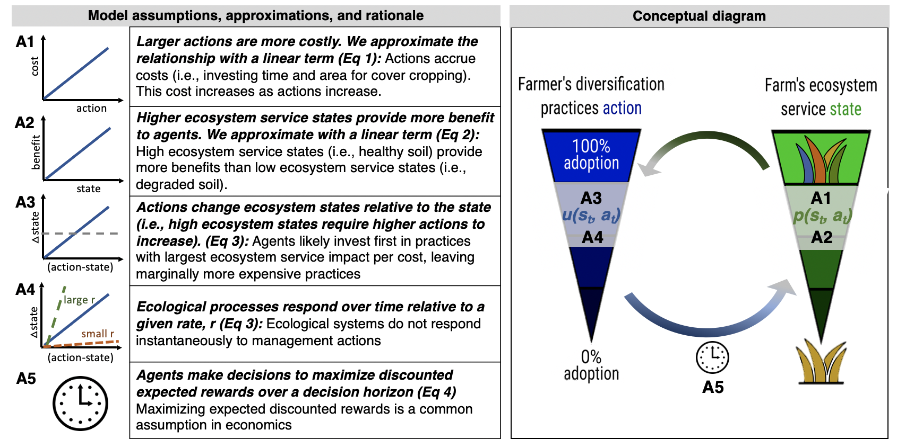

**Figure 1:** Conceptual diagram and model assumptions. The farmer’s choice of how much to invest (time and money) into the adoption of diversification practices (blue), and the resulting ecosystem services state (green), with a more diversified ecosystem state at the top, and a more simplified ecosystem state at bottom. Each time step, the farmer chooses the optimal action for their current ecosystem service state based on the perceived utility function, u, and state transition probability function, p. For a given ecosystem service state and action at time t, p describes how the ecosystem responds stochastically to result in an updated state at t + 1. The updated ecosystem service state then feeds back to influence the farmer’s future choices, leading to tradeoffs arising from the coupling of ecological processes with consecutive diversification practice adoption decisions over time. Main model assumptions (A1-A5) are outlined along with a brief rational for each approximation.

## Mathematical description

The farmer’s decision model can be expressed as

where is the set of available actions, the expected utility operator, the utility which the farmer associates with being in state and taking action at time , the myopic discount factor, and the land tenure of the farm ( if the farmer owns the land or has a long lease).

We assume a simple model of the farmer’s perceived utility as a function of the difference between the cost associated with diversification practice action , versus expected benefits derived from ecosystem state , at time , such that

The ecosystem state is also dynamic, evolving according to the transition probability function , such that

where . This provides a minimal state transition model in which the parameter sets the natural timescale at which the ecosystem can respond to changes in land mangement decisions, and defines the width of the state transition probability distribution, capturing the noise inherent to ecological system change. While we have assumed very basic transition and utility functions for this stylized model, in general more complicated nonlinear functions for both the ecosystem state transition and perceived utility are possible using this framework.

## Parameterization

We have parameterized the model to illustrate the emergence of bistability in SES resulting from agroecological investment decision-making given stochastic ecological responses over time (Figure 1 and Figure 2; Parameter values in Supporting information). We explore a larger parameter space in the supporting information, and explain why the choice of parameters does not change the main findings.

# Results

## Bistability in ecosystem services

Using the described model, we observe the behavior of agents’ sequential choices and the resultant environmental outcomes through time. The decision strategy, , describes the emergent optimal course of action for a given state and is the stationary optimal state-dependent decision strategy over an infinite time horizon (Figure 2A).

Agents’ initial ecosystem states were distributed normally around a mean of . We find that after following the optimal decision strategy (infinite horizon) for 20 decision cycles, agents have largely settled into two stable ecosystem states, with some farms transitioning to more simplified (lower levels of ecosystem services) farming systems, and others to more diversified (higher levels ecosystem services) systems (Figure 2B and 2C). Further, we find strong path dependency, with only 17% of agents who started in a simplified () state concluding in a diversified () state, and only 7% initially in the diversified state transitioning to a simplified state.

Initial ecosystem states are distributed normally (mean = 0.5; S.D. = 0.2; truncated at [0,1]). (A) Agents follow decision strategy \pi until t = 20. (B) Ecosystem state of each agent over time (500 simulations). (C) Initial ES distribution (dark blue) and final bimodal distribution at t = 20 (light blue).

**Figure 2:** Initial ecosystem states are distributed normally (mean = 0.5; S.D. = 0.2; truncated at [0,1]). (A) Agents follow decision strategy until . (B) Ecosystem state of each agent over time (500 simulations). (C) Initial ES distribution (dark blue) and final bimodal distribution at (light blue).

## Importance of temporal dynamics in coupled systems

Our baseline model shows how a simple coupling of human choices and ecological responses can result in bistable landscapes of high and low diversification practice adoption and, as a result, high and low levels of ecosystem services (Figure 2).

Figure 3A shows that with temporal human/environment interactions, there exists a region of cost/benefit ratio within which various bimodal ecosystem state distributions exist (this region is exemplified in Figure 2). By vary the time horizon of the decision process, the rate of the ecological response, and the cost/benefit ratio, we find that this tipping point disappears when the speed of response of either the ecological system or decision-making process overwhelms the coupling (a proxy for decoupling). When ecological processes become fast enough that the ecosystem responds almost immediately to farmer actions (), alternate stable states do not emerge, regardless of cost-benefit ratios (Figure 3C). Similarly, as decisions become temporally myopic (in this case, with a time horizon of 2 decision cycles), the potential for bistability in adoption trajectories disappears (Fig 3B). Only when both a gradually changing environment and a forward-looking decision-maker (i.e. a farmer who takes into account potential benefits over the long term) are coupled, do tipping point phenomena emerge in the decision strategy (and without non-monotonic assumptions), leading to two predominant ecosystem service states (Figure 3).

For three scenarios (coupled human/natural system, overly-myopic decision maker, and overly-fast ecological change), cost/benefit ratio was varied incrementally over 40 values, indicated by color shade, across a c:b range of width 0.15, encompassing the transition between a never invest'' to analways invest’’ policy. For each c:b, 500 replicate simulations were conducted as in Fig . Upper plots show distribution of ES state at t=20 for each c:b. Lower plots show density curve peak(s). (A) By coupling a forward-looking decision-maker and a slowly-adapting environment, complex dynamics like alternate stable states can emerge. However, with (B) a short-term decision strategy (solving the MDP over a 2-year time horizon), or (C) a fast ecological change rate (r = 0.95), no bimodality is observed.

**Figure 3:** For three scenarios (coupled human/natural system, short term decision strategies, and fast ecological change), cost/benefit ratio was varied incrementally over 40 values, indicated by color shade, across a range of width 0.15, encompassing the transition between a never invest'' to analways invest’’ policy. For each , 500 replicate simulations were conducted as in Fig . Upper plots show distribution of ES state at for each . Lower plots show density curve peak(s). (A) By coupling a forward-looking decision-maker and a slowly-adapting environment, complex dynamics like alternate stable states can emerge. However, with (B) a short-term decision strategy (solving the MDP over a 2-year time horizon), or (C) a fast ecological change rate (), no bimodality is observed.

## Implications for land tenure policy

While alternative mechanisms to explain a given phenomenom may seem inconsequntial to policy design, we show why this is not the case. Temporal factors were central themes emerging from our interview data about adoption patterns (Table 1), both the horizon on which decisions are made and the rate at which benefits accrue. Additionally, approximately 39% of U.S. farmland under lease, making the impact of land tenure on decision making is important for understanding agricultural management more broadly. For example, U.S. corn farmers who rent land are less likely than landowners to implement grassed waterways, strip cropping, contour farming, and conservation tillage (Soule, Tegene, and Wiebe (2000)).

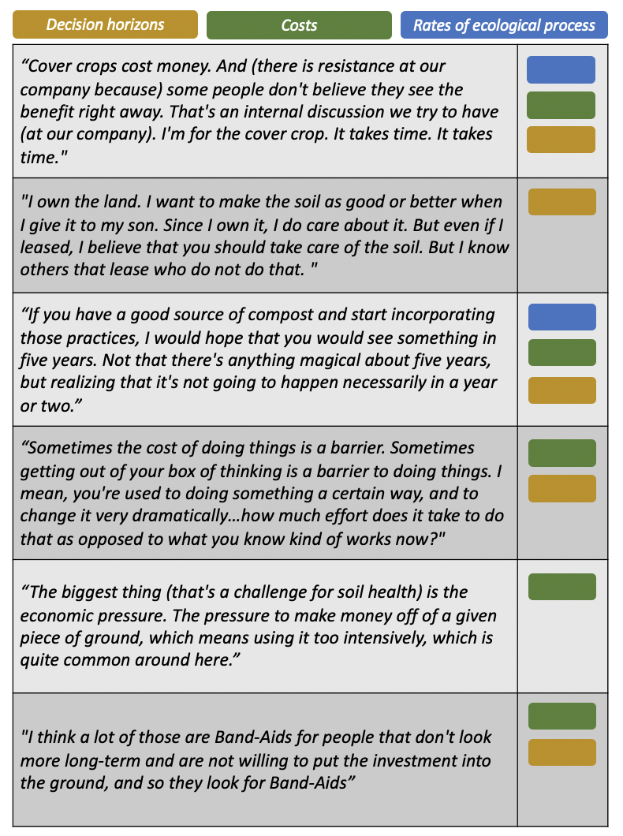

**Table 1:** Key quotes from farmers suggest that the temporal horizons of decision making and the rate at which farmers recieve ecosystem benefits as a result of those decisions are important factors in the adoption of diversification practices

In order to explore how the shorter horizon on which tenant farmers might make decisions might impact adoption patters, we solve the MDP on a constrained time horizon (20-decision cycles, in comparison to an infinite time horizon in Fig 2 (Fig 4B). Comparing the final state distribution of the long-tenure (baseline) versus the short-tenure model shows that, as a farmer’s expected land tenure duration decreases, it becomes optimal to reduce diversification adoption across a wider range of ecosystem states. This results in ecosystem state degradation even among farm sites with an initially high ecosystem service value, with 94% of farmers ending up in the simplified state at . It’s worth noting that land tenure itself does not necessarily define decision horizons, there are numerous factors (i.e. cultural, economic) that might also impact decision horizons.

The simulation is identical to that in Fig , but the MDP is solved under a finite, 20-year time horizon. (A) Result of short land tenure on ES state over time. (B) Comparison between final state distribution of short- vs. long-tenure model runs.

**Figure 4:** The simulation is identical to that in Fig 2 , but the MDP is solved under a finite, 20-year time horizon. (A) Result of short land tenure on ES state over time. (B) Comparison between final state distribution of short- vs. long-tenure model runs.

Starting from the same initial states as Fig , ES state timeseries are shown for (A) a large, abrupt incentive (100% of adoption expenses are covered for two years) vs. (B) a smaller, more sustained incentive (adoption cost is 80% of baseline for 10 years). Ignoring discounting, both packages have the same total cost to the funder (the equivalent of 2 years’ worth of full adoption cost offsets). After the incentive period, agents adjust their decision rules to that of the base case (i.e. no incentive) until t = 20. (C) Shows that the sustained incentive ultimately drove more DP adoption.

**Figure 5:** Starting from the same initial states as Fig , ES state timeseries are shown for (A) a large, abrupt incentive (100% of adoption expenses are covered for two years) vs. (B) a smaller, more sustained incentive (adoption cost is 80% of baseline for 10 years). Ignoring discounting, both packages have the same total cost to the funder (the equivalent of 2 years’ worth of full adoption cost offsets). After the incentive period, agents adjust their decision rules to that of the base case (i.e. no incentive) until . (C) Shows that the sustained incentive ultimately drove more DP adoption.

## Temporal dynamics and incentive structures

While the temporal horizon of land-use decisions impacts predicted and observed trajectories, incentives that shift cost-benefit structures influence management practices and have become an integral part of farming over the past half-century (Batáry et al. (2015); Graddy-Lovelace and Diamond (2017)). We explore the impact of incentive duration on the efficacy of policies to promote adoption of diversification practices by implementing two competing publicly funded incentive schemes: a short-term (two-time step) incentive which fully covers the cost of adoption, versus a longer-term (ten-time step) incentive which only partially offsets the adoption costs over those time steps. Formally, the cost of each incentive package is equal. Within the model, agents adapt their optimal decision strategy for the given cost-benefit ratio during the incentive period, and at its conclusion they revert to the baseline strategy (i.e. without payments).

We find longer, more sustained incentive programs to be more effective at encouraging adoption behavior over the critical threshold toward diversified farming (Fig 5). Once a farmer has crossed the viable ecosystem state threshold, it becomes less likely that they will return to simplified systems, even after incentives are removed. Because it takes a series of investment actions for the ecosystem service state to cross the investment threshold, longer-term incentives ultimately result in more diversification practice adoption.

# Discussion

Our analysis suggests a mechanism for bistability in social-ecological systems that is the result of temporal interactions between forward-looking decisions and ecological processes rather than complex structural assumptions about either system alone. While alternate stable states within social ecological systems, and farming systems in particular, have been previously explored and observed (Horan, Fenichel, Drury, et al. (2011b); J. Vandermeer (1997b); J. H. Vandermeer and Perfecto (2012)), our results shed light specifically on temporal feedbacks that might contribute to this pattern (Figure 6). We show how this mechanism provides novel insights not only for social-ecological research (Figure 3), but also for agricultural policy (Fig 4 and Fig 5).

In contrast to equilibrium models (J. H. Vandermeer and Perfecto (2012)), our model assumptions (Figure 1) reflect the delay between adopting a diversified practice and seeing the benefits. This reality is supported by our interviews with farmers. One farmer explains:

“Cover crops cost money. And (there is resistance at our company because) some people don’t believe they see the benefit right away. That’s an internal discussion we try to have (at our company). I’m for the cover crop. It takes time. It takes time”.

The time required to see benefits influences the adoption patterns seen across both short and long term tenants. However, as another farmer explains, “We do have hedge rows on several of the ranches, more where we have long-term leases.” Our model similarly reflects that secure land tenure impacts decision strategies and consequently is integral to understanding adoption patterns of diversified farming practices. This finding complements a larger body of sociological research documenting how security and length of land tenure affects adoption of sustainable agricultural practices (Fraser (2004); Long et al. (2017); Richardson Jr (2015); Soule, Tegene, and Wiebe (2000)). Policies that increase land tenure duration, such as regulating lease agreement terms, providing low interest loans, or promoting stable farm succession plans, may represent a key lever to enable farmers to adopt more diversified agroecological practices.

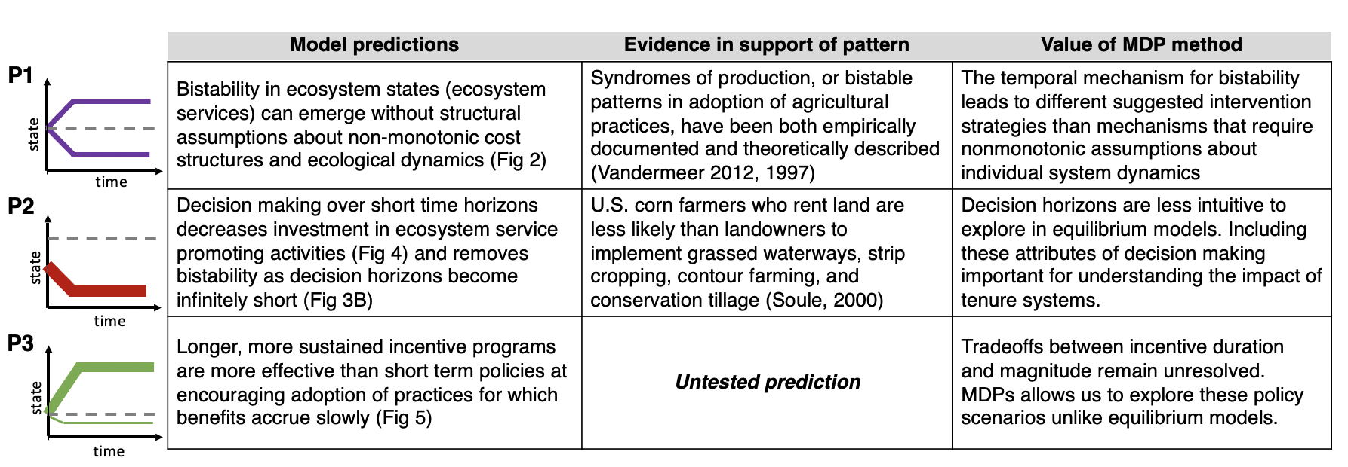

**Figure 6:** Table of the three main model predictions, evidence in support of the pattern, value added of the temporal mechanism and minimal assumptions.

Policies designed to promote agricultural sustainability and ecosystem services by reducing the costs of practice adoption are similarly interesting to explore with a markov decision process due to their sequential nature. What are the tradeoffs between short- and long-term incentive structures? Our results suggest that longer-term, sustained incentives, even when only partially covering the cost of adoption, may be more effective in shifting farmers from simplified ecological states to diversified states than more concentrated short-term incentives (Figure 6 P3). We show that the cost of interventions and the social-environmental benefit of those interventions are not necessarily equivalent. Rather, perceived stability of incentive programs over time may be an important driver of adoption, which can be overlooked if the temporal rates of coupled dynamics in social-environmental systems are not considered. This is particularly relevant to government payment programs and suggests that payments can be highly effective in encouraging adoption of diversification practices (or other ecosystem service promoting practices) when implemented over long time horizons. While the possibility of a policy discontinuation may contribute to the lack of impact for short-term incentives, reduced transaction costs that come with farmers making a longer-term commitment may also partially explain the greater impact of sustained incentives as compared to concentrated incentives.

By conceptualizing social environmental systems through a this lens, we offer insights into important agricultural patterns and thier implications for policy. We present a flexible model framework that can be built on to address numerous questions in social-ecological systems research and policy design. Expanding the boundaries of the model to include the effect of factors such as agricultural regulations and network structures would extend the scope of questions explored.

# Model implementation

The model was developed in the *R* programming language (R Core Team 2019). The *MDPtoolbox* library was used to set up and solve the MDP (Chades et al. 2017), *tidyverse* for data analysis (Wickham et al. 2019), and *ggplot2* to generate all figures (Wickham 2016). Code for our model and the experiments conducted in this paper is available freely at <https://github.com/boettiger-lab/dfs-mdp>.

# Author Contributions:

Conceptualization CB, MC, SW, PB, TB, LC, FC, KE, SG, AI, DK, CK, JL, EO, JO, MR, AS, JT, HW; Data curation: MC, SW, CB; Formal Analysis: MC, SW, CB; Funding acquisition: TB, AI, CK, DK, CB; Methodology: CB, MC, SW, PB, TB, LC, FC, KE, AI, DK, CK, EO, JT, HW; Code: MC, SW, CB; Visualization: MC, SW, CB; Writing – original draft: MC, SW, CB, LC; Writing – review & editing: CB, MC, SW, PB, TB, LC, FC, KE, SG, AI, DK, CK, JL, EO, JO, MR, AS, JT, HW

# Acknowledgments

Funding for this research was provided by the National Science Foundation grant number CNH-1824871

# References

Andow, David A., and Kazumasa Hidaka. 1989. “Experimental natural history of sustainable agriculture: syndromes of production.” *Agriculture, Ecosystems and Environment*. <https://doi.org/10.1016/0167-8809(89)90105-9>.

Batáry, Péter, Lynn V. Dicks, David Kleijn, and William J. Sutherland. 2015. “The role of agri-environment schemes in conservation and environmental management.” *Conservation Biology*. <https://doi.org/10.1111/cobi.12536>.

Beisner, B. E., D. T. Haydon, and K. Cuddington. 2003. “Alternative stable states in ecology.” [https://doi.org/10.1890/1540-9295(2003)001[0376:ASSIE]2.0.CO;2](https://doi.org/10.1890/1540-9295(2003)001%5b0376:ASSIE%5d2.0.CO;2).

Chades, Iadine, Guillaume Chapron, Marie-Josee Cros, Frederick Garcia, and Regis Sabbadin. 2017. *MDPtoolbox: Markov Decision Processes Toolbox*. <https://CRAN.R-project.org/package=MDPtoolbox>.

Cumming, Graeme S., David H.M. Cumming, and Charles L. Redman. 2006. “Scale mismatches in social-ecological systems: Causes, consequences, and solutions.” *Ecology and Society*. <https://doi.org/10.5751/ES-01569-110114>.

Dai, Lei, Daan Vorselen, Kirill S. Korolev, and Jeff Gore. 2012. “Generic indicators for loss of resilience before a tipping point leading to population collapse.” *Science*. <https://doi.org/10.1126/science.1219805>.

Downey, Sean S, W Randall Haas, and Stephen J Shennan. 2016. “European Neolithic Societies Showed Early Warning Signals of Population Collapse.” *Proceedings of the National Academy of Sciences* 113 (35). National Acad Sciences: 9751–6.

Foley, Jonathan A, Ruth DeFries, Gregory P Asner, Carol Barford, Gordon Bonan, Stephen R Carpenter, F Stuart Chapin, et al. 2005. “Global Consequences of Land Use.” *Science* 309 (5734). American Association for the Advancement of Science: 570–74.

Foley, Jonathan A, Navin Ramankutty, Kate A Brauman, Emily S Cassidy, James S Gerber, Matt Johnston, Nathaniel D Mueller, et al. 2011. “Solutions for a Cultivated Planet.” *Nature* 478 (7369). Nature Publishing Group: 337–42.

Fraser, Evan DG. 2004. “Land Tenure and Agricultural Management: Soil Conservation on Rented and Owned Fields in Southwest British Columbia.” *Agriculture and Human Values* 21 (1). Springer: 73–79.

Gladwell, Malcolm. 2006. *The Tipping Point: How Little Things Can Make a Big Difference*. Little, Brown.

Graddy-Lovelace, Garrett, and Adam Diamond. 2017. “From supply management to agricultural subsidies—and back again? The U.S. Farm Bill & agrarian (in)viability.” *Journal of Rural Studies*. <https://doi.org/10.1016/j.jrurstud.2016.12.007>.

Holbrook, Sally J, Russell J Schmitt, Thomas C Adam, and Andrew J Brooks. 2016. “Coral Reef Resilience, Tipping Points and the Strength of Herbivory.” *Scientific Reports* 6 (1). Nature Publishing Group: 1–11.

Horan, Richard D., Eli P. Fenichel, Kevin L. S. Drury, and David M. Lodge. 2011a. “Managing Ecological Thresholds in Coupled Environmentalhuman Systems.” *Proceedings of the National Academy of Sciences* 108 (18). National Academy of Sciences: 7333–8. <https://doi.org/10.1073/pnas.1005431108>.

Horan, Richard D., Eli P. Fenichel, Kevin L.S. Drury, and David M. Lodge. 2011b. “Managing ecological thresholds in coupled environmental-human systems.” *Proceedings of the National Academy of Sciences of the United States of America*. <https://doi.org/10.1073/pnas.1005431108>.

Kremen, Claire, Alastair Iles, and Christopher Bacon. 2012. “Diversified Farming Systems: An Agroecological, Systems-Based Alternative to Modern Industrial Agriculture.” *Ecology and Society* 17 (4). JSTOR.

Lenton, Timothy M, Hermann Held, Elmar Kriegler, Jim W Hall, Wolfgang Lucht, Stefan Rahmstorf, and Hans Joachim Schellnhuber. 2008. “Tipping Elements in the Earth’s Climate System.” *Proceedings of the National Academy of Sciences* 105 (6). National Acad Sciences: 1786–93.

Lippe, Melvin, Mike Bithell, Nick Gotts, Davide Natalini, Peter Barbrook-Johnson, Carlo Giupponi, Mareen Hallier, et al. 2019. “Using agent-based modelling to simulate social-ecological systems across scales.” *GeoInformatica*. <https://doi.org/10.1007/s10707-018-00337-8>.

Liu, Jianguo, Thomas Dietz, Stephen R Carpenter, Marina Alberti, Carl Folke, Emilio Moran, Alice N Pell, et al. 2007. “Complexity of Coupled Human and Natural Systems.” *Science* 317 (5844). American Association for the Advancement of Science: 1513–6.

Long, R, Kelly Garbach, L Morandin, and others. 2017. “Hedgerow Benefits Align with Food Production and Sustainability Goals.” *California Agriculture* 71 (3). University of California, Agriculture; Natural Resources: 117–19.

Mumby, Peter J., Alan Hastings, and Helen J. Edwards. 2007. “Thresholds and the resilience of Caribbean coral reefs.” *Nature*. <https://doi.org/10.1038/nature06252>.

Ong, Theresa Wei Ying, and Wenying Liao. 2020. “Agroecological Transitions: A Mathematical Perspective on a Transdisciplinary Problem.” <https://doi.org/10.3389/fsufs.2020.00091>.

Ostrom, Elinor. 2009. “A general framework for analyzing sustainability of social-ecological systems.” <https://doi.org/10.1126/science.1172133>.

R Core Team. 2019. *R: A Language and Environment for Statistical Computing*. Vienna, Austria: R Foundation for Statistical Computing. <https://www.R-project.org/>.

Redmond, William H. 2003. “Innovation, Diffusion, and Institutional Change.” <https://doi.org/10.1080/00213624.2003.11506608>.

Richardson Jr, Jesse J. 2015. “Land Tenure and Sustainable Agriculture.” *Tex. A&M L. Rev.* 3. HeinOnline: 799.

Rockström, Johan, Will Steffen, Kevin Noone, Åsa Persson, F Stuart Chapin, Eric F Lambin, Timothy M Lenton, et al. 2009. “A Safe Operating Space for Humanity.” *Nature* 461 (7263). Nature Publishing Group: 472–75.

Scheffer, Marten. 2010. “Foreseeing tipping points.” *Nature*. <https://doi.org/10.1038/467411a>.

Scheffer, Marten, Steve Carpenter, Jonathan A. Foley, Carl Folke, and Brian Walker. 2001. “Catastrophic shifts in ecosystems.” <https://doi.org/10.1038/35098000>.

Soule, Meredith J, Abebayehu Tegene, and Keith D Wiebe. 2000. “Land Tenure and the Adoption of Conservation Practices.” *American Journal of Agricultural Economics* 82 (4). Oxford University Press: 993–1005.

Stoate, C, A Báldi, Pl Beja, ND Boatman, I Herzon, A Van Doorn, GR De Snoo, L Rakosy, and C Ramwell. 2009. “Ecological Impacts of Early 21st Century Agricultural Change in Europe–a Review.” *Journal of Environmental Management* 91 (1). Elsevier: 22–46.

Vandermeer, John. 1997a. “Syndromes of production: An emergent property of simple agroecosystem dynamics.” *Journal of Environmental Management*. <https://doi.org/10.1006/jema.1997.0128>.

———. 1997b. “Syndromes of Production: An Emergent Property of Simple Agroecosystem Dynamics.” *Journal of Environmental Management* 51 (1). Elsevier: 59–72.

Vandermeer, John H., and Ivette Perfecto. 2012. “Syndromes of production in agriculture: Prospects for social-ecological regime change.” *Ecology and Society*. <https://doi.org/10.5751/ES-04813-170439>.

Vandermeer, John, and Ivette Perfecto. 2012. “Syndromes of Production in Agriculture: Prospects for Social-Ecological Regime Change.” *Ecology and Society* 17 (4). The Resilience Alliance.

Walker, Brian, C. S. Holling, Stephen R. Carpenter, and Ann Kinzig. 2004. “Resilience, adaptability and transformability in social-ecological systems.” *Ecology and Society*. <https://doi.org/10.5751/ES-00650-090205>.

Wickham, Hadley. 2016. *Ggplot2: Elegant Graphics for Data Analysis*. Springer-Verlag New York. <https://ggplot2.tidyverse.org>.

Wickham, Hadley, Mara Averick, Jennifer Bryan, Winston Chang, Lucy D’Agostino McGowan, Romain François, Garrett Grolemund, et al. 2019. “Welcome to the tidyverse.” *Journal of Open Source Software* 4 (43): 1686. <https://doi.org/10.21105/joss.01686>.